Table of Content
Contents
Dataset 5
Model Performance Analysis Based on Confusion Matrix 5
Matrix Components 6
Predicted Labels (columns): 6
Values in the Matrix 6
• Breakdown of the values: 7
Interpretation of Performance 7
• High True Positives (TP): 7
• False Positives (FP): 7
Color Gradient 8
Conclusion 8
Model Performance Analysis Based on F1-Confidence Curve 8
Overview of the F1-Score 8
Classes Analyzed 9
Observations from the Curves 9
Overall Performance 9
Confidence Levels 9
Recommendations for Improvement 10
Conclusion 10
Model Performance Analysis Based on PR-Curve 10
Key Metrics 11
Class Performance 11
• NO_tumor (Precision: 0.980) 11
• Meningioma (Precision: 0.942) 11
• Pituitary (Precision: 0.783) 12
• Glioma (Precision: 0.648) 12
• Space-occupying lesion (Precision: 0.001) 12
Overall Performance 12
• All Classes (mAP@0.5: 0.671) 12
Summary 12
Model Performance Overview 13
Train/Box Loss 13
Train/Cls Loss 13
Train/Dfl Loss 14
Val/Box Loss 14
Val/Cls Loss 14
Val/Dfl Loss 14
Metrics/Precision (B) 14
Metrics/Recall (B) 15
Metrics/mAP50 (B) 15
Metrics/mAP50-95 (B) 15
Summary 15
Model Performance and Quality Metrics 16
2. Suggestions to Improve Model Before Inference 16
Dataset 17
Model Performance Analysis Based on Confusion Matrix 17
Overall Performance 18
• Class-Specific Performance 18
• Key Observations 19
Recommendations for Improvement 20
• Address Class Imbalance: 20
• Improve Background Distinction: 20
• Space-occupying Lesion Detection: 20
• Model Architecture: 20
• Post-processing: 20
Model Performance Analysis Based on F1-Confidence Curve 21
Overall Model Performance 21
Class-Specific Performance 22
• NO_tumor Class: 22
• Meningioma Class: 22
• Pituitary Class: 22
• Glioma Class: 22
• Space-occupying lesion Class: 23
Key Observations 23
• Class Performance Hierarchy: 23
• Confidence Threshold Sensitivity: 23
• Class Imbalance Effects: 23
Recommendations 23
• Class-Specific Confidence Thresholds: 23
• Address Class Imbalance: 24
• Model Refinement: 24
• Validation Strategy: 24
Model Performance Analysis Based on PR-Curve 24
Overall Model Performance 25
Class-Specific Performance Analysis 25
• NO_tumor (0.954 AP): 25
• Meningioma (0.952 AP): 26
• Pituitary (0.764 AP): 26
• Glioma (0.713 AP): 26
• Space-occupying lesion (0.000 AP): 26
• Comparative Analysis 27
Key Observations 27
Recommendations for Improvement 27
• Address Class Imbalance: 27
• Model Architecture Adjustments: 28
Model Performance Overview 28
Loss Curves Analysis 29
• Training Losses 29
• Validation Losses 29
Interpretation: 29
Precision, Recall, and mAP Metrics 30
• Precision (metrics/precision(B)): 30
• Recall (metrics/recall(B)): 30
• mAP@0.5 (metrics/mAP50(B)): 30
• mAP@0.5:0.95 (metrics/mAP50-95(B)): 30
Generalization & Overfitting Check 30
Potential Issues & Recommendations 30
• Strengths 30
• Weaknesses 31
• Next Steps 31
Summary Table 31
Conclusion 32
Analysis of Labels Correlogram for Brain Tumor Detection Dataset 32
Distribution of Tumor Locations (x, y) 33
Distribution of Tumor Sizes (width, height) 34
Correlation Between Parameters 34
Potential Issues and Recommendations 34
Summary Table 35
Actionable Insights 35
Summary: 35

YOLOv11n Model Training Evaluation Report for Original Dataset

Dataset
The dataset is downloaded from roboflow.com
The dataset includes 1956 images.
Glioma-Meningioma-Pituitary-No are annotated in YOLOv11 format.
The following pre-processing was applied to each image:
* Auto-orientation of pixel data (with EXIF-orientation stripping)
* Resize to 640x640 (Stretch)
No image augmentation techniques were applied.

Model Performance Analysis Based on Confusion Matrix
A confusion matrix is a useful tool for evaluating the performance of a classification model. It summarizes the results of a classification task by comparing the true labels with the predicted labels.
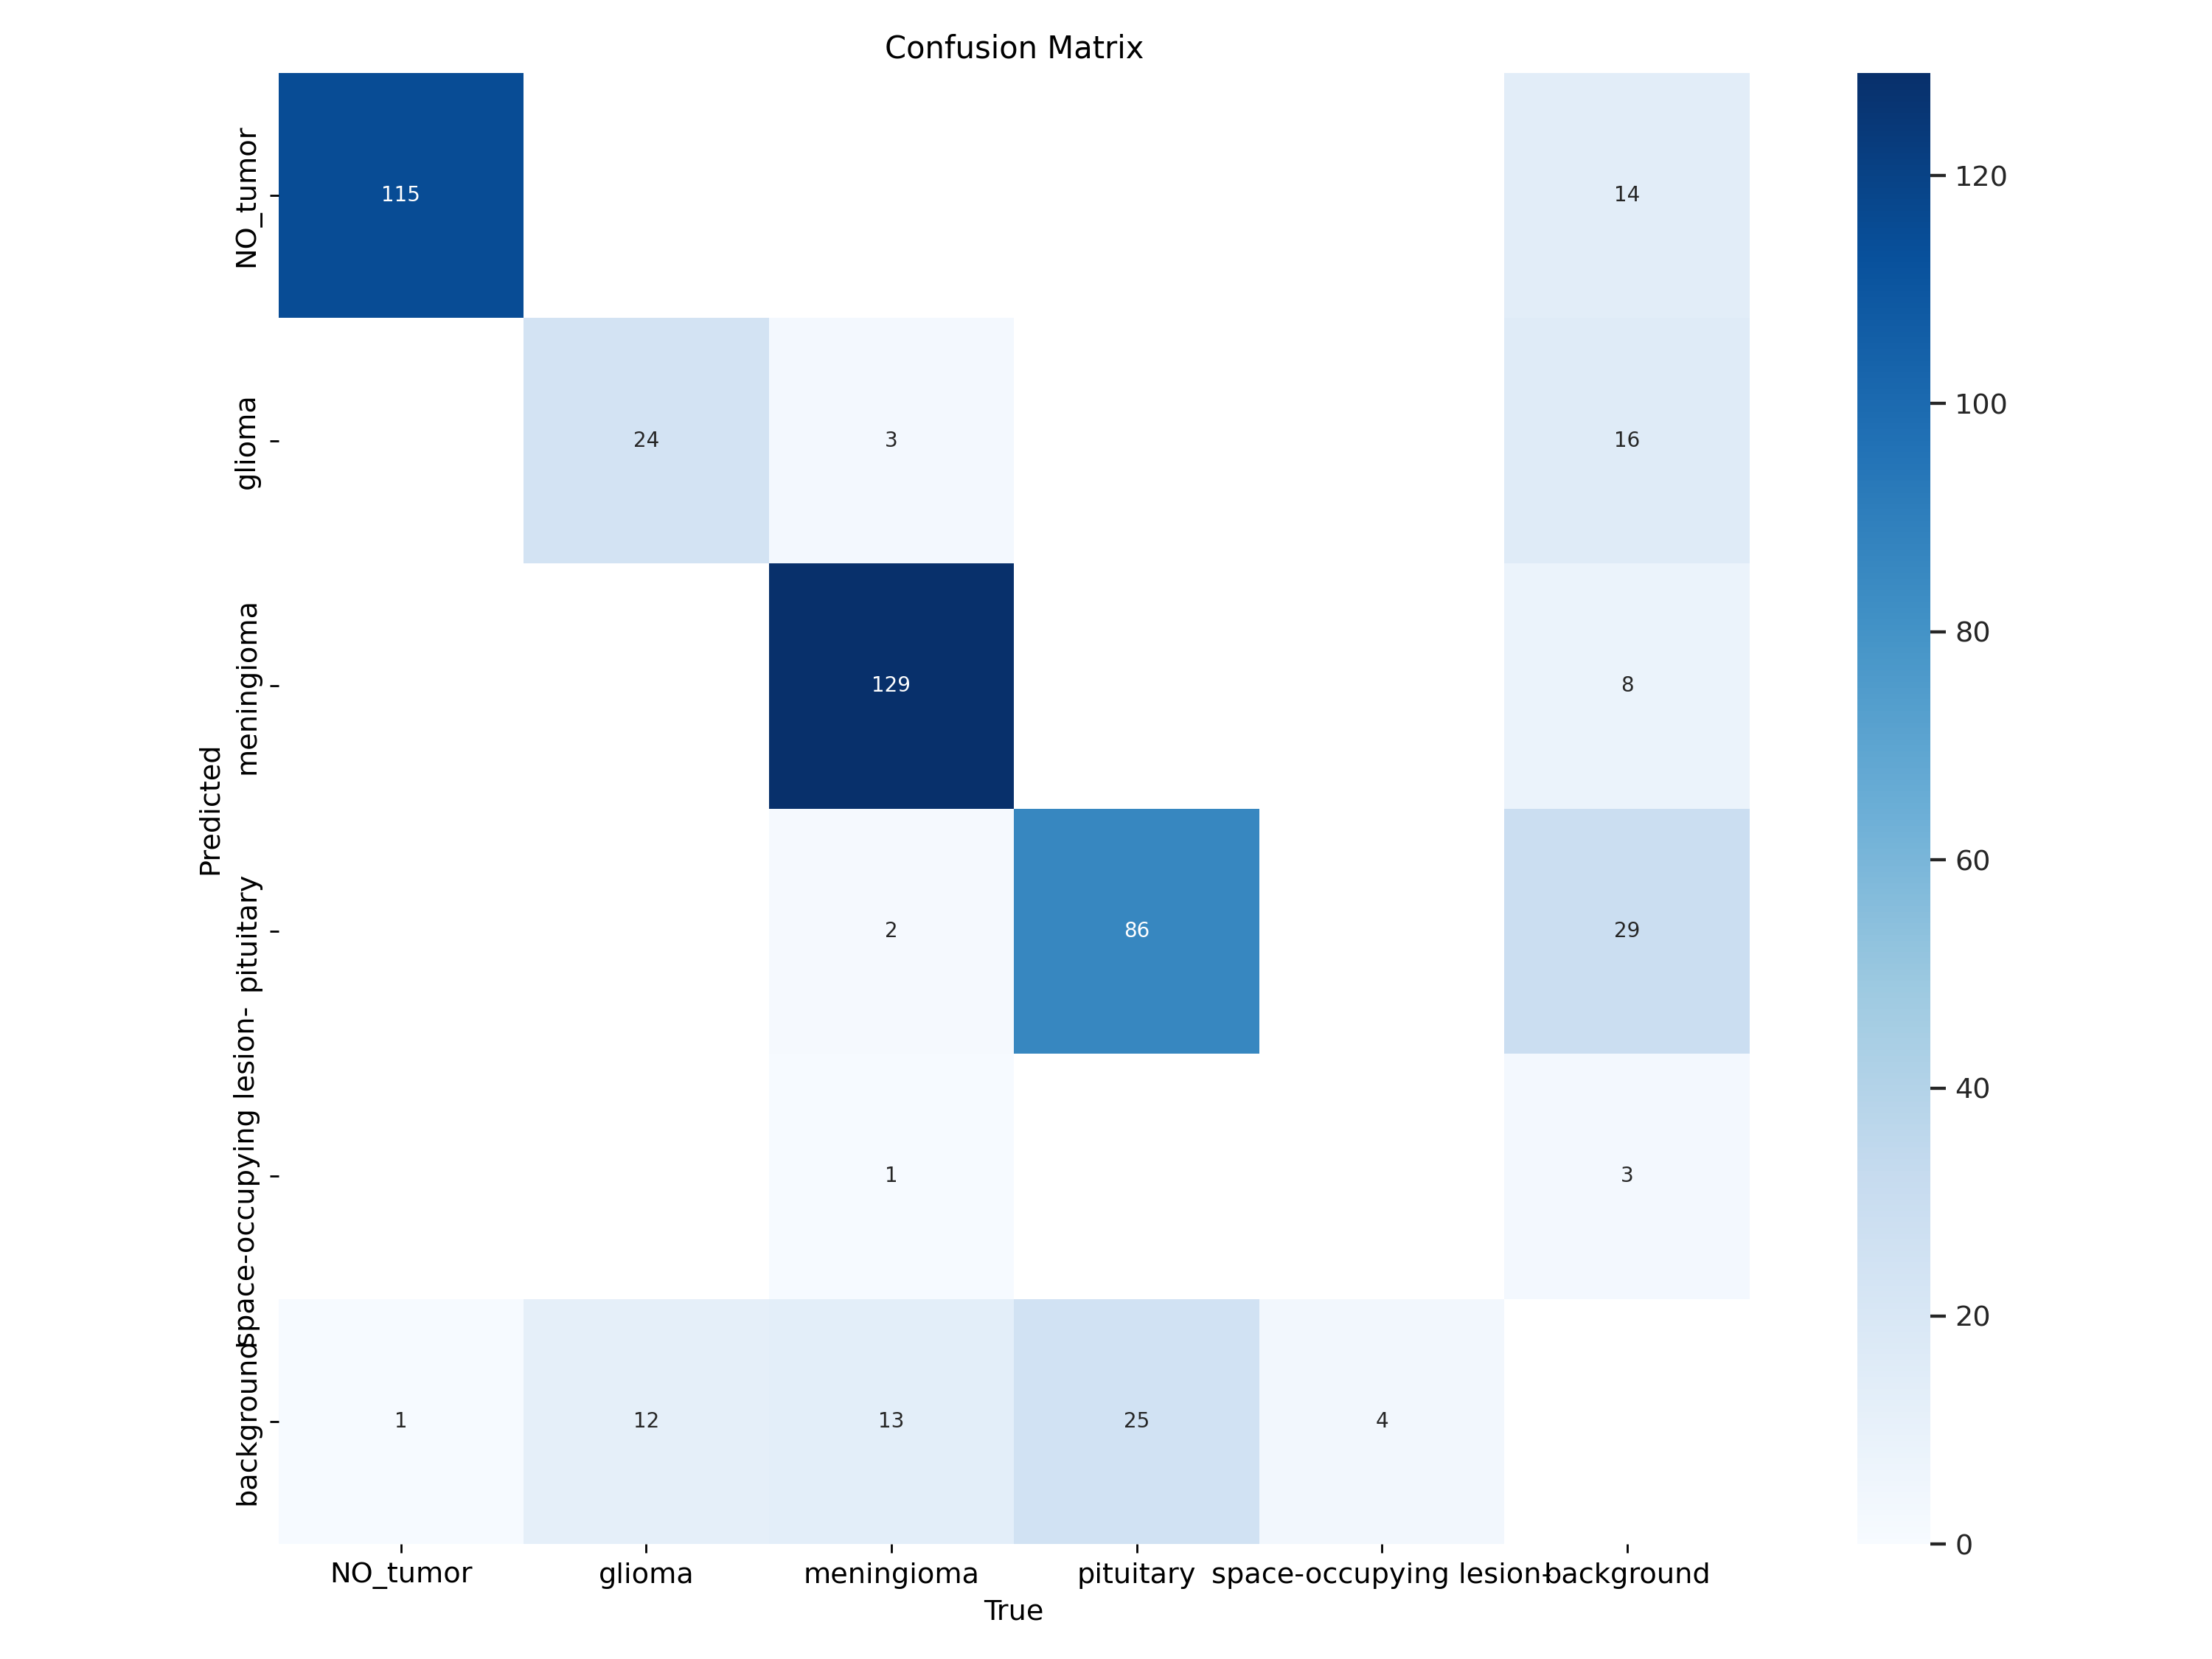

Matrix Components
- True Labels (rows):
- NO_tumor
- glioma
- meningioma
- pituitary
- space-occupying lesion
- background

Predicted Labels (columns):
Same categories as the true labels.

Values in the Matrix
Each cell in the matrix represents the count of instances for the respective true and predicted classes.

Breakdown of the values:

- NO_tumor:
- 115 correctly predicted as NO_tumor
- 14 misclassified as background, and 1 background wrongly predicted as NO_tumor

- glioma:
- 24 correctly predicted as glioma
- 16 misclassified as background, 3 as meningioma, and 12 background wrongly predicted as glioma

- meningioma:
- 129 correctly predicted as meningioma
- 8 misclassified as background. 2 pituitary cases, 1 space lesion, and 13 background wrongly predicted as meningioma

- pituitary:
- 86 correctly predicted as pituitary
- 29 misclassified as background, and 2 meningioma. 25 background cases wrongly predicted as pituitary

- space-occupying lesion:
- o correctly predicted as background
- 3 misclassified as background, 4 wrongly predicted as background

Interpretation of Performance

High True Positives (TP):
The model performs well for categories like NO_tumor and glioma, showing a high number of correctly classified instances.

False Positives (FP):
Some categories like glioma and pituitary have noticeable misclassifications, indicating areas where the model may need improvement.

Color Gradient
The color gradient represents the magnitude of values in the matrix, with darker shades indicating higher counts.

Conclusion
The confusion matrix provides insights into the classification performance, indicating areas of strength and weakness in predicting various tumor types. The data can guide further model enhancements and adjustments.

Model Performance Analysis Based on F1-Confidence Curve
The F1-Confidence Curve presented in the image provides insights into the performance of the trained YOLO model for brain tumor detection across different classes. Here’s a structured breakdown of the information conveyed by the curve:
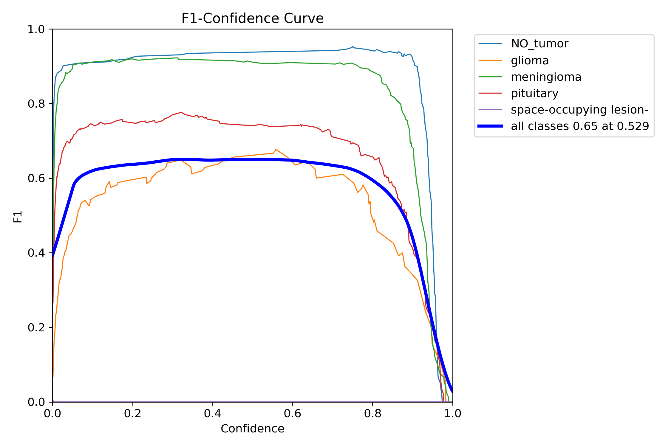

Overview of the F1-Score
- The F1-score is a measure of a model's accuracy that considers both precision and recall.
- It ranges from 0 to 1, where 1 indicates perfect precision and recall.

Classes Analyzed
- The performance is evaluated for the following tumor types:
  - NO Tumor
  - Glioma
  - Meningioma
  - Pituitary Tumor
  - Space-occupying Lesion

Observations from the Curves
- NO Tumor (Blue Line):
  - Shows a strong F1-score, maintaining high values (around 0.85) across multiple confidence levels.
- Glioma (Orange Line):
  - The F1-score is modest, peaking significantly lower than NO Tumor. It suggests that the model struggles to balance precision and recall for this class.
- Meningioma (Green Line):
  - Similar performance to Glioma, peaking below the 0.5 mark.
- Pituitary Tumor (Red Line):
  - F1-score is lower than NO Tumor, and approaches the 0.4 range.
- Space-occupying Lesion (Purple Line):
  - Shows the lowest F1-score, indicating consistent challenges in correctly identifying this class.

Overall Performance
- All Classes Combined (Thick Blue Line):
  - Achieved an overall F1-score of 0.65 at 0.529 Confidence.
  - Indicates moderate performance in detecting tumors across all classes but also highlights areas for significant improvement, particularly with classes like space-occupying lesions and gliomas.

Confidence Levels
- At low confidence levels (0.0 to 0.2), precision and recall are notably inconsistent, resulting in lower F1-scores.
- As confidence increases up to 0.65, the F1-scores improve, reflecting the model's capability in correctly identifying tumors.
- Beyond a certain confidence level, the F1-score stabilizes, indicating a threshold where the model has optimized its classification abilities.

Recommendations for Improvement
- Data Augmentation: Increase data diversity, especially for underperforming classes.
- Model Tuning: Fine-tune hyper parameters to improve recall and precision in low-confidence areas.
- Class Balancing: Ensure class representation is balanced in the training dataset to prevent bias.

Conclusion
The F1-curve indicates that while the model performs well overall, significant variability exists among different tumor types. Specifically, the NO Tumor class shows a strong predictive capability, while crucial tumor types like gliomas and space-occupying lesions require further optimization for improved detection.

Model Performance Analysis Based on PR-Curve
The Precision-Recall (PR) curve provides valuable insights into the performance of the YOLOv11n model trained for brain tumor detection. Below is an analysis of the curve based on the provided image.
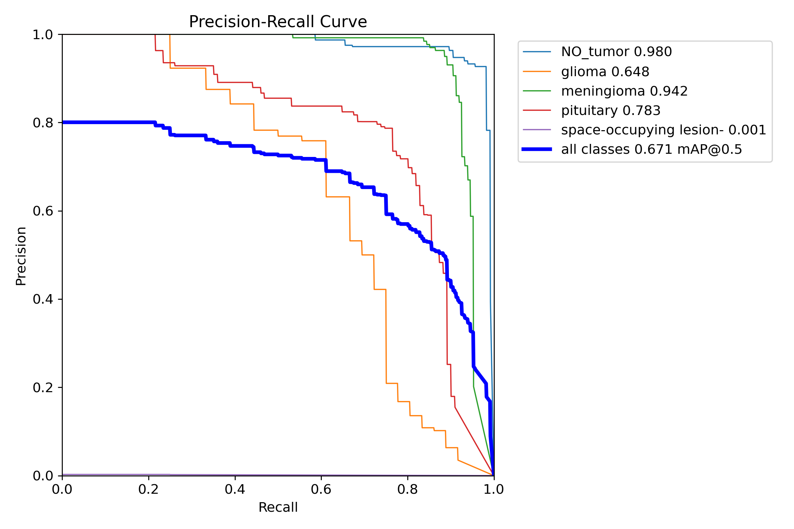

Key Metrics
- Each colored line represents a different class of tumors, showing the trade-off between precision and recall at various thresholds.
- The blue line represents the aggregated performance of all classes, noted as mAP (mean Average Precision) at a threshold of 0.5.

Class Performance

NO_tumor (Precision: 0.980)
  - Analysis: Extremely high precision indicates that when the model predicts no tumor, it’s very likely correct.
  - Recall: The model maintains relatively high recall, suggesting it can effectively identify instances of no tumor.

Meningioma (Precision: 0.942)
  - Analysis: This class also shows high precision, indicating reliable tumor classification.
  - Recall: Similar to NO_tumor, it suggests good detection of meningioma’s.

Pituitary (Precision: 0.783)
  - Analysis: Moderate precision indicates some errors in classification, meaning predictions may not be as reliable compared to the first two classes.
  - Recall: The recall for this class will need further exploration to confirm the effectiveness of detections.

Glioma (Precision: 0.648)
  - Analysis: Lower precision indicates a higher likelihood of false positives.
  - Recall: The ability to detect gliomas may need improvement, as indicated by the lower score.

Space-occupying lesion (Precision: 0.001)
  - Analysis: This class shows extremely low precision, indicating that the model struggles significantly with this category.
  - Recall: The model likely fails to detect space-occupying lesions adequately.

Overall Performance

All Classes (mAP@0.5: 0.671)
  - Analysis: This aggregated score indicates a moderate overall performance. The lower score for some classes suggests room for improvement, particularly in accurately detecting less prevalent types of tumors.

Summary
The model demonstrates excellent precision for the NO_tumor and meningioma categories, but struggles substantially with the space-occupying lesion class and shows moderate performance in gliomas and pituitary tumors.
Future work may involve enhancing data diversity, exploring model architecture improvements, or adjusting thresholds to better handle less frequent classes.
This analysis indicates that while the model performs well with common tumor types, optimization is necessary for rarer classes.

Model Performance Overview
The performance metrics and loss curves for the YOLOv11 model trained on a brain tumor detection dataset show varying trends, providing insights into the training and validation processes.
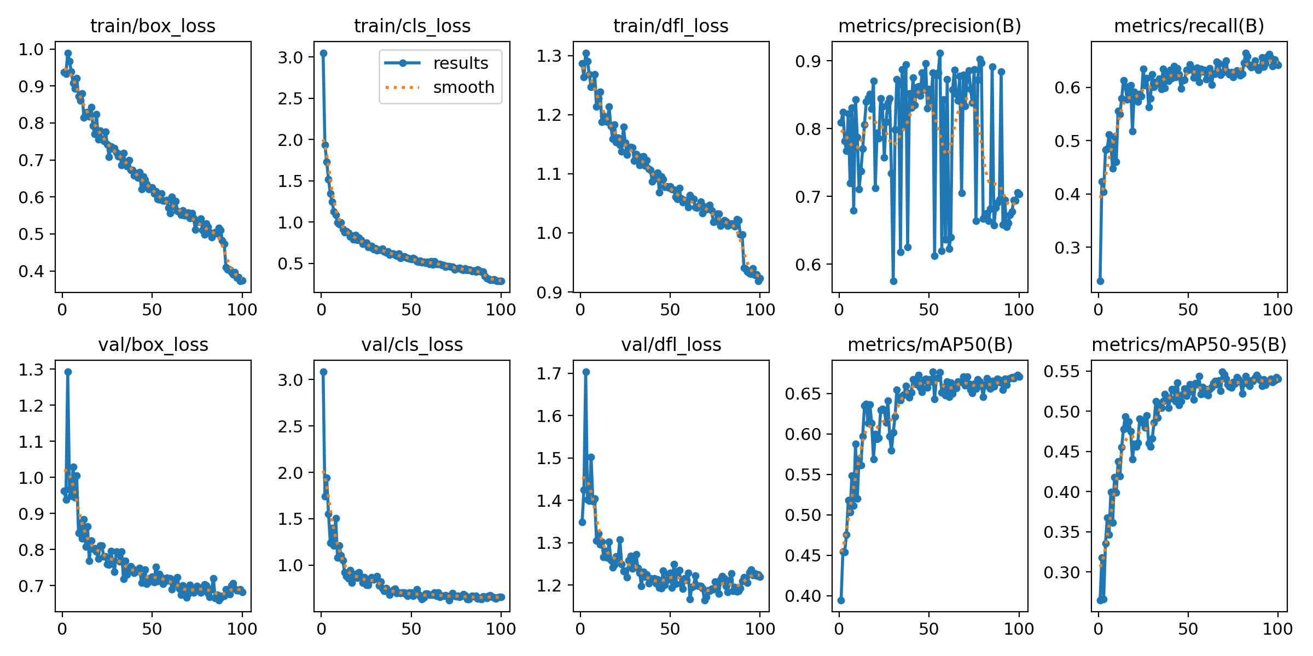

Train/Box Loss
- Description: Displays the loss related to the bounding box predictions during training.
- Observation:
  - Declining trend indicating that the model is learning to make better bounding box predictions.
  - Loss stabilizes closer to 0.4 after about 70 epochs.

Train/Cls Loss
- Description: Reflects the loss associated with classification tasks during training.
- Observation:
  - Decreasing loss, initially at around 2.5, dropping to just above 1.0, showing improved classification accuracy.

Train/Dfl Loss
- Description: Represents the distribution focal loss during training.
- Observation:
  - Decrease in loss value, stabilizing about 0.9 towards the end of training.
  - Suggests effective learning of object distributions.

Val/Box Loss
- Description: Loss related to bounding box predictions during validation.
- Observation:
  - Decreases to about 0.8, indicating good performance on unseen data.
  - Slight fluctuations suggest some variability in performance.

Val/Cls Loss
- Description: Classification loss during validation.
- Observation:
  - Shows a declining trend as well, settling around 1.1, which is acceptable indicating reliable classification.

Val/Dfl Loss
- Description: Validation loss for distribution focal loss.
- Observation:
  - Slightly higher than training loss, indicating potential difficulties in generalization.
  - Values stabilize around 1.4 by the end of the validation phase.

Metrics/Precision (B)
- Description: Measures the precision of bounding box predictions.
- Observation:
  - Fluctuates throughout epochs but generally trends upwards, reaching approximately 0.7.
  - Suggests many correct predictions amid challenges.

Metrics/Recall (B)
- Description: Reflects the model’s ability to correctly identify all relevant instances.
- Observation:
  - Steady growth, reaching nearly 0.6, indicating good model comprehensive performance on detection.

Metrics/mAP50 (B)
- Description: Measures mean Average Precision at IoU threshold of 0.5.
- Observation:
  - Increases steadily, peaking above 0.5, demonstrating effective bounding box predictions across classes.

Metrics/mAP50-95 (B)
- Description: Averaged mAP over multiple IoU thresholds from 0.5 to 0.95.
- Observation:
  - Trends upward, reaching about 0.55, indicating robust performance across different levels of overlap with ground truth boxes.

Summary
- The model demonstrates a consistent learning pattern, reducing both training and validation losses steadily over epochs.
- Precision and recall indicate the model's reliability in detecting and classifying tumors, with room for improvement in generalization given the slightly elevated validation losses.
- Overall, the performance metrics suggest that the YOLOv11 model is effectively tailored for the brain tumor detection task based on the dataset used.

Model Performance and Quality Metrics
This section outlines the evaluation metrics recorded during training and validation of the YOLOv8n object detection model. The results are summarized as follows:
• Box Loss (train/val): Steadily decreased, indicating successful learning of object localization.
• Class Loss (train/val): Rapid initial decline and convergence, showing good classification ability.
• DFL Loss (train/val): Gradual decrease, demonstrating improved object boundary confidence.
• Precision(B): Shows volatility with fluctuations between 0.6 and 0.95. This may be due to annotation noise or unstable predictions.
• Recall(B): Steadily increased to around 0.65, reflecting improved object detection coverage.
• mAP50(B): Increased to approximately 0.68, representing strong detection accuracy for the YOLOv11n model.
• mAP50-95(B): Improved to approximately 0.54, showing good overall detection performance.
Overall, the model shows no signs of overfitting, with training and validation losses decreasing consistently. The recall and mAP metrics demonstrate progressive improvement in detection capabilities.

2. Suggestions to Improve Model Before Inference
To further enhance model precision and reliability before using the model for inference, the following steps are recommended:
• Evaluate Label Quality: Review training dataset annotations for consistency and accuracy. Incorrect or overlapping bounding boxes can reduce model precision.
• Balance Dataset: Check for class imbalance issues. Ensure all classes are sufficiently represented in the dataset.
• Tune Confidence Threshold: During inference, consider adjusting the confidence threshold to reduce false positives. For example:
yolo detect predict model=best.pt conf=0.4
• Use a Larger Model: Upgrade to YOLOv11s for potentially better precision and mAP performance if resources allow.
• Apply Label Smoothing: This can help reduce overconfidence and improve generalization.
• Perform Post-Training Testing: Run inference on a diverse sample of test images to analyze predictions and identify any specific model weaknesses.
YOLOv11n Model Training Evaluation Report for Dataset 2

Dataset
The dataset is downloaded from roboflow.com
The dataset includes 1956 images.
Glioma-Meningioma-Pituitary-No are annotated in YOLOv11 format.
The following pre-processing was applied to each image:
* Auto-orientation of pixel data (with EXIF-orientation stripping)
* Resize to 640x640 (Stretch)
No image augmentation techniques were applied.
Key Difference: I have converted polygon labels to bounding box labels for all images in train/images. When I started training, yolo logs mention all labels correct except three.

Model Performance Analysis Based on Confusion Matrix
Based on the provided confusion matrix for the YOLO11n.pt model trained on a brain tumor detection dataset with 5 classes, here's a comprehensive analysis of the model's performance:
:
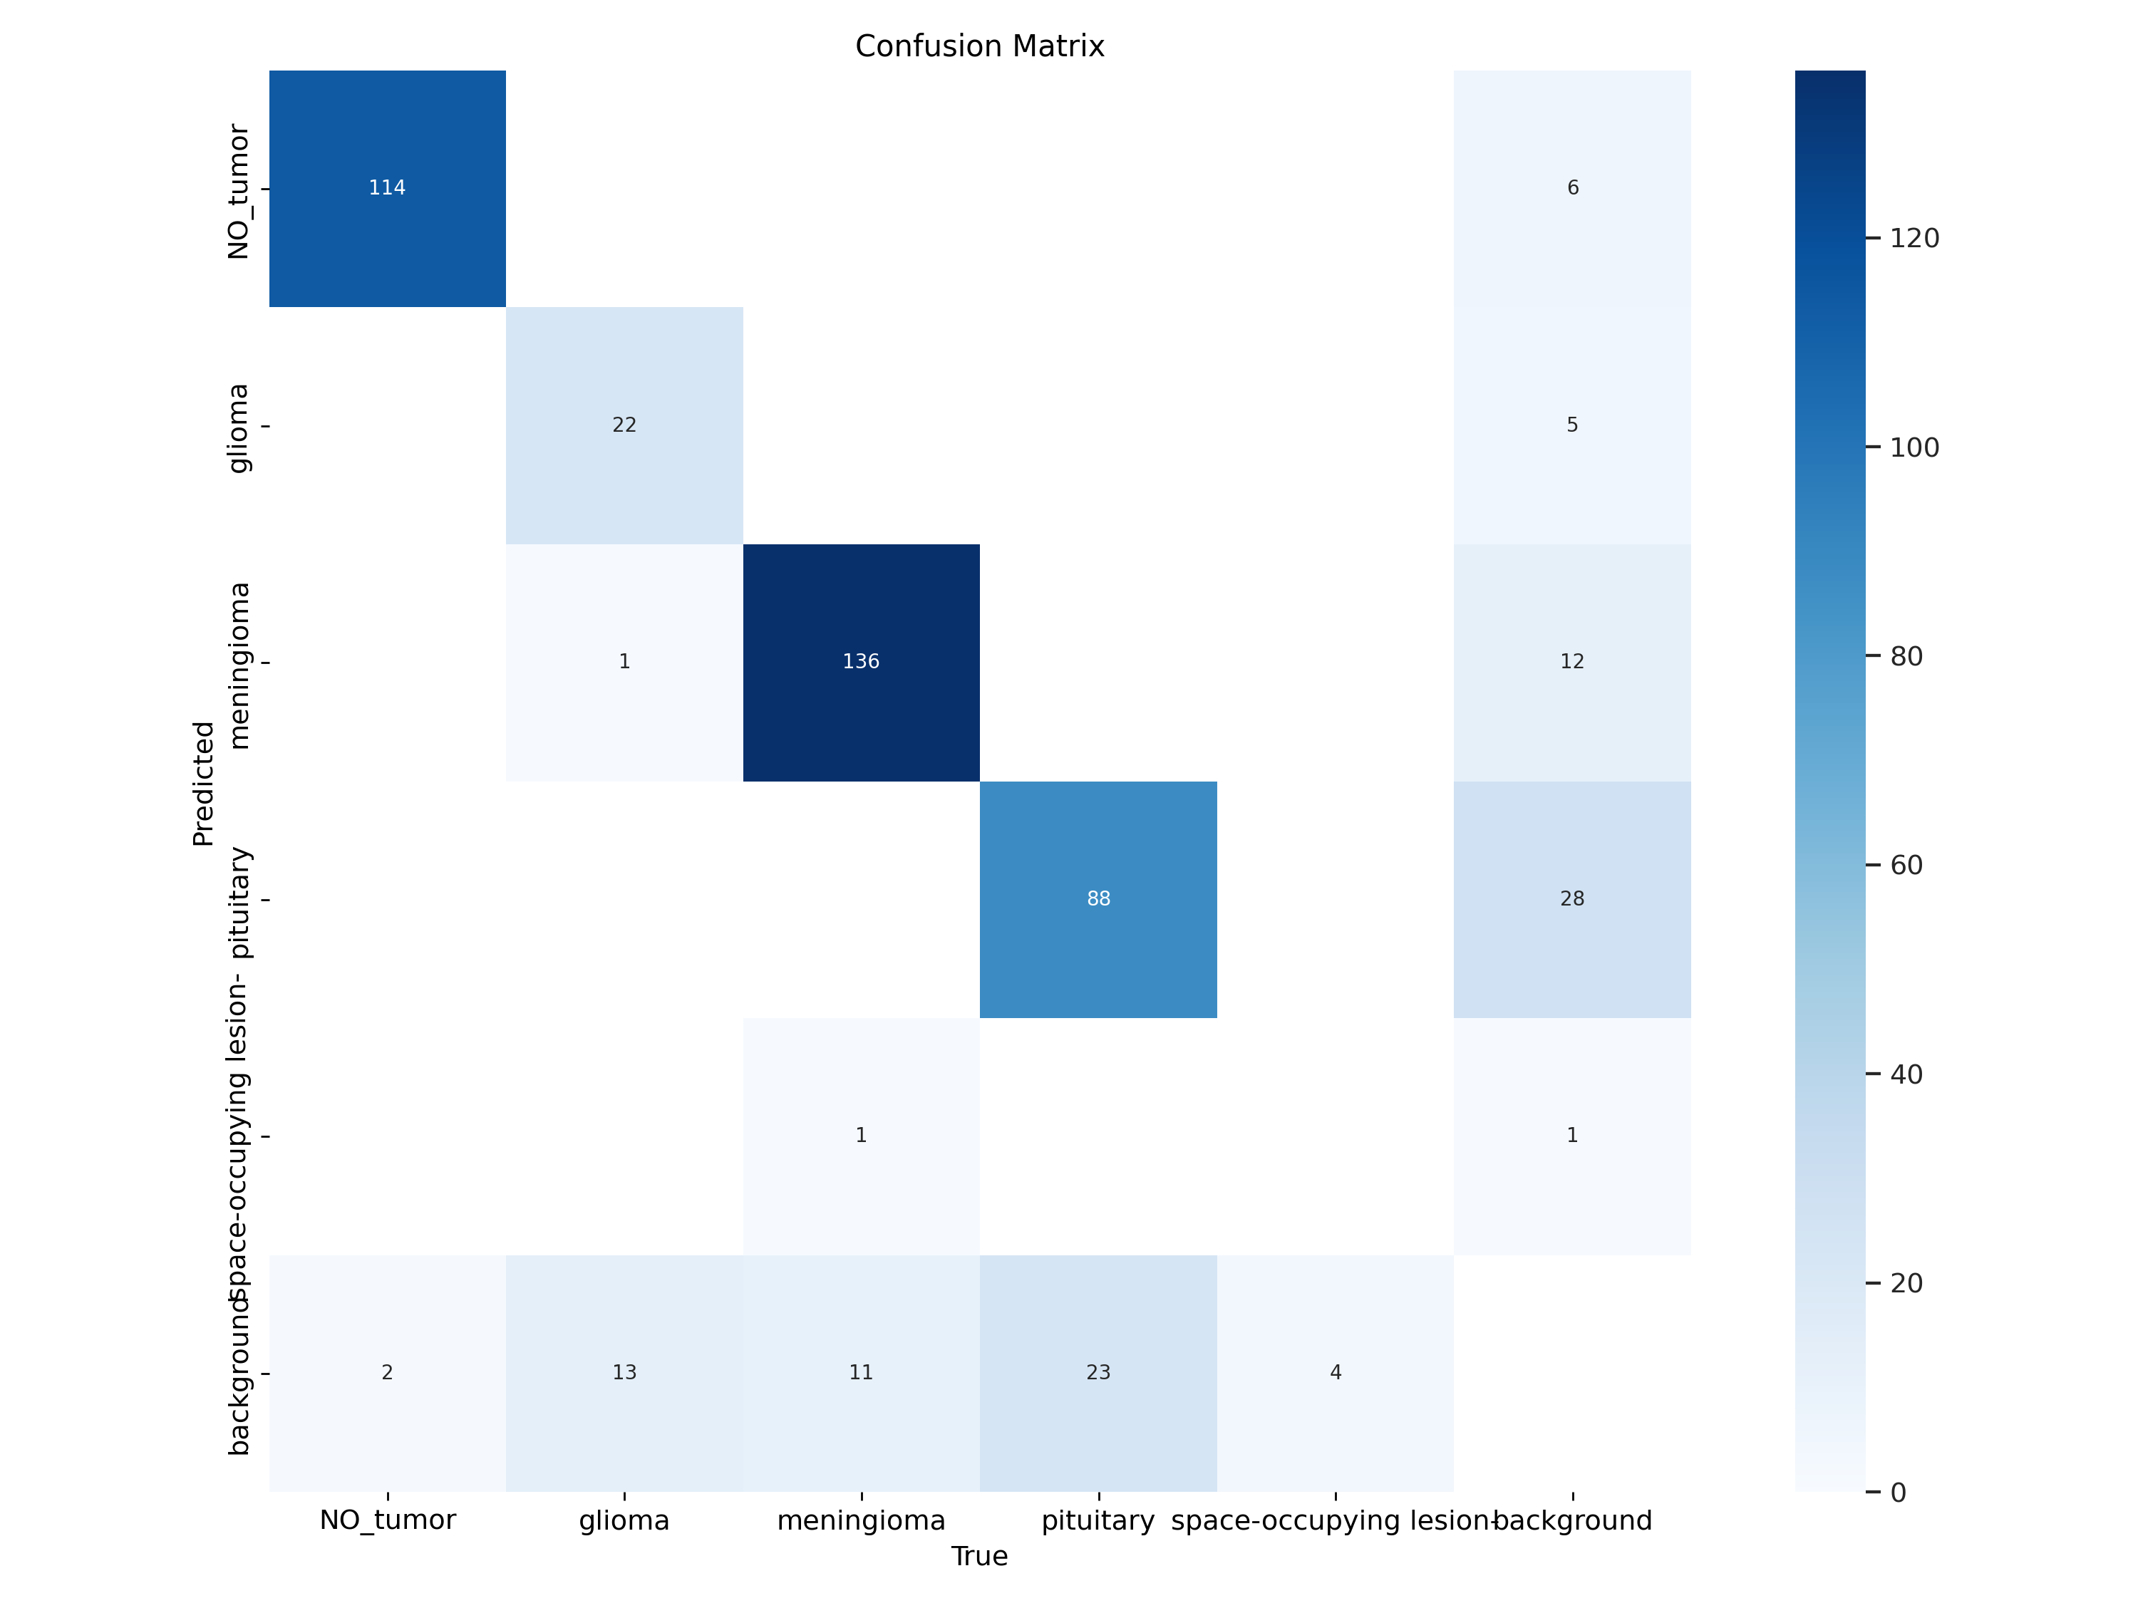

Overall Performance
The model demonstrates varying levels of effectiveness across the different tumor classes, with an estimated overall accuracy of approximately 77%. The performance is notably strong for certain classes but shows significant weaknesses in others.

Class-Specific Performance

NO_tumor Class:
- Strong performance with 114 correct predictions out of 116 total cases
- High precision (95%) and recall (98.3%)
- Very few misclassifications, with only 2 cases classified as background
- 6 background cases were incorrectly classified as NO_tumor

Meningioma Class:
- Excellent performance with 136 correct predictions
- High precision (91.3%) and recall (91.9%)
- Main error: 11 meningioma cases misclassified as background
- 12 background cases were incorrectly identified as meningioma

Pituitary Class:
- Good performance with 88 correct predictions
- Notable confusion with background class:
  - 23 pituitary cases misclassified as background
  - 28 background cases incorrectly classified as pituitary
- Moderate precision (75.9%) and recall (79.3%)

Glioma Class:
- Moderate performance with only 22 correct predictions
- Major issue with false negatives: 13 glioma cases classified as background
- One glioma case misclassified as meningioma
- Precision approximately 81.5% but lower recall around 61.1%

Space-occupying lesion Class:
- Very poor performance with only 1 correct prediction out of 5 true cases
- 4 cases were misclassified as background
- Low precision (33.3%) and recall (20%)
- Appears to be the least represented class in the dataset

Key Observations

Class Imbalance:
- The dataset shows significant class imbalance with meningioma (approximately 148 samples) and NO_tumor (approximately 116 samples) being the most common
- Space-occupying lesion class is severely underrepresented with only 5 samples

Background Misclassification Pattern:
- A recurring issue is the model's tendency to confuse actual tumor classes with background
- Approximately 53 actual tumor cases were classified as background
- About 52 background cases were incorrectly classified as tumor types

Confusion Between Classes:
- Very little inter-class confusion between tumor types
- Most misclassifications occur between a specific tumor class and the background

Recommendations for Improvement

Address Class Imbalance:
  - Implement data augmentation techniques specifically for underrepresented classes
  - Consider using weighted loss functions to give more importance to minority classes

Improve Background Distinction:
  - Fine-tune the model to better differentiate between tumor tissues and background
  - Enhance preprocessing techniques to improve tissue-background separation

Space-occupying Lesion Detection:
  - Collect more training examples for this rare class
  - Consider transfer learning or few-shot learning techniques to improve detection with limited samples

Model Architecture:
  - Experiment with different YOLO variants or other detection architectures
  - Consider ensemble methods to improve overall performance

Post-processing:
  - Implement confidence thresholding to reduce false positives from background
The model performs well on common tumor types but requires significant improvement for rare classes. The high number of background misclassifications suggests that boundary detection between tumor and non-tumor regions needs refinement.

Model Performance Analysis Based on F1-Confidence Curve
Based on the provided F1-confidence curve for the YOLOv11n model trained on brain tumor detection, I can offer a comprehensive analysis of how the model performs across different tumor classifications.
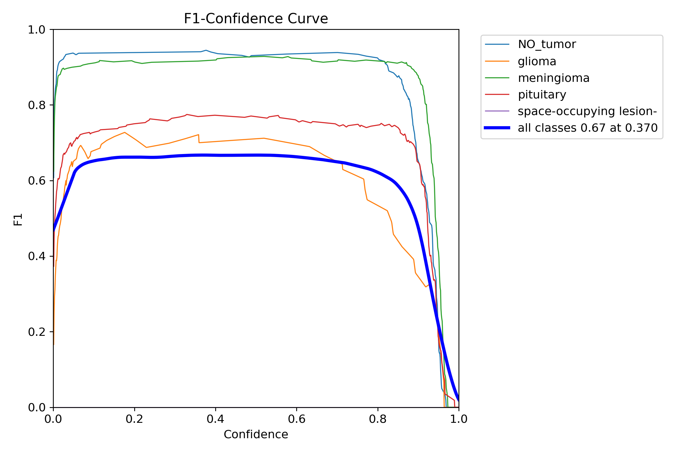

Overall Model Performance
The model achieves an overall F1 score of 0.67 at an optimal confidence threshold of 0.370, indicating moderate performance across all classes. This threshold represents the best balance between precision and recall for the complete dataset.

Class-Specific Performance

NO_tumor Class:
  - Exceptional performance with F1 scores consistently around 0.93-0.94
  - Maintains high F1 scores across a wide range of confidence thresholds (0.05-0.85)
  - Shows stable performance, indicating robust detection capabilities
  - Minimal degradation until very high confidence thresholds (>0.85)

Meningioma Class:
  - Strong performance with F1 scores around 0.92-0.93
  - Similar stability pattern to NO_tumor class
  - Maintains its high F1 score across various confidence thresholds
  - Represents one of the most reliably detected classes

Pituitary Class:
  - Moderate performance with F1 scores around 0.75-0.77
  - Less stable than the top two classes, showing more sensitivity to threshold changes
  - Performance peaks in the middle confidence range (0.3-0.7)
  - Shows a gradual decline as confidence thresholds approach extremes

Glioma Class:
  - Lower performance with F1 scores around 0.67-0.72
  - More variable performance across the confidence spectrum
  - Shows best results at moderate confidence levels (0.2-0.6)
  - Performance degrades more quickly at higher confidence thresholds compared to other classes

Space-occupying lesion Class:
  - Performance curve is not distinctly visible in the chart
  - Likely indicates extremely poor performance or insufficient representation
  - May suggest the model struggles significantly with this class

Key Observations

Class Performance Hierarchy:
  - Strong detection: NO_tumor and meningioma (F1 > 0.90)
  - Moderate detection: pituitary (F1 ≈ 0.75)
  - Weaker detection: glioma (F1 ≈ 0.70)
  - Poor detection: space-occupying lesion (insufficient data to assess)

Confidence Threshold Sensitivity:
  - All classes maintain relatively stable F1 scores in the 0.1-0.8 confidence range
  - All classes show sharp performance drops when confidence exceeds 0.85
  - The overall model curve (bold blue) suggests an optimal confidence threshold of 0.370

Class Imbalance Effects:
  - The significant variation in F1 scores between classes indicates potential class imbalance
  - Better-performing classes likely have more training samples
  - Space-occupying lesion class appears severely underrepresented

Recommendations

Class-Specific Confidence Thresholds:
  - Consider using different confidence thresholds for each class:
    - NO_tumor and meningioma: 0.5-0.7 (higher precision without sacrificing recall)
    - Pituitary and glioma: 0.3-0.4 (balance precision and recall)

Address Class Imbalance:
  - Employ data augmentation techniques for underrepresented classes
  - Implement weighted loss functions to prioritize learning from minority classes
  - Consider advanced sampling techniques during training

Model Refinement:
  - Fine-tune the model with focus on improving glioma and space-occupying lesion detection
  - Experiment with different model architectures or ensemble approaches
  - Consider specialized data preprocessing for difficult classes

Validation Strategy:
  - Implement stratified cross-validation to better assess performance across all classes
  - Evaluate model with additional metrics beyond F1 score (e.g., AUC-ROC, specificity)
The model shows promising results for common tumor types but requires significant improvement for less common classes. Addressing class imbalance and optimizing class-specific confidence thresholds could substantially improve overall performance.

Model Performance Analysis Based on PR-Curve
Based on the provided precision-recall (PR) curve, I can offer a comprehensive analysis of the YOLOv11n model's performance across the five brain tumor classes.
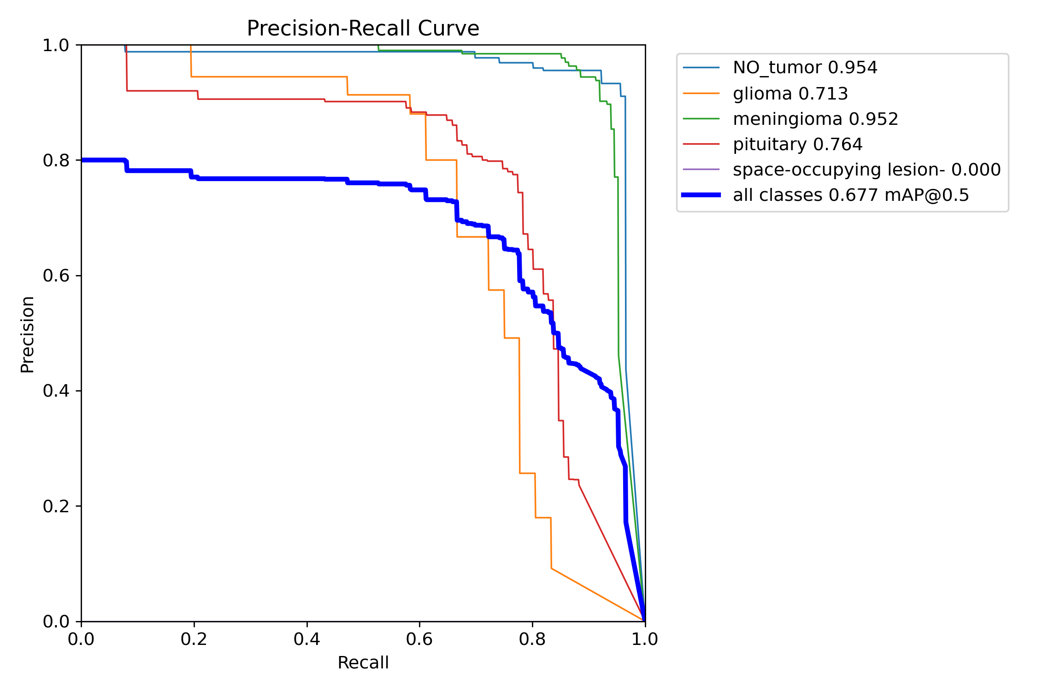

Overall Model Performance
The overall model performance measured by mean Average Precision (mAP@0.5) is 0.677, which indicates moderate detection capability across all classes. The all-classes PR curve (bold blue line) shows a generally declining trend as recall increases, with precision starting around 0.80 at low recall and gradually decreasing.

Class-Specific Performance Analysis

NO_tumor (0.954 AP):
  - Exceptional performance with near-perfect precision (~1.0) maintained across a wide recall range (0-0.9)
  - The curve only shows significant precision drop when recall exceeds 0.9
  - This indicates the model rarely mistakes other classes or background for NO_tumor
  - High AP value confirms reliable detection across virtually all confidence thresholds

Meningioma (0.952 AP):
  - Nearly identical performance to NO_tumor class
  - Maintains precision close to 1.0 for recall values up to approximately 0.9
  - Sharp drop in precision only at very high recall values
  - Suggests robust and reliable detection capabilities for this class

Pituitary (0.764 AP):
  - Good but noticeably lower performance than the top two classes
  - Starts with high precision (~0.9) at low recall
  - Shows steady decline in precision as recall increases beyond 0.6
  - More pronounced performance degradation at high recall values
  - The curve shape indicates more false positives at lower confidence thresholds

Glioma (0.713 AP):
  - Moderate performance with a distinctive step-like pattern in the PR curve
  - Maintains good precision (~0.95) initially but drops to ~0.9 at very low recall
  - Shows significant decline in precision when recall exceeds 0.7
  - Steep drops suggest discrete confidence thresholds where performance changes dramatically
  - Indicates challenges in maintaining precision while achieving high recall

Space-occupying lesion (0.000 AP):
  - Complete failure in detection with 0.000 AP
  - No visible curve in the PR plot
  - Suggests the model cannot detect this class at all
  - Likely due to extreme class imbalance or insufficient training examples

Comparative Analysis
The classes form three distinct performance tiers:
- High-performance tier (AP > 0.95): NO_tumor and meningioma
- Medium-performance tier (AP 0.7-0.8): Pituitary and glioma
- Failed detection tier (AP = 0): Space-occupying lesion
This stratification suggests the model's effectiveness is highly dependent on class representation in the training data.

Key Observations
- Class Imbalance Impact: The dramatic performance gap between classes strongly suggests significant class imbalance in the training dataset, with space-occupying lesion likely being severely underrepresented.
- Precision-Recall Tradeoff: For all classes except space-occupying lesion, the model can maintain high precision (>0.9) up to certain recall thresholds, after which performance degrades rapidly.
- Detection Confidence: The step-like pattern in the glioma curve indicates that confidence scores are not smoothly distributed, suggesting potential issues with the model's uncertainty estimation for this class.
- Overall Detection Capability: Despite variations, the model shows strong detection ability for 4 out of 5 classes, with only the space-occupying lesion class showing complete failure.

Recommendations for Improvement

Address Class Imbalance:
  - Implement data augmentation specifically for underrepresented classes
  - Consider synthetic data generation for the space-occupying lesion class
  - Apply class weighting in the loss function

Model Architecture Adjustments:
  - Experiment with feature pyramid networks to improve detection of smaller tumors
  - Consider using transfer learning from larger YOLO variants

Training Strategy:
  - Implement curriculum learning by gradually introducing difficult examples
  - Use focal loss to address class imbalance
  - Employ hard negative mining to improve discrimination between similar classes

Data Quality:
  - Review and potentially clean the training data for the space-occupying lesion class
  - Ensure proper annotation consistency across all classes
The model demonstrates excellent performance for common tumor types but requires significant improvement for the space-occupying lesion class. With targeted improvements addressing the class imbalance and refinement of detection thresholds, overall performance could be substantially enhanced.

Model Performance Overview
The performance metrics and loss curves for the YOLOv11 model trained on a brain tumor detection dataset show varying trends, providing insights into the training and validation processes.
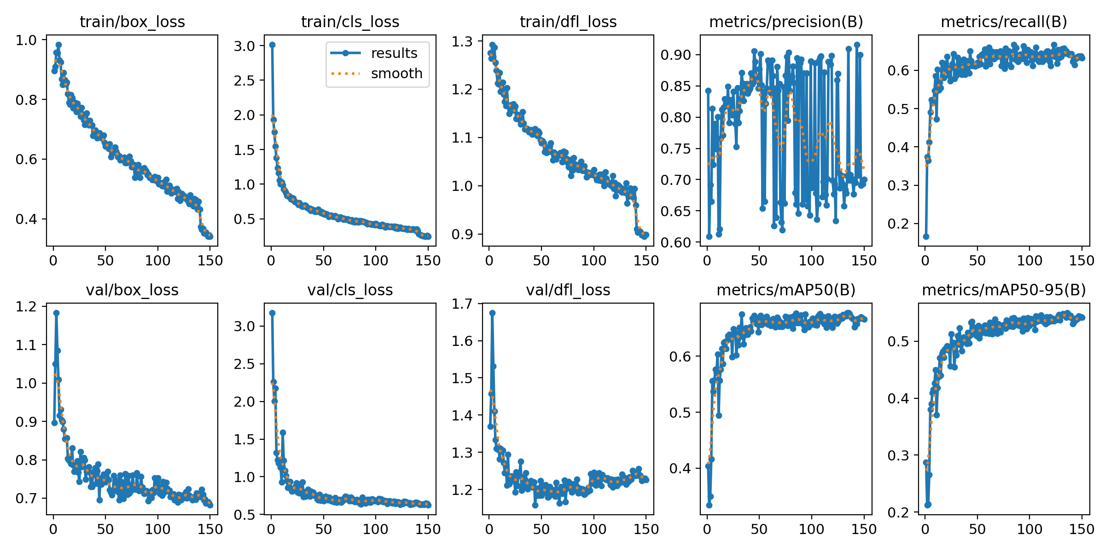

Loss Curves Analysis

Training Losses
  - Box Loss: Steadily decreases from ~1.0 to below 0.4, indicating improved bounding box localization.
  - Classification Loss: Drops sharply in early epochs and then decreases gradually, showing the model is learning to classify tumors effectively.
  - DFL (Distribution Focal Loss): Consistent downward trend, showing better box regression.

Validation Losses
  - Box, Classification, DFL Losses: All decrease and stabilize, with no signs of divergence or overfitting. Validation losses are slightly higher than training losses, which is expected.
Interpretation:
The model is learning well, with both training and validation losses decreasing and stabilizing, indicating good convergence and no overfitting.

Precision, Recall, and mAP Metrics

Precision (metrics/precision(B)):
  - Starts high, fluctuates in early epochs, then stabilizes around 0.8–0.9.
  - Some late-epoch noise, but the overall trend is positive.

Recall (metrics/recall(B)):
  - Rapid improvement in the first 20 epochs, then plateaus around 0.65.
  - Indicates the model is correctly identifying most true positives, but there is room for improvement in catching all tumors.

mAP@0.5 (metrics/mAP50(B)):
  - Increases quickly, stabilizing above 0.7.
  - Suggests good overall detection performance at a standard IoU threshold.

mAP@0.5:0.95 (metrics/mAP50-95(B)):
  - Steadily rises and stabilizes just above 0.5.
  - Indicates moderate performance across stricter IoU thresholds.

Generalization & Overfitting Check
  - Losses: Validation and training losses are close, indicating minimal overfitting.
  - Metrics: Both mAP and recall/precision stabilize, showing consistent generalization.

Potential Issues & Recommendations

Strengths
  - Strong localization and classification learning: Losses decrease smoothly.
  - Good precision: Model is confident in its positive predictions.
  - Solid mAP@0.5: Indicates reliable detection for most classes.

Weaknesses
- Recall is moderate: Some tumors, especially rare types (like 'space-occupying lesion-'), may be missed.
- mAP@0.5:0.95 is lower: Performance drops with stricter localization requirements, suggesting room for improvement in bounding box accuracy.

Next Steps
  - Class Imbalance: Augment data for underrepresented classes (e.g., 'space-occupying lesion-').
  - Recall Boost: Consider lowering detection thresholds or using recall-focused loss functions.
  - Model Tuning: Try larger YOLO variants or ensembling for further gains.
  - Post-processing: Adjust NMS (Non-Maximum Suppression) thresholds to balance precision and recall.

Summary Table
Metric | Value (Approx.) | Interpretation
Training Box Loss | ↓ 1.0 → 0.4 | Improved localization
Training Cls Loss | ↓ 3.0 → 0.5 | Improved classification
Validation Box Loss | ↓ 1.2 → 0.7 | Good generalization
Precision | 0.8–0.9 | High positive prediction confidence
Recall | ~0.65 | Moderate, some missed detections
mAP@0.5 | >0.7 | Good detection at standard threshold
mAP@0.5:0.95 | >0.5 | Moderate across stricter thresholds

Conclusion
Your YOLOv11n model for brain tumor detection is well-trained, with strong precision and good mAP. The main area for improvement is recall, especially for rare tumor types. Focus future efforts on data balancing, recall optimization, and possibly model scaling for even better results.

Analysis of Labels Correlogram for Brain Tumor Detection Dataset
The attached image is a labels correlogram (pair plot) for your brain tumor detection dataset, visualizing the distribution and relationships of bounding box parameters:
- x (center x-coordinate, normalized)
- y (center y-coordinate, normalized)
- width (normalized)
- height (normalized)
Below is a detailed analysis and insights based on this plot:
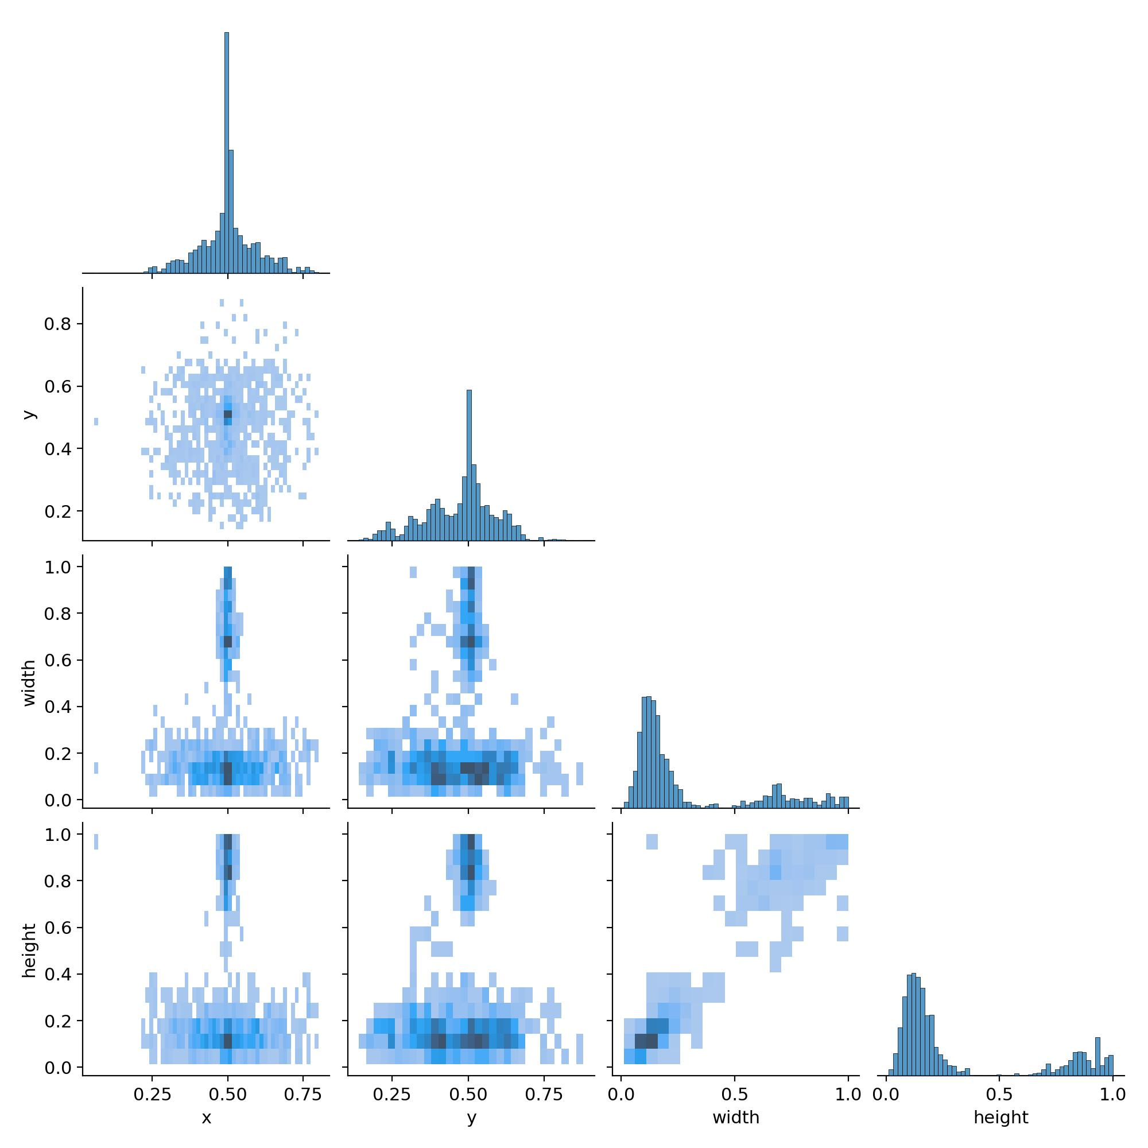

Distribution of Tumor Locations (x, y)
- x and y Histograms:
Both x and y coordinates are centered around 0.5, indicating that most tumors are located near the center of the images.
- x vs y Scatter:
The scatter plot is densest in the middle, confirming a strong central tendency. This is typical for medical imaging datasets where the region of interest (e.g., the brain) is centered.
Insight:
Your dataset is well-centered, which is beneficial for model training, as the model can focus on learning tumor features rather than searching the entire image.

Distribution of Tumor Sizes (width, height)
- Width and Height Histograms:
Most bounding boxes have a width and height between 0.1 and 0.3 (normalized units), with a sharp peak and a long tail toward larger sizes.
- Width vs Height Scatter:
There is a cluster of small-to-medium boxes, but a few outliers with large bounding boxes (width or height close to 1.0). This suggests some tumors are very large, possibly spanning almost the entire image.
Insight:
Most tumors are small to medium-sized, but there are some very large tumors. The presence of outliers may affect model performance, especially for rare, large tumors.

Correlation Between Parameters
- x vs width / y vs height:
There is a concentration of points in the center for x and y, but width and height are not strongly correlated with position.
- Width vs Height:
There is a positive correlation: larger widths tend to come with larger heights, which is expected (tumors that are large in one dimension are often large in another).
Insight:
Tumor size is not strongly dependent on location, but larger tumors are generally proportional in both dimensions.

Potential Issues and Recommendations
- Outliers:
A few bounding boxes are extremely large (width or height near 1.0). These could be valid (e.g., very large tumors) or no tumor (background is predicted as tumor) or annotation errors. Solution: Review these samples to ensure label quality.

- Class Representation:
This correlogram does not show per-class distributions. If certain tumor types (e.g., 'space-occupying lesion-') are rare or have different size/location patterns, consider stratified augmentation or analysis.

Summary Table
Parameter | Distribution Center | Spread | Outliers Present? | Correlation
x (center) | 0.5 | Moderate | No | None
y (center) | 0.5 | Moderate | No | None
width | 0.1–0.3 | Skewed right | Yes (up to 1.0) | Positive with height
height | 0.1–0.3 | Skewed right | Yes (up to 1.0) | Positive with width

Actionable Insights
- Dataset is well-centered: This is good for model learning.
- Most tumors are small/medium: Model should be able to generalize well, but ensure anchor boxes are appropriate for this distribution.
- Review outliers: Check very large bounding boxes for annotation errors.
- Consider per-class analysis: If performance is poor for a class, check if its label distribution is different.

Summary:
The dataset's bounding box labels are mostly well-distributed and centered, with a healthy variety of tumor sizes. Watch out for outliers and consider further analysis if you see class-specific performance issues. This strong label distribution provides a solid foundation for object detection models like YOLO.

