

**Software Requirements Specification Document**

**(CS360)**

**Heal & Help**





**Group Number: 06**

|  |
| --- |
| **Daniyal Ahmed** |
| **Furqan Lodhi** |
| **Iman Aleem** |
| **Mirza Osama Baig** |
| **Qasim Rafi** |

|  |  |
| --- | --- |
| **Course:** Software Engineering CS360  **Instructor:** Suleman Shahid  **University:** Lahore University of Management Sciences (LUMS |  |

**Version: 1.0**

**Date: (24/02/2020)**

**Number of hours spent on this document:** 50

|  |  |
| --- | --- |
|  |  |

**Contents**

**Contents iii**

**1** **Introduction 1**

1.1 Document Purpose 1

1.2 Product Scope 1

1.3 Intended Audience and Document Overview 1

1.4 Definitions, Acronyms and Abbreviations 1

1.5 References and Acknowledgments 1

**2** **Overall Description 2**

2.1 Product Perspective 2

2.2 Product Functionality 2

2.3 Users and Characteristics 2

2.4 Assumptions and Dependencies 2

**3** **Specific Requirements 3**

3.1 Functional Requirements 3

3.2 External Interface Requirements 4

3.3 Use Case View 5

**4** **Other Non-functional Requirements 6**

4.1 Performance Requirements 6

4.2 Safety and Security Requirements 6

4.3 Software Quality Attributes 6

**Appendix A – Top 10 User Stories 7**

**Appendix B – Architectural Spike (One Story) 8**

**Appendix C - Group Log 9**

**Appendix D – Contribution Statement 10**

**Appendix E – WorkFlow of Features 1****1**

# Introduction

## Document Purpose

This document explains in detail the scope, audience, functionality, assumptions & dependencies, user characteristics, and its functional and non-functional requirements for the mobile application called Heal & Help. This will be the first version of the entire application, i.e no subparts of this application exist.

In addition, the intended audience, any and all definitions and abbreviations, user stories and an architectural spike are also included in this document.

## Product Scope

We aim to make an organized platform in the form of a mobile application that helps the user to maintain and take control of their mental health by tracking some of their daily activities and performing designated exercises. Moreover, the user can interact with other users and counselors to discuss any potential issues they’re facing, in an environment which respects their choice of anonymity and privacy.

***Short term Objectives:***

* Ability of tracking the health factors that significantly contribute to one’s mental health.
* Access to exercises that can be done to lower down stress levels no matter what place and time. For example, during exam days, stress levels of students often peak to an unhealthy level, leading to mental breakdowns and low productivity. Doing the exercise found most convenient in the context can drastically reduce levels without waiting for medicinal results to show up.
* Provision of an online forum where users can interact with other users and express their thoughts and views by making posts and sharing images/videos*.*

The forum provides a space where users can, anonymously or by choosing to reveal their identity, ask for opinions of like minded people who themselves are users of the app, and can get constructive suggestions rather than just keeping their issues to themselves. This can help in identification of any user who’s heading towards mental illness and thus consultation and therapy can be done in a timely manner.

* Offering a chat service where users can have a more personalized and private experience of interaction with another trusted user or a counselor, in case they don’t feel comfortable in discussing their issue on the forum.

***Long Term Objective:***

* To normalize the idea of taking care of one's mental health and consulting help when needed, in a stereotypical society where it is considered as a taboo to speak about mental health issues freely. There is always this fear of being labeled as a “mental patient”. Within the scope of this course, we’re limiting the user pool to that of within LUMS. In case of positive use trends after deployment, we aim to bring the application as an open-source product in the app market.

## Intended Audience and Document Overview

This SRS document is intended to be read by:

* The Instructor of CS 360
* Teaching Assistants
* Advisors: Psychology at LUMS
* Documentation Writers: Group 6

Reading Suggestions:

* Should be familiar with computers
* Should know English
* It is suggested to read the sections sequentially, and to reference the appendixes as one progresses, in order to clarify the jargon and definitions.

## Definitions, Acronyms and Abbreviations

* Advisor: Helping the application developers by providing advice and consultation on features and measures
* Admin: System administrator who is given specific permission for managing and controlling the system
* GUI: A visual way of interacting with a computer
* Gulf of Execution: The gap between a user's goal for action and the means to execute that goal
* Users: Someone who interacts with the application
* WPA2: security protocol and security certification program developed by the Wi-Fi Alliance to secure wireless computer networks
* Stakeholder: Any person who has interaction with the system who is not a developer

## References and Acknowledgments

ADA Regulations and Their Impact on Design Professionals

Rlicorp.com.(2020) <https://www.rlicorp.com/sites/default/files/pdf/dple/dple171_ADA_Impact_Design_Professionals.pdf>

Greenberg, A., Greenberg, A., Nield, D., Barrett, B., Barrett, B., Graff, G., Greenberg, A. and Newman, L. (2020). *Hacker Lexicon: What Is End-to-End Encryption?*. [online] WIRED. Available at: <https://www.wired.com/2014/11/hacker-lexicon-end-to-end-encryption>

Material Guidelines

<https://material.io/design/guidelines-overview/#addition>

Medium. (2020). Interaction Design patterns : iOS vs Android. [online] Available at: <https://medium.com/@vedantha/interaction-design-patterns-ios-vs-android-111055f8a9b7>

Work?, H. (2020). *How Does A Cell Phone Tracker App Work? - Safeguarde.com*. [online] Safeguarde.com. Available at: <https://safeguarde.com/cell-phone-tracker-app-work/>

# Overall Description

## Product Perspective

The product is based on the design scheme and functional ideas of renowned health and fitness apps in the market such as S-Health, Google Fit etc. The domain that the product aims to serve in is mental health, so all services provided are directly or indirectly linked to it. Considering the context of LUMS, the product can serve as a more functionally diverse replacement for the Help@LUMS group by the Psychology@LUMS society.

This system will consist of two parts: one mobile application and a web portal for the backend server. Since this is a data-centric product it will need somewhere to store the data, which will be the database. The purpose of the mobile application is to provide the user the related services which are discussed in the Product Functions section. The server will manage the updating of user data in the database and will send necessary responses to the user.

The mobile application will be compatible for smart phones having operating systems starting from Android 4.0 or iOS 4 onwards and WPA2 secured WiFi protocol or Data Streaming option. The application will be compatible for all range of smartphone screens.

Users of the application will be of two types:

**Member**: Members will have access to all the features of the app mentioned in the Product Functionality Section 2.2, with the option of turning anonymous in the features where it is available.

**Counselor**: The counselors are given the same nature of access to the application as the member with additional features of **creating extensive profiles with more than identification details** and **limitation of not being able to turn anonymous** at any point. The counselors will be screened first and then be given the required access

The mobile application in response to a user action on its features, will send the server the necessary updated data, using which the server will make the update in the hosted database if the user is verified and send back the needed response back to the application. For example in case of the feature (d) mentioned in Product Functions section, clicking on the water tracker button will send the server the updated number of glasses along with the identification data of the user, in an end-to-end TCP protocol generated packet. The server on receiving and parsing the packet will verify the user. In case of success, it will make the update in the database for the specific user and send the success message to the mobile application. In case of failure, it will send an error message to the mobile application.

The choice of client interaction with the database through the server is to ensure the security and verification of user data before making any update in the database. This will prevent any phantom updates or updates made by a user A influencing those of user B.

The mobile application has some restrictions about the resource allocation per feature. To avoid problems with overloading the operating system, the application might only be allowed to use 70 megabytes of memory while running the application. The maximum amount of hard drive space is also 70 megabytes.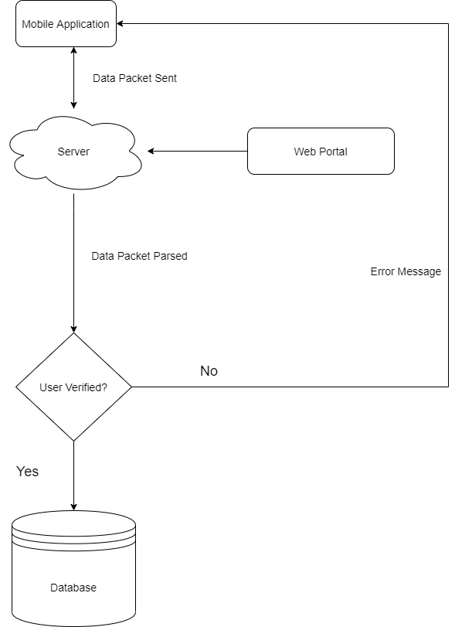

## Product Functionality

1. **Login/Register:** Initially there will be a login screen where the user can login to an already existing account or sign up. Users will be asked to login through their username and password. Users can create an account/sign up by using a valid LUMS email ID, their actual and dummy username. The details of the account will be stored in a cloud Database and will be used to match credentials during login. After logging in, the user will have the option to enjoy four features
2. **Online Forum:** Users will be able to see all the posts that have been uploaded by other users in a particular order contingent on the time of arrival of the respective posts i.e. the posts displayed on the top shall be uploaded the latest. The users will be able to post both as anonymous or if they are comfortable they can choose to display their username. All posts will be uploaded on the cloud Database and will always be present on the feed. Furthermore, users will be able to like, comment and report posts as anonymous. Users will be notified if they receive any message or some other user likes or comments on their post. Users can also search for specific posts by entering key words and all posts matching will be displayed. Also, users will have the option of reporting the other users if they see any malicious activities.
3. **Chat System:** Users can interact with each other through a private chat system. Users can opt to be anonymous or reveal their identity to the other user. Users will be able to send messages and images to each other on this private chat platform. Furthermore, users can have one-to-one chat with counsellors which the admins themselves can appoint and give them access to chat with. This will help to ensure that there are no fake accounts regarding the counsellors.
4. **Trackers:** The user will have access to two different trackers i.e. water and period. Users will have to manually input the number of glasses of water they have had through the use of a plus and a minus button. The app will give a reminder every 3 hours after the last addition of a glass of water and the count will be restarted before the start of each day. The period tracker is specifically for females. The user will receive reminders when the start of the cycle is due and the user will be kept up to date regarding the different phases of the cycle.
5. **Meditation:** There will be different exercises which the user can participate in. This includes breathing exercises where the user will be asked to take deep breaths. There will be an inbuilt timer which would indicate when to start and when to go to the next phase. Users will also have access to an in-built playlist full of soothing music to calm their nerves. Users will have the option of having their own music played as well.
6. **Notifications:** Regarding the chat system and online forum, users will receive notifications every time a user receives a message or if they get a like or comment on their post. This will help the user to keep up to date with their activities on the app and keep them engaged with the application.
7. **Delete Account:** A rather unfortunate feature, sometimes the users feel the need to delete their account and move away from the app. The users will have to enter their password to verify that they really want to delete their account and not just a prank played by one of their friends

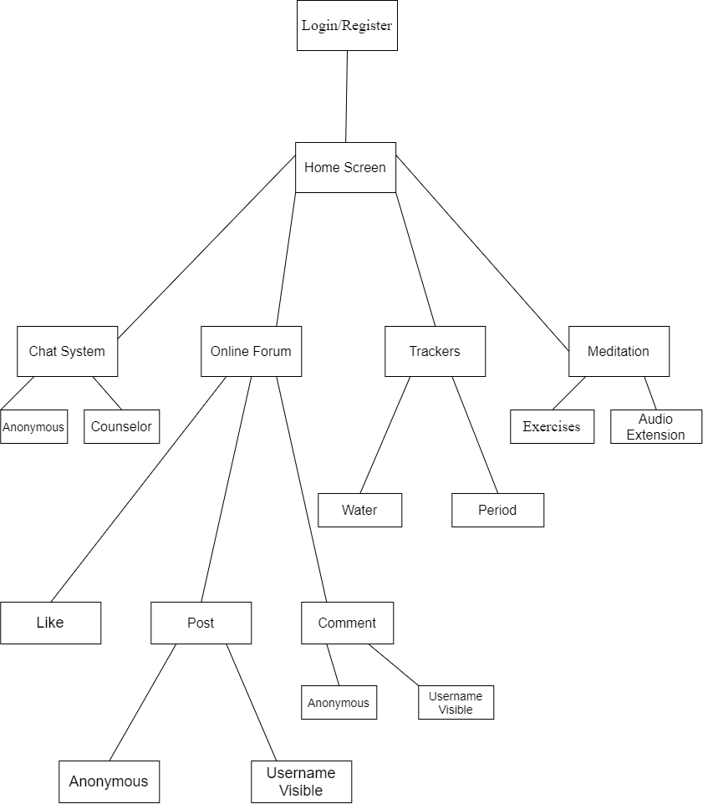

To give a rough idea about the design and the feature layout of the application, we provide the following link to serve as a template:

<https://projects.invisionapp.com/prototype/ck3efetz500cydp01g9qqk3gd/play>

## Users and Characteristics

**Members:**

* Members will have access to all the features of the app mentioned in the Product Functionality Section 2.2, with the option of turning anonymous in the features where it is available
* Their data will be stored in the database connected to the server
* They will be students/faculty of LUMS whoare supposed to have smart phones having operating systems starting from Android 4.0 or iOS 4 onwards and WPA2 secured WiFi protocol or the Data Streaming option
* They should’ve basic knowledge about operating an application and understanding its features

**Counselors:**

* The counselors are given the same nature of access to the application as the member with additional features of **creating extensive profiles with more than identification details** and **limitation of not being able to turn anonymous at any point.** The limitation is imposed so that people know their identities completely and can develop trust to share personal information with them.
* The counselors will be screened first and then be given the required account details
* Counsellors will be expected to have at least a Masters in Science degree in Psychology or related fields.
* Their data will be stored in the database connected to the server
* There supposed tohave smart phones having operating systems starting from Android 4.0 or iOS 4 onwards and WPA2 secured WiFi protocol or the Data Streaming option
* They should’ve basic knowledge about operating an application and understanding its features

**Web Server Users:**

* This is consists of the administration users who’ll be operating the web server portal for monitoring the user traffic on the application and troubleshooting any potential problems that arise
* They are supposed to have technical expertise and qualification in network management and coding

## Assumptions and Dependencies

* No more than 50,000 chat connections open at one instance
* Users have javascript enabled
* Users are to have basic internet access to avail the chat, discussion forum and counsellor features
* A mobile device that can support basic dependencies of the application is expected for proper user experience
* Users should be accessing only authenticated data

# Specific Requirements

## Functional Requirements

**RQ<1> - Login/Register**

|  |  |
| --- | --- |
| **Description** | The system will allow the user to either create a new account using a valid LUMS email address or login in to an existing account. The app will also give the option to change your password if the user has forgotten their password. To access the rest of the features it is necessary to have an account. |
| **Display** | The user will be given the option to either login or register an account or change their password. All three cases are explained below. |
| **Case 1** | **Register an account** |
| **Input** | Users will be requested to enter a name, a unique username, a valid email address and a valid password that meets standards. |
| **Process** | The email that has been added will be sent a verification email to check whether that account exists and is actually used by the user. Once that confirmation is received the details of the account are added to the cloud database. |
| **Output** | Registration Successful and account has been created |
| **Case 2** | **Log into existing account** |
| **Input** | Users will be asked to enter their username and password and that will be verified with the database. |
| **Process** | The username and password will be sent to the server. There the server will check the database to see if the username exists and then the corresponding password of that account will be checked in the database. If it exists then the server accepts the login request. |
| **Output** | Login Successful message is displayed and the user is given access to the other features in the application. |
| **Case 3** | **Change existing password** |
| **Input** | The user will be requested to enter the email address of the account of which they want the password to be changed.After this they will be requested to enter the new password. |
| **Process** | The email address will be checked from the database. A verification will be sent to that email address. Once verification is completed the user will be asked to enter a new password. The new details will be updated in the database. |
| **Output** | Password updated screen is displayed and the user can now login to their account using their new password. |

**RQ<2> - Online Forum**

|  |  |
| --- | --- |
| **Description** | The users will be able to interact with one another through an online forum. Users will be able to post their thoughts on this forum which will be visible to all other users. Users will have the option to post as anonymous or they can post with their usernames visible. Users can like and comment on posts with the option of being anonymous as well. Users will also have the option of searching for specific posts. |
| **Display** | After selecting this option, the users will have the option to:   * View Posts * Post as anonymous or showing their identity * Like and comment with the option of being anonymous * Report a post or a user in case they are being harassed or bullied * Search for specific posts * Report other users for malicious content   Details of all the steps are mentioned below. |
| **Case 1** | **View Posts** |
| **Process** | For viewing posts, the posts will be visible as soon as we open this feature. The posts will be sorted based on how recently the post was added. Users will be able to scroll through posts. |
| **Case 2** | **Posting** |
| **Input** | Users will be asked to enter text which they want to post. They will press Post button so that it is displayed on the feed |
| **Process** | The input will be sent to the server and then stored in the database so that it can be displayed on the feed. |
| **Output** | The text posted will be displayed on the feed |
| **Case 3** | **Like Posts** |
| **Input** | Users can press the like button and can choose the option of remaining anonymous. |
| **Process** | The system will receive the signal and send it to the server, the database will be updated by increasing the like counter on that post. |
| **Output** | The post will show that the user has liked this post. |
| **Case 4** | **Comment on Posts** |
| **Input** | Users can add in text to the comment bar and add in under the post. They have the option to comment anonymously. |
| **Process** | The system will receive the text and send it to the server, the database will be updated by adding that comment to the post in the database. |
| **Output** | The post will show that the user has commented and it will be visible to all users. |
| **Case 5** | **Search for Posts** |
| **Input** | Users will be requested to enter the key words of what he wants to search. |
| **Process** | The keywords will be sent to the server. The server will check the keywords with the posts in the database and return those posts to the client. |
| **Output** | All the posts will be displayed to the user. |
| **Case 6** | **Report Users** |
| **Input** | Users will be requested to press the report button next to the user they wish to report. |
| **Process** | The server will receive this packet and check the posts of that user, if it finds malicious words than the server will send the user a warning notification. |
| **Output** | The user who has posted malicious content will be sent a notification receiving a warning. |

**RQ<3> - Chat System**

|  |  |
| --- | --- |
| **Description** | Apart from interacting only through posting and commenting, users will be given the option to communicate with each other on a private basis. Once again as with the online forum, users will be given to chat anonymously with one another. There is an added option where users can communicate directly with counsellors which will be chosen from the admins only. They will be given special access where they cannot post and they can only communicate directly with users. |
| **Display** | After selecting this option, the users will have the option to:   * Chat with other users with the option of anonymity * Chat with Counsellors with the option of anonymity   Details of all the steps are mentioned below. |
| **Case 1** | **Chat with other users** |
| **Input** | Users will have the option to message anyone who has posted already, only then can they know about that account. The user has the option to keep his identity anonymous. The user can type text and send it to the other user. |
| **Process** | The input will be sent to the server and the server will send that message to the other client on the server. For this to happen both accounts must be on the server. The database will record all the messages that any user has sent to another user and the time at which the message was sent. |
| **Output** | A chat forum will be displayed which will show all the messages that the user has sent and received from that user. Users will receive notifications every time they receive a message. |
| **Case 2** | **Chat with counselors** |
| **Input** | Users will have the option to message any counsellor they wish to communicate with.The user has the option to keep his identity anonymous. The credentials of the counsellors will be visible to users and so they can choose which counsellor they want based on the counselor’s specialities. |
| **Process** | The input will be sent to the server and the server will send that message to the other client on the server. For this to happen both accounts must be on the server. The database will record all the messages that any user has sent to another counsellor and the time at which the message was sent. Counsellor will not have access to messaging first to the user as that user will be anonymous. |
| **Output** | A chat forum will be displayed which will show all the messages that the user has sent and received from that counselor. Users will receive notifications every time they receive a message. |

**RQ<4> - Trackers**

|  |  |
| --- | --- |
| **Description** | In our application, there are two different trackers i.e. water tracker and period tracker. In a water tracker, the user will be able to track the number of glasses of water they have drunk so that they can achieve their goals in terms of water consumption. Furthermore there is a special tracker for females to keep track of their menstruation cycle. The user will input the expected start date of the cycle and the algorithm will divide the month into the 4 phases of the cycle and give reminders at the start of each phase. |
| **Display** | After selecting this option, the users will have the option to:   * Keep track of water consumption * Look at the stages of their cycle   Details of all the steps are mentioned below. |
| **Case 1** | **Water Tracker** |
| **Input** | When the user opens the water tracker, they will initially see the count as zero. Everytime they drink water they will have to manually increment the count by using the plus button and the user can also decrease the count. |
| **Process** | When the user presses the plus button, the count value is increased. There is also a timer that keeps track of the time gone by since the last time there was an increment in the value. If the timer exceeds three hours, the user is sent a notification to drink water. Once the whole day passes, the counter is reset and the number of glasses drunk are added to the database so that the user can check his counts and see if he is reaching his goal. |
| **Output** | The screen shows the number of glasses drunk, when the button is pressed the value is incremented by 1. When the day is completed the value shown is zero. |
| **Case 2** | **Period Tracker** |
| **Input** | When the user opens the period tracker, they will be asked to input the expected starting date of the cycle. |
| **Process** | The system will store that information in the database and through that knowledge, estimate when the next cycle will start and send a reminder every time a new phase in the cycle is about to start. The algorithm will predict the starting dates of each phase. |
| **Output** | The user will be sent a reminder and the reminder will be there in their notifications which will tell that the next phase is starting in one day. |

**RQ<5> - Meditation**

|  |  |
| --- | --- |
| **Description** | In our application, we have another feature of meditation. This feature is designed for users to relax through meditation exercises. One exercise is where the user will start and will be requested to inhale for four seconds, keep their breath in for 7 seconds and release for 8 seconds. The app will keep track of time and play a beep every time there is a change of activity. Furthermore the users will be able to play relaxing music which are from the in-built playlist in the database. Not only that, the users will be able to play their own music from other apps on their mobile phone. |
| **Display** | After selecting this option, the users will have the option to:   * Select meditation exercises. * Choose from the list of exercises available. * Select music from in-built playlist or from their own music.   Details of all the steps are mentioned below. |
| **Case 1** | **Meditation Exercises** |
| **Input** | When the user opens the meditation exercises, they will have access to the different exercises and can choose any one of them. |
| **Process** | When the user clicks on the desired exercise, the server will access the database and start that exercise. The system will start the timer, start and stop based on the requirements of the exercise and play a beep every time there is a change in activity. |
| **Output** | The screen shows the timer so that the user can keep track of his progress and every time the exercise is finished it is added to the database. |
| **Case 2** | **In-built audio playlist** |
| **Input** | The user can open the in-built playlist and play any music from the inbuilt playlist. |
| **Process** | The system receives the message, will request the song from the database and play it for the user. |
| **Output** | The user will hear the music throughout and when there is a beep the volume of the music will be lowered. |
| **Case 3** | **Add in user selected playlist** |
| **Input** | The user can also incorporate his own music into this app. For this to happen, the user will have to grant access of his storage device in the mobile to the app. |
| **Process** | The system will use the storage of the mobile device and access the audio files. When the user will access any file the system will add that to their database and play the audio from there. |
| **Output** | The user will hear the music throughout and when there is a beep the volume of the music will be lowered. |

**RQ<6> - Delete Account**

|  |  |
| --- | --- |
| **Description** | Another small yet important feature in our app is that we give the users the option to delete their account. Users who feel that they do not want to carry on with this application can delete their account. |
| **Display** | There will be a button which will ask for the user's password upon clicking. |
| **Input** | When the user presses the button, the user will be asked to enter the current password of their account. |
| **Process** | When the user enters the password, the server receives it and compares it with the password in the database. If the passwords match then the details of the account are removed from the database, else the server returns a negative signal. |
| **Output** | The screen shows that the account has been removed successfully, if the password entered is incorrect then it requests the user to re-enter password. |

## External Interface Requirements

### User Interfaces

* All interaction with the user shall be via a GUI integrated in the mobile application.
* The server will tag posts based on specific keywords and make separate screens for them. Each screen of the forum will have posts belonging to the same tag. The user will be presented with different screens, each for a separate problem, e.g. all depression related posts shall appear on a different screen from the anxiety related posts.
* At the very bottom of the screen, there will be a navigation bar with tabs, that the user can use to toggle between the different features of the app, e.g. if the user needs to visit the meditation page, there will be a tab at the bottom of the screen to do so.
* Hover (or pressing for 2-3 seconds in case of mobiles) over the tabs or certain features whose icons might be difficult to see for some users, will cause pop-ups with enlarged icons and information to appear.
* Some of the posts will be hidden from the user and will be blurred out based on trigger warnings, and can only be viewed if the user gives their permission. These warnings will also be given on the basis of tagged keywords.
* The homepage for the user when they open the app will be the screen with the trackers on it so that they have convenient access to them.
* The app will also allow the user to search for very specific problems, just in case something similar to what the user has been going through has been posted previously by a different user.
* Since our app touches very sensitive issues, we need to make sure that the app itself is not a cause for any triggers, so the colour scheme that we have chosen for the app will be a white and green (tentative to change based on advice from Psychology @ LUMS and user reviews) since green is perceived to be a calming colour. All texts in the app will be white.
* To minimize gulf of execution and evaluation for the user pool and to reduce the rigor of operating the app, the screens will have more visual aid in the form of icons and symbols that follow mental models of users based on their prior experience of using such platforms and applications. Except for the forum and chat features, text will be minimal on the screen and would mainly be in pop-ups and dialog boxes.

* All of the above mentioned design and interface choices go in compliance with the American with Disabilities Act (ADA)

### Hardware Interfaces

The application will be able to run on Android and iOS devices as mentioned in the Product Perspective section. But besides this, since neither the mobile application nor the web portal have any designated hardware, it does not have any direct hardware interfaces. The mobile application, although, will be using GPU and memory for resource allocation.

### Software Interfaces

The tentative plan for the software interfaces is follows:

* Using Flutter [v1.15.3](https://storage.googleapis.com/flutter_infra/releases/dev/windows/flutter_windows_v1.15.3-dev.zip) or React Native JS v0.61 for the development of the mobile application
* The server and its web portal will be hosted on Google Firebase
* The database will employ the framework from MongoDB
* The chat mechanism will be based on end to end TCP protocol

## Use Case View

### Use Case Table

1. Use Case table

|  |  |
| --- | --- |
| Primary Actor | Associated Use cases |
| Member | - Log in/sign up  - Sign out  - Make profile  - Edit profile  - Delete profile  - Post on online forum (anonymously or otherwise)  - Tag post  - Search for posts  - Comment & like posts (anonymously or otherwise)  - Report post/comment  - Browse counsellor profiles  - Use water tracker  - Use period tracker  - Use meditation feature  - Use audio feature  - Chat with other users (anonymously or otherwise) |
| Counsellor | - Log in/sign up  - Sign out  - Make profile  - Delete profile  - Edit profile  - Browse other counsellor profiles  - Post on online forum (non-anonymously)  - Tag post  - Search for posts  - Comment & like posts (non-anonymously)  - Report post/comment  - Use water tracker  - Use period tracker  - Use meditation feature  - Use audio feature  - Chat with other users (non-anonymously) |
| Administrator | - Check for reported posts and comments  - Check for bugs |

### Use Case Diagram

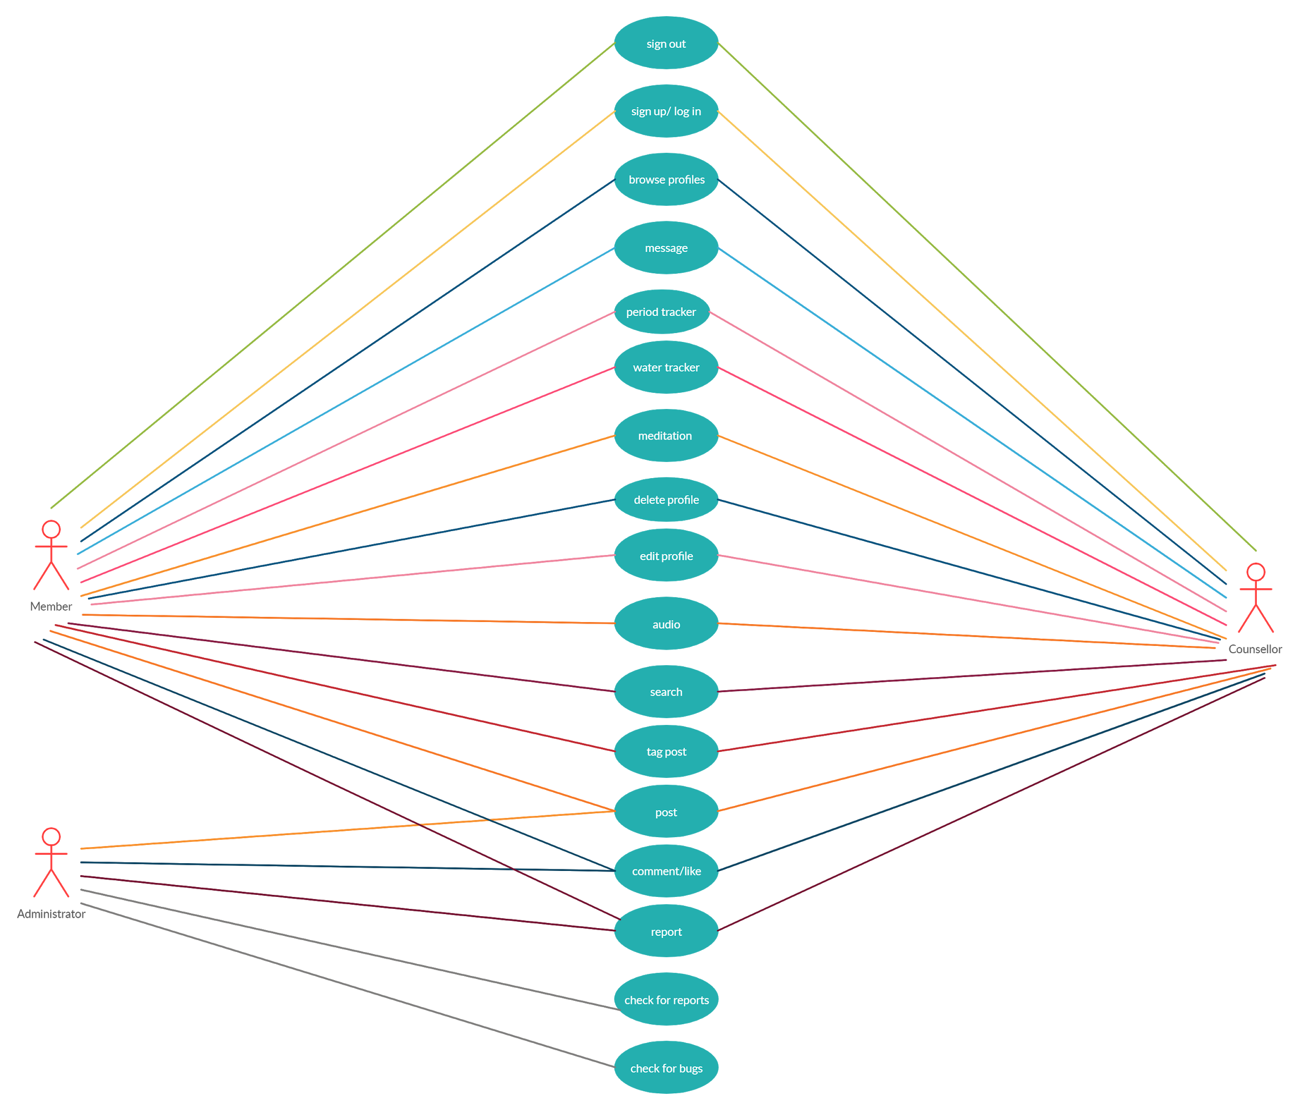

### Use Case Description

|  |  |
| --- | --- |
| **Use Case 1** | Report post/comment |
| **Actors** | Member/counsellor |
| **Pre-conditions** | Post/comment exists |
| **Post-conditions** | Post/comment reported to administrator at server side. |
| **Successful completion** | The user will click on the report button and generate a complaint. |
| **Alternative** | None |

|  |  |
| --- | --- |
| **Use Case 2** | Post on Online Forum |
| **Actors** | Members/counsellors |
| **Pre-conditions** | User has an account and is logged in. |
| **Post-conditions** | Post made on forum. Saved in database and visible on forum. |
| **Successful completion** | User selects the “Make New Post” option, enters the text, then selects the“Post” option. Members will have the option of posting anonymously, while counsellors will not. |
| **Alternative** | None |

|  |  |
| --- | --- |
| **Use Case 3** | Use meditation feature |
| **Actors** | Member/counsellor |
| **Pre-conditions** | Logged in and on the meditation feature screen. |
| **Post-conditions** | The user completes the meditation exercise. |
| **Successful completion** | On the meditation screen, the user selects from the given list the exercise they want to perform. |
| **Alternative** | None |

|  |  |
| --- | --- |
| **Use Case 4** | Chat with other users |
| **Actors** | Members/counsellors |
| **Pre-conditions** | User has a valid account and is on the chat screen. |
| **Post-conditions** | The users are chatting among themselves. |
| **Successful completion** | User enters the name of a member or counsellor they want to start a correspondence with. Members will have the option of staying anonymous while counsellors will not. |
| **Alternative** | User selects the “message” option on a member or counsellor’s profile. |

|  |  |
| --- | --- |
| **Use Case 5** | Search for posts |
| **Actors** | Members/counsellors |
| **Pre-conditions** | Post exists and has relevant tags. |
| **Post-conditions** | User finds the relevant posts according to the tag searched for. |
| **Successful completion** | User will search for the tag relevant to the posts they want to see and select the tag then. Result should display all posts which have the same tag as the one searched. |
| **Alternative** | User selects the tag under a post which will redirect to a screen displaying all posts with the same tag. |

# Other Non-functional Requirements

## Performance Requirements

***Response Times:***

**Login/Signup screen:**

In case of successful signup/login or a failed one, the relevant validation message will be displayed to the user within 4 seconds. This includes verification of email address and password from the database through server and the server sending the verification message back.

**Chat Delivery:**

A message delivery from one user to another will not take more than 2 seconds based on the server clock time, but may vary depending on the connectivity and the bandwidth of the connection of the device with the internet

**Online Forum:**

* A post or a comment that will only have text-based script in it, will not take more than 2 seconds to get displayed and accessible to all other users at the forum
* A post or a comment that will have text-based script along with a picture (.jpg, .png format etc) will not take more than 8 seconds to get displayed and accessible to all other users at the forum. The posting time might vary depending on the number of pictures attached.
* The posting time for post or a comment that will have a text-based script along with a video will totally depend on the no. of bytes of the video
* All the above scenarios are considered including the browser render time and the delivery time to the browser

**Trackers:**

* Transfer of updated user data from client end the to server end, and then back to client end with verification, would not take more than 3 seconds

**Reminders:**

* The client host will send data to the server automatically after 10 seconds, given that no user interrupt comes. In case of a user interrupt comes, then the user data will be sent to the user right then and the next automated update will be sent after the next 10 seconds. Viewing the data components, the server will generate reminders for the client. If sent by the server, a single reminder will be received by the client in not more than 3 seconds

**Workload:**

* Recovery time in case of failure of a transaction in the database due to crash will not be greater than 60 seconds
* Also when connecting to the server the delay is based on the distance of the 2 systems and the configuration between them so there is high probability that there will be or not a successful connection in less than 20 seconds
* The application will be able to cater to 50000 traffic at a certain time which includes updating data in the database which is visible to other users and that data which is not. The response times mentioned above will be followed for >95% of the maximum user traffic.

## Safety and Security Requirements

* Messages shared between users should be encrypted to maintain privacy. All data that is privacy sensitive, must be persisted on the server in order for basic functionality.
* Chat between two users will have end-to-end encryption .
* In case a user's device crashes, a backup of their chat history and data records must be stored on remote database servers to enable recoverability.
* Regular updates of the application to ensure that none of the users lose any data.
* There is a bug tracker available where users can report any bugs they have encountered so that the developers can fix it in the next release.
* Disclose security policies & practices to the users when signing up/in.
* Disclose rules and regulations for posting and sharing of information on forums and chats.
* Online reporting system for users to report inappropriate and unlawful behaviour by other users.
* For moderation of the forum, the Psychology at LUMS society will be acting as advisors in moderating to prevent online hate speech, bullying and inappropriate posts and comments.

## Software Quality Attributes

***4.3.1 Reliability***

The system will not crash 95% of the screen time, other than as the result of an device’s operating system error. In case of a database transaction failure, it will recover according to the measures mentioned in Section 4.1 Performance Requirements.

***4.3.2 Security and Privacy***

The system will offer complete anonymity to all users, depending on how the user chooses to avail it. During signup, the user will be asked to provide their name, a dummy username for the app and password for their account. They’ll be asked to provide their LUMS email address for the verification link to be sent on.

During login, they’ll be asked for their username and password details.

The chats and passwords will be secured through end-to-end encryption.

***4.3.3 Safety***

Since our app focuses on mental health problems, since it is a very sensitive topic, we will need to make sure that it does not cause any triggers, so all trigger warning posts will be blurred out from the user, unless the user wishes to view them, and the app will be designed based on calming and neutral colours, for example we do not want our colours and our themes to trigger a fit for epileptic users etc

***4.3.4 Packaging Requirements***

The system shall be packaged along with source code and all documentation, and shall be available for electronic transfer as a single compressed file. The uncompressed set of files shall include a README file containing a minimal guidance for installing and running the software, including recompilation if needed.

***4.3.5 Maintainability***

All code shall be fully documented. Each function shall be commented with pre and post conditions. All program files shall include comments concerning authorship and date of last change.The code shall be modular to permit future modifications.

***4.3.6 Usability***

The product is designed to cater to a user pool in which individuals differ on the basis of background, technical expertise and experience of using such apps before. The learning curve is aimed to be minimized, to prolong user interaction. The design and deployment of the product will be done following the measures of the certified 10 Usability Heuristics.

**Appendix A – Top 10 User Stories**

* As a user who is sensitive about his personal information, I want an anonymity feature so that other users cannot track my activity in the application. This application has anonymity features in the crucial aspects like posting and chatting which is essential for me.

* As a sportsperson who is constantly participating in sports events, I want to keep track of my menstrual cycle so that I am aware of my upcoming cycle. I am often very busy and the thought of my cycle about to begin often leaves my mind so the reminders sent by the application will prove to be very beneficial for me.

* As a student who needs to deal with academic stress in the form of exams and assignments, I need to have access to quick meditation exercises so that I can calm my nerves.

* As an instructor who is always on the run from one classroom to another, I need to keep track of my water intake each day so that I don’t get dehydrated and my productivity doesn’t turn low. The water tracker feature of this app will really help me in assuring that.

* As a user who is often stressed and might not prefer to talk openly about it, I want a chat option that helps me converse with other people going through the same phase and venting my frustrations, as it really helps in achieving a peace of mind.

* As a user who is having a tough time lately, I want to have an anonymous( or otherwise) chat with counselors so they may guide me as to how I can make things better for myself.

* As someone who wouldn’t prefer posting myself (even anonymously), I want a mechanism of searching that allows me to enter certain phrases (tags) that filter out relevant posts so that it becomes easier for me to find posts for myself.

* As a frequent user of the application, I want to have the ability to report a comment or post that is rude, offensive, inappropriate, and/or uncalled for so that the forum remains a safe space for everyone.

* As someone who likes meditation and indulges in audio therapy, I want to have a feature that allows me to play calming music so that it may help me with my stress and/or anxiety.

* As a user who likes to have different perspectives on a certain issue being faced, I shall like to make posts on a forum where people can comment on a post and provide guidance. The app’s online forum offers that.

**Appendix B – Architectural Spike (One Story)**

Enabling end-to-end encryption in two-way chat might turn out to be a challenge as a developer as there are choices of a robust mechanism is a concern. Moreover, due to lack of technical expertise and experience in the field of cryptography, some additional time might be required for the integration and testing of such a mechanism.

**Appendix C - Group Log**

*10th Feb, 17th Feb, 24th Feb ( 5:50 P.M. ) --------> Meetings with the TA*

*5th February --------> Brainstorming and finalising app structure*

*10th February --------> Review of app structure and identifying architectural*

*spikes and solutions*

*12th February --------> Discussing layout of SRS document and division*

*21th February --------> SRS Iteration 1 completion*

*23rd February --------> SRS Iteration 2 completion*

*24th February --------> SRS finalization*

**Appendix D – Contribution Statement**

|  |  |  |  |
| --- | --- | --- | --- |
| *Name* | *Contributions in this phase* | *Approx. Number of hours* | *Remarks* |
| Daniyal Ahmed | -SRS Management  -Product Perspective  -Performance Requirements  -Product Scope  -User stories | 10 | N/A |
| Furqan Lodhi | -External Interface Requirements  -Software Quality Attributes  -User Stories | 10 | N/A |
| Iman Aleem | -Document purpose  -Use Cases  -User stories  -Users and characteristics | 10 | N/A |
| Mirza Osama Baig | -Intended audience and document review  -Definitions  -Assumptions and dependencies  -Safety and security requirements | 10 | N/A |
| Qasim Rafi | -Product Functionality  -Functional Requirements  -Workflow of Features  - References and Acknowledgements  - User Stories | 10 | N/A |

**Appendix E – Workflow of Features**

