KEY INFORMATION

**UNPLUGGED ACTIVITIES** are tasks that take place away from a Computer in order to model key concepts (algorithm, sequencing etc).  
(Curzon et al. (2018, *Computer Science Education*, ed. Sentance et al.) details how unplugged activities can help learners understand abstract concepts through physical objects that can be touched, manipulated, and described).

**PLUGGED ACTIVITIES** include actual coding on Scratch.

**EXTENSION** activities include more challenges and plugged activities. These can be used when the lesson is finished earlier (most likely with higher grade students).

**EACH LESSON INCLUDES THESE SECTIONS: -**

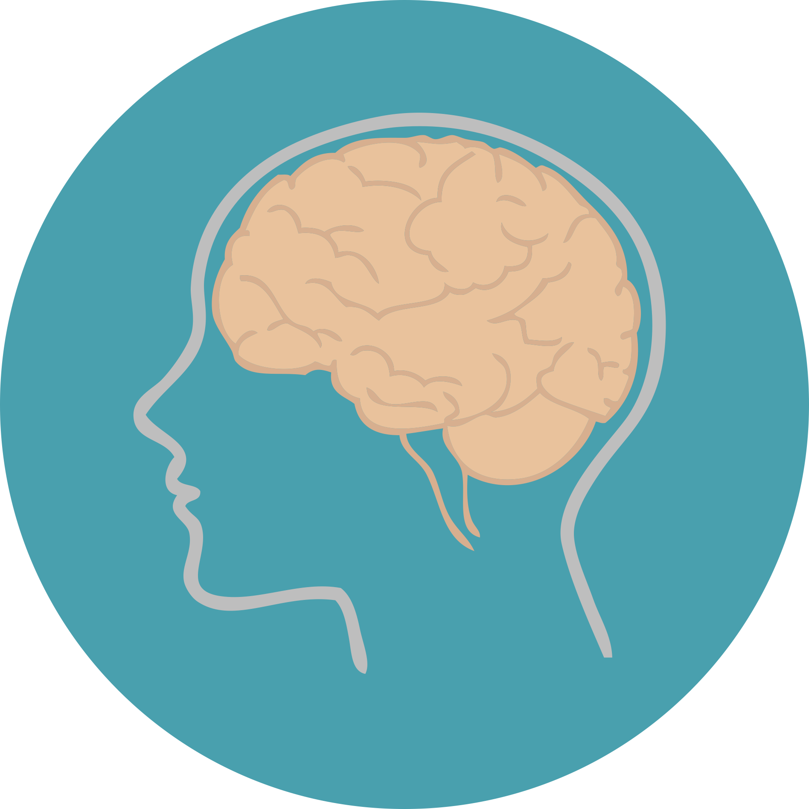

**CONCEPT/DEFINITION** defines a new coding term or explains a new concept.







**TEACHER NOTES** include helpful information for teachers. It may also include links to projects created for D&L teacher’s training as well as links to plugged activities of each lesson.



TABLE OF CONTENTS

1. INTRODUCTION TO CODING
2. UNDERSTANDING SCRATCH
3. CODING CONCEPT: SEQUENCING WITH EXAMPLES
4. CREATE AN ANIMATED CONVERSATION
5. CODING CONCEPT: **LOOPS** WITH EXAMPLES
6. **MINECRAFT MODULE** TO REVISE CONCEPTS
7. CODING CONCEPT: **PARALLELISM** AND **EVENTS**   
    **PROJECT 1:** ANIMATE YOUR NAME/ GOOGLE LOGO
8. **PROJECT 2:** ANIMATE A DANCE PARTY
9. PEN EXTENSION TOOL BY SCRATCH (ART ORIENTED)
10. CODING CONCEPT: **DEBUGGING** WITH EXAMPLES

**FIRST MONTH (1st micro goal): ACHIEVEMENT UNLOCKED ☺**   
(these 8 lessons might take up to 10 classes)  
Can brainstorm whether we should name this level. Will better be able to decide once all lessons have been developed.  
- JUNIOR SCRATCH ANIMATOR?  
- LEVEL 1 COMPLETED?

LESSON 1: INTRODUCTION TO CODING

WHAT IS CODING?

WHAT IS AN ALGORITHM?

DIFFERENT LANGUAGES AND PLATFORMS FOR CODING.





**PLUGGED ACTIVITIES**

**UNPLUGGED ACTIVITIES**

1. Create an account on Scratch
2. Explore Scratch
3. Code a student.
4. Cross through a maze.
5. Code a friend
6. Create a Teacher’s account using instructions provided in a separate pdf file.
7. Listen to MIT Scratch Inventor’s TEDtalk. Can also show bits of it to kids to educate them about the founder of Scratch.

**TEACHER NOTES**



LESSON 2: UNDERSTANDING SCRATCH

REVISE WHAT IS SCRATCH?

UNDERSTAND DIFFERENT PARTS OF SCRATCH

UNDERSTAND ATTRIBUTES ASSOCIATED WITH SPRITES AND BACKDROPS.

**UNPLUGGED ACTIVITIES**

**PLUGGED ACTIVITIES**

**TEACHER NOTES**

Learn why “Hello World” is used as a first program by programmers?





1. Understand Stage Coordinates
2. Explore Scratch backdrops
3. Explore Scratch Sprites.
4. Code “HELLO WORLD” -1ST PROGRAM
5. Understand Cartesian Coordinates
6. Play a Coordinates game



PLUGGED ACTIVITIES

LESSON 3 - SEQUENCING



WHAT IS SEQUENCING?

REAL LIFE EXAMPLES.



PLUGGED ACTIVITIES

UNPLUGGED ACTIVITIES



1. Create an Origami Heart

Code your character to move:

1. In square shape
2. In rectangle shape  
   s

**TEACHER NOTES**



- Link plugged and unplugged activities.

- Follow the link created by D&L for plugged activities. Remix to save to your account for   
 practicing.



**LESSON 4 – ANIMATE A CONVERSATION**

**UNPLUGGED ACTIVITIES**

**PLUGGED ACTIVITIES**

**TEACHER NOTES**

- Link plugged and unplugged activities and explain the use of “wait blocks”.

- Follow link provided in the lesson to create a copy (click “remix”) of the project in your account   
 for practicing.



WHAT IS ANIMATION?

APPLY SEQUENCING AND ANIMATION CONCEPTS



Code a meaningful conversation between two people .   
 (scenario defined by the teacher).

Introduce each other/ Converse in pairs.

**LESSON 5 – LOOPS AND ANGLES**

**UNPLUGGED ACTIVITIES**

**PLUGGED ACTIVITIES**

**TEACHER NOTES**

- Link plugged and unplugged activities.

- Follow link provided in the lesson to create copy (click “remix”) of the project in your account   
 for practicing.

WHAT ARE LOOPS?  
ANGLES IN SCRATCH.  
REAL LIFE EXAMPLES





1. Loopy Routine
2. Students walk in a square
3. Redo activity from lesson 3 using loops.
4. Add background music using loops.



**LESSON 6 – MINECRAFT MODULE: VOYAGE AQUATIC**

**UNPLUGGED ACTIVITIES**

1. Loopy Routine continued.
2. Code loopy routine.
3. Code Minecraft Activity by Code.org

**PLUGGED ACTIVITIES**

CONTINUE LOOPY ROUTINE ACTIVITY  
REVISE CONCEPTS USING MINECRAFT





**TEACHER NOTES**

- Link plugged and unplugged activities.

- Only complete the first 6 activities of Minecraft coding.

**LESSON 7 – PROJECT 1: ANIMATE YOUR NAME/GOOGLE LOGO**

**UNPLUGGED ACTIVITIES**

PROJECT: Animate your name or Google logo

**PLUGGED ACTIVITIES**

**TEACHER NOTES**

WHAT IS PARALLELISM?  
WHAT IS AN EVENT?





1. All students jump at the same time.
2. Play “Simon Says”.



- Link plugged and unplugged activities.

- Follow link provided in the lesson to create copy (click “remix”) of the project in your account   
 for practicing.



**LESSON 8 – DANCE PARTY ANIMATION**

**UNPLUGGED ACTIVITIES**

PROJECT: DANCE PARTY ANIMATION

**PLUGGED ACTIVITIES**

**TEACHER NOTES**

- Link plugged and unplugged activities.

- Follow link provided in the lesson to create copy (click “remix”) of the project in your account   
 for practicing.

THIS PROJECT REINFORCES ALL CONCEPTS LEARNED SO FAR





Imagine a dance party.

**LESSON 9 – PEN EXTENSION TOOL**

**PLUGGED ACTIVITIES**

**TEACHER NOTES**

- Link plugged and unplugged activities.

- Follow link provided in the lesson to create copy (click “remix”) of the project in your account   
 for practicing.

Art creation using scratch.





**UNPLUGGED ACTIVITIES**

1. Draw a square
2. Help Scratch cat catch a mouse by drawing a staircase
3. Draw a smiley face

Play Pictionary



**LESSON 10 – DEBUGGING**

**UNPLUGGED ACTIVITIES**

**PLUGGED ACTIVITIES**

**TEACHER NOTES**

- Link plugged and unplugged activities.

- Follow link provided in the lesson to create copy (click “remix”) of the project in your account   
 for practicing.

WHAT IS DEBUGGING?





1. Teacher will sing a poem with some mistakes for students to identify.
2. Debug Code #1.
3. Debug Code # 2.
4. Debug Code # 3.

Extension Activity 1: Redo the 2 activities this time using x and y coordinates from a given point (say (0,0)) using “go to x, y” coding block.

Extension Activity 2: Try different lengths of squares and rectangles  
( **For triangle and other polygons, angle knowledge is a must, hence it is beyond the scope of this lesson. (older kids can try this)**