**Technical Stack:**

Python Programming language

MYSQL as database

Django for the APIs

**Step 1:**

**SQL Queries:**

**Total records at the time of query:**

219859

Query 1 :

SELECT count(*) from app_yellotaxitrip where total_amount < 5;

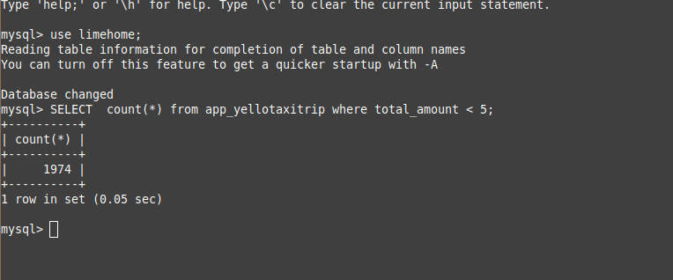

Execution time:

0.05 sec

Query 2:

SELECT EXTRACT(HOUR FROM `app_yellotaxitrip`.`tpep_pickup_datetime`), COUNT(EXTRACT(HOUR FROM `app_yellotaxitrip`.`tpep_pickup_datetime`)) AS `peak_hour_rides` FROM `app_yellotaxitrip` GROUP BY EXTRACT(HOUR FROM `app_yellotaxitrip`.`tpep_pickup_datetime`) ORDER BY `peak_hour_rides` DESC;

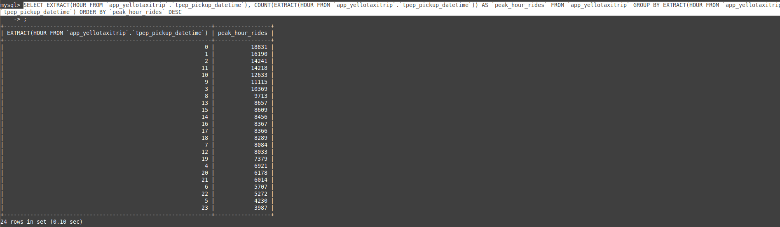

Execution time:

0.10 sec

Query 3 :

SELECT ROUND(AVG(tip_amount) * 100 / SUM(tip_amount),10) FROM app_yellotaxitrip;

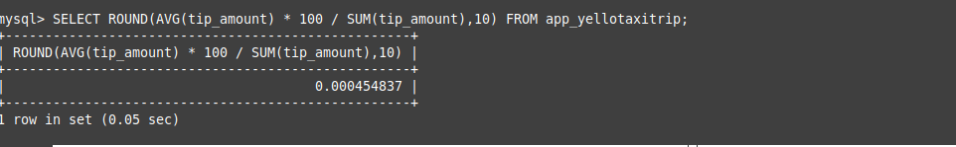

Execution time:

0.05 sec

**Step 02:**

When the amount of data is increased.

**SQL Queries:**

**Total records at the time of query:**

314482

Query 1:

SELECT count(*) from app_yellotaxitrip where total_amount < 5;

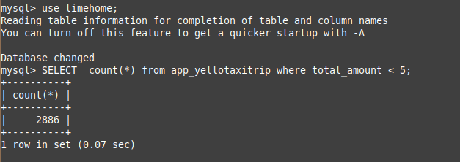

Execution time:

0.07 sec

Query 2:

SELECT EXTRACT(HOUR FROM `app_yellotaxitrip`.`tpep_pickup_datetime`), COUNT(EXTRACT(HOUR FROM `app_yellotaxitrip`.`tpep_pickup_datetime`)) AS `peak_hour_rides` FROM `app_yellotaxitrip` GROUP BY EXTRACT(HOUR FROM `app_yellotaxitrip`.`tpep_pickup_datetime`) ORDER BY `peak_hour_rides` DESC;

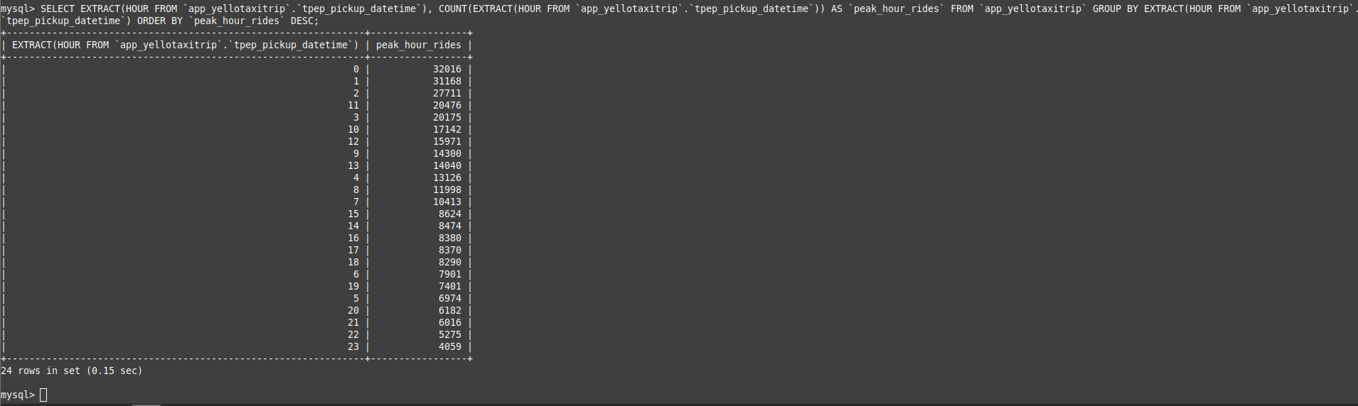

Execution time:

0.15 sec

Query 3:

SELECT ROUND(AVG(tip_amount) * 100 / SUM(tip_amount),10) FROM app_yellotaxitrip;

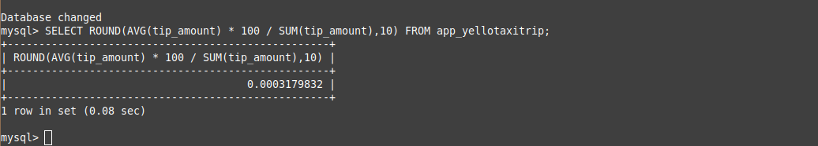

Execution time:

0.08 sec