Product Listing Page
- Reference Link
Design cards as in the reverence link and zero margin padding from left right.
https://peorajewellery.com/collections/clutches-and-sling-bags?page=1

Product detail Page
- In Mobile View Small should be shown as in desktop view showing at left hand side reference link https://peorajewellery.com/products/festive-finesse-golden-party-clutch

Login Page
- User the account using account number and OTP
  - Login Pop-up (Phone Number)
  - OTP Pop-up modal
  - Reference link
  - https://www.iconicindia.com/collections/women-handbags/products/dkny-ss23-r31ebw92-bgd-black-handbags
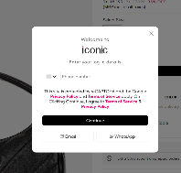

Home Page
- Video Section Just Below the (• WOMEN'S WORK BAG)
https://baggit.com/
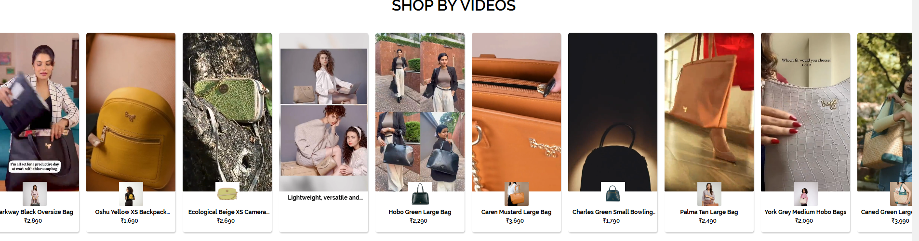
- Please Enhance more home page and mobile friendly
- Reference link https://peorajewellery.com/
- Brand Logo
- Use this brand logo for now


