POWER SYSTEM FAULT ANALYSIS USING MATLAB/SIMULINK
Three-Phase Power System Operation, Fault Simulation and Impact Analysis

Software | MATLAB/Simulink R2026
System Type | Three-phase transmission/distribution network
Selected Fault | Three-phase short-circuit fault at Bus 2
Measurement | Current and voltage sensor (three phase)

1. Introduction
Fault analysis is an important part of power-system studies because faults produce abnormal currents and voltages and can affect the stability and safe operation of the network. In this project, a three-phase power-system model is developed in MATLAB/Simulink and a three-phase short-circuit fault is applied at Bus 2. The voltage and current responses are observed using a current and voltage sensors (three phase) and Scope.

2. Objectives
- Model the operation of a three-phase power system in MATLAB/Simulink.
- Connect the source, buses, π-section transmission lines and loads correctly.
- Choose and apply an appropriate fault condition.
- Observe the change in three-phase voltage and current during the fault.
- Analyze the effect of the fault on the connected power system.
- Prepare a technical report containing the procedure, observations and conclusions.

3. Power System Model Used
The simulation consists of a three-phase source followed by Bus 1, π-section Line 1, Bus 2, π-section Line 2, Bus 3, π-section Line 3 and a Three-Phase V-I Measurement block. After the measurement point, Bus 4 supplies Parallel RLC Load 1 and feeds π-section Line 4. The output of Line 4 is connected to Bus 5, which supplies Parallel RLC Load 2. A three-phase fault is connected at Bus 2.

Figure 1: representation of the Simulink power-system model.

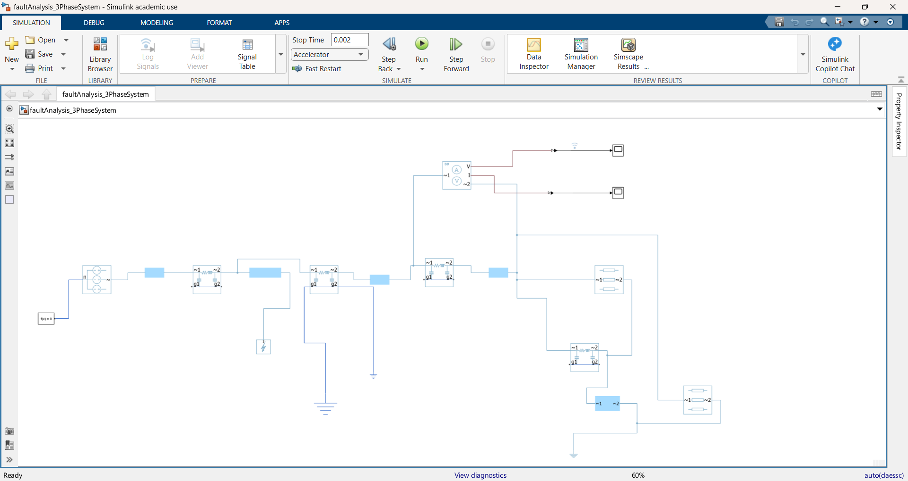

Scope0: waveform
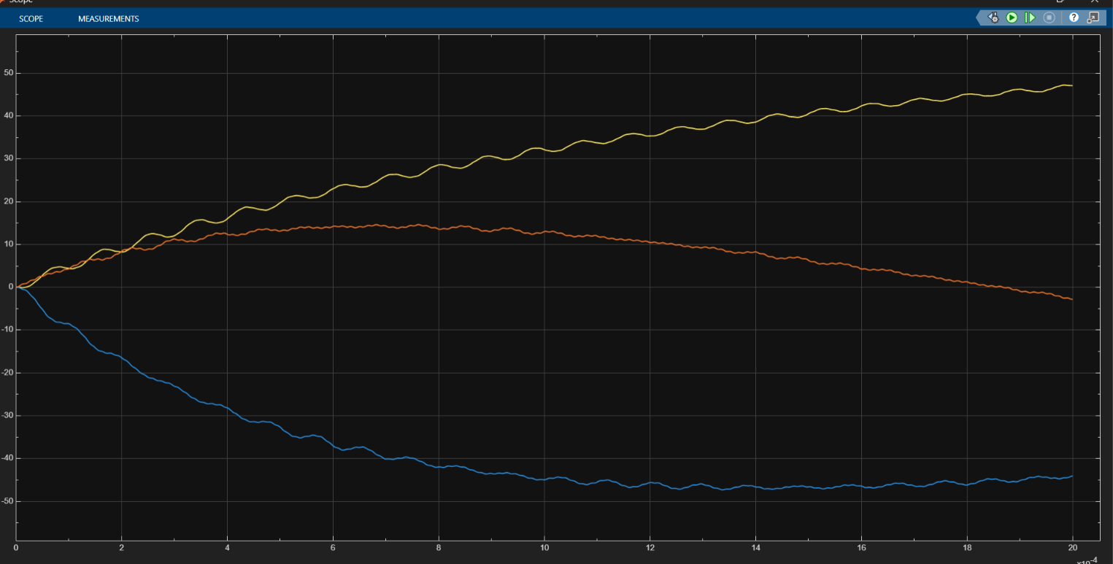

Scope1:output waveform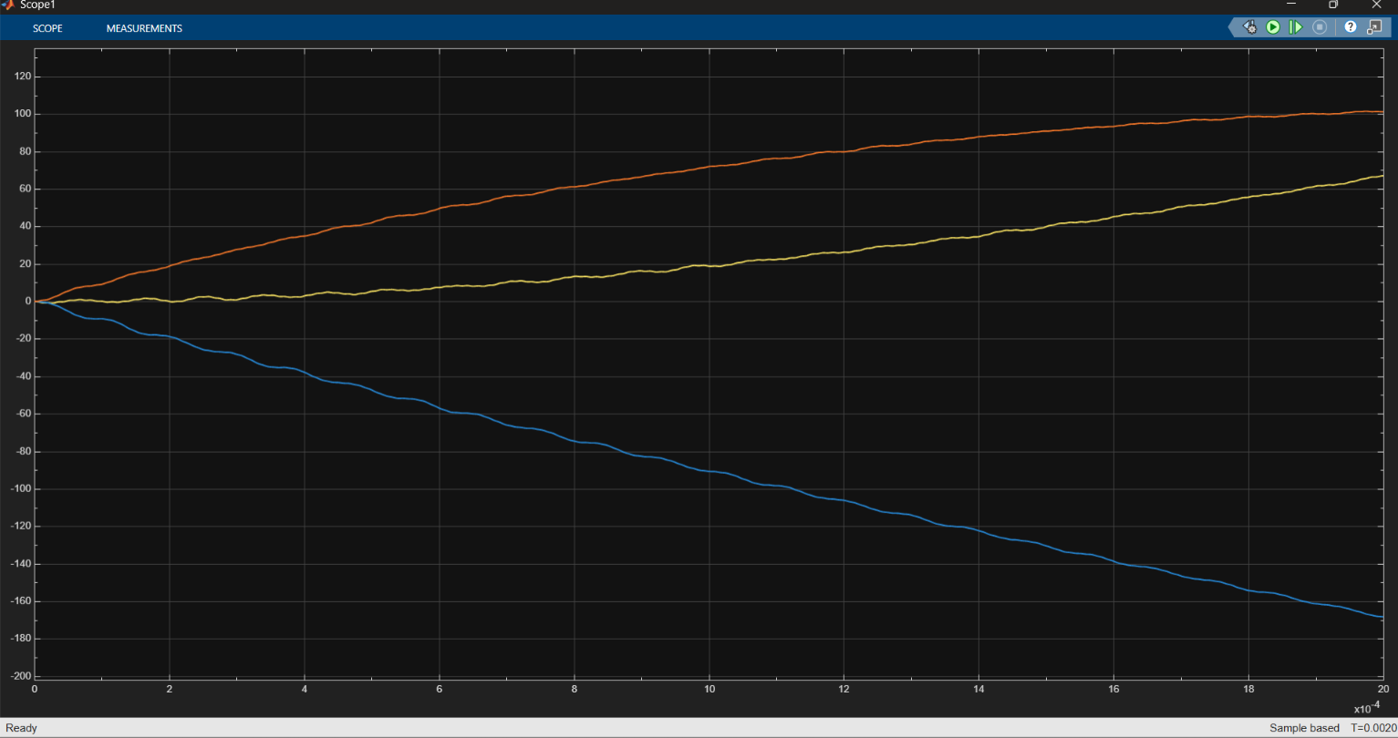

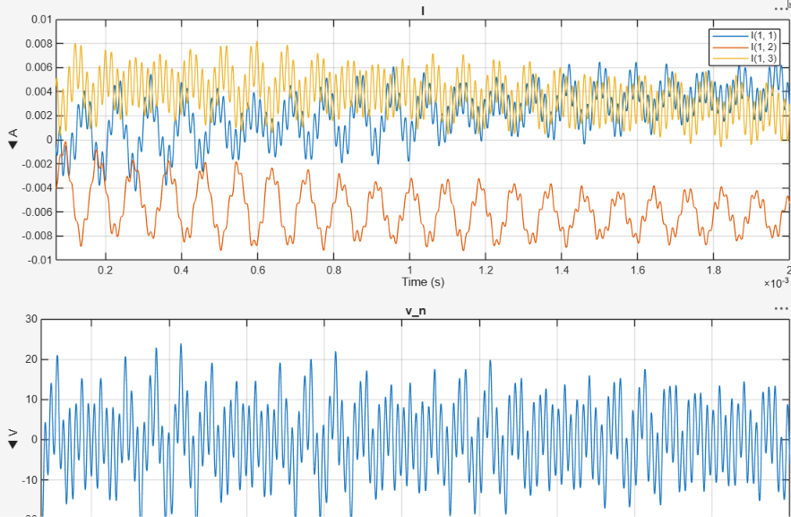

Fault analysis: waveform

Bus bur : o wave form
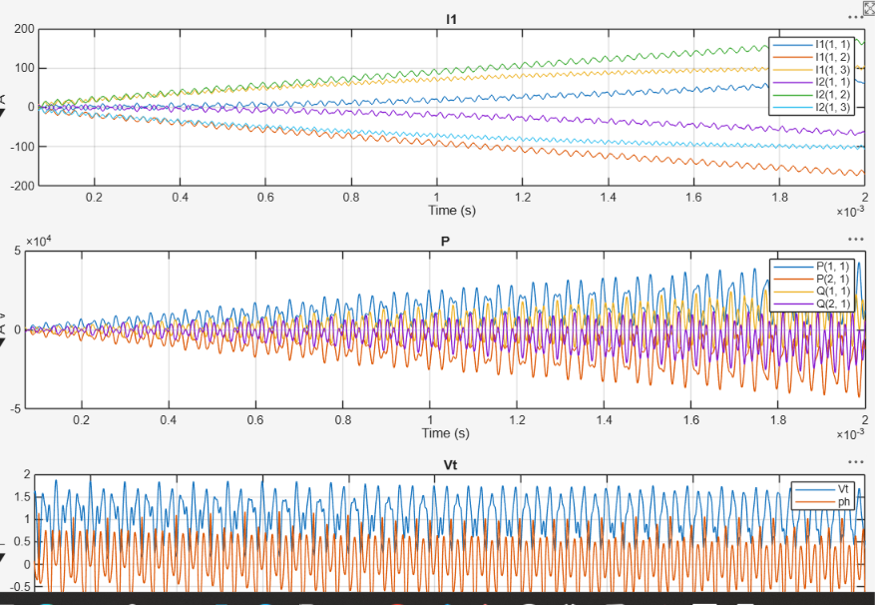
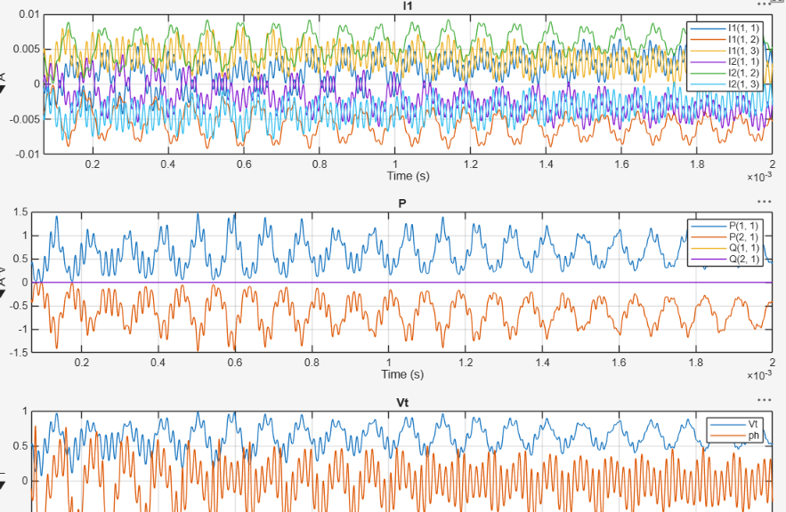
BUSBAR 1: waveform

BUSBAR : 2 OUTPUT WAVEFORM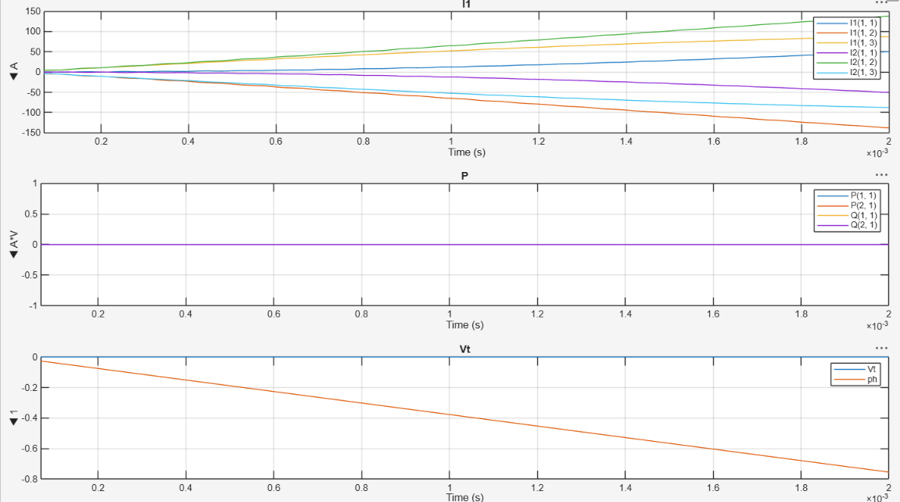

Busbar : 3 output waveform 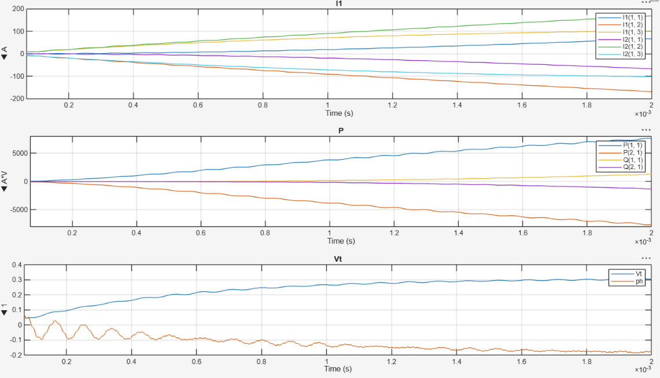 Busbar : 4 output waveform

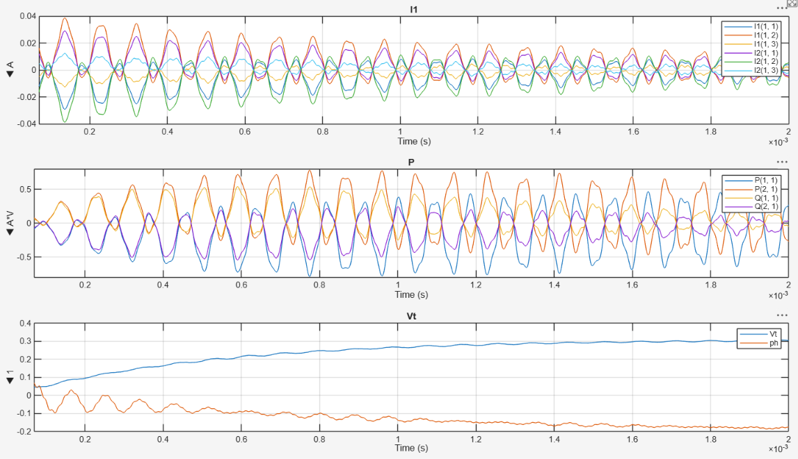

STEP BY STEP SIMULATION PROCESS

Step 1 – Create the model: Open MATLAB/Simulink R2026 and create a new model. Add the required three-phase source,
Bus sections, π-section transmission lines, Three-Phase Fault, voltage and current sensors (three phase), Parallel RLC Loads, Ground and Scope blocks.
Step 2 – Connect the source to Bus 1: Connect the three phases A, B and C of the Three-Phase Source to Bus 1. Keep the phase order unchanged: A to A, B to B and C to C.
Step 3 – Connect π Section Line 1: Connect Bus 1 to the input terminals of π Section Line 1. Connect its output terminals to Bus 2 phase-by-phase.
Step 4 – Install the fault at Bus 2: Connect the Three-Phase Fault block in parallel at Bus 2. The A, B and C terminals of Bus 2 are connected to the corresponding A, B and C terminals of the fault block. The main transmission path from Bus 2 to Line 2 remains continuous.
Step 5 – Connect π Section Line 2 to Bus 3: Connect the output of π Section Line 2 to Bus 3, maintaining the A-B-C phase sequence.
Step 6 – Connect π Section Line 3: Connect Bus 3 to π Section Line 3. The output of Line 3 is connected to the input of the current and voltage sensors (three phase)
Step 7 – Connect the current and voltage sensors (three phase) : Place the current and voltage sensors (three phase) in series with the three-phase network. Connect Vabc and Ibac measurement outputs to the Scope (directly or through a suitable signal-routing block if required by the chosen Simulink configuration).
Step 8 – Create Bus 4: The electrical output of the V-I Measurement block is connected to Bus 4. Bus 4 acts as the branch point for Parallel RLC Load 1 and π Section Line 4.
Step 9 – Connect Parallel RLC Load 1: Connect the three phases from Bus 4 to the corresponding terminals of Parallel RLC Load 1.
Step 10 – Connect π Section Line 4 and Bus 5: Connect Bus 4 to π Section Line 4, and connect the output of Line 4 to Bus 5.
Step 11 – Connect Parallel RLC Load 2: Connect the three phases of Bus 5 to Parallel RLC Load 2. Connect the required neutral/reference terminal to Ground according to the selected RLC-load configuration.
Step 12 – Set the simulation: Enter the source, line, fault and load parameters specified by the laboratory/project instructions. Select a simulation time long enough to show the pre-fault, fault and post-fault portions of the waveform.
Step 13 – Run the normal operating condition: First run the model with the fault disabled/open. Observe the three-phase voltage and current at the measurement point and save the Scope waveform as the pre-fault reference.
Step 14 – Apply the selected fault: Enable the three-phase fault at Bus 2 for the selected fault time interval. Run the simulation again and observe the voltage and current changes.
Step 15 – Compare the results: Compare the pre-fault and fault-period waveforms. Record the maximum/peak fault current, minimum voltage during the fault, duration of the disturbance and any post-fault recovery observed.

5. Fault Condition Chosen
A three-phase short-circuit fault is selected at Bus 2. This is a symmetrical fault involving all three phases simultaneously. Bus 2 is chosen because it is electrically between the first and second π-section line sections, allowing the disturbance to propagate toward the downstream network and loads while also affecting the source-side current.
The fault is applied for a finite time interval during the simulation. The exact fault start time, clearing time and fault impedance should be entered according to the values used in the actual Simulink model.

6. Analysis of the Impact of the Fault
The fault causes a major change in the electrical conditions around Bus 2. Because the fault provides a low-impedance path for the three phases, the current supplied toward the fault rises sharply compared with the normal operating condition. At and electrically close to the faulted bus, the three-phase voltage is expected to fall significantly during the fault interval.
Fault current: A sharp increase in current is expected when the three-phase fault is applied. The measured peak/rms value should be taken directly from the Scope or logged simulation data.
Parameter
Bus voltage: The voltage at the faulted bus and nearby buses is expected to decrease during the fault. The magnitude of the decrease depends on source strength, line impedance and fault impedance.
Downstream loads: The voltage disturbance can propagate through the network toward Bus 4 and Bus 5, so the RLC loads may experience a temporary voltage deviation.
Transmission-line response: The π-section lines contribute series impedance and shunt capacitance, so they influence the magnitude and propagation of the fault current and voltage disturbance.
Post-fault behavior: After fault clearing, voltage and current should move toward their pre-fault values. Any transient or oscillatory behavior should be identified from the Scope waveform.
- Scope waveform showing fault clearing and post-fault recovery.

8. Discussion
The simulation demonstrates why fault studies are required in power-system operation. Under normal conditions, the source supplies the transmission network and loads through the π-section lines. When the three-phase fault is applied at Bus 2, the network impedance seen by the source changes abruptly. This produces a transient increase in current and a reduction in voltage near the fault location. The disturbance can also be observed at downstream buses and loads through the interconnected transmission path.
The severity of the observed disturbance depends on the source voltage, system impedance, line parameters, fault impedance, fault duration and load parameters. Therefore, the final numerical conclusions should be based on the measured Scope data rather than assumed values.

9. Conclusion
A three-phase power-system model was developed in MATLAB/Simulink using a three-phase source, buses, π-section transmission lines, a current and voltage sensors (three phase) and RLC loads. A three-phase sho 11. Student Details

10. Precautions / Checks
- Maintain the same phase sequence A-B-C throughout the circuit.
- Connect the fault block at Bus 2 as a parallel fault branch; do not insert it in series with the transmission line.
- Ensure Bus 4 is downstream of current and voltage sensors (three phase) the and is the branch point for Load 1 and Line 4.
- Check that Bus 5 supplies Load 2 and that the required reference/ground connection is present.
- Verify that all electrical terminals are actually connected; a visual crossing of lines is not necessarily an electrical connection.
- Use the same source, line, load and fault parameters in the report that were used in the final simulation.

