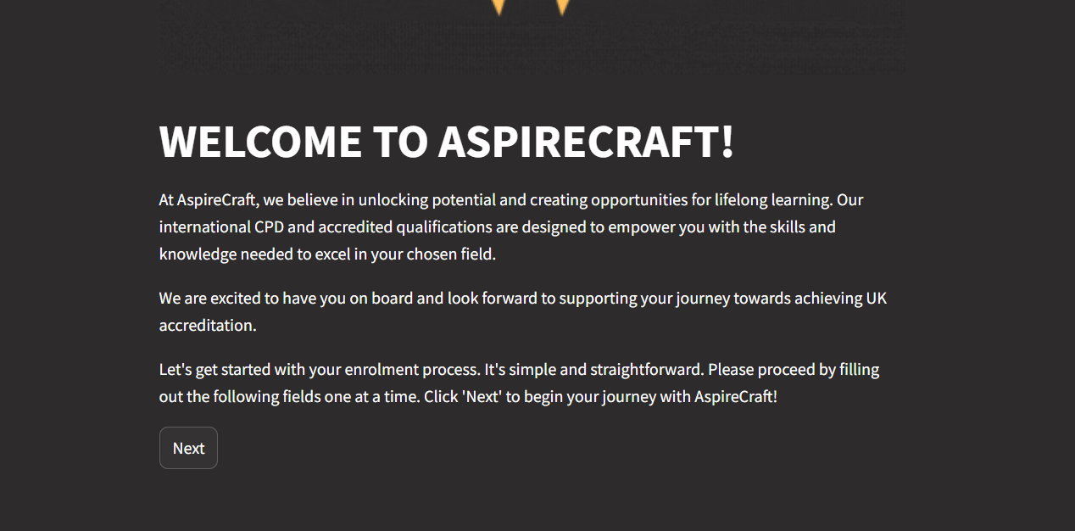

U’ll send notes for above

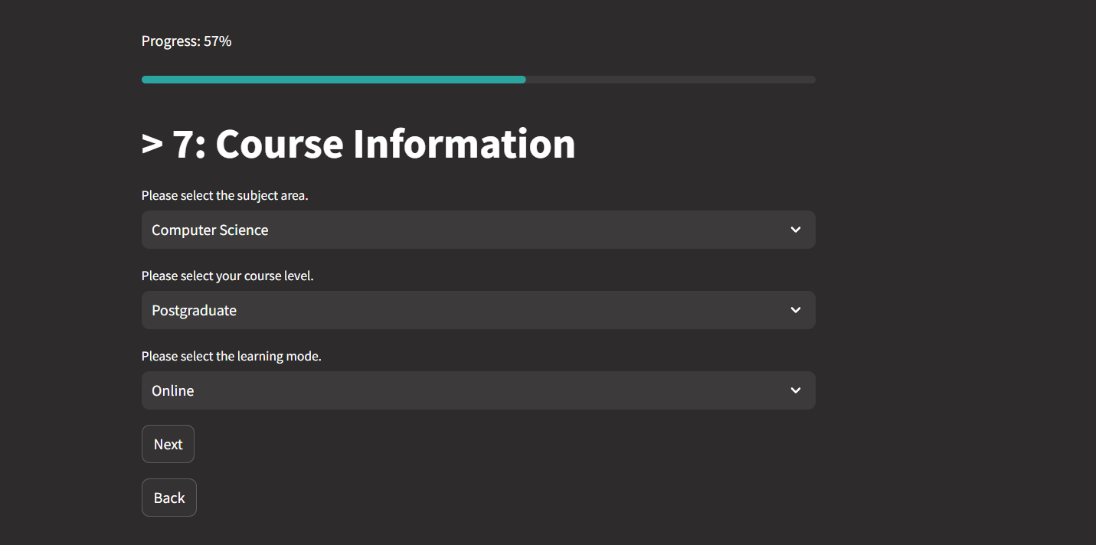

Instead of course information -> Select Services

They can select more than 1 (multi select):

|  |
| --- |
| * *IELTS*: options below |
| * *CPD courses :* cpd.txt |
| * *Int Accredited courses* : below |
| * *Summer Internship Programme : Which package are you interested in?*   single select (which cohort you would like to be part of )  Basic or Premium Package |
| : explanation to be displayed which is below & in text file |
| * *University Success :* |
| * *Teacher & Assessment Training*: options below |
| * *Business Accelerator :* options below |

For Int Accredited courses :

“Which sector do you wish to achieve accreditation?”

|  |
| --- |
| Health, public services and care |
| Construction, planning and the built environment |
|  |
| Information and communication technology |
| 9. Arts, media and publishing |
| 13. Education and training |
| 14. Preparation for Life and Work |
| 15. Business, administration and law |

|  |
| --- |
| **Basic Package (Included for All Students):**   * 2 weeks work experience in teaching hospitals across England. * Accredited UK medical CPD or certification courses (e.g., ACLS, BLS). * CPD training on patient communication and NHS protocols. * Accommodation in university dorms near teaching hospitals. * Guided London tours to iconic landmarks (e.g., Big Ben, Buckingham Palace).   **Premium Package (Optional Upgrade):**   * All Basic Package features. * Private, upscale accommodation. * Entertainment: Theme parks, cultural shows, or private river cruises. * Career mentorship with UK medical professionals. * Exclusive tours to elite medical facilities (e.g., Royal Society of Medicine). * Concierge services: Airport pickups, personalized itineraries, and meal customization. |

**Business Accelerator Services:**  
Please select the services you are interested in:

* **MVP Testing**: Minimal Viable Product testing and validation.
* **Business Plan Review**: Expert feedback on your business plan.
* **Market Gap Analysis**: Identifying opportunities in your target market.
* **Workforce Development**: Training and support for building your team.
* **Growth Management**: Strategies for scaling and managing business growth.

**Teacher & Assessment Training:**  
Please select your professional vocational sector where you have:

* An accredited qualification.
* More than 2 years of professional industry work experience.

Options:

* **Health & Social Care**
* **Construction & Engineering**
* **Business & Administration**
* **Digital & IT**
* **Education & Training**
* **Retail & Customer Service**
* **Hospitality & Tourism**
* **Creative Arts & Media**
* **Other (please specify)**

**IELTS Preparation:**

Please select your primary reason for taking the IELTS exam:

* **Higher Education Abroad**: Admission to universities or colleges in English-speaking countries.
* **Immigration**: Meeting language requirements for migration to countries like the UK, Canada, or Australia.
* **Professional Registration**: Certification for professions such as nursing, engineering, or accounting.
* **Employment**: Enhancing job prospects in international or English-speaking environments.
* **Personal Development**: Assessing and improving English language proficiency for personal growth.

*Note: Understanding your motivation helps tailor your preparation effectively.*

Review:

**1. Personal Information**

* Full Name
* Date of Birth
* Contact Details:
  + Email
  + Phone Number (with country code)
* Nationality
* Country of Residence
* Preferred Language of Communication

**2. Program/Service Selection**

* Select the program/service you are applying for:
  + **International Career Advice and Navigation (ICAN)**
  + **Teaching and Assessment Programme**
  + **International Accredited Courses**
  + **University Success (Admissions Support)**
  + **Summer International Internship Programme**
  + **Functional Skills Commerce (English & Math Training)**
  + **Business Incubation Services**

**3. Professional and Educational Background**

* Highest Level of Education:
  + High School Diploma
  + Bachelor's Degree
  + Master's Degree
  + Doctorate
  + Other (please specify)
* Accredited Qualifications (Dropdown or Text Field for Sectors)
* Years of Professional Industry Work Experience:
  + Less than 1 year
  + 1–2 years
  + 3–5 years
  + More than 5 years
* Current Role or Profession
* Preferred Vocational Sector (if applicable):
  + Health & Social Care
  + Construction & Engineering
  + Business & Administration
  + Digital & IT
  + Education & Training
  + Retail & Customer Service
  + Hospitality & Tourism
  + Creative Arts & Media
  + Other (please specify)

**4. Program-Specific Details**

**For each selected program/service, please provide the following details:**

**International Career Advice and Navigation (ICAN):**

* **Career Goals: Outline your career aspirations and sectors of interest (open text).**
* **Reason for Interest:** 
  + **Career exploration and development.**
  + **CV building and job placement support.**
  + **Personalized career diagnostics.**

**Teaching and Assessment Programme:**

* **Vocational Sectors: Specify your sector(s) with accredited qualifications and work experience.**
* **Work Aspirations: Indicate your interest in working for a UK teacher recruitment agency.**
* **Reason for Interest:** 
  + **To gain qualifications as an accredited educator.**
  + **To enhance teaching skills and pedagogy.**
  + **To achieve UK tutor certification and recognition.**
  + **To deliver affordable, high-quality education globally.**

**International Accredited Courses:**

* **Field of Study: Select your preferred field (e.g., digital transformation, healthcare, sustainability).**
* **Reason for Interest:** 
  + **To advance your career with globally recognized qualifications.**
  + **To meet employer requirements for niche skills.**
  + **To gain expertise in emerging markets.**

**University Success (Admissions Support):**

* **Higher Education Goals: Specify target countries, universities, or courses.**
* **Assistance Needed: Select areas of support (e.g., IELTS preparation, portfolio development).**
* **Reason for Interest:** 
  + **Simplifying university applications.**
  + **Securing admissions abroad.**
  + **Personalized guidance for successful placement.**

**Summer International Internship Programme:**

* **Package Selection: Choose between Basic or Premium.**
* **Reason for Interest:** 
  + **To gain hands-on work experience in UK hospitals or allied sectors.**
  + **To enhance employability with practical international exposure.**
  + **To participate in cultural and professional development activities.**

**Functional Skills Commerce:**

* **Current Role: Specify your position (e.g., migrant worker, business owner).**
* **Reason for Interest:** 
  + **To improve workplace communication and productivity.**
  + **To meet employer expectations for functional skills.**
  + **To access better employment opportunities.**

**Business Incubation Services:**

* **Business Details: Provide your business idea or existing plan (open text).**
* **Reason for Interest:** 
  + **To develop and validate a business plan.**
  + **To receive professional guidance on team recruitment and leadership.**
  + **To connect with investors and achieve investor readiness.**
  + **To future-proof your business idea.**

**5. Supporting Documents (Optional)**

**Note:- Please note that we will require additional documents to complete enrolment at later stage.**

* Upload CV or Portfolio (if applicable).
* Upload Supporting Documents (certificates, qualifications, etc.).

**6. Additional Information**

* Preferred Start Date/Timeline for Participation. (Options:- ASAP, 1 to 2 months, 2 to 4 months, 6 months + )
* Additional Comments or Requests (open text field).

Folders in drive:

|  |
| --- |
| India |
| Taiwan |
| Vitnamese |
| Singapore |
| Indonesia |
| Malasia |
| UAE |
| Saudi Arabia |
| Qatar |
| Philipines |
| Srilanka |
| Pakistan |
| Morocco |
| Tunisia |
| Egypt |

Azerbaijan

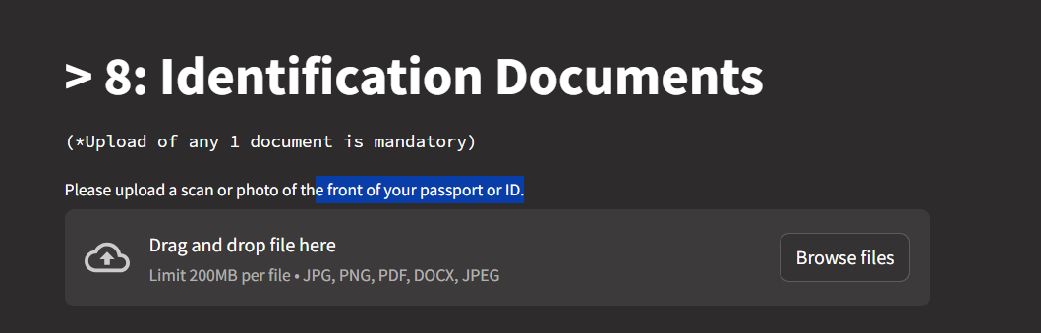

CV

docs must be optional Optional