* Make it optional “Preferred Language of Communication:”
* Put “optional” for optional ones.
* “Please enter your WhatsApp number (international format starting wit” Change to -> *“Please Enter Your Contact number”*
* 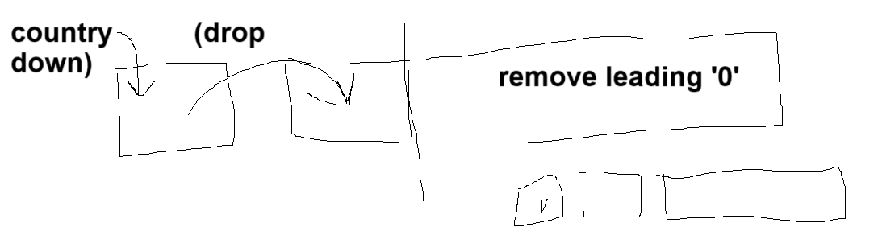
* **Remove:  
  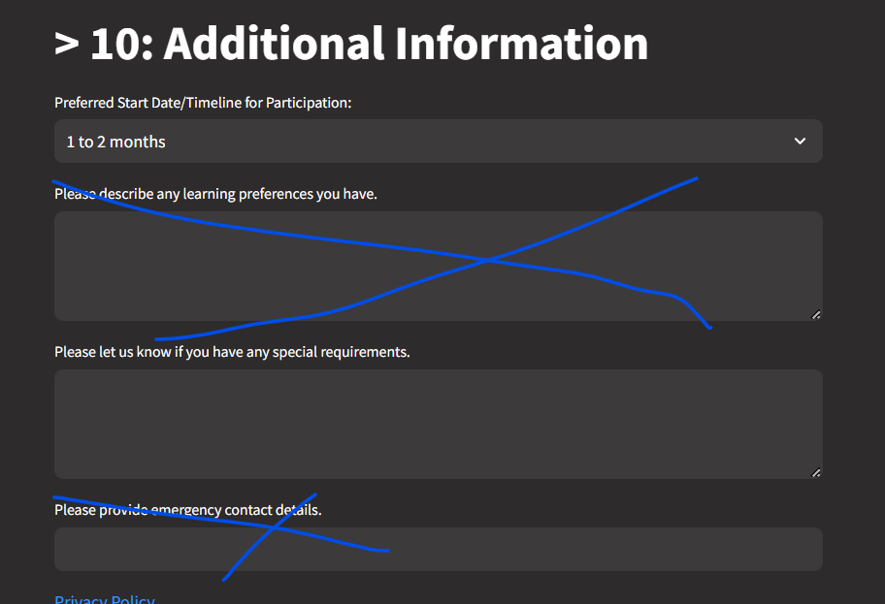**

**In final doc add logo as well of aspirecraft:**

