**✅ Final MVP Specification**

**System Name:** Multi-Hotel Room Booking Local Platform

**Languages:** English (with Arabic support)

**Deployment:** On-premise (internal hotel network)

**Tech Stack:** Next.js + Express.js + PostgreSQL

## **1. Project Overview**

This is a **private, on-premise booking system** for hotel owners and their staff. There is **no guest-facing website**: all reservations are created manually by staff using the platform.

* **Owner:** Manages one or more hotels, enters room data, pricing, availability, and creates staff accounts.
* **Staff:** Uses the system to view real-time availability and book rooms for guests.

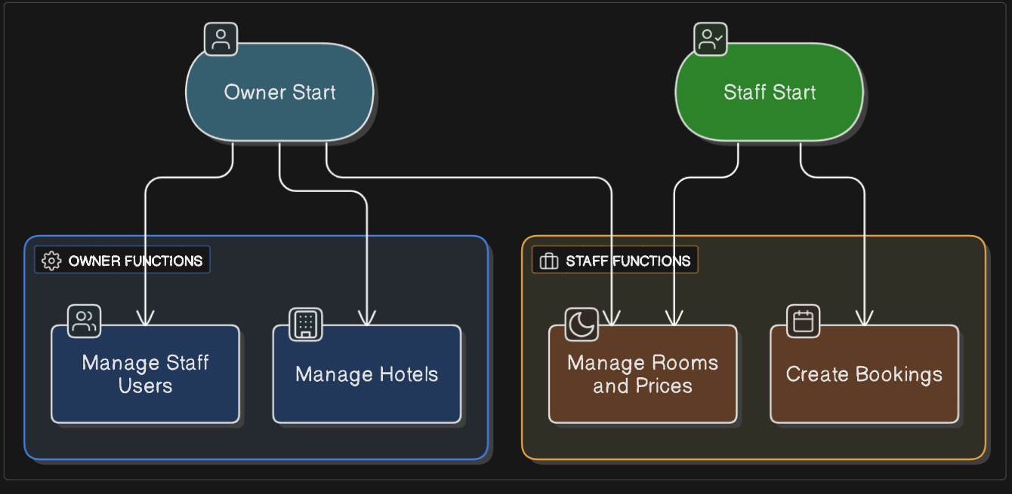

## **2. Objectives**

* Build a **centralized internal platform** to manage multiple hotels and room types.
* Enable the owner to:
  + Add, edit, and remove hotels (contact, location).
  + Define room types (quantity, capacity, features, views).
  + Set pricing and availability periods.
  + Create and manage staff users.
* Enable staff to:
  + Browse and filter available rooms.
  + Create, edit, and cancel reservations on behalf of guests.
* Support **English and Arabic** throughout the interface.

## **3. Users & Permissions**

|  |  |  |
| --- | --- | --- |
| **Role** | **Access Panel** | **Capabilities** |
| Owner | Admin Dashboard | Full control over hotels, rooms, pricing, availability, staff |
| Staff | Booking Dashboard | View room data, manage reservations for guests |

## **4. Core Features**

### **Owner (Admin Dashboard)**

* **Hotel Management**
  + Create, update, delete hotels (name, address, phone, email)
* **Room Type Management**
  + Define room types per hotel (name, quantity, max guests)
  + Assign amenities (e.g. air conditioning, Wi-Fi, jacuzzi)
  + Assign view categories (e.g. Haram view, city view)
* **Pricing**
  + Set base rates for each room type + view combination
* **Availability Periods**
  + Specify start and end dates for each room type’s availability
* **Staff Management**
  + Invite staff users and assign roles

### **Staff (Booking Dashboard)**

* **Dashboard Overview**
  + Quick view of hotels, room types, and current availability
* **Booking Workflow**
  + Select hotel, room type, dates, and guest count
  + Enter guest details and confirm reservation
  + Validate capacity and availability in real time
* **Reservation Management**
  + View and search existing bookings
  + Edit or cancel reservations as needed

## **5. System Design Overview**

* Single Next.js application with two role-based views.
* Shared Express.js API and central PostgreSQL database.
* Deployed on the hotel’s local network for secure, offline operation.

## **6. MVP Timeline (12 Weeks)**

|  |  |
| --- | --- |
| **Week** | **Focus Area** |
| 1 | UI/UX: Style tile, user flows, low-fi wireframes |
| 2 | High-fi mockups & interactive prototype |
| 3 | Project setup: Git repositories, Docker, CI/CD |
| 4 | Authentication system and user roles |
| 5 | Hotel creation and management module |
| 6 | Room type, amenities, and view definitions |
| 7 | Availability period setup and calendar UI |
| 8 | Pricing module and validation logic |
| 9 | Booking dashboard UI and reservation logic |
| 10 | Reservation management and reporting overview |
| 11 | English/Arabic translation support |
| 12 | QA testing, performance tuning, on-prem deployment |

## **7. Cost Estimate & Payment Milestones**

**Total Fixed Price:** **$4,000**

**Structure:** Six milestones, payable on approval.

|  |  |  |  |  |
| --- | --- | --- | --- | --- |
| **Milestone** | **Deliverables** | **% Fee** | **Amount (USD)** | **Due** |
| **M1: UX Kickoff** | Style tile, user flows, low-fi & hi-fi mockups, prototype | 20% | $800 | Upon contract signing |
| **M2: Core Setup** | Repo setup, Docker & CI/CD, DB schema, auth & roles | 15% | $600 | End of Week 3 |
| **M3: Hotel & Rooms** | Hotel CRUD, room types, amenities, views | 15% | $600 | End of Week 6 |
| **M4: Availability & Pricing** | Availability periods, calendar UI, pricing module | 20% | $800 | End of Week 8 |
| **M5: Booking Flow** | Staff booking dashboard UI, reservation workflows | 15% | $600 | End of Week 10 |
| **M6: Final Delivery** | QA reports, performance tuning,  on-premise deployment, docs | 15% | $600 | End of Week 12 (Sign-off) |

* **First Payment (M1 – $800)** due at project start.([Aglowid IT Solutions](https://aglowiditsolutions.com/blog/cost-to-hire-a-software-developer/?utm_source=chatgpt.com)).
* Remaining invoices due within 7 days of each milestone’s approval.

## **8. 💬 Why $4,000 Is Feasible**

1. **Reduced Scope & Part‑Time Allocation**: We focus exclusively on core MVP functionality, delivering a working prototype with essential data flows—this limits total hours to ~80 ([Qubit Labs](https://qubit-labs.com/average-hourly-rates-offshore-development-services-software-development-costs-guide/?utm_source=chatgpt.com)).
2. **Lean Team Structure**: Utilizing a small, multi‑skilled team (designer + full‑stack engineer) to maximize efficiency and minimize overhead ([FREELANCERMAP.COM](https://www.freelancermap.com/freelancer/Saudi%20Arabia-119.html?utm_source=chatgpt.com)).
3. **Competitive Regional Rates**: At **USD 50/hr**, our blended rate is below typical mid‑market agency fees of **USD 120–250/hr** while ensuring quality work ([FullStack](https://www.fullstack.com/labs/resources/blog/software-development-price-guide-hourly-rate-comparison?utm_source=chatgpt.com)).
4. **Fixed‑Price Certainty**: A capped fee protects you from overruns common in time‑and‑materials models and aligns incentives for rapid delivery ([geniusee.com](https://geniusee.com/single-blog/cost-of-outsourcing-software-development?utm_source=chatgpt.com)).

## **9. Payment Information**

To initiate payment, please use one of the following methods:

**Bank Transfer**

* **Account Name:** osama zenhom saad - اسامه زينهم سعد
* **IBAN:** EG510002036303630383000000465
* **Account Number:** 3630383000000465
* **SWIFT/BIC:** BMISEGCXXXX

**Vodafone Cash Wallet**

* **Wallet Number:** 01026454497