SNOWA
EXHIBITION GAMING PLATFORM
Product, UX & Game Design Specification
SOURCE OF TRUTH — VERSION 1.0
This document defines the agreed product behavior, participant journey, game rules, reward and raffle model, administration capabilities, integration expectations, and design constraints for the exhibition release. It is intentionally written in English for engineering handoff. The production participant experience is Persian and right-to-left.

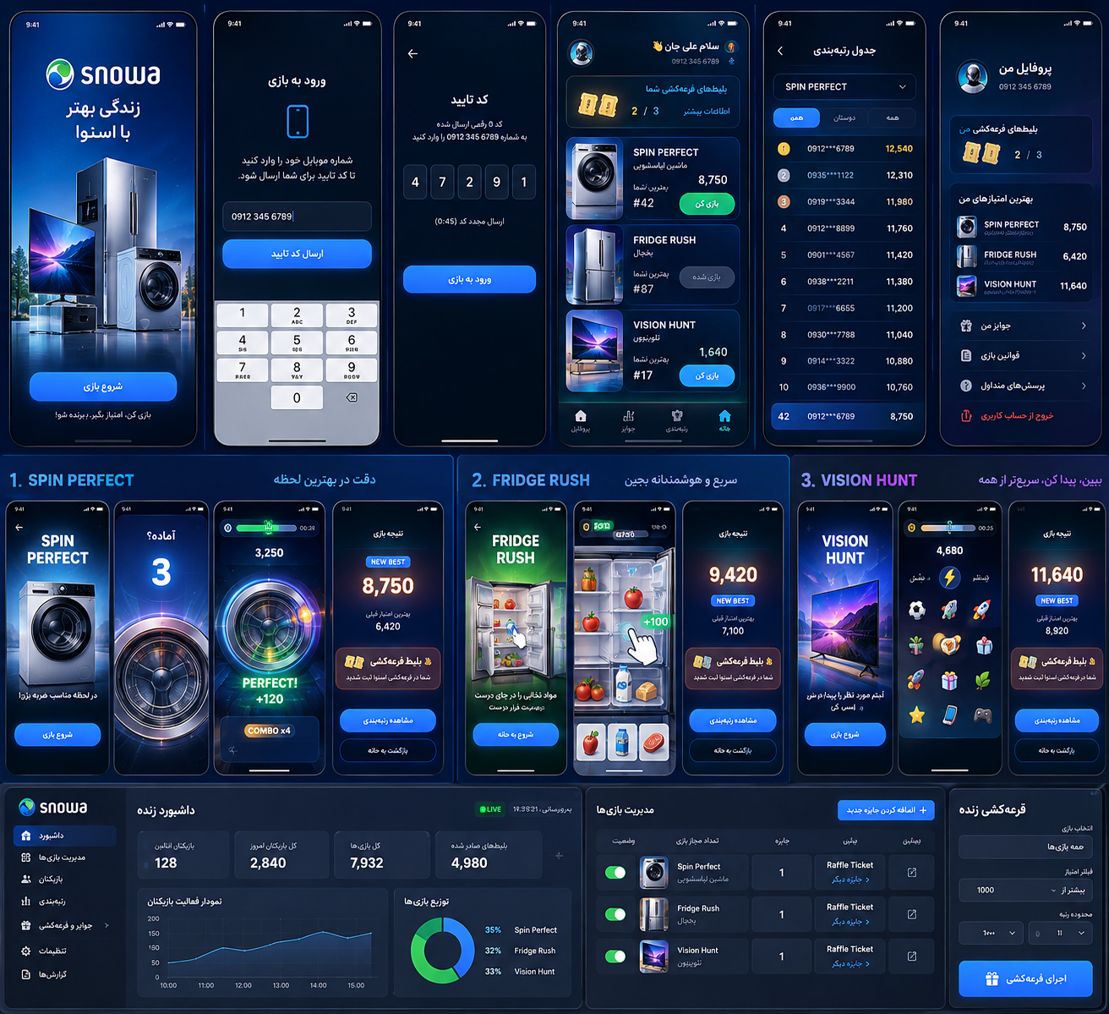
Visual direction reference — concept only; final production copy and titles must follow the Persian localization rules in this specification.
Document Field | Value
Project | Snowa Exhibition Gaming Platform
Document | Product, UX & Game Design Specification
Version | 1.0
Date | 28 September 2026
Status | Approved design baseline for technical documentation and prototyping
Audience | Product, game design, UI/UX, frontend, backend, QA, DevOps, event operations
Confidentiality | Confidential — project use only

0. Document Control and Reading Guide
This specification is the product and game-design baseline that the technical documentation agent and implementation team must treat as authoritative unless a later approved revision explicitly changes a requirement. It describes what the system must do and how the player experience should behave; implementation-level choices may be refined in the subsequent technical architecture package as long as the product behavior remains unchanged.

0.1 Change Control
Version | Date | Summary | Status
1.0 | 28 Sep 2026 | Initial exhibition scope: OTP + participant name, three record games, best-score model, raffle tickets, dynamic rewards, live leaderboard, live draw, admin controls, PWA/mobile requirements, and external score API. | Baseline

0.2 Table of Contents
- 1. Product Vision and Event Context
- 2. Non-Negotiable Product Decisions
- 3. Users, Roles and Permissions
- 4. End-to-End Participant Journey
- 5. Persian Localization and RTL Standard
- 6. Authentication and Participant Profile
- 7. Participant Home / Game Lobby
- 8. Shared Game Runtime and Attempt Rules
- 9. Game 01 — Spin Perfect
- 10. Game 02 — Fridge Rush
- 11. Game 03 — Vision Hunt
- 12. Scoring, Best Score and Ranking Rules
- 13. Reward System and Raffle Tickets
- 14. Live Leaderboard and Public Score Display
- 15. Live Raffle Engine
- 16. Administration Panel
- 17. External API Integration
- 18. Conceptual Data Model
- 19. Real-Time Behavior
- 20. PWA, Mobile and Responsive Requirements
- 21. Security and Anti-Cheat Requirements
- 22. Reliability and Failure Handling
- 23. Analytics and Event Instrumentation
- 24. Visual Design System
- 25. Audio and Haptics
- 26. Asset Production Plan
- 27. Performance Budgets
- 28. Accessibility and Exhibition Usability
- 29. Acceptance Criteria
- 30. Technical Documentation Agent Handoff
- 31. Implementation Phasing
- 32. Known Open Items
- Appendix A — Persian UI Copy Starter Set
- Appendix B — Requirement Traceability Matrix
- Appendix C — Concept Art References

1. Product Vision and Event Context
A fast, visually premium, mobile-first exhibition experience that turns booth traffic into measurable participation, brand exposure, ranking competition and live raffle engagement.
The exhibition release is a focused campaign product rather than a general-purpose loyalty platform. Visitors scan a QR code, verify their phone number, provide their name, play up to three short record-based games, receive raffle eligibility, optionally receive additional rewards configured by administrators, and compare their best scores with other participants.
The system must feel like one coherent Snowa gaming experience even though the three games use different mechanics. Shared authentication, game shell, score presentation, reward behavior, result screens, ranking language, visual system and admin controls should make the platform feel unified.

1.1 Primary Event Goals
- Maximize qualified participation from booth visitors with minimal onboarding friction.
- Create memorable interaction with Snowa products through gameplay, not passive advertising.
- Produce fair, comparable record scores suitable for live rankings.
- Encourage participants to complete all three games by granting one core raffle ticket per completed game.
- Enable event operators to control game availability, attempts, rewards, live leaderboards and live raffles without code changes.
- Capture reliable participant and score data and forward the agreed data to Snowa's external API.
- Operate reliably on participant-owned mobile phones and tablets through a QR-first PWA/web experience.

1.2 Product Success Signals
Area | Success Signal
Onboarding | A visitor can move from QR scan to the lobby with no unnecessary account-registration steps.
Gameplay | Each game is understandable within seconds and usually completes in under one minute.
Completion | A participant can complete all three games in approximately 3–4 minutes excluding queue/wait time.
Brand | Each game makes a Snowa appliance a central visual/gameplay object rather than only showing a logo.
Operations | Event staff can change attempts, game state and extra rewards from admin without redeployment.
Engagement | Live ranking and live draw produce visible event moments suitable for a booth display.
Data | Every accepted attempt is auditable and the official leaderboard uses the player's best valid score per game.

2. Non-Negotiable Product Decisions
PRODUCT LANGUAGE
All participant-facing production screens, gameplay instructions, errors, result messages, rewards and navigation are Persian and RTL. Internal identifiers and engineering documentation may remain English. Official Snowa trademark artwork may remain in its supplied brand form.

ID | Decision | Required Behavior
PD-01 | QR-first entry | The experience opens directly in a mobile browser/PWA from exhibition QR codes; installation is never required.
PD-02 | Phone + OTP | Phone-number verification is required before participation.
PD-03 | Name after OTP | A first-time verified user must provide a display name after successful OTP verification and before entering the lobby. Returning users with a stored name skip this step.
PD-04 | Three record games | The initial event includes exactly three record-based games: Spin Perfect, Fridge Rush and Vision Hunt as internal names.
PD-05 | Attempts are admin controlled | Default: one valid attempt per participant per game. Admin can change the allowed attempt count independently for each game.
PD-06 | Best score wins | When multiple attempts are allowed, the official score is the highest valid score ever achieved by that user in that game. Lower later scores never replace the best.
PD-07 | Core raffle ticket | Every game completion grants the game's base raffle ticket once per participant per game. Replays do not create additional base tickets unless an explicitly configured extra-ticket reward applies.
PD-08 | Extra rewards are dynamic | Admin may configure additional rewards without removing the core raffle-ticket behavior.
PD-09 | Server authority | Attempts, eligibility, official scores, ticket grants, reward grants and raffle winners are authoritative on the server.
PD-10 | Live draw is filterable | Admin can run a live raffle using selectable eligibility rules, including all participants, score thresholds, ranking ranges, specific-game participation and all-game completion.
PD-11 | External score API | After a valid game result, the backend persists the result first and then sends the agreed participant/score payload to the external Snowa API using reliable retry semantics.
PD-12 | Mobile-first | Portrait mobile is the primary gameplay target. Tablet is fully supported. Desktop remains operational mainly for admin, public displays and QA.

3. Users, Roles and Permissions
Role | Purpose | Core Permissions
Participant | Exhibition visitor | Verify phone, set/display name, view lobby, play enabled games within attempt limits, view own best score/rank/tickets/rewards, view permitted leaderboard content.
Event Operator | Day-to-day booth staff | View dashboard, participants, live scores, leaderboards and draw screens; run operational actions allowed by role policy.
Event Administrator | Controls event configuration | Enable/disable games, change attempt limits, configure extra rewards, manage leaderboard/display settings, create and run live raffles, view/export data and audit logs.
Super Admin | Restricted project owner role | All admin permissions plus sensitive configuration such as integrations, administrator management, emergency overrides and event-level settings.
Public Display | Read-only booth screen | Show live leaderboard, current draw animation/results or approved event content. No personal phone numbers in full.
External Snowa System | Integration target | Receives agreed participant/game/score records through server-to-server API delivery.

3.1 Public Privacy Default
Public ranking screens should display the participant name in an event-safe format and must never expose a full phone number. Recommended default: full entered name plus optionally a masked phone fragment only if event stakeholders explicitly require disambiguation. Admin views may show the full verified phone number according to role permissions.

4. End-to-End Participant Journey

4.1 Primary Flow
QR Scan
↓
Mobile Landing
↓
Phone Number
↓
OTP Verification
↓
First Visit? → Enter Name
↓
Game Lobby
↓
Choose Enabled Game
↓
Pre-game Instructions
↓
Server-authorized Game Session
↓
Gameplay
↓
Result Validation + Best Score Update
↓
Raffle Ticket + Optional Extra Reward
↓
Result / Rank
↓
Back to Lobby → Next Game / Leaderboard

4.2 Experience Principles
- No mandatory install step; the browser experience must be complete.
- Each screen has one obvious primary action.
- No long forms. Phone, OTP and first-time name are the only mandatory participant inputs.
- Game instructions are visual, short and understandable without reading a paragraph.
- Participants are never eliminated early from a timed game because of a mistake; mistakes reduce score/combo instead.
- After every valid first completion, the raffle-ticket reward is clearly acknowledged.
- After a replay, the result screen must distinguish current-attempt score from the persistent best score.
- After all available attempts are used, the lobby clearly shows the game as completed with the final best score and rank.

4.3 Target Session Duration
Step | Target Typical Time
Phone + OTP | ~15–30 seconds depending on SMS delivery
Name entry (first visit only) | ~5–10 seconds
Spin Perfect | ~40 seconds + short result
Fridge Rush | ~50 seconds + short result
Vision Hunt | ~40 seconds + short result
Complete all three | Approximately 3–4 minutes excluding OTP latency and user pauses

5. Persian Localization and RTL Standard
The production participant application is Persian-first and right-to-left. The administration interface is also expected to be Persian/RTL for event operations unless a later approved operations decision introduces an optional English admin locale. The technical implementation must not hard-code layout assumptions that make RTL fragile.

5.1 Language Rules
- No participant-facing English labels such as “Play”, “Leaderboard”, “New Best”, “Raffle Ticket” or “Reward” in the final production UI.
- Internal game slugs may remain English: spin-perfect, fridge-rush, vision-hunt.
- Working Persian display titles may be changed by brand approval without changing technical identifiers.
- All error, retry, connection, OTP, reward, draw, consent and game-instruction messages require Persian copy.
- Accept both Persian and Latin digits in phone/OTP input and normalize internally.
- Scores and timers may use Latin digits for visual clarity if approved by UI design; language copy remains Persian.
- All text components must support RTL direction, Persian line breaking and safe truncation on 360px-wide devices.

5.2 Working Player-Facing Game Titles
Internal Name | Working Persian Display Name | Notes
Spin Perfect | لحظه طلایی | Timing/precision game around the washing-machine drum. Brand may rename.
Fridge Rush | چیدمان سریع | Fast placement/sorting game inside a Snowa refrigerator. Brand may rename.
Vision Hunt | شکار تصویر | Reaction/visual-search game presented through a Snowa TV/scene. Brand may rename.

6. Authentication and Participant Profile

6.1 Phone Entry
- Iranian mobile-number input is the primary expected format for the event unless the event requirements later expand the country scope.
- Normalize whitespace, Persian digits, Latin digits and acceptable local prefixes before OTP request.
- Rate-limit OTP requests and verification attempts server-side.
- Display clear Persian cooldown/resend states and never reveal whether an arbitrary phone already exists before verification.

6.2 OTP Verification
The OTP screen must support automatic one-time-code suggestions where the browser/OS provides them, manual entry, resend cooldown, correction of the phone number, and graceful handling of expired/incorrect codes. Successful verification establishes an authenticated participant session.

6.3 First-Time Name Collection
Immediately after successful OTP verification, if the participant does not yet have a name, show a single-field profile step requesting the participant name. The field label and validation are Persian. On success, persist the name and enter the lobby. A returning participant with a stored name skips this step.
NAME IS DISPLAY DATA
The entered name is used for greetings, profile screens, ranking presentation and draw presentation. It is not identity verification. Validation should reject empty/obviously invalid values and enforce a practical length, but should not create unnecessary friction.

6.4 Returning Participants
A returning participant authenticates with phone + OTP and sees existing best scores, used attempts, raffle tickets and reward history. Attempt limits and active game availability are always re-read from current server configuration.

7. Participant Home / Game Lobby

7.1 Required Lobby Information
- Greeting using the participant name.
- Current raffle-ticket count and progress across the three core games.
- Three game cards in a stable layout.
- For each game: enabled/disabled state, best score, current rank when available, attempts used / attempts allowed, and primary action.
- Access to overall navigation such as leaderboard, rewards/profile and rules if included in final design.
- Clear completion state when no attempts remain.

7.2 Game Card States
State | Behavior
Not played | Show game art, available ticket indicator, attempt allowance and Persian “Start Game” action.
Played, attempts remain | Show best score, rank, attempts remaining and “Play Again” action.
Attempts exhausted | Show best score/rank and completed state; no play action.
Admin disabled | Keep card visible but mark temporarily unavailable; do not remove the card and shift the layout.
Loading/config unavailable | Show a recoverable state and retry rather than allowing an unauthorized game start.

7.3 Replay Warning
Because the official score is the best valid score, no warning about replacing a better score is necessary. A replay can only preserve or improve the official best score. The result screen must still show the current attempt score separately from the best score when they differ.

8. Shared Game Runtime and Attempt Rules
The three games should share a common shell for session authorization, pre-game states, timer/score HUD conventions, pause/background handling, result submission, reward presentation, sound settings, haptics, analytics and exit behavior. The gameplay modules remain independent.

8.1 Attempt Lifecycle
- Participant selects an enabled game with at least one remaining attempt.
- Client requests a server-authorized game session. The server checks authentication, game status and attempt limit.
- Server returns a short-lived session identifier/token and authoritative configuration needed for that attempt.
- Game assets are ready; countdown begins only after the runtime is ready.
- Gameplay runs for the configured duration/mechanics.
- Client submits the attempt result once using an idempotent submission identifier.
- Server validates session, timing, attempt count and score sanity; accepted attempt is persisted.
- Server calculates official best score = max(previous best, accepted attempt score), updates ranking, grants first-completion raffle ticket if needed, evaluates optional extra rewards, and queues external API delivery.
- Client receives authoritative result and renders the result/reward experience.

8.2 Attempt Counting
Only an accepted game start/result lifecycle should consume an attempt according to the technical policy established in the architecture specification. The implementation must avoid unfairly consuming an attempt because of a server error before gameplay starts. Once meaningful gameplay has begun, refresh/background/abandon rules must be explicit and server-enforced to prevent exploitative retries.

8.3 Shared Result Model
attempt_score: score from the just-finished attempt
best_score: highest accepted score for this participant + game
is_new_best: true when attempt_score > previous best
rank: current rank based on best_score
base_raffle_ticket_granted: true only on first valid completion for that game
extra_rewards: zero or more admin-configured grants
attempts_used / attempts_allowed: authoritative server values

9. Game 01 — Spin Perfect
Internal identifier: spin-perfect • Working Persian title: لحظه طلایی • Hero product: Snowa washing machine • Core skill: timing and precision
Spin Perfect is the fastest game to understand and is the recommended first vertical-slice implementation. The washing-machine drum is the central playfield. A moving indicator travels around a ring and the participant taps when it aligns with the scoring zone.

9.1 Target Experience
Property | Baseline
Typical duration | 40 seconds
Primary control | Single tap anywhere in the active playfield
Orientation | Portrait-first
Failure behavior | No early game over; a miss resets combo / yields no base points
Primary visual | 2.5D washing machine with animated drum/ring
Difficulty | Progressively faster/more variable timing and narrower target window
Core reward | One raffle ticket on first valid completion of this game

9.2 Gameplay Loop
- Countdown → indicator begins moving around the drum ring.
- Player taps when the indicator is inside the target window.
- Runtime classifies the timing result as Perfect, Great, Good or Miss.
- Immediate visual/audio/haptic feedback displays the result and points.
- Perfect results build combo; misses break combo.
- Difficulty increases through speed, direction change, target-window size and controlled speed variation.
- At timer end, motion resolves cleanly and the result is submitted.

9.3 Baseline Scoring
Timing Result | Base Points | Combo Effect
Perfect | 100 | Increase combo
Great | 70 | Maintain or limited combo according to final prototype tuning
Good | 40 | No strong combo gain
Miss | 0 | Reset combo

Baseline combo multipliers: x1.0 for combo 1–2, x1.2 for combo 3–5, x1.5 for combo 6–9, and x2.0 for combo 10+. Exact windows and score ceilings must be calibrated in the prototype so legitimate mobile devices produce consistent results.

9.4 Difficulty Curve
Time Window | Behavior
0–10 s | Large target window, moderate predictable speed. Teach by doing.
10–20 s | Increase speed; slightly smaller target.
20–30 s | Introduce direction change or stronger tempo variation.
30–40 s | Smallest fair window, highest controlled speed variation, strongest visual intensity.

9.5 Feedback
Perfect timing should feel highly satisfying: brief ring flash, controlled particles, score pop, subtle camera/scale punch and light haptic feedback on supported devices. The effect must remain short enough not to obstruct the next timing opportunity.

9.6 Result
Show attempt score, “new best” state when applicable, persistent best score, rank, base raffle-ticket status and optional extra rewards. A replay button appears only if attempts remain and the game is still enabled.
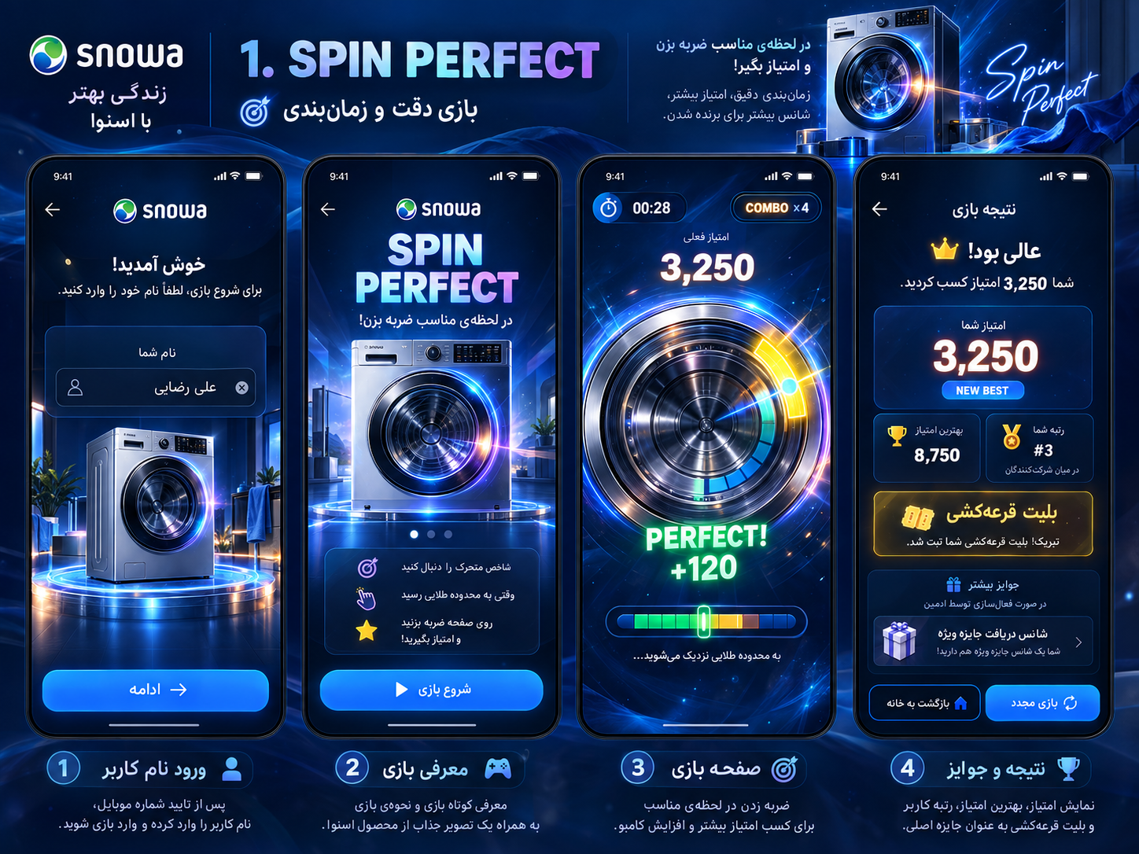
Figure 1 — Spin Perfect concept reference. Final player-facing title/copy must be Persian; English wording in concept art is placeholder/internal.

10. Game 02 — Fridge Rush
Internal identifier: fridge-rush • Working Persian title: چیدمان سریع • Hero product: Snowa refrigerator • Core skill: quick recognition and placement
Fridge Rush turns the open refrigerator into the playfield. Food/items appear in a mobile-friendly tray and the participant places each item into the appropriate refrigerator zone as quickly and accurately as possible.

10.1 Target Experience
Property | Baseline
Typical duration | 50 seconds
Primary control | Touch drag-and-drop with large hit targets and snap behavior
Orientation | Portrait-first
Failure behavior | Wrong placement costs score / returns item; no early game over
Primary visual | Open Snowa refrigerator as a 2.5D interactive board
Difficulty | More simultaneous items, faster tempo, optional item timers / final rush
Core reward | One raffle ticket on first valid completion of this game

10.2 Refrigerator Zones
The initial design should use four to five clearly differentiated drop zones such as freezer, upper/middle shelf, door rack and vegetable drawer. The exact semantic mapping must be intuitive and visually signposted; gameplay should feel arcade-like rather than educational or punitive.

10.3 Item Set
The prototype may begin with approximately 8–10 distinct items such as milk, juice, water, apple, vegetables, cake, ice cream/frozen food, eggs and cheese. Item art must remain recognizable at small mobile sizes.

10.4 Baseline Scoring
Action | Points / Effect
Correct placement | +100 base
Correct in < 1 second | +50 speed bonus
Correct in < 2 seconds | +30 speed bonus
Correct in < 3 seconds | +15 speed bonus
Wrong placement | −20 and item returns / remains actionable
Combo 3 | x1.1
Combo 5 | x1.25
Combo 8+ | x1.5

10.5 Rush Mode
After a defined streak such as five correct placements, activate a short Rush Mode (baseline five seconds) with stronger feedback and a temporary score multiplier. The exact trigger and multiplier are prototype-tuning parameters, not hard-coded business rules.

10.6 Dynamic Reward Presentation
Fridge Rush may visually surface a bonus object during gameplay (for example, a branded mystery item), but the client must not independently decide the reward. The server evaluates configured reward rules and the authoritative extra reward is revealed on or immediately after the result screen. The core raffle ticket remains independent and guaranteed on first valid completion.
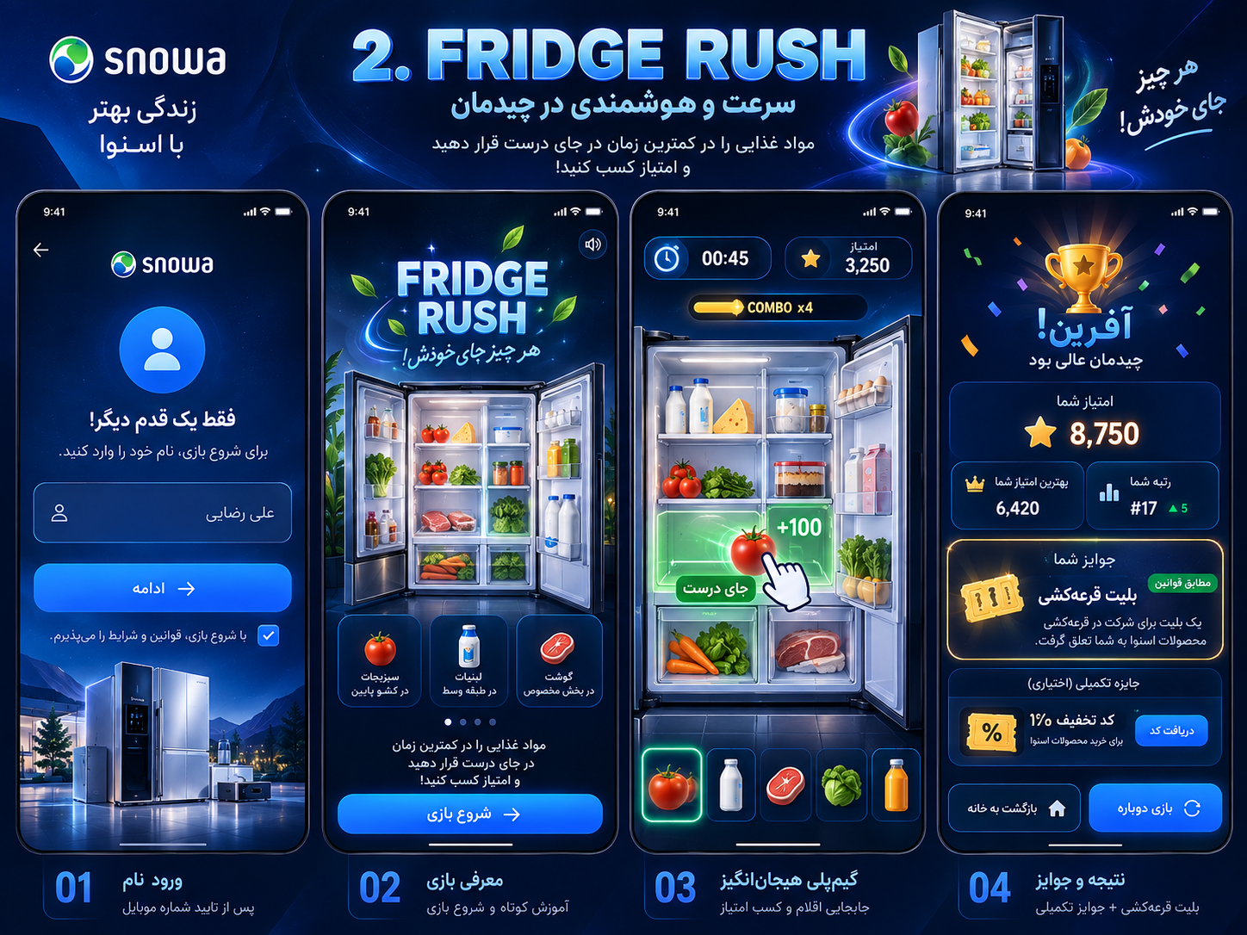
Figure 2 — Fridge Rush concept reference. Final production copy must comply with Persian/RTL rules.

11. Game 03 — Vision Hunt
Internal identifier: vision-hunt • Working Persian title: شکار تصویر • Hero product: Snowa television / branded room scene • Core skill: reaction and visual search
Vision Hunt presents a visual-search challenge inside a Snowa TV or branded scene. Each round shows a target and a field/scene containing multiple objects. The participant must find and tap the target as quickly as possible while avoiding incorrect taps.

11.1 Target Experience
Property | Baseline
Typical duration | 40 seconds
Primary control | Tap target object
Orientation | Portrait-first
Round tempo | Approximately 1–2.5 seconds per successful target depending on difficulty
Failure behavior | Wrong tap deducts score and briefly locks input to prevent spam
Primary visual | Snowa TV / interior scene with recognizable targets and brand-safe object art
Core reward | One raffle ticket on first valid completion of this game

11.2 Baseline Reaction Scoring
Reaction Time | Speed Bonus
< 400 ms | +100
400–700 ms | +80
700–1000 ms | +60
1000–1500 ms | +30
> 1500 ms | +0

A correct target also receives the round base score defined during prototype tuning. A wrong tap applies a baseline −50 penalty and a short ~250 ms input lock. The exact score ceiling must be calibrated after the final number of rounds and scene complexity are fixed.

11.3 Difficulty Curve
- Begin with fewer, larger, static distractors.
- Increase object count gradually.
- Introduce subtle object motion only after the basic mechanic is learned.
- Use visually similar distractors at higher difficulty while preserving fair recognition.
- Optional later rounds may briefly fade or partially obscure targets, but never in a way that depends on color alone.

11.4 Layout Randomization
Target placement and distractor layout must not repeat as a small fixed sequence. Use session/config seed data or equivalent runtime generation so memorizing screen locations does not dominate the leaderboard. The architecture agent should specify how this interacts with replay validation and anti-cheat controls.
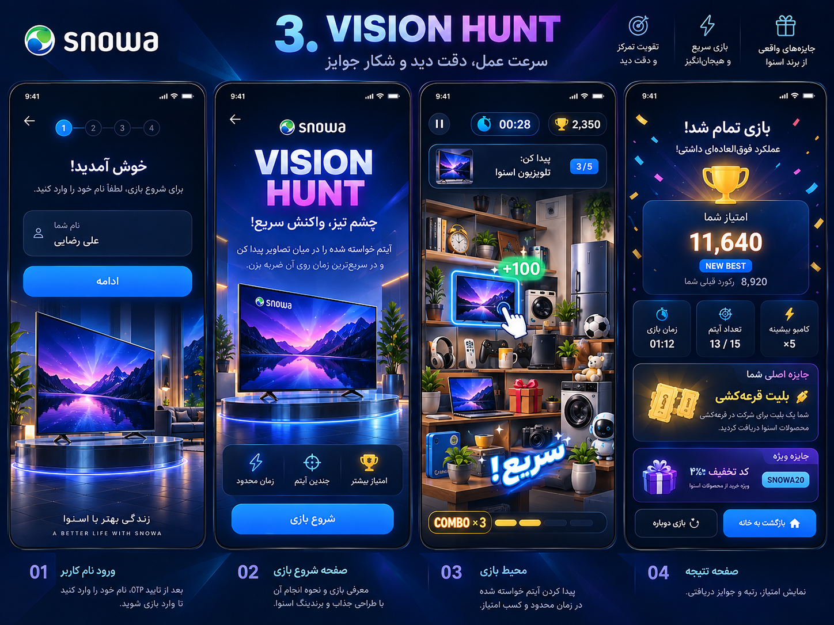
Figure 3 — Vision Hunt concept reference. Final game title/copy is Persian; concept art is a visual direction reference.

12. Scoring, Best Score and Ranking Rules

12.1 Official Score Rule
OFFICIAL SCORE = BEST VALID SCORE
For each participant and each game, the leaderboard score is the maximum score among all accepted attempts. Example: 6,200 → 4,100 → 7,900 produces an official score of 7,900. The 4,100 attempt remains in attempt history but never lowers the official score.

12.2 Attempt History
Every accepted attempt must be stored for audit and analytics, including session identifier, attempt number, raw/validated score, timing metadata, created/completed timestamps, device/client metadata that is permitted to be collected, validation result and external integration delivery state.

12.3 Ranking
Each game has an independent leaderboard based on best score. Higher score ranks first. Recommended deterministic tie-break: the participant who achieved that best score earlier receives the higher rank. The ranking service must not use a random tie-break.

12.4 Combined / Event-Wide Rank
An event-wide combined leaderboard is not required for v1.0. If added later, scores from different games must be normalized before combination because raw score scales may differ. The technical documentation must not invent a combined-score rule unless explicitly approved.

13. Reward System and Raffle Tickets

13.1 Core Ticket Rule
The main reward of all three games is a raffle ticket. On the first valid completion of each game, the participant receives one base raffle ticket for that game. With three games, a participant can normally earn three base tickets by completing all three games. Replaying the same game does not grant another base ticket.
Action | Base Ticket Outcome
First valid completion of Spin Perfect | +1
Replay Spin Perfect | +0
First valid completion of Fridge Rush | +1
Replay Fridge Rush | +0
First valid completion of Vision Hunt | +1
Replay Vision Hunt | +0
Admin-configured extra ticket reward | +N according to reward rule

13.2 Core Ticket Is Mandatory
In the standard event configuration, the base raffle ticket is a fixed core reward of each game and should not be removable through normal reward editing. Administrators add extra rewards alongside it. If a future event needs a different core model, that should be an explicit event-level configuration controlled by a higher-privilege role.

13.3 Extra Reward Types
Reward Type | Examples / Behavior
Discount code | Single-use or campaign code, displayed in Persian result/reward UI.
Additional raffle ticket | Adds one or more extra entries beyond the base ticket.
Physical prize | Creates a claim/fulfillment record; admin can track delivery status.
Free shipping / purchase benefit | A redeemable benefit with terms and validity.
Special benefit | Any business-defined reward with a configured Persian title/description.
No extra reward | Core raffle ticket still applies.

13.4 Reward Rules
Extra reward rules may depend on game, score threshold, completion, probability, campaign limit, per-user limit, total inventory and active time window. Reward evaluation is server-side. Inventory/limit checks must be atomic so concurrent players cannot exceed the configured reward budget.

13.5 Reward Display
Result flow order should remain consistent: attempt score → best score/new-best state → rank → base raffle ticket → extra reward(s) → actions. If the base ticket was already earned in an earlier attempt, display an “entry active/already received” state rather than falsely announcing another ticket.

14. Live Leaderboard and Public Score Display

14.1 Per-Game Leaderboards
Each of the three games has a live leaderboard based on authoritative best scores. Admin and public display views should update without full-page refresh. Participant lobby/profile may request current rank on demand or receive updates according to the chosen real-time architecture.

14.2 Public Display
- Designed for a large booth monitor with high-contrast typography and a small number of readable columns.
- Show rank, participant display name, game and score as appropriate.
- Never display full phone numbers publicly.
- Allow operator to switch between game leaderboards and live raffle presentation.
- Use stable animated transitions; avoid rapid reordering that makes the display unreadable.
- If connection drops, clearly show a stale/reconnecting state instead of silently presenting outdated data as live.

14.3 Live Score Feed
The admin dashboard should show recent accepted scores/attempt events in near real time. This feed is operational visibility, not the source of truth; persisted server records remain authoritative.

15. Live Raffle Engine
The live raffle is an event operation feature. The administrator defines eligibility, previews the eligible population, chooses the number of winners, starts a draw, and presents the server-selected winner(s) through a live animation. Selection must be server-side and auditable.

15.1 Required Eligibility Filters
Filter | Required Options
Participant population | All verified participants
Game participation | Played a specific game; played any game; completed all three games
Score | Score greater than / greater-or-equal to a configured threshold for a selected game
Rank range | Participants ranked from N to M in a selected game leaderboard (e.g., 1–1000)
Ticket ownership | Has at least one valid raffle ticket; optional minimum ticket count
Combination | Architecture should support combining compatible filters with explicit AND logic where approved

15.2 Draw Workflow
- Admin opens “Create / Live Draw”.
- Admin selects eligibility filters and number of winners.
- System calculates and displays eligible count before execution.
- Admin confirms draw. Server freezes an eligibility snapshot and creates an immutable draw record.
- Server selects winner(s) according to the approved random-selection implementation.
- Client/public display runs animation using only the already-authorized draw result or a controlled reveal protocol; the browser does not decide the winner.
- Winner result, eligibility rules, eligible count, execution time and administrator identity are recorded in the audit trail.

15.3 Duplicate Winner Policy
Default recommendation: within one draw containing multiple winners, the same participant cannot win twice. Whether a previous winner may win again in a later, separate draw is an event-level policy and remains configurable/open until operations confirms it.

15.4 Raffle Fairness
The technical architecture document must define the random selection method, snapshot semantics, duplicate prevention and audit data. It must also separate visual “spinning ticket” animation from actual winner selection to prevent any impression that frontend animation affects the result.

16. Administration Panel
The admin interface is the event control room. It must prioritize operational clarity and safe changes over generic CMS flexibility. Critical actions require confirmation and create audit records.

16.1 Dashboard
- Event live/offline status and current event name/date.
- Online/active players (definition to be specified technically), total verified participants, accepted attempts and average session/play metrics.
- Recent activity stream.
- Live leaderboard summary.
- Participation distribution by game.
- Quick access to game controls, rewards and live raffle.

16.2 Game Management
Control | Behavior
Enable / disable | Independent switch for each game. Disabled games remain visible to participants as unavailable.
Attempts per participant | Positive integer configured per game; server-enforced immediately for new session starts.
Core reward | Shows fixed base raffle ticket as the core game reward.
Extra rewards | Add/edit/disable configured extra reward rules.
Game status/metrics | Player count, accepted attempts, average/best score and recent activity.
Leaderboard | Open per-game leaderboard and public-display view.
Emergency stop | Immediate prevention of new game sessions while preserving existing data; exact in-progress-session policy to be specified technically.

16.3 Participant Management
Search/filter participants by name and verified phone. View game attempts, best scores, tickets, rewards, external API delivery status and relevant audit data. Manual score/reward changes, if permitted at all, must require elevated permissions, reason entry and immutable audit records.

16.4 Reward Management
Create and manage extra reward definitions including Persian display content, game applicability, trigger, score condition, probability, inventory/limit, active window and redemption/fulfillment information. The UI must make it difficult to accidentally create unlimited expensive rewards.

16.5 Raffle Management
Build filters, preview eligible count, select number of winners, execute draw, view historical draws and show an event/public display mode. Draw results cannot be silently edited after completion.
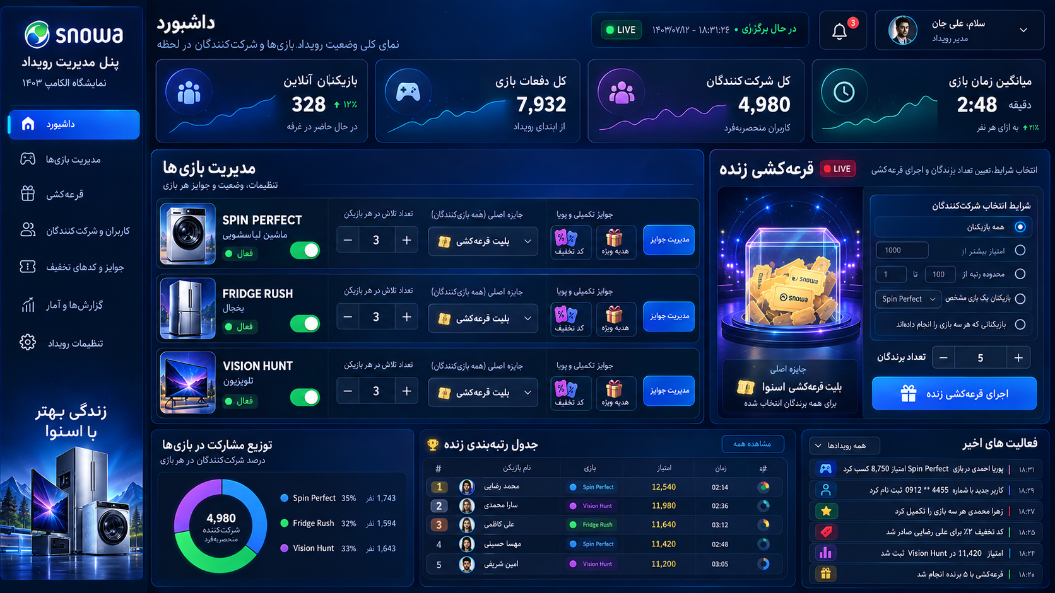
Figure 4 — Admin dashboard concept reference. Final controls must map to the requirements above and use real event metrics.

17. External API Integration
After each accepted game result, the platform must send the required participant/game/score data to the external Snowa API. This integration must be server-to-server. The game browser must never call the external API directly or hold external API credentials.

17.1 Minimum Required Business Payload
{
"phone": "09123456789",
"game_id": 1,
"game_name": "spin-perfect",
"score": 8750
}

The final external contract may additionally include participant name, attempt score, best score, event identifier, timestamps and idempotency identifiers if the receiving API supports them. The technical documentation agent must not invent mandatory external fields; it should define an adapter around the final agreed external contract.

17.2 Delivery Semantics
- Persist the accepted result locally before external delivery.
- Do not block the participant result screen on external API availability.
- Queue delivery through a reliable outbox/job mechanism and retry transient failures.
- Use idempotency so retries do not create unintended duplicates in the receiving system if supported.
- Expose failed/pending/success delivery status in admin for operations.
- Keep enough error metadata for support without storing secrets in logs.

17.3 Which Score Is Sent
Unless Snowa specifies otherwise, after each accepted attempt the integration should send the participant’s current authoritative best score for that game, because that is the official record used by the platform. The technical API document should explicitly include both attempt_score and best_score internally so the adapter can satisfy either external interpretation without changing game logic.

18. Conceptual Data Model
The following entities describe product concepts, not a final database schema. The technical documentation agent should normalize and index them appropriately while preserving the behaviors defined here.
Entity | Key Product Responsibilities
Participant | Verified phone, display name, profile state, created/last-seen metadata.
OtpChallenge / Auth Session | Verification lifecycle, rate limits and authenticated session state.
Event | Exhibition configuration, active dates/status and event-level policies.
Game | Stable identifier, Persian display content, enabled state, attempt limit and version/config reference.
GameSession | Server-authorized start, participant/game, timestamps, expiration, seed/config, completion state.
Attempt | One submitted gameplay result with score, validation metadata and status.
BestScore | Derived/current official maximum per participant + game; may be materialized for performance.
Leaderboard Entry | Derived ranking view of best score + deterministic tie-break metadata.
RaffleTicket | Ticket grant with source game/reward, participant, event, status and timestamp.
RewardDefinition | Extra reward configuration, conditions, inventory and Persian presentation.
RewardGrant | Actual issued reward, participant/game/session source and fulfillment/redemption state.
Draw | Immutable raffle execution: filters, snapshot/eligible count, admin, time, policy.
DrawWinner | Winner(s) linked to draw and participant/ticket as defined by final algorithm.
AdminUser / Role | Authentication and permissions for event operations.
AuditLog | Security/operational history for sensitive changes and draw actions.
ExternalDelivery | Outbox record for Snowa API payload, status, attempts and last error.

19. Real-Time Behavior
Live score feeds, leaderboards and draw displays should update without full-page refresh. The implementation may use WebSocket, Server-Sent Events or another suitable mechanism. The technical architecture document should select the simplest reliable option for the hosting environment and expected concurrency.

19.1 Events Worth Broadcasting
- participant_joined (optional operational metric)
- attempt_accepted
- best_score_changed
- leaderboard_changed
- game_status_changed
- game_attempt_limit_changed
- reward_definition_changed
- draw_started
- draw_completed
- system_status_changed

19.2 Consistency
Real-time messages are hints for UI refresh. The server database remains authoritative. Clients must be able to reconnect, re-fetch current state and recover from missed events without corrupting rankings or draw state.

20. PWA, Mobile and Responsive Requirements

20.1 Primary Device Targets
Class | Representative Viewports | Priority
Mobile portrait | 360×800, 390×844, 430×932 | Highest
Tablet portrait | 768×1024 and similar | High
Mobile/tablet landscape | Supported, not primary gameplay composition | Medium
Desktop browser | Admin, public display, QA; participant flow remains functional | High for admin/display

20.2 PWA Behavior
- Full functionality in browser without installation.
- Installability may be offered but must never block play.
- Service worker/cache policy should speed repeat asset access without serving stale game configuration indefinitely.
- Game assets should be lazy-loaded per selected game; do not download all heavy game assets before the lobby is usable.
- Once a game has started and required assets are loaded, a brief network interruption should not automatically destroy gameplay. Submission/reconnect behavior must be defined securely.
- Respect mobile safe areas, virtual keyboard, notch and browser UI changes.

20.3 Touch Rules
Interactive targets must be comfortably touchable. Fridge Rush gameplay should disable page-scroll gesture conflicts inside the active game canvas (e.g., equivalent touch-action behavior) while keeping the surrounding application accessible. Do not require hover.

21. Security and Anti-Cheat Requirements
Requirement | Product Security Expectation
Server-authorized sessions | A game cannot submit a valid score without a session created after server checks.
Attempt enforcement | Attempt limits are enforced on the server, not merely hidden in UI.
Score sanity | Reject impossible or clearly invalid scores/timings based on versioned game configuration.
Idempotent submission | Duplicate network submission cannot create additional attempts, tickets or rewards.
No frontend secrets | External API, SMS provider and admin secrets never ship to browser.
Admin protection | Strong admin authentication, role-based authorization and audit logs for sensitive actions.
OTP abuse controls | Rate limiting, resend cooldowns, brute-force protections and provider failure handling.
Reward inventory | Atomic limit/inventory enforcement.
Raffle authority | Winner selection and eligibility snapshot are server-side and auditable.
Input validation | Normalize/validate all identifiers, phone/name data and admin-configured reward fields.
Transport | HTTPS only in production; secure session/cookie/token practices appropriate to architecture.

21.1 Anti-Cheat Reality
Browser games cannot make client manipulation impossible. The goal is to make leaderboard/reward manipulation materially harder and detectable through server-authorized sessions, timing constraints, versioned score bounds, idempotency, behavioral logs and anomaly monitoring. The technical security document should define the exact validation strategy per game after prototype score ranges are measured.

22. Reliability and Failure Handling

22.1 Failure Principles
- Never lose an accepted score because the external Snowa API is unavailable.
- Never grant a duplicate base ticket because the result was retried.
- Never count the same network submission as multiple attempts.
- Never show a draw winner until the server has persisted the draw result.
- If live connection fails, fall back to current-state fetch/retry and show a reconnecting/stale indicator where relevant.
- Participant-facing errors must be short, Persian and action-oriented.

22.2 Background / Refresh During Game
The architecture and game-runtime specification must define what happens when a mobile browser is backgrounded, refreshed or closed after an attempt starts. The policy must balance fairness and accidental interruptions while preventing infinite free retries. A short grace/reconnect policy may be used, but it must be server-controlled and versioned.

22.3 External Integration Outage
The platform remains playable if the external score API is temporarily unavailable, provided its own core backend is healthy. The admin panel must surface backlog/failed deliveries so operations knows when synchronization is degraded.

23. Analytics and Event Instrumentation
Analytics should support event operations, product learning and incident diagnosis without replacing transactional records. Personally identifiable information should not be sent to third-party analytics unless explicitly approved.

23.1 Recommended Product Events
Event | Key Properties
qr_landing_view | campaign/source if available, device class
otp_requested | normalized country/prefix metadata, outcome — no raw OTP
otp_verified | success/failure reason category
profile_name_saved | first-time/updated
lobby_viewed | available games, ticket count
game_start_requested | game, attempts remaining
game_session_started | game, attempt number, version
game_completed | game, attempt score, duration
best_score_changed | game, old/new best, rank if available
raffle_ticket_granted | source game/reward, quantity
extra_reward_granted | reward type/id
leaderboard_viewed | game/context
draw_executed | draw id, eligible count, winner count — admin audit event
external_delivery_status | success/retry/fail category

23.2 Core Metrics
- Verified participants
- Game starts and completions per game
- Completion rate per game
- Average / median / percentile scores
- Replay rate when attempts > 1
- Participants completing all three games
- Base tickets issued
- Extra rewards issued / inventory remaining
- Leaderboard engagement
- Draw eligible counts and execution history
- External API delivery success/backlog

24. Visual Design System
The accepted direction is premium arcade + clean futuristic appliance. It should feel energetic and modern without becoming childlike, visually noisy or generic cyberpunk. Snowa products are hero objects and are integrated into the mechanics.

24.1 Visual Principles
- Deep navy/blue environments with controlled cyan, electric blue, purple and reward-gold accents.
- Clean glass/panel surfaces and large score typography.
- 2.5D product renders/illustrations with tasteful glow/reflection and high product recognizability.
- Particles and motion are strongest on success moments, not continuously everywhere.
- Consistent reward-ticket visual language across all games.
- Persian typography must be legible on mobile and not squeezed into English-designed component widths.
- Keep critical game information inside safe zones and away from browser chrome/notches.

24.2 Shared Screen Families
Screen Family | Shared Components
Authentication | Snowa brand header, progress/context, input, primary CTA, error/cooldown states
Lobby | Greeting, ticket progress, game cards, navigation
Pre-game | Hero product, short Persian instructions, start CTA, sound toggle if used
Gameplay | Timer, score, combo/state indicators, pause/background behavior, game canvas
Result | Attempt score, best score, rank, ticket, extra rewards, replay/home actions
Leaderboard | Game selector, rank rows, participant highlight
Admin | Sidebar/navigation, live status, metrics cards, game controls, draw module, audit/activity

25. Audio and Haptics
Audio must add excitement without becoming exhausting in a busy exhibition environment. Games should work when the phone is muted. Sound effects are more important than long music loops; if background music is used it should be subtle, loop cleanly and remain low in perceived loudness.

25.1 Shared Audio Cues
- Countdown / game start
- Correct / perfect action
- Error / miss
- Combo milestone
- Final seconds
- Score/result reveal
- Signature raffle-ticket reward sound
- Extra reward reveal

25.2 Haptics
Use light haptics only on supported devices and only for high-value feedback such as perfect timing, correct placement, target hit and reward reveal. Haptics are enhancement, never required to understand state.

26. Asset Production Plan
After this specification is approved, asset creation should proceed game-by-game in the same order as prototype development. Each asset set should be produced with web optimization and responsive cropping in mind.

26.1 Shared Assets
- Official Snowa logo/brand assets supplied by client
- Raffle ticket icon/3D object and reward glow states
- Common UI icons: back, sound, timer, trophy, ranking, replay, home, gift
- Particle sheets / lightweight VFX textures
- Result/reward celebration elements
- Persian font selection and licensing verification
- Common backgrounds/gradients and card textures

26.2 Spin Perfect Assets
- Washing-machine hero render/illustration
- Drum/ring layers suitable for rotation
- Indicator, timing zones and glow states
- Perfect/Great/Good/Miss feedback graphics
- Combo/VFX elements
- Pre-game and result product compositions

26.3 Fridge Rush Assets
- Open refrigerator hero / interactive board
- Clearly separable refrigerator-zone overlays
- 8–10 food/item assets plus future extensibility
- Drag shadows, valid/invalid drop states, snap feedback
- Rush-mode effects
- Optional bonus/mystery reward object

26.4 Vision Hunt Assets
- TV hero frame and/or branded room scene
- Target card/indicator
- Object/distractor library with readable silhouettes
- Selected product/brand objects where approved
- Hit/wrong-tap effects
- Difficulty variants and scene layers

26.5 File/Runtime Guidance
Prefer SVG for simple UI/icons where appropriate and optimized WebP/AVIF/PNG sprite assets for raster art based on browser support and alpha needs. Large images should have responsive sizes. The technical asset pipeline should define compression, atlasing and cache-busting. Source art remains separate from runtime exports.

27. Performance Budgets
Area | Target / Constraint
Gameplay frame rate | Target 60 FPS on representative mid-range Android devices; degrade gracefully rather than stutter.
Input response | Immediate visible response to touch; game logic must not depend on network round trips during ordinary gameplay.
Initial lobby | Lightweight; do not preload all game art/audio before basic lobby usability.
Game loading | Lazy-load selected game package with visible progress only when needed.
Network calls | Batch/avoid unnecessary polling when real-time channel/state fetch can be used.
Assets | Optimize large hero art; avoid unbounded texture dimensions and heavy video backgrounds unless proven safe.
Memory | Release game-specific assets/resources when safe after leaving a game; avoid repeated leaks across three games.
Admin/public display | Stable for hours of operation; no progressive memory growth from live event streams/charts.

28. Accessibility and Exhibition Usability
The event is fast-paced, but accessibility and broad usability still matter. The application should not rely on tiny text, hover, color-only distinctions or long instructions. All essential participant flows must remain understandable on common mobile devices.
- Minimum comfortable touch targets and spacing.
- High contrast for score/timer/action states.
- Do not communicate success/failure only through color; pair color with text/icon/motion.
- Provide visible sound toggle where audio is used and do not require audio to play.
- Avoid excessively fast flashing/strobing effects.
- Persian text must scale/fit without clipping at supported viewport widths.
- Fridge Rush drop targets must be large; Vision Hunt targets must remain fair for touch; Spin Perfect timing should be calibrated across refresh rates.
- Preserve a straightforward “Back to Lobby” recovery path after results/errors.

29. Acceptance Criteria

29.1 Participant Flow
ID | Acceptance Criterion
AC-001 | A first-time visitor can scan QR, verify phone by OTP, enter name and reach lobby.
AC-002 | A returning verified participant with a stored name is not asked to enter name again unless profile editing is invoked.
AC-003 | All participant-facing production text is Persian/RTL except approved brand artwork/trademarks.
AC-004 | Lobby shows three stable game cards and current attempts/best score/rank/ticket state.
AC-005 | Disabled game remains visible but cannot start.
AC-006 | Server prevents starting a game after the configured attempt limit is exhausted.
AC-007 | When multiple attempts are allowed, lower later scores do not reduce official best score.
AC-008 | Every accepted attempt remains auditable even if it is not the best score.
AC-009 | First valid completion of each game grants exactly one base raffle ticket; replay does not duplicate it.
AC-010 | Configured extra rewards can be granted in addition to the base ticket.
AC-011 | Result screen displays authoritative attempt score, best score, rank, ticket state and extra rewards.
AC-012 | Leaderboard ranking uses best score and deterministic tie-break behavior.
AC-013 | Admin can enable/disable each game and change its attempt limit without deployment.
AC-014 | Admin can add/configure extra rewards without removing the core ticket in normal operation.
AC-015 | Admin can preview and execute a live raffle with required filter types and a chosen winner count.
AC-016 | Raffle winner selection is server-side, persisted and auditable.
AC-017 | Public display never exposes full phone numbers.
AC-018 | Accepted game result is persisted even if external Snowa API is down; delivery retries later.
AC-019 | Duplicate result submission cannot consume extra attempts or grant duplicate tickets/rewards.
AC-020 | The complete participant app works in mobile browser without PWA installation.
AC-021 | All three games are usable on supported mobile portrait and tablet portrait layouts.
AC-022 | Admin/public live views recover after real-time disconnect by re-fetching authoritative state.

30. Technical Documentation Agent Handoff
The next agent should not redesign the product. Its job is to convert this approved product/game specification into implementation-ready technical documentation, identify engineering decisions that still require approval, and preserve all non-negotiable product behavior.

30.1 Required Technical Deliverables
- System architecture document with component boundaries and deployment topology.
- Technology decision record(s), including final client framework/game runtime/backend/data store/real-time mechanism based on hosting constraints.
- Database schema / ERD with indexes, uniqueness constraints and transactional rules for attempts, best scores, tickets, rewards and draws.
- Authentication/OTP sequence diagrams and session/security model.
- Game-session and score-submission protocol including idempotency, abandonment/background policy and anti-cheat validation per game.
- Internal API specification (OpenAPI or equivalent) for participant app, admin, leaderboard and raffle.
- External Snowa API adapter contract with outbox/retry/idempotency behavior.
- Real-time event contract for live score/leaderboard/admin/public display.
- Reward engine technical model including probability/inventory concurrency rules.
- Raffle engine design including snapshot semantics, random-selection implementation, duplicate policy and audit data.
- Admin RBAC permissions matrix and audit-log model.
- PWA/service-worker/cache strategy and asset-loading strategy.
- Observability plan: structured logs, metrics, alerts, integration backlog health and event-day dashboard.
- Testing strategy: unit, integration, E2E, game logic, cross-device, load, security and event rehearsal.
- Deployment/runbook: environments, release, rollback, backups, event-day operations and incident recovery.

30.2 Technical Agent Constraints
- Do not change “best valid score” into “latest score”.
- Do not grant one base raffle ticket per replay; base ticket is once per game per participant.
- Do not make frontend score/ticket/reward/draw decisions authoritative.
- Do not require app installation.
- Do not expose the external Snowa API directly to the browser.
- Do not create an event-wide combined leaderboard formula unless separately approved.
- Do not invent final OTP vendor, external API authentication, hosting topology or raffle legal rules where this document marks them open.
- Do not replace Persian player-facing UI requirements with English developer placeholders in production.

30.3 Reference Implementation Direction (Not Yet a Locked Architecture)
The current design discussion favors a modern TypeScript web application, a dedicated HTML5 game runtime such as Phaser for the gameplay canvas, a PWA/browser shell for authentication/lobby/result/admin, and a server-authoritative backend with real-time updates. Nuxt 4 + TypeScript + Phaser 3 was discussed as a strong candidate. The technical agent should validate this against hosting, concurrency, team skill and deployment constraints before treating it as final architecture.

31. Implementation Phasing
Phase | Deliverable | Why This Order
0 — Technical Design | Architecture, DB/API/security/test/deployment docs | Remove implementation ambiguity before coding.
1 — Vertical Slice | OTP → name → lobby → Spin Perfect → result → best score → ticket → leaderboard | Validates the entire platform loop with the simplest game.
2 — Shared Platform | Admin game controls, reward engine, participant management, real-time leaderboard | Turns prototype into reusable event platform.
3 — Game 02 | Fridge Rush on shared runtime | Adds drag/sorting mechanic and richer product interaction.
4 — Game 03 | Vision Hunt on shared runtime | Adds reaction/search mechanic and completes game set.
5 — Live Raffle | Filter builder, snapshot, draw, public animation, audit | Build after participants/tickets/rankings are stable.
6 — External Integration Hardening | Snowa API adapter, retries, admin sync health | Rehearse real contract and outage handling.
7 — Exhibition Hardening | Cross-device QA, load, anti-cheat tuning, offline/reconnect, runbook rehearsal | Prepare for event-day failure modes.

32. Known Open Items
These items are intentionally not fabricated in this product specification and must be resolved before production or explicitly documented as configuration assumptions in the technical package.
Open Item | Needed Decision / Input
OTP provider | Provider, credentials, message template, delivery limits/cost and test environment.
External Snowa API | Base URL, authentication method, required/optional fields, response/error semantics, rate limits and sandbox.
Hosting / infrastructure | Final hosting region/provider, database/cache availability, TLS/CDN/WAF and expected concurrent participation.
Event dates / hours | Needed for event configuration, operational monitoring and reward windows.
Expected scale | Peak concurrent users, total participants and public-display count for load planning.
Prize legal/operational rules | Eligibility restrictions, consent/terms, duplicate-winner policy across separate draws, prize fulfillment and retention.
Official product imagery | Approved washer/refrigerator/TV models and brand usage guidelines.
Final Persian game titles | Brand approval of working titles.
Persian font | Approved web font and licensing/performance requirements.
Admin language | This spec expects Persian/RTL admin; confirm whether bilingual admin is needed.
Profile edit policy | Whether participants may change their display name after first entry and whether changes affect historical ranking display.
Data retention | How long phone/profile/attempt/reward/draw data must be retained after the exhibition.
Consent/privacy copy | Final Persian terms/privacy text and whether explicit checkbox is required before play.
Reward inventory | Actual discount/physical reward definitions, limits and fulfillment process.
Public leaderboard naming | Full entered name vs first name + surname initial; phone masking if any.

Appendix A. Persian UI Copy Starter Set
The following Persian strings are a starter vocabulary for design/prototyping. Final copy should be reviewed by the brand/content owner. Internal code keys remain English.
Context / Key | Suggested Persian Copy
phone.title | ورود به بازی
phone.prompt | شماره موبایل خود را وارد کنید
phone.sendOtp | ارسال کد تایید
otp.title | کد تایید
otp.prompt | کد ارسال‌شده را وارد کنید
otp.resend | ارسال مجدد کد
profile.nameLabel | نام و نام خانوادگی
common.continue | ادامه
lobby.greeting | سلام {name}
lobby.games | بازی‌ها
lobby.tickets | بلیط‌های قرعه‌کشی من
game.bestScore | بهترین امتیاز
game.rank | رتبه شما
game.attempts | تعداد تلاش
game.remainingAttempts | تلاش باقی‌مانده
game.start | شروع بازی
game.replay | بازی دوباره
game.unavailable | موقتاً غیرفعال
game.completed | تکمیل شده
result.title | نتیجه بازی
result.score | امتیاز این بازی
result.newBest | رکورد جدید!
result.best | بهترین رکورد شما
result.ticketGranted | بلیط قرعه‌کشی دریافت شد
result.ticketActive | بلیط قرعه‌کشی شما فعال است
result.extraReward | جایزه ویژه
nav.home | بازگشت به خانه
leaderboard.title | جدول رتبه‌بندی
leaderboard.you | رتبه شما
error.retry | تلاش مجدد
error.connection | ارتباط با سرور برقرار نشد. دوباره تلاش کنید.
raffle.title | قرعه‌کشی زنده
raffle.winner | برنده قرعه‌کشی
admin.active | فعال
admin.inactive | غیرفعال
admin.gameManagement | مدیریت بازی‌ها
admin.rewards | جوایز
admin.participants | شرکت‌کنندگان
admin.draw | قرعه‌کشی
admin.reports | گزارش‌ها

Appendix B. Requirement Traceability Matrix
ID | Requirement | Source Section
AUTH-001 | Phone + OTP required | §6
AUTH-002 | Name captured after first successful OTP | §6.3
LOC-001 | Participant UI Persian/RTL | §5
GAME-001 | Three record games | §9–11
GAME-002 | Attempt limit configurable per game | §8, §16
SCORE-001 | Official score is highest valid attempt | §12
SCORE-002 | All attempts retained for audit | §12.2
REW-001 | One base raffle ticket per game first completion | §13.1
REW-002 | Dynamic extra rewards | §13.3–13.4
LB-001 | Live per-game leaderboard | §14
RAFFLE-001 | Live server-side filtered raffle | §15
ADMIN-001 | Game enable/disable | §16.2
ADMIN-002 | Change attempt limits | §16.2
ADMIN-003 | Manage extra rewards | §16.4
API-001 | Send phone/game/score after accepted result | §17
API-002 | Persist first and retry external delivery | §17.2
PWA-001 | Browser-first PWA; install optional | §20
SEC-001 | Server-authoritative session/result/reward/draw | §21
RT-001 | Near-real-time leaderboard/admin/public updates | §19
PERF-001 | Mobile performance and lazy game assets | §27
OPS-001 | Audit sensitive admin/draw actions | §15–16, §21

Appendix C. Concept Art References
The images below record the approved visual direction, not pixel-perfect final UI. They contain mixed placeholder English/Persian in some areas. Final production screens must obey the Persian/RTL language standard in §5 and the functional rules in this document.
Overall participant/admin concept board
Spin Perfect concept board
Fridge Rush concept board
Vision Hunt concept board
Administration dashboard concept
END OF BASELINE
Any later change to attempts, best-score semantics, base raffle-ticket rules, game mechanics, raffle eligibility, external integration semantics or Persian-language requirement should be recorded as a new approved document version before implementation diverges.

