|  |  |
| --- | --- |
| **Serial no** | **Table of contents** |
| **01** | **Introduction** |
|  | 1.1 Problem statement |
|  | 1.2 Scope of project |
| **02** | **System Analysis** |
|  | 2.1 Definition |
|  | 2.2 Description of present system |
|  | 2.3 Limitation of present system |
|  | 2.4 Description of Proposed system |
|  | 2.5 Feasibility study |
|  | 2.5.1 Technical feasibility |
|  | 2.5.2 Economical feasibility |
|  | 2.5.3Behavioural feasibility |
| **03** | **Requirement Analysis** |
|  | 3.1 Introduction |
|  | 3.2 functional requirements |
|  | 3.3 Non-functional requirements |
|  | 3.4 interface requirement |
| **04** | **System Specification** |
|  | 4.1 Hardware specification |
|  | 4.2 Software specification |
|  | 4.3 Language specification |
| **05** | **Risk Management** |
| **06** | **Process Model** |
|  | 6.1 Water-fall process model |
| **07** | **System Design** |
|  | 7.1 ERD |
|  | 7.2 STD |
|  | 7.3 DFD |
|  | 7.4 Architectural design |
|  | 7.5 HCI |
| **08** | **Testing** |
|  | 8.1 White box testing |
|  | 8.2 Black box testing |
|  | 8.3System testing |
|  | 8.4 Acceptance testing |
| **09** | **SECURITY** |
| **10** | **CONCLUSION & REFERENCES** |

**CHAPTER 01**

**INTRODUCTION**

1. Introduction:-

The internet’s arrival and its subsequent popularity in Pakistan have made online trading in Pakistan, which is about the online purchase and sales of shares, one of the extremely popular means of trading. Both beginner and experienced traders and investors in Pakistan are taking advantage by trading online because through internet, traders can easily trade by sitting at home. Constructive uses of new technologies have always contributed positively towards improving human life standards and the economy of a country.

**1.1 PROBLEM STATEMENT:-**

Many people have a talent to make home-made handicrafts. But due to lack of resources they can’t show their talent at huge level. Our system provides them opportunity to sale their handicrafts by sitting at home without going to any market place. This system is less time consuming and reliable.

**1.2 PROJECT SCOPE:-**

It is a web-based system through which customer can easily buy and sale handicrafts online or other source they think suitable.

This system gives access to a local person to make valid himself by registration. He will be able to buy & sell handicrafts.

**CHAPTER 02**

**SYSTEM ANALYSIs**

**2. SYSTEM ANALYSIS :**

**2.1 DEFINATION:**

System Analysis is the detailed study of the various operations performed by the system and their relationships within and outside the system. Analysis is the process of breaking something into its parts so that the whole may be understood. System analysis is concerned with becoming aware of the problem, identifying the relevant and most decisional variables, analyzing and synthesizing the various factors and determining an optimal or at least a satisfactory solution. During this a problem is identified, alternate system solutions are studied and recommendations are made about committing the resources used to design the system.

**2.2 DESCRIPTION OF PRESENT SYSTEM:**

Existing system refers to the system that is being followed till now. Presently there is no web-base system through which hand weaver can trade inside and outside the country. Yet it is a manual system .

For example, If a person wants to buy computer and accessories, domestic used things, mobile and accessories and many different goods etc., he should directly contact to the various websites such as olx.pk, kamyu.pk, etc. which provides the online trading facilities.

**2.3 LIMITATIONS OF PRESENT SYSTEM :**

• Difficult for persons.

• Time consuming.

To avoid all these limitations and make the working more accurately the system needs to be computerized.

**2.4 DESCRIPTION OF PROPOSED SYSTEM :**

Online Trading is aimed at developing a web-based system. In this system the person can sales online and do many things. The details of all the things are made available to them through the website. It will help administrator of the system to insert, delete, and update records of particular item on the basis of different criteria.

* Give up to date information about the product detail.
* Give up to date information about the customer
* Insert, delete, change and update the items, supplier, and customer record easily.

**What is new in this project?**

This system will serve the customers from buyer to seller. It will be modified according to their need. This system will be run on the small normal pc, a high level pc, all this will depend on the requirements of the customer What is their budget, their technology, their demand?

**ADVANTAGES:**

* This system provides online help for legal queries.
* This system helps all the users to view the registration.
* The system is user friendly.

**Project Plan:**

A project plan is used for the tracking different activities in project and setting a time frame for every phase and activity. The project plan for trade share system has been prepared on estimates and keeping in view the complexity and

size of the system.

**Total allocated time:**

The total allocated time for the project based on estimate.

|  |  |
| --- | --- |
| **Analysis** | **1 -2 weeks** |
| **Design** | **2 weeks** |
| **Documentation** | **2 weeks** |
| **Manufacturing time** | **3-4 weeks** |
| **Budget** | **30,000 RS** |

**ADVANTAGES:**

* This system provides online help for legal queries.
* This system helps all the users to view the registration.
* The system is user friendly.

**2.5 FEASIBILITY STUDY:**

A feasibility analysis usually involves a thorough assessment of the operational (need), financial and technical aspects of a proposal. Feasibility study is carried out to determine whether the proposed system is possible to develop with available resources and what should be the cost consideration.

Once the scope has been identified it is reasonable to ask "is the project Feasible? "There are many factors, which may affects the proposed system,all these feasibilities are necessary to start work on proposed system.

• Technical Feasibility

• Economic Feasibility

• Behavioural Feasibility

**2.5.1 Technical Feasibility:**

Technical Feasibility deals with the hardware as well as software requirements. We have to find out whether the necessary technology, the proposed equipment have the capacity to hold the data, which is used in the project, should be checked to carry out this technical feasibility. The technical feasibility issues usually raised during the feasibility stage of investigation includes these

• This software is running in windows 7 Operating System, which can be easily installed.

• The system can be expanded.

**2.5.2 Economical Feasibility:**

The technique of cost benefit analysis is often used as a basis for assessing economic feasibility. This system needs some more initial investment than the existing system, but it can be justifiable that it will improve quality of service. Thus feasibility study should canter along the following points:

➢ Improvement resulting over the existing method in terms of accuracy

timeliness.

➢ Cost comparison

­­­­­­­­­­­­­­­­­­­­­➢ Estimate on the life expectancy of the hardware

➢ Overall objective

Our system is economically feasible. It does not require much cost to be involved in the overall process. The overall objectives are in easing out the requirement processes.

**2.5.3 Behavioural/ Operational Feasibility:**

This analysis involves how it will work when it is installed and the assessment of political and managerial environment in which it is implemented. People are inherently resistant to change and computers have been known to facilitate change. The new proposed system is very much useful to the useful to the users and there for it will accept broad audience from around the world.

The newly designed system will contain the following features and capabilities

1. Reliability

2. Adaptability

3. Performance

4. Accuracy

5. Efficiency

6. Easy to use

7. Error control

8. Easy to maintain

**CHAPTER 04 REQUIREMENT ANALYSIS**

**3. REQUIREMENT ANALYSIS:**

**3.1 INTRODUCTION:**

**Definition:** The requirements for a system are the descriptions of what the system should do— the services that it provides and the constraints on its operation. These requirements reflect the needs of customers for a system that serves a certain purpose such as controlling a device, placing an order, or finding information.

Software system requirements are often classified as functional requirements or non- functional requirements:

**3.2 Functional requirements:**

These are statements of services the system should provide, how the system should react to particular inputs, and how the system should behave in particular situations. In some cases, the functional requirements may also explicitly state what the system should not do.

In our project, the system should take the input from the consumer and provides services according to his need.

**3.3 Non-functional requirements**:

These are constraints on the services or functions offered by the system. They include timing constraints, constraints on the development process, and constraints imposed by standards.

**3.4 Interface Requirements:**

Interface requirements includes those requirements which tells about system appearances.

Our system interface requirements are colour, buttons, banners, animations, special software for images, back-ground colour etc.

**CHAPTER 04**

**SYSTEM SPECIFICATION**

**4. System specification:**

**4.1 Hardware specification:**

The selection of hardware is very important in the existence and proper working of any software. When selecting hardware, the size and requirements are also important.

Minimum Requirements:

Processor : Pentium II class, 450MHz

RAM : 128MB

Hard Disk Drive : 3GB

Video : 800X600, 256 colors

CD-ROM : Required

The proposed System is developed on:

Processor : INTEL Pentium 4

RAM : 512MB

Hard Disk Drive : 40GB

Key Board : Standard 101/102 or Digi Sync Family

Monitor : Display Panel (1024 X 764)

Display Adapter : Trident Super VGA

Network Adapter : SMC Ethernet Card Elite 16 Ultra

Mouse : Logitech Serial Mouse

**4.2 Software specification:**

Operating System : Windows XP

Front- End : C#. NET with ASP. NET

Back- End : MS SQL SERVER 2005 EXPRESS

**4.3 Specification of language :**

* HTML
* XAML
* C#

**CHAPTER 05**

**Risk Management**

**5.1 Risk Identification & Management:**

**Risk management** is the identification, assessment, and prioritization of risks. Try to avoid the risk if not then try to minimize it.

**Project Risks:**

There is no risk associated with project. There are no resources & schedule related risks in our project.

**Product Risks:**

There are no risks associated with the product as we are not compromising with the quality of our system.

**People Risk:**

There are no people risks involved in our project as we have predefined roles in the system development.

**Requirements Risk:**

As we are not developing this software according to customer’s requirements so no requirement risk is involved.

**Tools Risk:**

There may be the problem about the availability of the tools in our local market.

**Technology Risk:**

The technology may change. so it can be a significant risk.

**Estimation Risk:**

Cost risk can occur if the actor demands high cost or the cost of heavy tools required for the development of software increases.

**Risk Planning:**

Among mentioned risks the most significant is tools risk we can manage it by identifying different markets where these tools are available easily. And then selecting best among them.

**CHAPTER 06**

**PROCESS MODEL**

REQUIREMENTS

ANALYSIS

DESIGN

IMPLEMENTATION

TESTING

MAINTENANCE

**WATER –FALL PROCESS MODEL**

**­­­­­­­­­­­­­­­­**

**6.1 Waterfall Model**

The waterfall model derives its name due to the cascading effect from one phase to the other as is illustrated in above figure. In this model each phase well define starting and ending point, with identifiable deliveries to the next phase. Note that this model is sometime referred to as the linear sequential model or the software life cycle model.

* **Requirements:**

In the requirement phase the need to create the application is specified. What is the need of the system is defined. What information to be feeder to create the application will come under the requirement phase?

* **Analysis:**

Find out relevant information from both relevant and irrelevant information

 ➢ **Design:**

The next phase is the Design phase where the application is designed according to the forms and other modules created. This phase is much important phase because it will structure the layout of your application.

 ➢ **Implementation:**

Together all modules in one module or to bring things in original form.

 ➢ **Testing**

After the whole application is being developed the main phase is the verification phase where the whole application tested and verified to check the whole application.

 ➢ **Maintenance:**

After the successful verification of the application the main phase is the maintenance phase where the application needs to be maintained for its successful operation in future.

**CHAPTER 07**

**SYSTEM DESIGN**

**7.1 Entity-relationship diagram: (ERD)**

This diagram will show the relationships of the certain entities involved in the system.

**7.2 Data flow diagram: (DFD)**

DFD will help to understand the information domain and the functional domain at the same time.

**7.3 State Transitional Diagram: (STD)**

This is a behavioral model and helps to understand the different states that the system changes throughout the procedure. It has two levels. Level 0 or tells us the overview of the states while the level 1 tells about the detail study of the states been changed.

Sign up

Login

account

user

Approve

has Has

Visit

Contain

Paymentent

Store

Has

Pay\ receive

Admin

Buy\ Sale

Check

Item

bids

saless

gets

***ERD:***

supplierent

Invoke log in() invoke sign up() confirm() buy() search() confirm() sale() ok()

Log out

Item detail

Discount on item

Information of customer

Item list

Payment choice

form

Account detail

Select result

Give item

Registration

Log in\sign up

system

Disagree() Confirm() Select() bank() select() cash() select item()` buy() discount()

**STD:**

**DFD:**

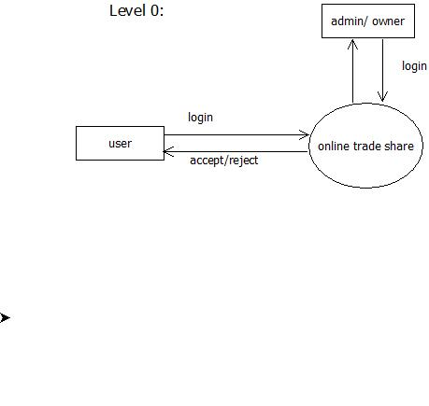

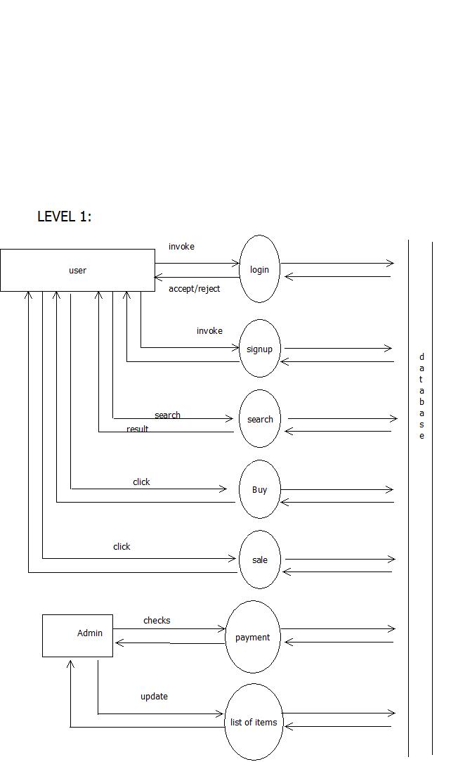

**CHAPTER 08**

**TESTING**

**8. Testing:**

This chapter discusses the importance of testing of a system, the need for testing, and how the Testing is performed on this system. Different testing techniques are applied to find the reliability of the system.

Testing is the process of establishing confidence that a system does what it is supposed to do. It is the process of finding errors in software. Testing is a continuous process from the start of the software to the completion. The software that meets the requirements is good quality software. Prime benefit of testing is that it results in improved quality.

**8.1 White box Testing :**

White box testing is also called Glass box testing is a test case design control; structure of the procedural design to derive test cases using White box testing method, the software engineer can derive the test cases that guarantee that all independent paths within the module have been exercised at least once. Exercise all logic decisions on their true or false sides. Execute all loops at their boundaries and within their operational bounds. Exercise internal data structure to ensure their validity.

**8.2 Black box Testing:**

Black box testing, also called behavioral testing, focuses on the functional requirements of software. This testing approach enables the software engineer to derive the input conditions that will fully exercise all requirements for a program. Black box testing attempts to find the errors like

• Incorrect or missing functions

• Interface errors

• Errors in data structures or external database access

• Behavior or performance errors

• Initialization and termination errors

In Black box testing software is exercised over a full range of inputs and outputs are observed for correctness.

**8.3 System testing:**

In system testing all the units of the software are combined and tested as an integrated system.

**8.4 Acceptance testing:**

The acceptance testing is a process to verify the readiness of the software for implementation or use. The software is checked for completeness that whether it is ready or not. After successful completion of acceptance testing the software is ready and can be exported.

**Chapter 09**

**SECURITY**

**09. SECURITY**

The system security problem can be divided into four related issues: security, integrity, privacy and confidentiality. They determine the file structure, data structure and access procedures.

**Security**

System security refers to the technical innovations and procedures applied to the hardware and operating systems to protect against deliberate or accidental damage from a defined threat. In contrast, data security is the protection of data from loss, modifications and destruction.

**Integrity**

System integrity refers to the proper functioning of programs, appropriate physical security and safety against external threats such as eavesdropping and wiretapping.

**Confidentially**

The term confidentiality is a special status given to sensitive information in a data base to minimize the possible invasion of privacy. It is an attribute of information that characterizes its need for protection. System security is the technical means of providing such protection. In contrast privacy is largely a procedural matter of how information is used.

**Chapter 10**

**CONCLUSION**

**& REFERENCES**

**CONCLUSION:**

Now a day’s manual process for the citizens to sales for their handi-crafts product such like dresses, bags , mirror etc… has become a huge task.

The main features of this site includes flexibility, reduce manual work in an efficient manner, a quick, convenient, reliable and effective way to apply for their online trading market committee records. The project could very well be enhanced further as per the requirements.

**REFRENCES:**

* **Software engineering by Roger pressman.**
* **Software engineering by Somerville.**
* **wikipedia**