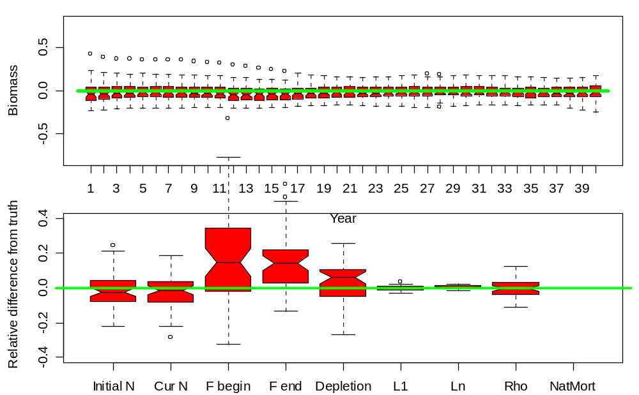

Model 1, Reference case
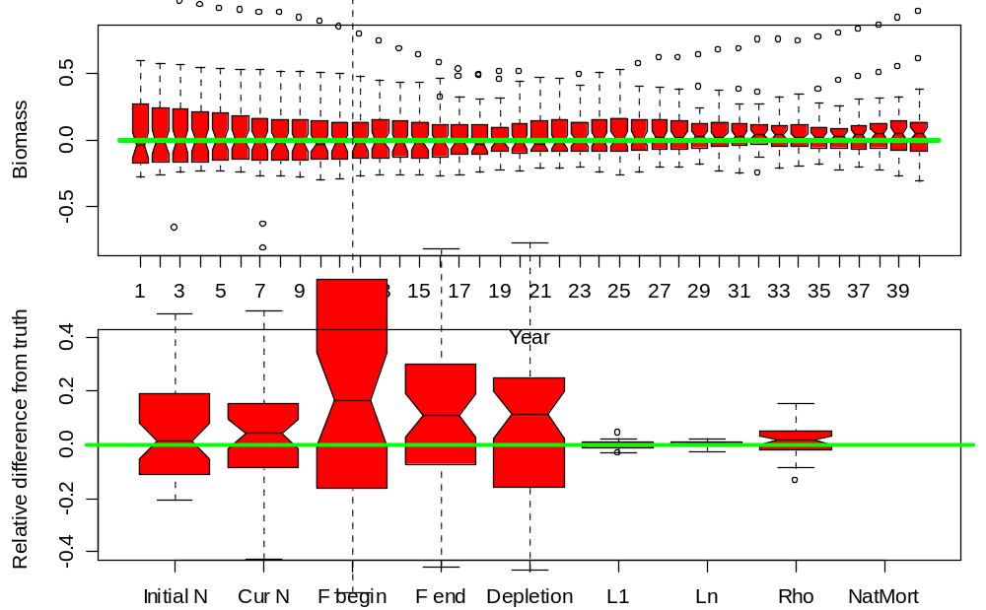

Model 2, High effort variability
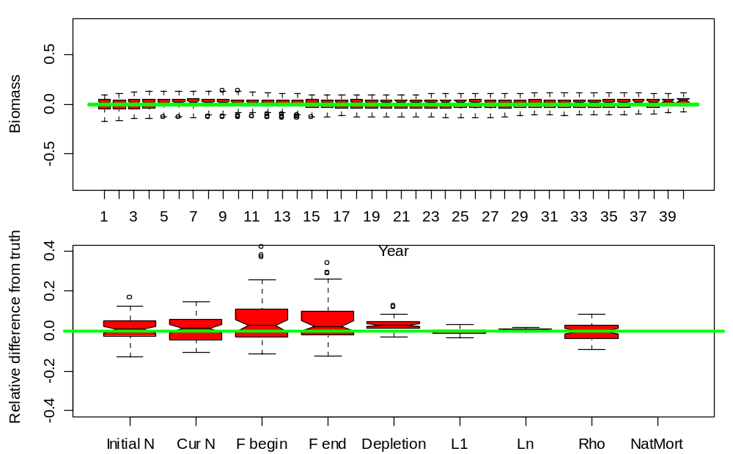

Model 3, Low effort variability
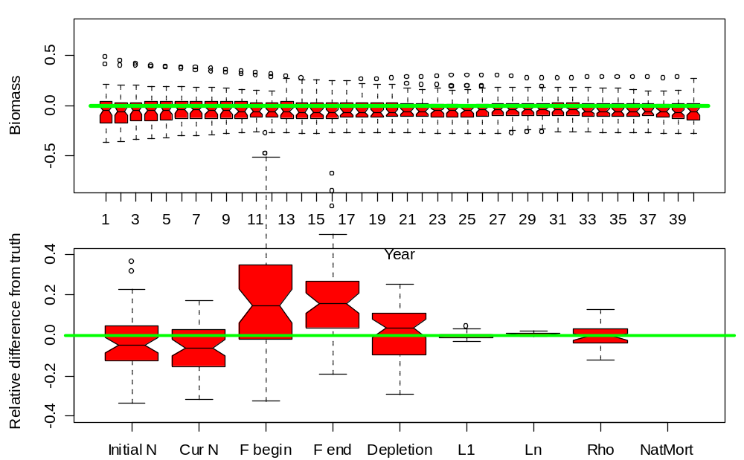

Model 4, Low effort (half Model 1)
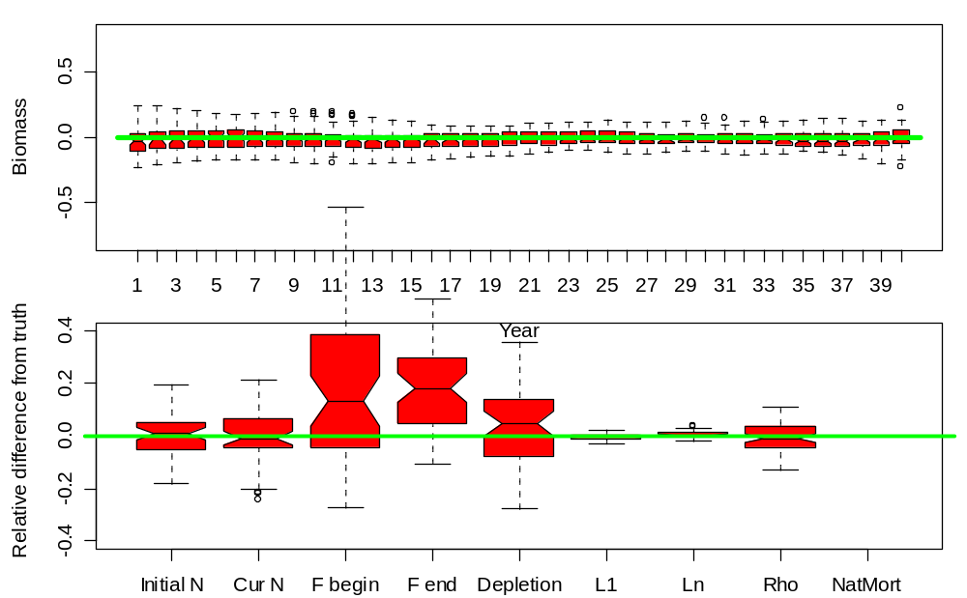

Model 5, High effort (double Model 1)

Model 6, Low variability in recruitment
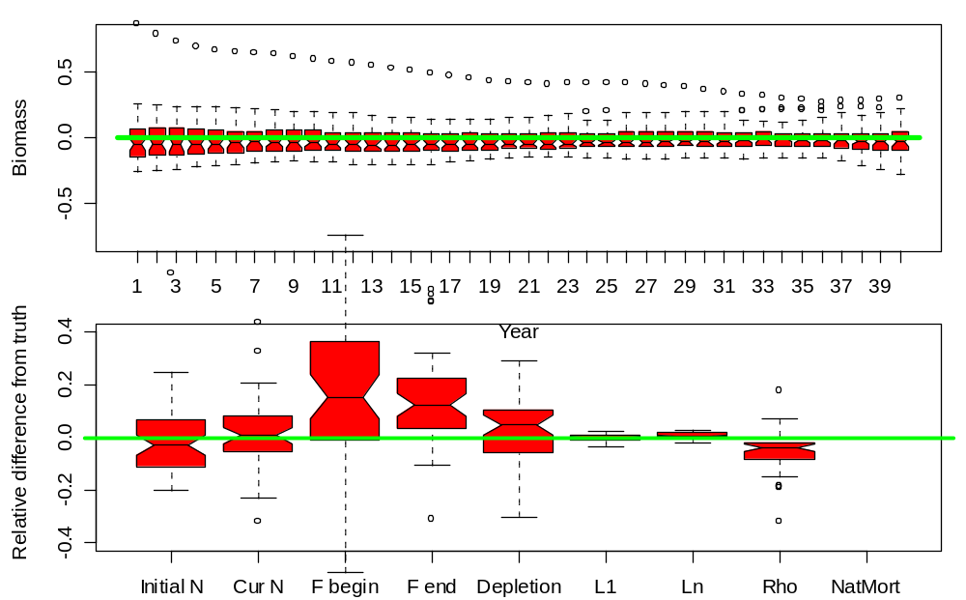

Model 7, High, variable in recruitment 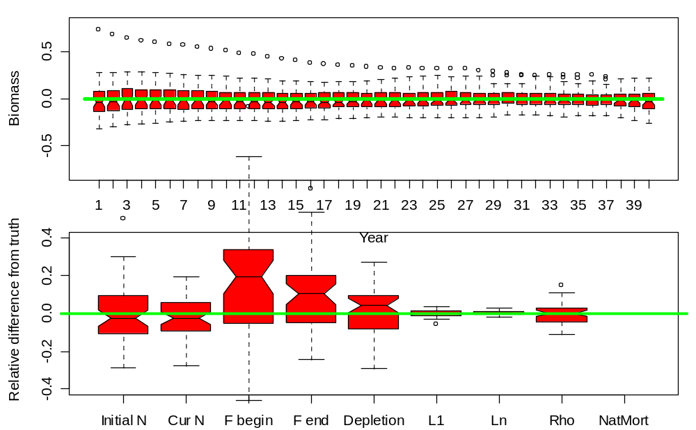

Model 8, Low variability in length-at-age
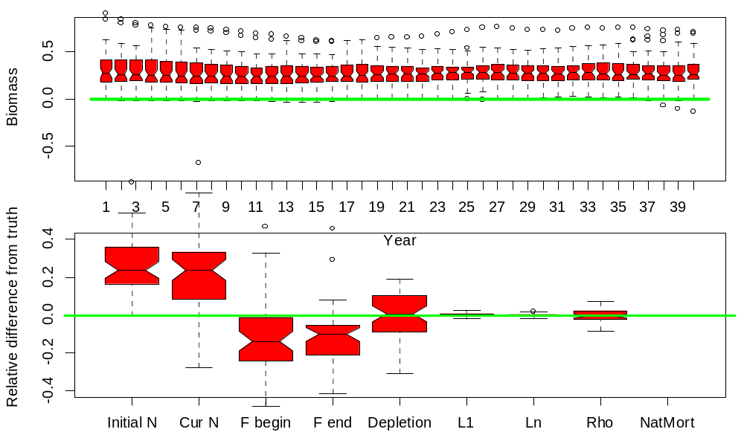

Model 9, Low sample size, high effort and catch variability
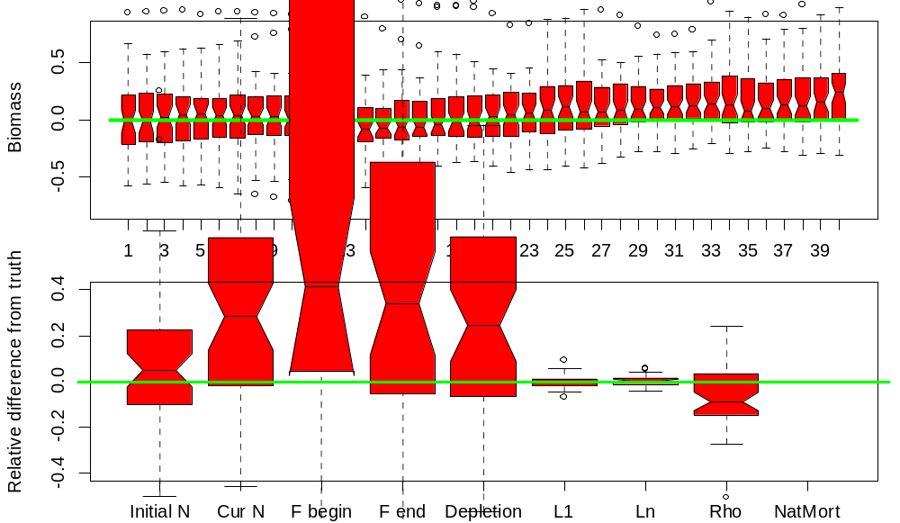

Model 10, Growth varies by cohort and by year
