Some Simulation Analyses for Evaluating Length Based
Stock Assessment Methods

James N. Ianelli
NMFS Alaska Fisheries Science Center
7600 Sand Point Way NE
Seattle, WA 98115-6349 USA
Email: Jim.Ianelli@noaa.gov

Abstract
MULTIFAN-CL (MFCL; Hampton et al. 1998) is a statistical stock assessment approach designed for complex data and fisheries. Similar methods are gaining acceptance as the most sensible approach for fisheries stock assessment analyses. However, testing the methods assumptions via simulations are not common, particularly as analyses become fairly complex. In this paper we construct a simple simulation model useful for evaluating some basic assumptions about the ability of MFCL to estimate the underlying dynamics and parameters of interest. Using only length frequency data, together with information on catch and effort levels, we found that MFCL performed quite well, usually within about 10% of the true values. When estimatation of natural mortality (M) was attempted, MFCL typically underestimated the true value M and also underestimated stock size. A number of simulation scenarios were developed including: different levels of variability in the simulated “observed” fishing effort; different levels of overall effort; changes in the sampling levels for the length frequency data; changes in recruitment variability; changes in the variability in length-at-age and growth rates among cohorts; and changes in the underlying trend of fishery catchabilities. These results shed some light on the capabilities of MFCL and where problems may arise in assumptions. For example, estimating a trend in catchability when in “truth” there was no trend was much less prone to large errors compared to assuming no trend in catchability (from MFCL estimates) when in fact there were trends from the simulated data.
Table of Contents
Abstract 1
Introduction 5
Methods 5
The simulation model 5
Population dynamics 5
Growth 6
Simulated length frequencies 7
Generation of data 7
Multifan CL configuration 9
Results and Discussion 9
Literature Cited 11
Figures 12

List of Figures
Figure 1. True mean length-at-age used for all simulations. 12
Figure 2. Cohort mean lengths-at-age for the variable growth-rate simulation case (Case 10). Top panel is prior to the annual deviations in mean length at age have been added; lower panel shows the actual mean lengths-at-age applied for generating the simulated length frequency distributions. 13
Figure 3. Illustration component distributions that comprise the contaminated distribution used for generating the distribution of length at age. 13
Figure 4. Reference case example simulated length frequency data set for Fishery 1 (left panel) and Fishery 2 (middle panel). Right-most panel shows simulated length frequency data set for Cases 8 & 9 (Fishery 1), where a low sample size of 100 was assumed (the reference case assumed a sample size of 400 fish per time period/fishery). 14
Figure 5. Initial numbers at age (upper left) and recruitment time series used for the simulations. The reference case (upper left) was used in all cases except Cases 6 & 7 (lower panels). 14
Figure 6. Age-specific selectivity used for all the simulation cases. 15
Figure 7. Reference case fishing effort values used for the simulations. The “observed” effort (with 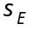=0.2) is overlaid as an example for a single simulated data set. The two sets of lines are for the two different fisheries. 15
Figure 8. Case 1, reference results for absolute biomass (top panel) and recruitment (lower panel) to illustrate the overall trends. The “boxes” of the plots represent the quartile locations, with the mid-line equal to the median. The “whiskers” (vertical lines) represent distances of 1.5 times the inter-quartile range extended from edge of box, or to the extreme data point (if less than that value). The notches of two plots do not overlap then the medians are significantly different at the 5 percent level. 16
Figure 9. Case 1, reference results for selectivity-at-age estimates compared to true values (solid line) for both fisheries. 17
Figure 10. Case 1, reference results for relative difference from “truth” for biomass (upper panel) and selected output variables and parameters (lower panel). “Initial N” is the total numbers at the beginning of year 1, “Cur N” is the total numbers at the beginning of year 40, “F begin” and “F end” are the year 1 and year 40 fishing mortalities, “Depletion” is the biomass ratio of year 40 over year 1, “L1,” “Ln,” and “Rho” are parameters for the growth model, and “NatMort” represents natural mortality (assumed fixed and known in this case). 18
Figure 11. Case 1b, reference case with natural mortality estimated. 18
Figure 12. Case 2, high effort variability (40% CV compared to 20% in reference case). See Fig. 10 caption for details. 19
Figure 13. Case 3, low effort variability (1% CV) and no catch uncertainty (reference case has 5% CV). See caption for Fig. 10 for details. 19
Figure 14. Case 4, low effort levels (half the values used in Case 1). See caption for Fig. 10 for details. 20
Figure 15. Case 5, high effort levels (double the values used in Case 1). See caption for Fig. 10 for details. 20
Figure 16. Case 6, same as reference case but with low variability in recruitment (as in lower left panel of Fig. 5). See caption for Fig. 10 for details. 21
Figure 17. Case 7, same as reference case but with high variability in recruitment (as in lower right panel of Fig. 5). See caption for Fig. 10 for details. 21
Figure 18. Case 8, same as reference case but with high effort variability (40% CV compared to 20% in reference case) and low sampling effort (100 per year compared to 400 for reference case; e.g., right-most panel of Fig 3). See caption for Fig. 10 for details. 22
Figure 19. Case 9, same as case 8 but with CV = 40% for catch compared with 5% in reference case (high variability in catch, effort, and length sampling). See caption for Fig. 10 for details. 22
Figure 20. Case 10, same as reference case but with low variability in length-at-age. See caption for Fig. 10 for details. 23
Figure 21. Case 11, same as reference case but with growth varying by cohort and by year (e.g., Fig. 2). See caption for Fig. 10 for details. 23
Figure 22. Case 12, trend in fishery catchabilities (but MFCL not estimating trend). Note: vertical scale on lower panel has been expanded 24
Figure 23. Case 12b, Case 12 with catchability trend estimated (AND occurring in simulations) 24
Figure 24. Case 1c, reference case catchability trend estimated (but not occurring in simulations). 25
Figure 25. Depletion levels across Cases 1-11 showing the mean, median, and quartiles of the simulations relative to the true value (here equal to 0). 25
Figure 26. Year 40 total fishing mortality for Cases 1-11 showing the mean, median, and quartiles of the simulations relative to the true value (here equal to 0). 26
Figure 27. Estimates of growth rates for Cases 1-12b showing the mean, median, and quartiles of the simulations relative to the true value (here equal to 0). 27

List of Tables
Table 1. Pre-determined simulation values and stochastic quantities for simulation cases. 8
Table 2. Simulation model descriptions. Unless otherwise specified, all cases are identical to the reference case (Case 1). 8
Table 3. Summary statistics on simulation estimates relative to true values (e.g., 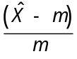, where 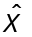 is the estimate from a simulated data set, and is the true value). 28

Introduction
The following documents a simulation model constructed to evaluate the MULTIFAN Catch-at-Length (MFCL) model currently applied to several different stocks of tuna in the Pacific (e.g., Hampton et al. 1998; etc). Similar, though less complex, age-based models are becoming increasingly used for a variety of stock assessments (e.g., Ianelli et al. 1999, McAlister and Ianelli 1998). However, testing the methods assumptions via simulations are fairly rare, particularly as analyses become more complex.
While MFCL has been designed to analyze spatially disaggregated fisheries data from any number of fisheries, we restrict analyses here to a single area with two fisheries. The goal of this research is to highlight areas where biases may be introduced and evaluate consequences of assumptions typically assumed in most stock assessment settings. We selected a 40 period time frame (here considered as years but could easily be construed as quarters or months) with lengths covering 50 discrete length ranges (e.g., from 15 – 64 cm).

Methods

The simulation model

Population dynamics
The model we employed has a common population dynamics form. We used an explicit age-structured model with the standard catch equation as the underlying population model (e.g., Fournier and Archibald 1982). Predicted numbers-at-age and catch-at-age in year t modeled as:
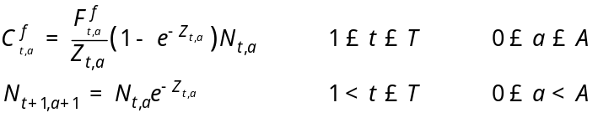
(1)
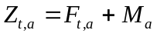
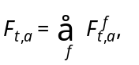
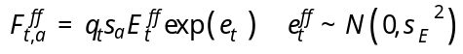
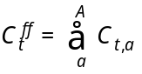
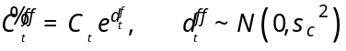
where
T is the number of years of fishing (i.e., t=1 corresponds to 1960, and t=T corresponds to 1999),
A is the largest age considered (A=14),
N_{t,a} is the number of fish age a at the start of year t, with N_{t,1} wholly determined from the simulation model
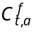 is the catch by number of age a in year t for fleet f,
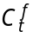 is the total catch by number in year t for fleet f,
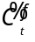 is the “observed” catch in year t for fleet f,
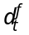 is the observation error of catch in year t for fleet f,
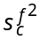 is the level of catch variability specified in the simulations (default value of 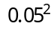),
F_{t,a} is the instantaneous fishing mortality for age a in year t,
M_{a} is the instantaneous natural mortality for age a, and
Z _{t,a} is the instantaneous total mortality for age a in year t.
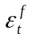 is the observation error of fishing effort exerted by fleet f,
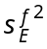 is the level of effort variability specified in the simulations (default value of 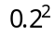),
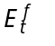 is the actual effort assumed for fishery f, and
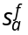 is the selectivity of gear f.

Growth
The form of the von Bertalanfy growth model was parameterized as in Fournier et al. (1998) with modifications as follows:
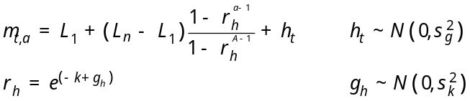
where
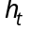 is the annual variability in mean length at age
h is an index for cohort-specific growth term (e.g., cohort h),
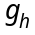 is the error term for cohort-specific growth rate,
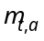 is the mean length of fish in year t at age a,
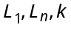 are parameters of the von Bertalanfy growth curve, and
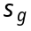 is the standard deviation of annual mean-length-at-age, and
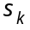 is the cohort-specific variability in growth rates.
The expected value for mean lengths-at-age for the simulations age are shown in Figure 1.
The variability in mean length for the simulations was done in two ways: one as a random effect independent of year and age class (), and one that had a growth rate that varied among cohorts (). These effects are illustrated in Fig. 2.

Simulated length frequencies
The length distributions are based on the mean lengths at age () and specified age-specific standard deviations (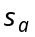) about those means. The probability 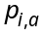 that an age a fish selected randomly from a length frequency sample lies in length interval i in year t is:
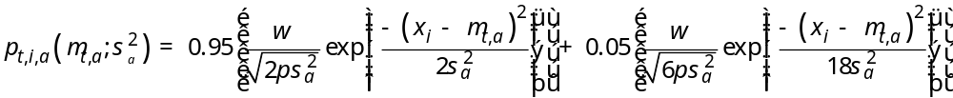
where w is the width of the length intervals, is the midpoint of length interval i. Note that this represents two contaminated normal distributions with one having 3 times the standard deviation than the other (but only 5% of the total probability). The appearance of this distribution and it’s components are shown in Figure 3. These distributions (one for each year and age) are then applied to the determined, age and fishery-specific catches to generate the underlying true fishery-specific length frequencies, 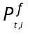:
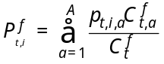.
These length-frequencies were then sampled using multinomial sampling with a default size of 400 fish per year. A lower sampling level using a sample size of 100 was done in some simulation cases (Cases 8 & 9). The appearance of typical length frequency data sets is shown in Figure 4.

Generation of data
The population dynamics model used to generate data sets for ready analyses with MFCL was programmed in AD Model Builder (©Otter Research, Victoria Canada). The steps to implementation were:
- Read specifications of current Case
- Compute the mortality by age and year
- Compute numbers-at-age given recruitments and initial year values
- Compute catch-at-age by each fishery
- Calculate mean lengths at age
- Convert catch-at-age to catch-at-length for each fishery and year
- Write simulated data.

Table 1. Pre-determined simulation values and stochastic quantities for simulation cases.
Determined values | Stochastic quantities
Variation in the distribution of mean length at age (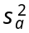) | Observed effort for each fishery  (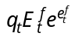; output as data; Fig. 5)
Initial numbers at age (N_{1,a}, 1aA) | Observed catch for each fishery (; output as data)
Selectivity (; Fig. 6) | Annual mean lengths-at-age (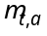,Fig. 7)
Overall mean length at age (as determined from von-Bertalanfy growth; Fig. 8) | Sampled length frequencies (output as data; e.g., Fig. 9).
Recruitment (N_{t,1}, 1<tT; e.g., Fig. 10)
Natural Mortality (M_{a}=0.2)
Actual fishing effort (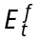; Fig. 11)

Table 2. Simulation model descriptions. Unless otherwise specified, all cases are identical to the reference case (Case 1).
Cases | Description
1 | Reference case: =0.2; =0.05; =1.5; =0.0; N=400;
1b | Reference case, natural mortality estimated
2 | High effort variability (=0.4)
3 | Low effort variability (=0.01)
4 | Low effort levels (half the values used in Case 1)
5 | High effort levels (double the values used in Case 1)
6 | Low variability in recruitment (see Fig. 12)
7 | High recruitment variability (see Fig. 13)
8 | Low sampling, and poor effort data; =0.4; N=100
9 | Low sampling, poor catch and effort data; =0.4; =0.4; N=100
10 | Low variance in length at age distribution;
11 | Growth varies by cohort and by year; =0.05
12 | Trend in fishery catchabilities (2% increase in yr⁻¹); trend not estimated within MFCL
12b | Trend in fishery catchabilities (2% increase inper year); trend estimated within MFCL
1c | Reference case, no trend in simulation but trend estimated within MFCL

Multifan CL configuration
We implemented the MFCL program with the minimum amount of modification and testing of features—we treated the estimation analyses as a “black box.” Our knowledge of using the software involved knowing a few options for the types of data that we simulated. We used MFCL in a progressive form for estimating parameters from simulated data as follows:
- Estimate initial stages with fixed standard deviations in length at age;
- Estimate length-dependent standard deviations
- Estimate K (growth rate)
- Estimate time-trend in catchabilities (if option is set)
- Estimate natural mortality (if option is set)
- Write report files containing estimates of interest.
The report files created by MFCL were then queried for a variety of indicators on stock condition and compared with the “true” values for each simulation case.

Results and Discussion
The reference case estimated the absolute biomass trend and recruitment history quite well (assuming known, true natural mortality rate; Fig. 14). The estimates of age-specific selectivity were also close to their true values (Fig. 15) but with a slight over estimate for the older ages in Fishery 2. For the comparisons over different cases, we summarized the 50 simulation estimates (for each case) in the form of a box plots relative to the “true” values (e.g., Fig. 16). Summary statistics for key indicators for each case are given in Table 3.
Case 1b, the reference data set with the MFCL option to estimate natural mortality (M) turned on (it was assumed fixed and known for all other analyses) reveals that the ability to estimate M was poor (Fig. 17). The median of simulation estimates for M was about 20% lower than the true value, resulting in an overall underestimate of absolute stock size and overestimate of fishing mortality rate. The estimated levels of depletion (ratio of year 40 biomass over year 1 biomass) were slightly higher than their true values for this case, on average.
Cases 2 & 3 examined the effect of the accuracy of the fishery effort data.. When effort is poorly measured (CV~40%; Case 2) the effect was to increase the range of estimates but did not appear to introduce any further bias (Fig. 18). Similarly, the effect of measuring effort precisely greatly reduced the variability in the analyses of simulated data sets, but had bias levels similar to the reference case (Fig. 19).
Cases 4 & 5 were constructed to evaluate the effect of fishing mortality levels. The purpose was to determine the amount that fishing may contribute to the accuracy of MFCL as a stock assessment method. For example, in Case 4 we halved the reference case fishing mortality rate; in Case 5 we doubled the rate. Case 4 population estimates tended to be biased low (and hence the fishing mortality rates biased high), whereas results from Case 5 improved the situation and provided generally more accurate and precise results relative to the reference case and Case 4 (Figs. 20 & 21.
Cases where the true recruitment pattern was changed (Cases 6 & 7; Fig. 22) showed that the growth rate parameter, was estimated more accurately and precisely when recruitment was more variable (Fig. 23 versus Fig. 24). Intuitively, the length-based method should estimate growth better when a progression of modes from large recruitments occurs as in Case 7.
Reducing the sample size for the length frequency data increased the variability in the estimates (Cases 8 & 9; Figs. 25 & 26). The biases in the estimates of fishing mortality rates and depletion levels were somewhat higher in these cases compared to the reference case. Also, having increased variability on the catch information (Case 9) changed the biases qualitatively and increased the variability among the simulations.
Reducing the variance in the length-at-age (Case 10) distributions introduced a large positive bias in the absolute numbers and biomass estimates resulting in an under-estimate of fishing mortality (Fig. 27). The estimate for depletion for this case was unbiased and, as expected, the growth parameter estimates were highly precise and accurate. In Case 11, where cohorts had variability in growth in addition to annual variability in mean lengths-at-age, MFCL performed quite well in estimating parameters of interest though there appeared to be some time-series effect in the estimates of biomass (Fig. 28).
Case 12 evaluated the ability of MFCL to estimate an increasing trend in catchability over time. This case, with both fisheries having a 2% per annum increase in catchability, showed that MFCL performs well for the early parts of the time period but the biomass estimates tended to be over-estimated at the end of the time series (Fig. 29). This is presumably due to the fact that MFCL implements a random-walk time series effect in catchability that depends on the information provided from other data sources. In this situation, the early part of the time series of estimates is relatively unbiased since observations on the age composition (as through the length frequency data) are much greater than during the latter period. This decline in information in the amount of change in catchability results in having the random walk component change less. Presumably the variance about these estimates would increase and may provide sufficient warning about the degree of uncertainty in the recent biomass estimates. Alternatively, implementing a Kalman-filter approach to trends in catchability may prove more reliable than using a simple random walk. At the time of this writing, this aspect of MFCL was still in the developmental stages.
Cases 1-11 all appeared to have some positive bias in the estimate of depletion level (Fig. 30). Similarly, the estimates for the most recent year’s fishing mortality tended to have positive biases as well (Fig. 31). The different simulation scenarios had more variable effect on the biases for the growth rate, but were mostly negatively biased (but more precisely estimated than depletion; Fig. 32).
The results presented here do not nearly test the full complex capabilities of MFCL but do provide a foundation for further evaluations for this type of software. The next step would be to implement a spatially disaggregated version of the simulation model that allows sensitivity analyses for the effect of tag releases and other data on estimating movement among areas. The addition of tagging data may also improve some of the shortcomings found here, particularly regarding the ability of MFCL to estimate natural mortality rate.

Acknowledgements
Vivian Haist is thanked for providing assistance in using MFCL and in reviewing a draft version of this paper.

Literature Cited
Fournier, D.A. and Archibald, C.P. 1982. A general theory for analyzing catch-at-age data. Can. J. Fish. Aquat. Sci. 39:1195-1207.
Fournier, D.A., J. Hampton, and J.R. Sibert. 1998. MULTIFAN-CL: a length-based, age-structured model for fisheries stock assessment, with application to South Pacific albacore, Thunnus alalunga. Can. J. Fish. Aquat. Sci. 55:2105-2116.
Ianelli, J.N. and D.A. Fournier. 1998. Alternative age-structured analyses of the NRC simulated stock assessment data. In Restrepo, V.R. [ed.]. Analyses of simulated data sets in support of the NRC study on stock assessment methods. NOAA Tech. Memo. NMFS-F/SPO-30. 96 p.
Ianelli, J.N., L. Fritz, G. Walters, N. Williamson and T. Honkahleto. 1999. Bering Sea-Aleutian Islands Walleye Pollock Assessment for 2000. In Stock assessment and fishery evaluation report for the groundfish resources of the Eastern Bering Sea and Aleutian Island Region, 2000. North Pacific Fishery Management Council, P.O Box 103136, Anchorage, AK 99510. 98p.
McAllister, M.K. and Ianelli, J.N. 1997. Bayesian stock assessment using catch-age data and the sampling-importance resampling algorithm. Can. J. Fish. Aquat. Sci. 54:284-300.

Figures
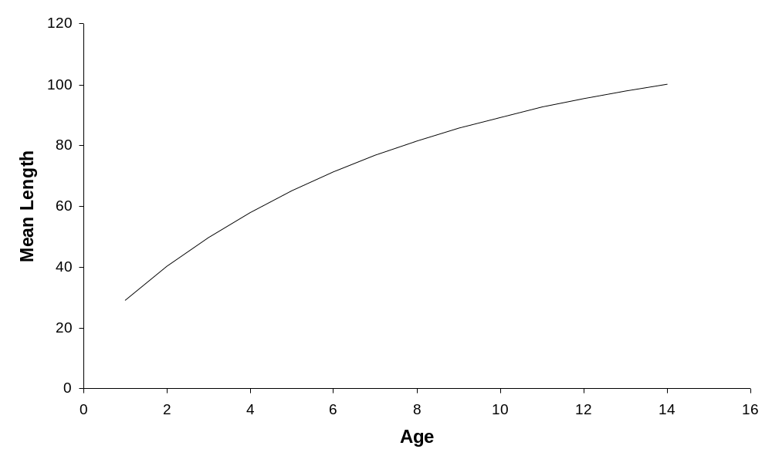

Figure 33. True mean length-at-age used for all simulations.
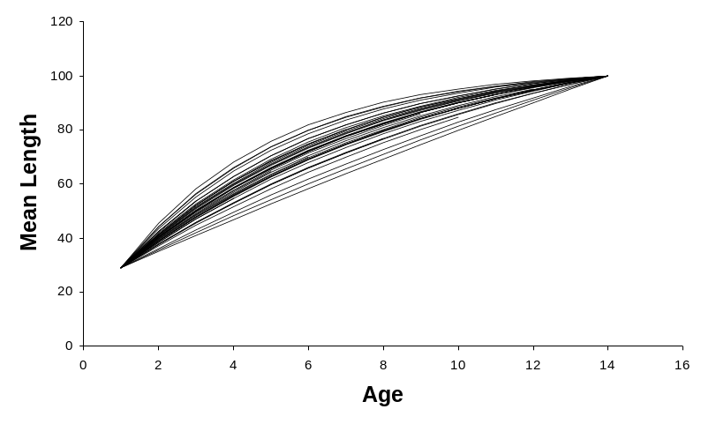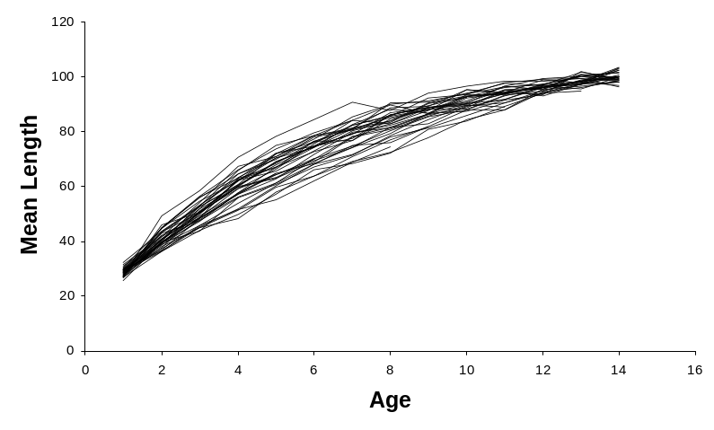

Figure 34. Cohort mean lengths-at-age for the variable growth-rate simulation case (Case 11). Top panel is prior to the annual (non-cohort specific) deviations in mean length at age have been added; lower panel shows the actual mean lengths-at-age applied for generating the simulated length frequency distributions.
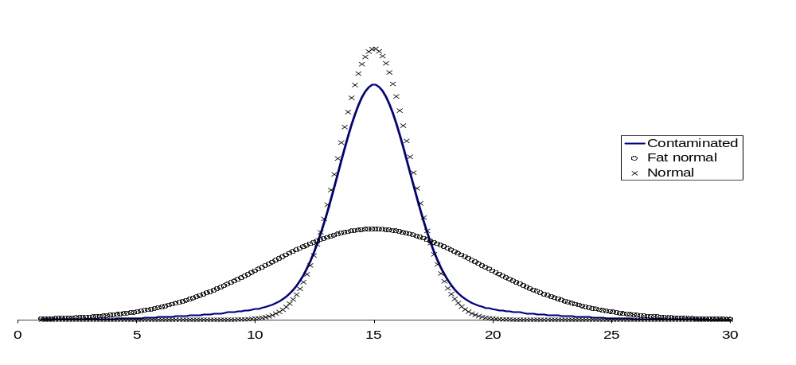

Figure 35. Illustration component distributions that comprise the contaminated distribution used for generating the distribution of length at age.
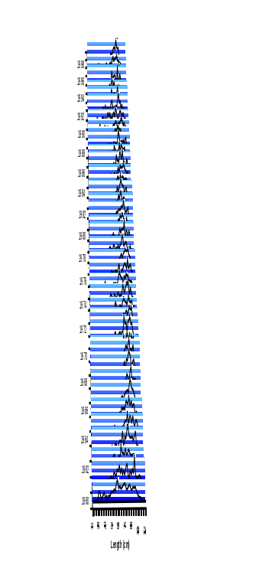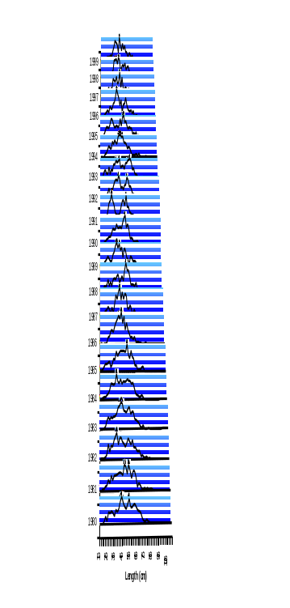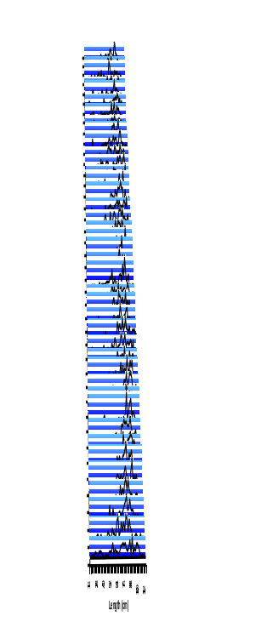

Figure 36. Reference case example simulated length frequency data set for Fishery 1 (left panel) and Fishery 2 (middle panel). Right-most panel shows simulated length frequency data set for Cases 8 & 9 (Fishery 1), where a low sample size of 100 was assumed (the reference case assumed a sample size of 400 fish per time period/fishery).
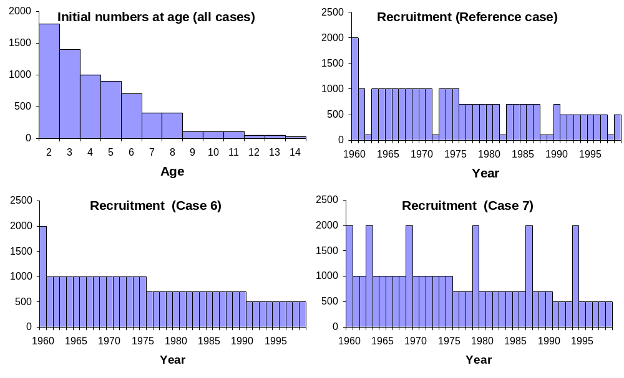

Figure 37. Initial numbers at age (upper left) and recruitment time series used for the simulations. The reference case (upper left) was used in all cases except Cases 6 & 7 (lower panels).
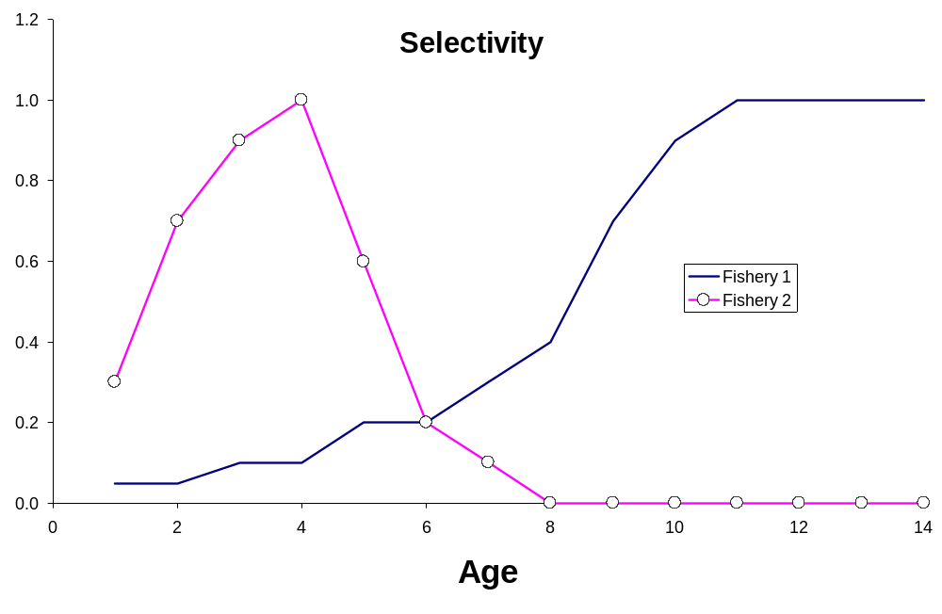

Figure 38. Age-specific selectivity used for all the simulation cases.

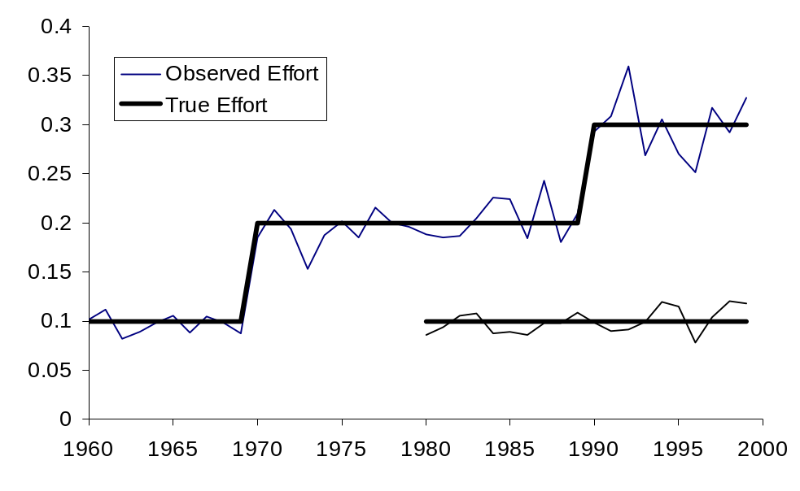

Figure 39. Reference case fishing effort values used for the simulations. The “observed” effort (with =0.2) is overlaid as an example for a single simulated data set. The two sets of lines are for the two different fisheries.

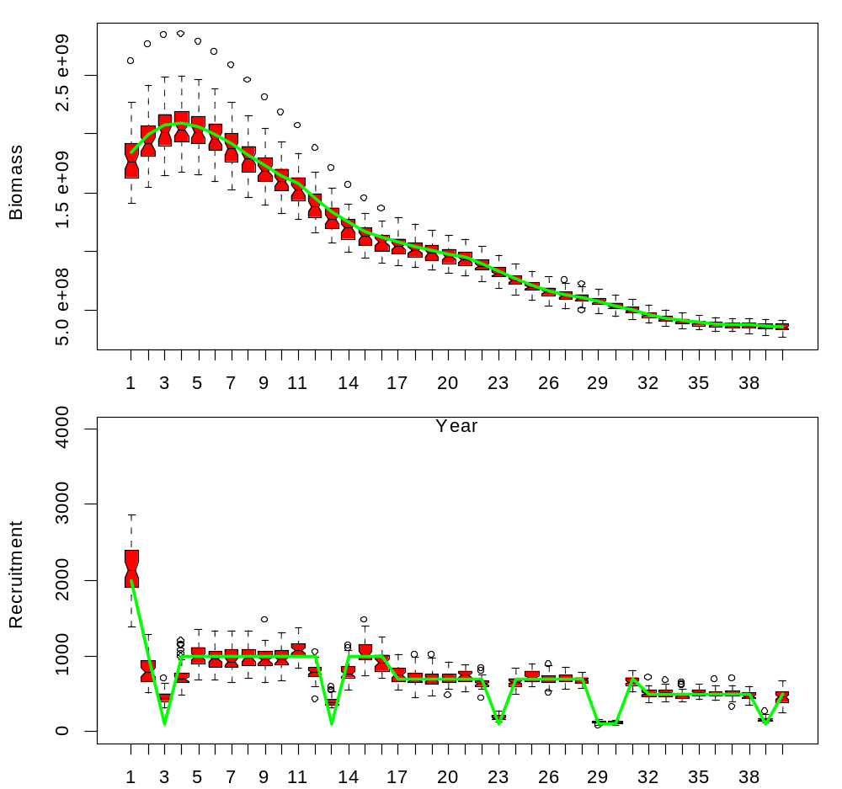

Figure 40. Case 1, reference results for absolute biomass (top panel) and recruitment (lower panel) to illustrate the overall trends. The “boxes” of the plots represent the quartile locations, with the mid-line equal to the median. The “whiskers” (vertical lines) represent distances of 1.5 times the inter-quartile range extended from edge of box, or to the extreme data point (if less than that value). The notches of two plots do not overlap then the medians are significantly different at the 5 percent level.
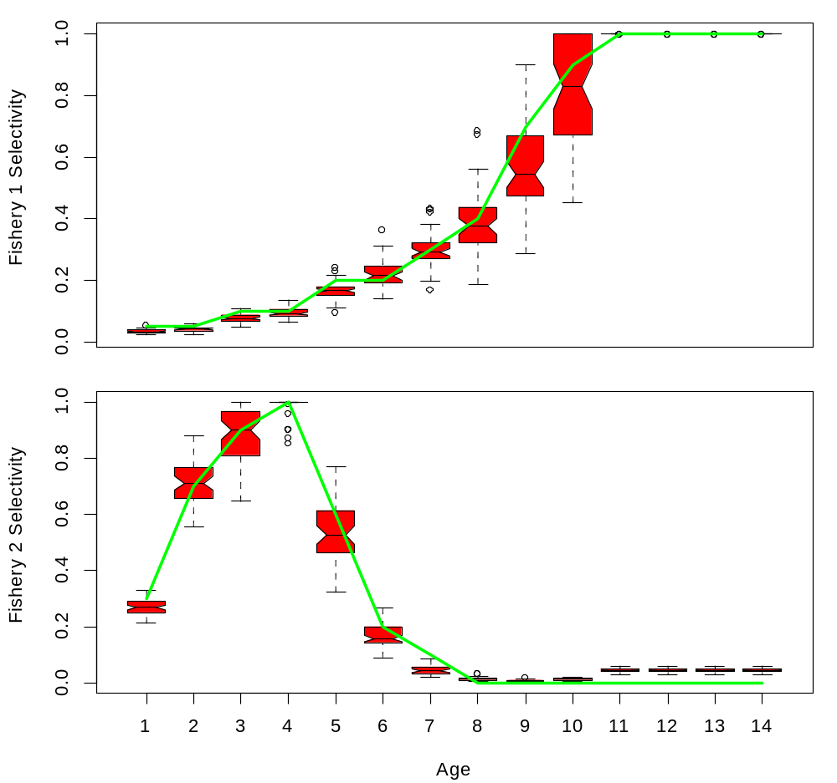

Figure 41. Case 1, reference results for selectivity-at-age estimates compared to true values (solid line) for both fisheries.

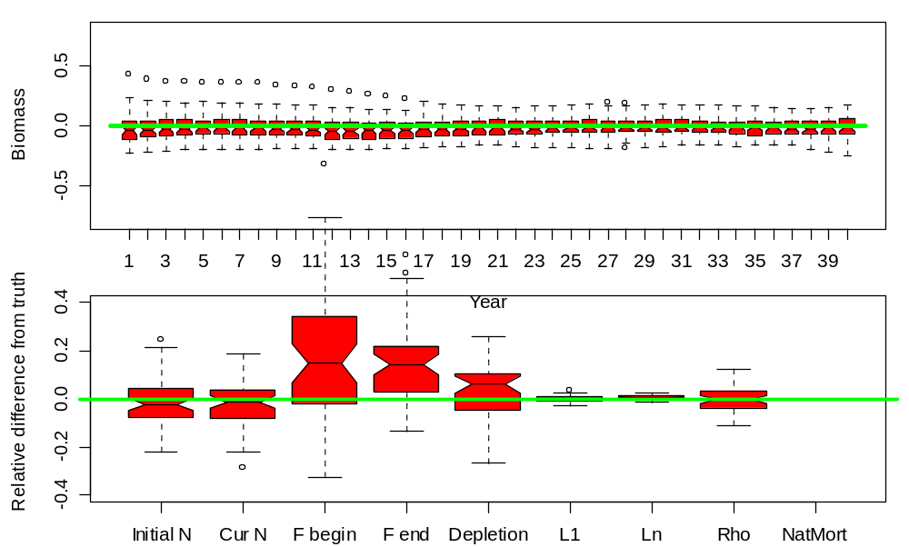

Figure 42. Case 1, reference results for relative difference from “truth” for biomass (upper panel) and selected output variables and parameters (lower panel). “Initial N” is the total numbers at the beginning of year 1, “Cur N” is the total numbers at the beginning of year 40, “F begin” and “F end” are the year 1 and year 40 fishing mortalities, “Depletion” is the biomass ratio of year 40 over year 1, “L1,” “Ln,” and “Rho” are parameters for the growth model, and “NatMort” represents natural mortality (assumed fixed and known in this case).
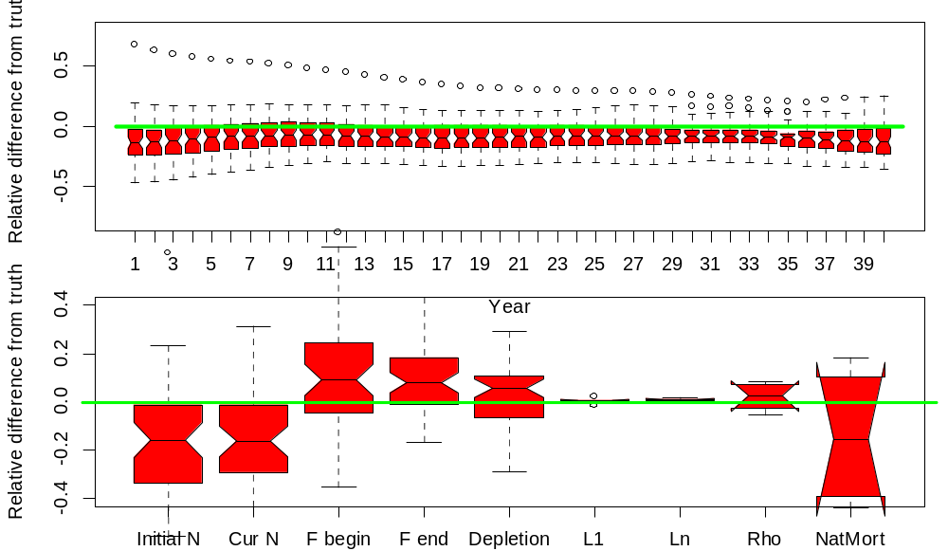

Figure 43. Case 1b, reference case with natural mortality estimated.

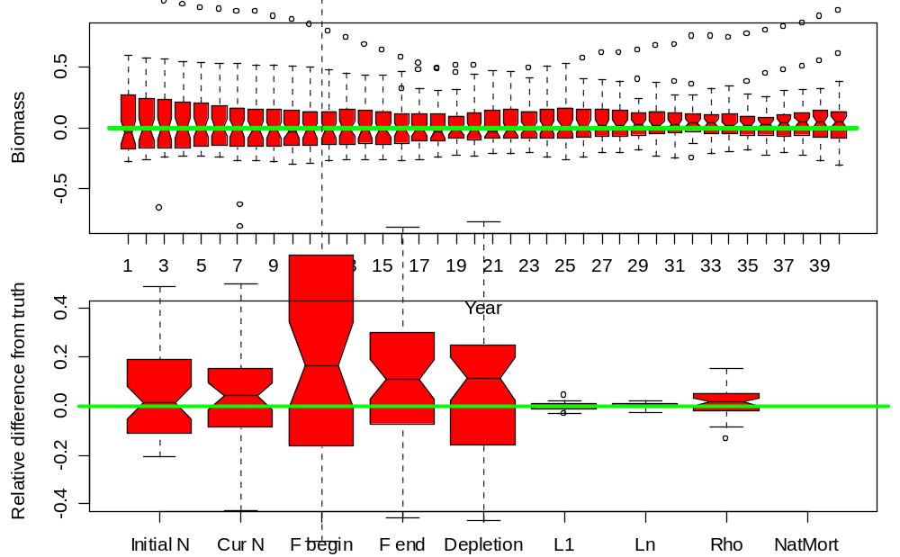

Figure 44. Case 2, high effort variability (40% CV compared to 20% in reference case). See caption for Fig. 45 for details.
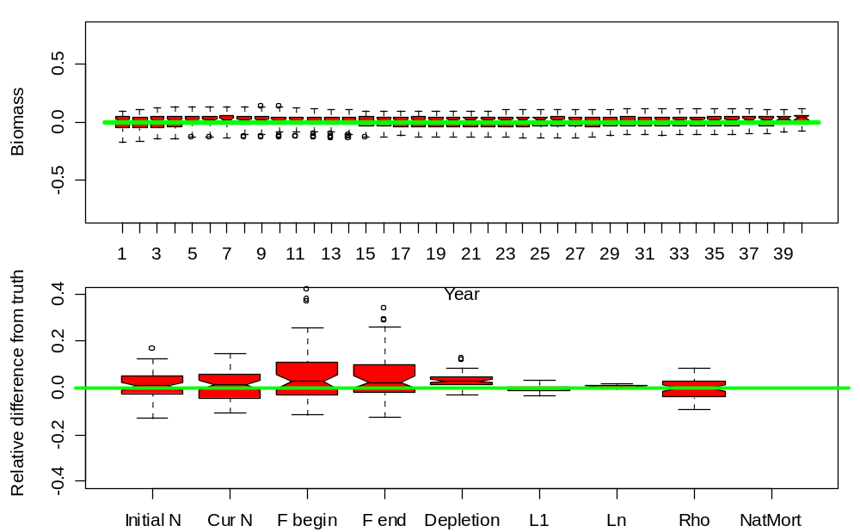

Figure 46. Case 3, low effort variability (1% CV) and no catch uncertainty (reference case has 5% CV). See caption for Fig. 47 for details.

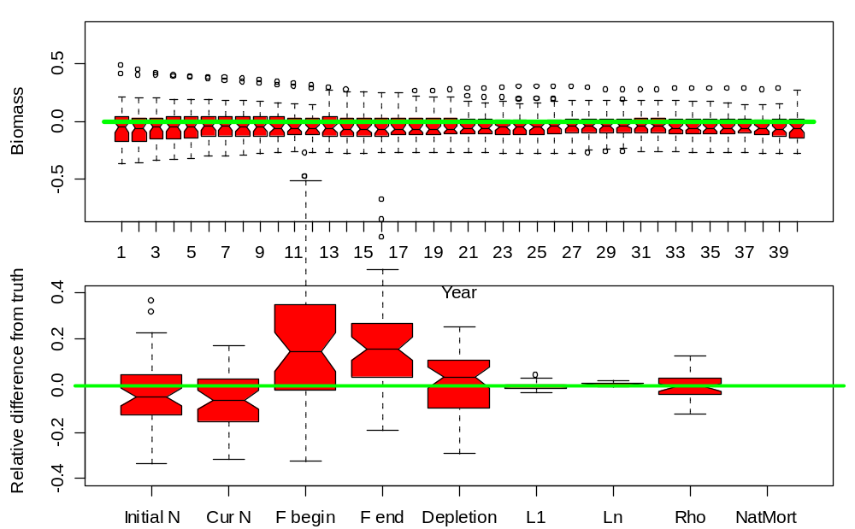

Figure 48. Case 4, low effort levels (half the values used in Case 1). See caption for Fig. 49 for details.
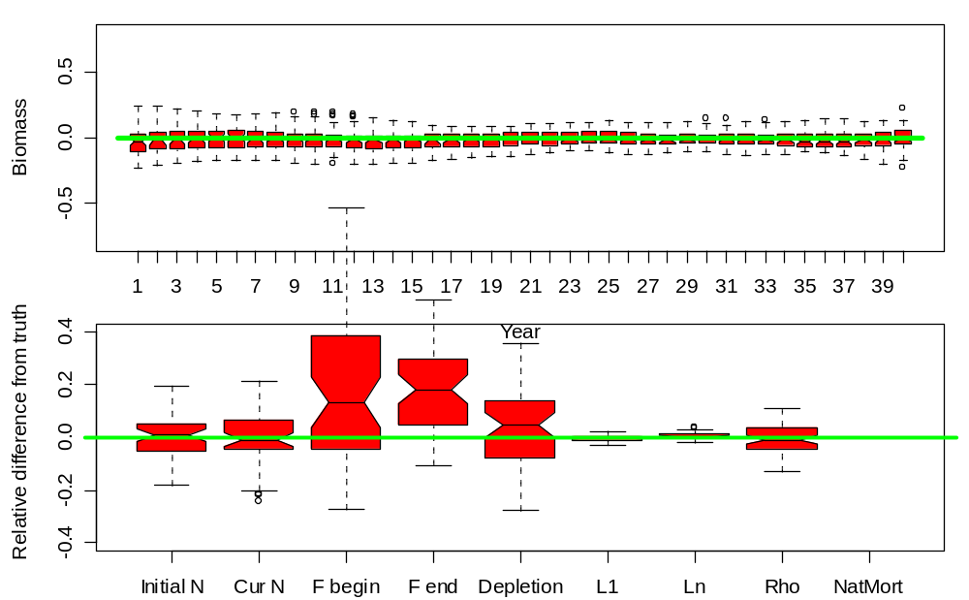

Figure 50. Case 5, high effort levels (double the values used in Case 1). See caption for Fig. 51 for details.

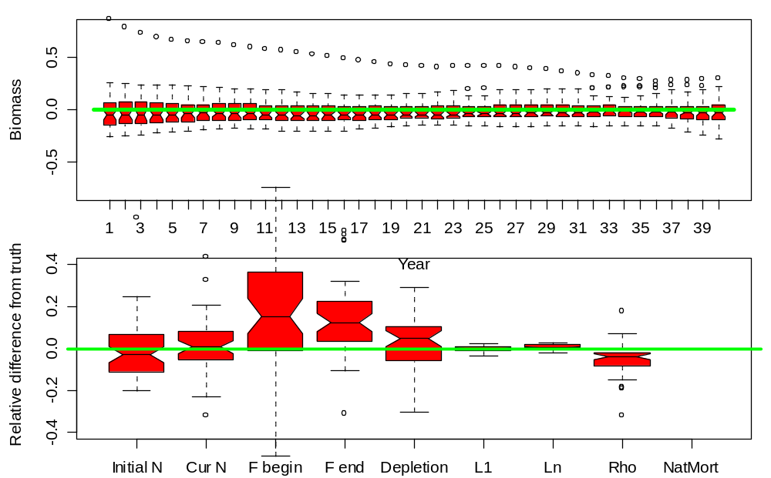

Figure 52. Case 6, same as reference case but with low variability in recruitment (as in lower left panel of Fig. 53). See caption for Fig. 54 for details.

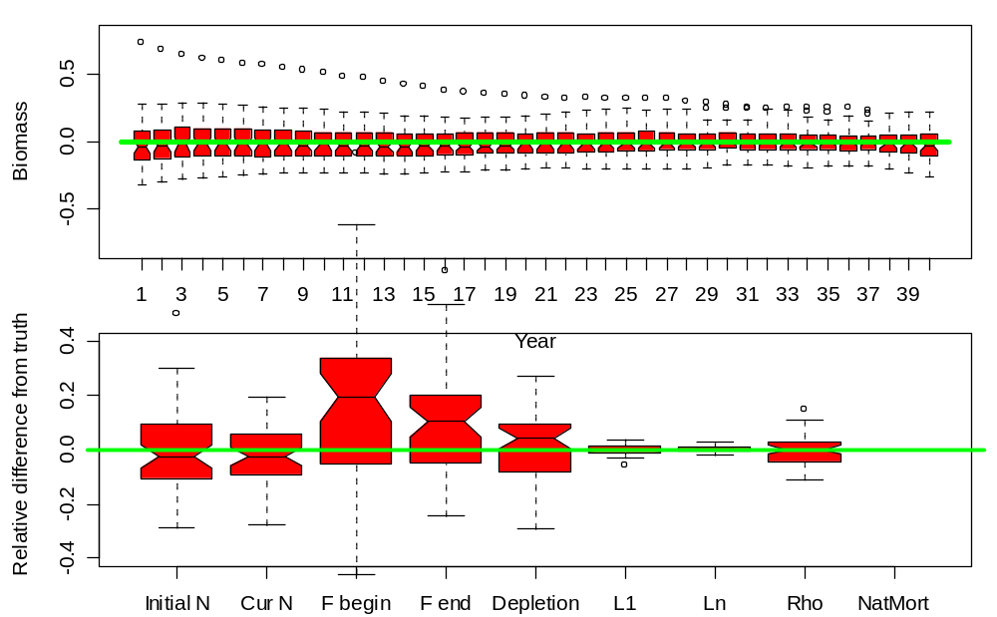

Figure 55. Case 7, same as reference case but with high variability in recruitment (as in lower right panel of Fig. 56). See caption for Fig. 57 for details.

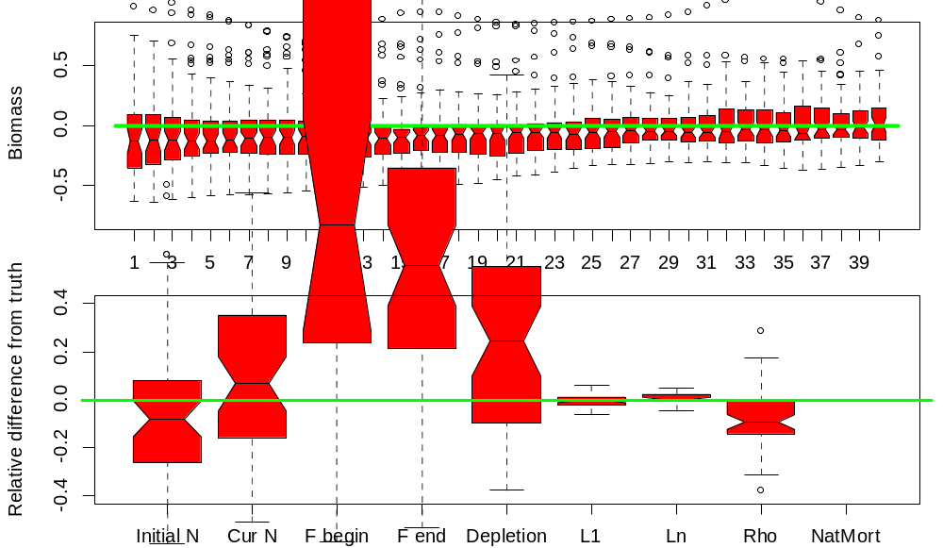

Figure 58. Case 8, same as reference case but with high effort variability (40% CV compared to 20% in reference case) and low sampling effort (100 per year compared to 400 for reference case; e.g., right-most panel of Fig 59). See caption for Fig. 60 for details.
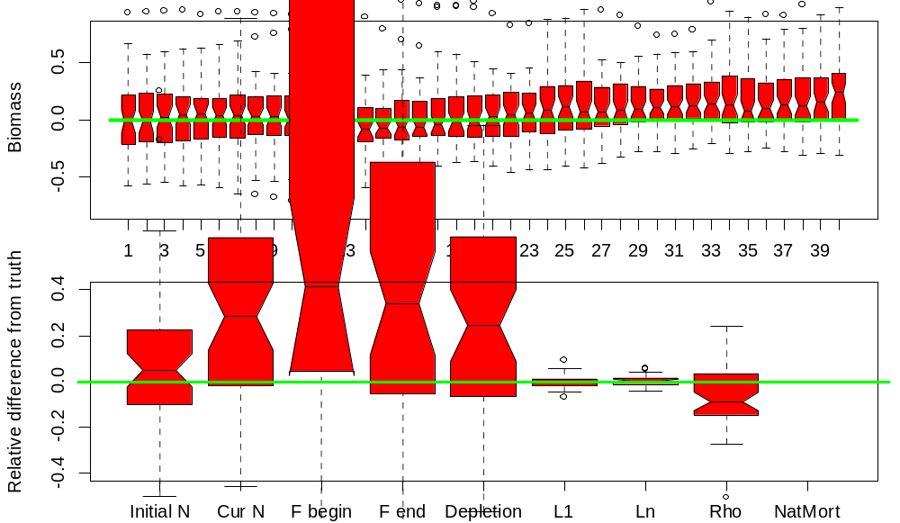

Figure 61. Case 9, same as case 8 but with CV = 40% for catch compared with 5% in reference case (high variability in catch, effort, and length sampling). See caption for Fig. 62 for details.
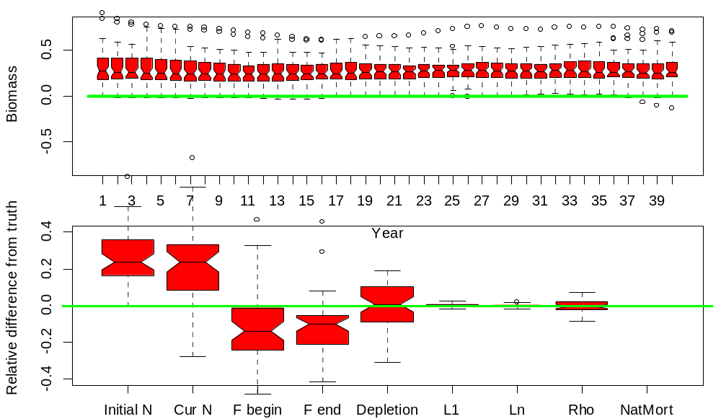

Figure 63. Case 10, same as reference case but with low variability in length-at-age. See caption for Fig. 64 for details.
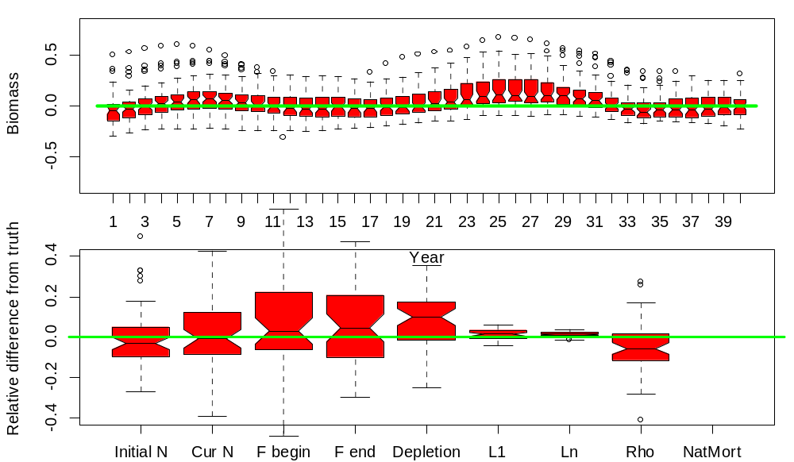

Figure 65. Case 11, same as reference case but with growth varying by cohort and by year (e.g., Fig. 66). See caption for Fig. 67 for details.
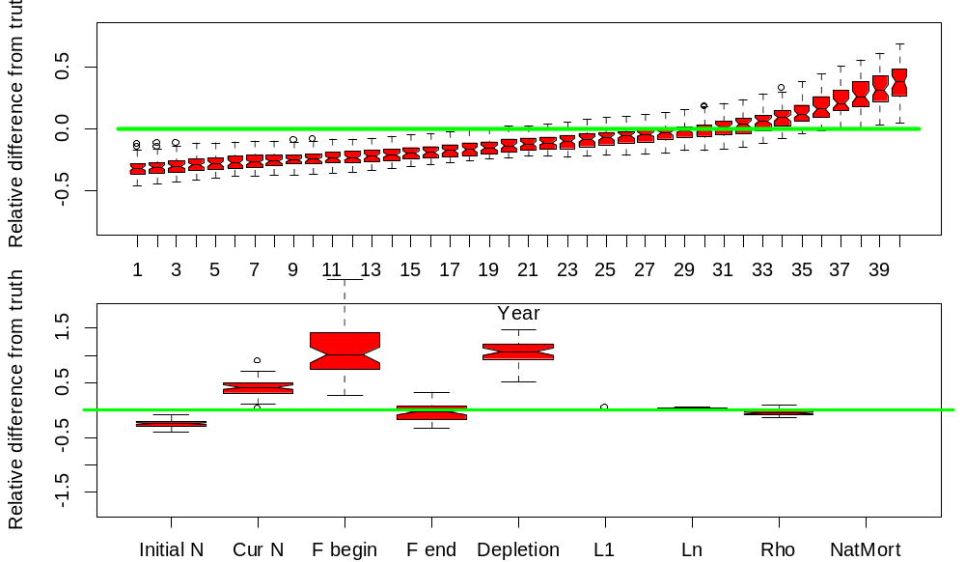

Figure 68. Case 12, trend in fishery catchabilities (but MFCL not estimating trend). Note: vertical scale on lower panel has been expanded
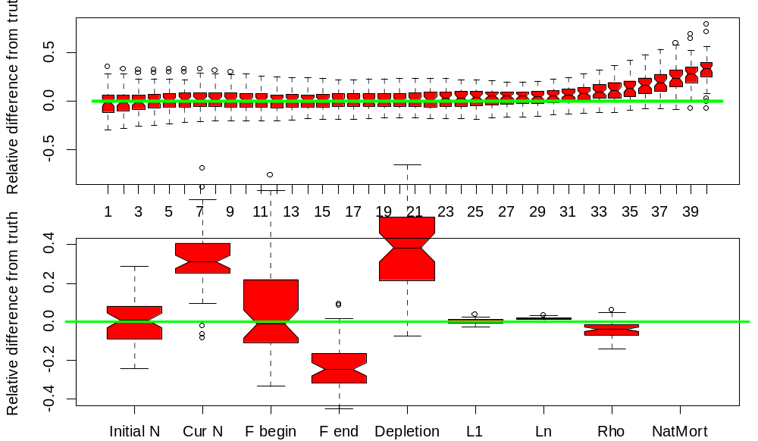

Figure 69. Case 12b, Case 12 with catchability trend estimated (AND occurring in simulations)
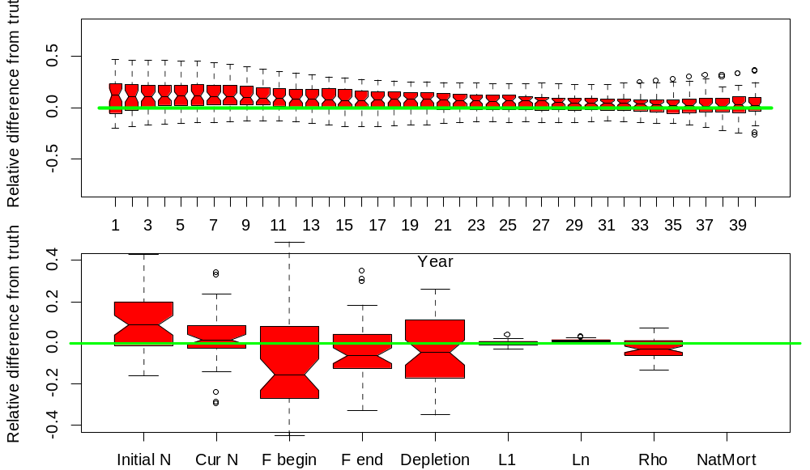

Figure 70. Case 1c, reference case catchability trend estimated (but not occurring in simulations).

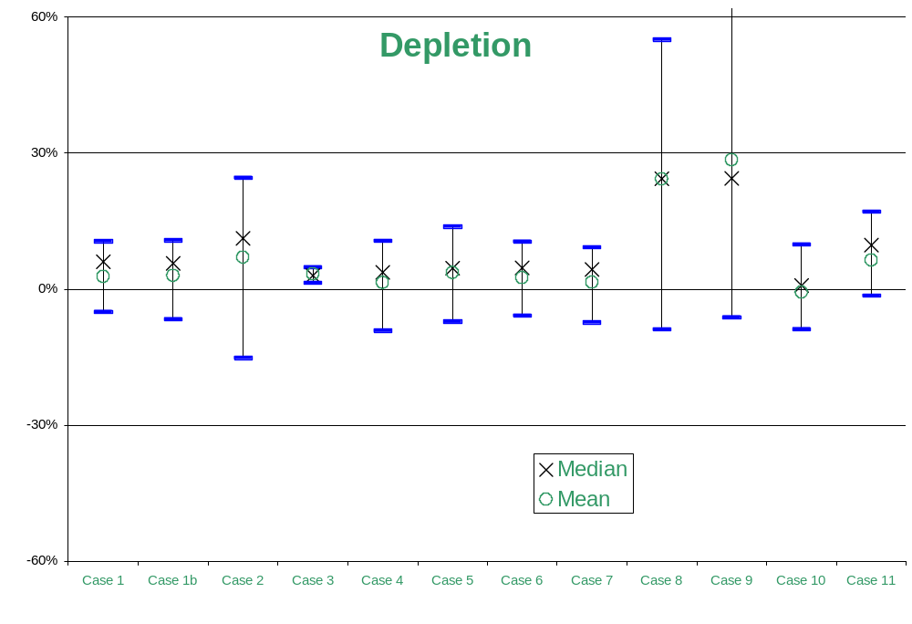

Figure 71. Depletion levels across Cases 1-11 showing the mean, median, and quartiles of the simulations relative to the true value (here equal to 0).
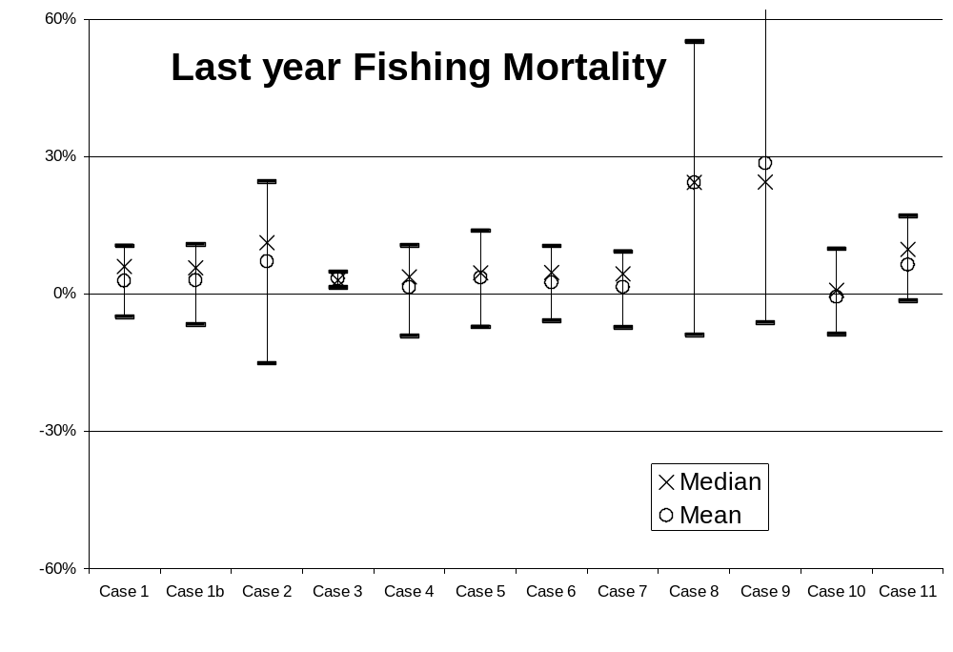

Figure 72. Year 40 total fishing mortality for Cases 1-11 showing the mean, median, and quartiles of the simulations relative to the true value (here equal to 0).

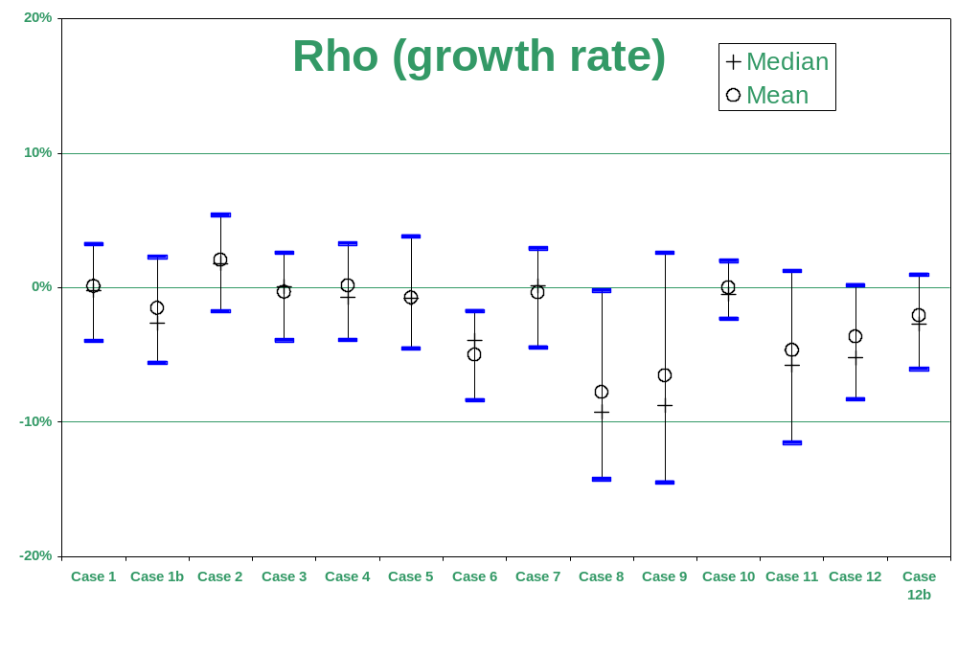

Figure 73. Estimates of growth rates for Cases 1-12b showing the mean, median, and quartiles of the simulations relative to the true value (here equal to 0).

Table 4. Summary statistics on simulation estimates relative to true values (e.g., , where is the estimate from a simulated data set, and is the true value).
Case 1 | N yr 1 | N yr 40 | F yr 1 | F yr 40 | Depletion | L1 | Ln | Rho
1st Quartile | -7% | -8% | -1% | 4% | -5% | -1% | 0% | -4%
Median | -2% | -1% | 15% | 14% | 6% | 0% | 1% | 0%
Mean | -1% | -2% | 17% | 15% | 3% | 0% | 1% | 0%
3rd Quartile | 4% | 4% | 34% | 22% | 11% | 1% | 1% | 3%
Case 1b
1st Quartile | -34% | -29% | -4% | -1% | -7% | -1% | 0% | -6%
Median | -16% | -16% | 9% | 8% | 6% | 0% | 1% | -3%
Mean | -16% | -15% | 10% | 10% | 3% | 0% | 1% | -2%
3rd Quartile | -2% | -2% | 24% | 18% | 11% | 1% | 1% | 2%
Case 2
1st Quartile | -11% | -9% | -16% | -7% | -15% | -1% | -1% | -2%
Median | 1% | 4% | 17% | 11% | 11% | 0% | 0% | 2%
Mean | 5% | 6% | 23% | 15% | 7% | 0% | 0% | 2%
3rd Quartile | 18% | 15% | 60% | 30% | 25% | 1% | 1% | 5%
Case 3
1st Quartile | -2% | -4% | -3% | -2% | 1% | -1% | 0% | -4%
Median | 1% | 1% | 3% | 2% | 3% | 0% | 1% | 0%
Mean | 1% | 1% | 6% | 5% | 3% | 0% | 1% | 0%
3rd Quartile | 5% | 6% | 11% | 9% | 5% | 1% | 1% | 3%
Case 4
1st Quartile | -12% | -15% | -1% | 4% | -9% | -1% | 0% | -4%
Median | -5% | -6% | 15% | 16% | 4% | 0% | 1% | -1%
Mean | -3% | -6% | 21% | 17% | 1% | 0% | 1% | 0%
3rd Quartile | 5% | 2% | 34% | 26% | 11% | 1% | 1% | 3%
Case 5
1st Quartile | -5% | -4% | -4% | 5% | -7% | -1% | 0% | -5%
Median | 1% | -1% | 14% | 18% | 5% | 0% | 1% | -1%
Mean | 0% | 0% | 18% | 18% | 4% | 0% | 1% | -1%
3rd Quartile | 5% | 7% | 39% | 29% | 14% | 1% | 1% | 4%
Case 6
1st Quartile | -11% | -5% | -1% | 4% | -6% | -1% | 0% | -8%
Median | -3% | 1% | 15% | 12% | 5% | 0% | 1% | -4%
Mean | 0% | 2% | 18% | 14% | 2% | 0% | 1% | -5%
3rd Quartile | 7% | 8% | 36% | 22% | 10% | 1% | 2% | -2%
Case 7
1st Quartile | -10% | -9% | -5% | -4% | -7% | -1% | 0% | -4%
Median | -2% | -3% | 19% | 10% | 4% | 0% | 0% | 0%
Mean | 0% | -1% | 18% | 12% | 2% | 0% | 0% | 0%
3rd Quartile | 9% | 6% | 33% | 20% | 9% | 1% | 1% | 3%

Table 5. Cont’d. Summary statistics on simulation estimates relative to true values (e.g., , where is the estimate from a simulated data set, and is the true value).
Case 8 | N yr 1 | N yr 40 | F yr 1 | F yr 40 | Depletion | L1 | Ln | Rho
1st Quartile | -25% | -16% | 25% | 22% | -9% | -2% | -1% | -14%
Median | -8% | 7% | 73% | 56% | 24% | 0% | 0% | -9%
Mean | -3% | 13% | 284% | 171% | 24% | -1% | 1% | -8%
3rd Quartile | 8% | 35% | 212% | 96% | 55% | 1% | 2% | 0%
Case 9
1st Quartile | -10% | -2% | 6% | -5% | -6% | -2% | -1% | -14%
Median | 5% | 28% | 41% | 34% | 24% | 0% | 0% | -9%
Mean | 14% | 39% | 244% | 104% | 29% | 0% | 0% | -7%
3rd Quartile | 22% | 62% | 177% | 92% | 63% | 1% | 1% | 3%
Case 10
1st Quartile | 17% | 9% | -24% | -21% | -9% | -1% | -1% | -2%
Median | 24% | 24% | -14% | -10% | 1% | 0% | 0% | 0%
Mean | 26% | 23% | -11% | -12% | -1% | 0% | 0% | 0%
3rd Quartile | 35% | 33% | -1% | -6% | 10% | 1% | 0% | 2%
Case 11
1st Quartile | -9% | -8% | -6% | -9% | -1% | -1% | 1% | -12%
Median | -3% | -1% | 3% | 5% | 10% | 1% | 1% | -6%
Mean | -1% | 1% | 8% | 7% | 6% | 1% | 1% | -5%
3rd Quartile | 5% | 12% | 22% | 20% | 17% | 3% | 2% | 1%
Case 12
1st Quartile | -29% | 31% | 75% | -17% | 92% | -1% | 1% | -8%
Median | -24% | 41% | 101% | -4% | 107% | 0% | 2% | -5%
Mean | -24% | 40% | 108% | -4% | 105% | 0% | 2% | -4%
3rd Quartile | -21% | 49% | 139% | 5% | 121% | 1% | 2% | 0%
Case 12b
1st Quartile | -23% | 17% | 15% | -23% | 45% | -2% | 1% | -6%
Median | -15% | 25% | 30% | -16% | 56% | -1% | 2% | -3%
Mean | -15% | 25% | 34% | -15% | 57% | -1% | 2% | -2%
3rd Quartile | -8% | 32% | 54% | -8% | 74% | -1% | 3% | 1%
Case 1c
1st Quartile | -14% | -10% | -12% | -6% | -6% | -2% | 1% | -4%
Median | -5% | -2% | 1% | 2% | 5% | -2% | 1% | -1%
Mean | -4% | -3% | 6% | 2% | 6% | -1% | 1% | 0%
3rd Quartile | 3% | 3% | 26% | 11% | 20% | -1% | 2% | 3%

This was prepared for presentation at the MULTIFAN CL workshop held in Honolulu, Feb. 1st – 3rd, 2000.

