|  |  |
| --- | --- |
|  | **Activity 1: Creating a Simple JSP Page** |

Problem Statement

Consider a scenario where you have been asked to create a simple JSP page that displays the current time of the Web server. The Web page should display output as shown in the following figure.

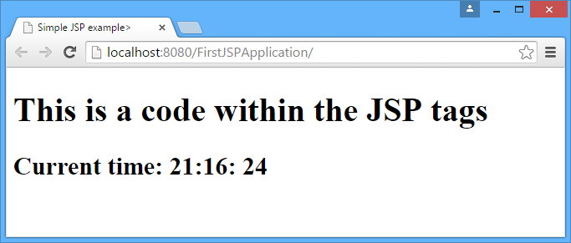

The Expected Output

Solution

To create a JSP page, you need to perform the following steps:

1. Open NetBeans**.**
2. Click **File** 🡪 **New Project**. The **New Project** dialog box appears, as shown in the following figure.

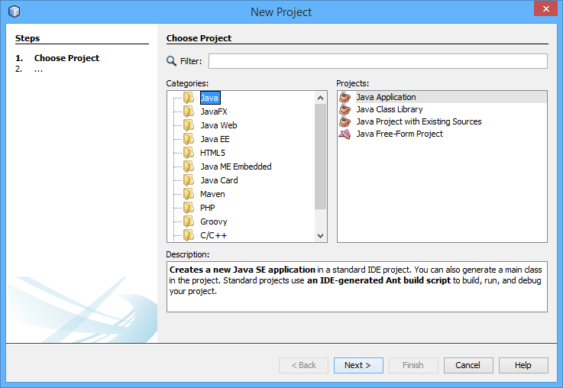

The New Project Dialog Box

1. Select **Java** **Web** in the **Categories** tree view.
2. Select **Web Application** in the **Projects** list box.
3. Click the **Next** button. The **New Web Application** dialog box appears.
4. Type **FirstJSPApplication** in the **Project Name** text box.
5. Click the **Next** button.
6. Select the server and other details.
7. Click the **Finish** button.
8. Select the **Web Pages** folder.
9. Click **File** 🡪 **New File**. The **New File** dialog box appears.
10. Select **Web** in the **Categories** tree view.
11. Select **JSP** in the **File Types** list box.
12. Click the **Next** button.
13. Enter **FirstPage** in the **File Name** text box.
14. Click the **Finish** button.
15. Open your JSP file and replace the code written between the **<html></html>** tags with the following code:

<HEAD><TITLE>Simple JSP example></TITLE></HEAD>

<BODY>

<H1>This is a code within the JSP tags </H1>

<%--This is the JSP content that displays the server time--%>

<H2> Current time: <%= new java.util.Date().getHours() %>:<%= new java.util.Date().getMinutes()%>: <%= new java.util.Date().getSeconds() %></H2>

</BODY>

1. Save the **FirstPage.jsp** file.
2. Click **File** 🡪 **New File**. The **New File** dialog box appears.
3. Select **Standard Deployment Descriptor (web.xml)** in the **Categories** tree view.
4. Click the **Next** button.
5. Click the **Finish** button.
6. Select the **Pages** tab in the web.xml file to set the welcome file of the application.
7. Click the **Browse** button. The **Browse Files** dialog box appears, as shown in the following figure.

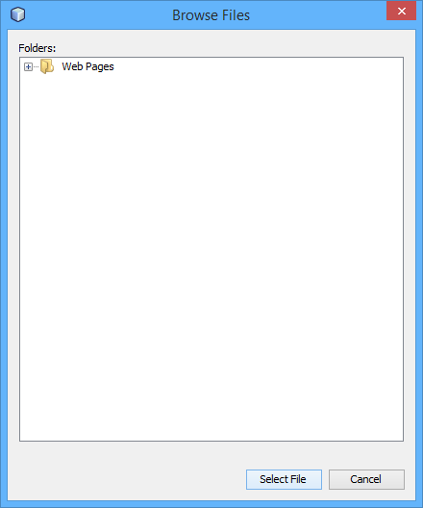

The Browse Files Dialog Box

1. Select the **FirstPage.jsp** file.
2. Click the **SelectFile** button.
3. Press the **F6** key to run the application. Web browser will display output, as shown in the following figure.



The Expected Output