**Data Model**

The ERM for the Family Shopping List consists of several entities as depicted in Figure 1. A good starting point to walk through the model is the family entity. It provides a connection to all family_members where a family consists of at least one member. In this application the number of family members is capped to the number of available colors.

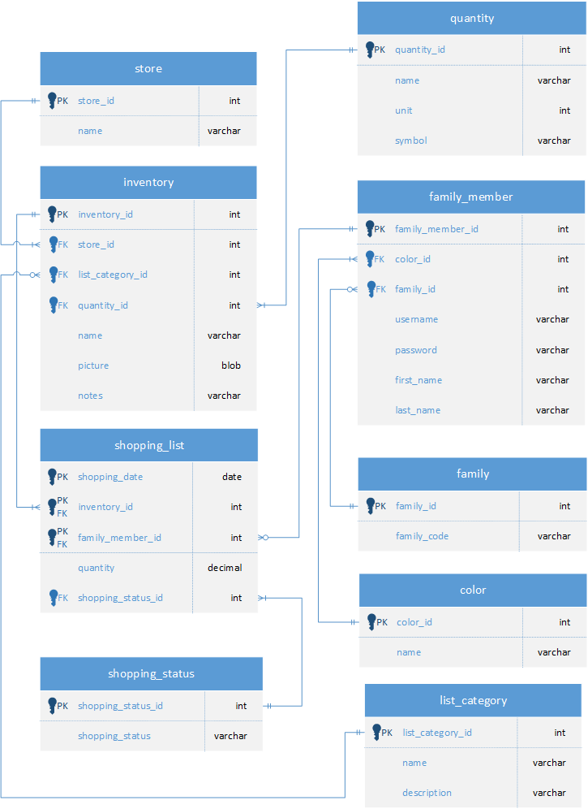

Figure 1: Entity Relationship Model (ERM) for Family Shopping List

Each family member is assigned to exactly one color. The color is used by the application to symbolize the member of the family as a colored dot. Hence, the number of colors is the limit of how many members a family can have. There is no immediate reason why this number cannot be increased. It is currently set to 7 during the seeding process of the database. The colors that the first member can choose from are red, pink, green, purple, bule, orange, and gray. Every following member has less to choose from, obviously.



Figure 2: Family entity to join all family members together

The family_code attribute in family (Figure 2) is used by the application to allow joining an existing family by a new family member. It is created by the application when a new family signs up and a family registration is completed, which includes a family member is signed up and this is important because if no member signs up the code cannot be accessed anymore. This is indicated by the optional relationship between family and family_member.



Figure 3: Family members basic data attributes

The family_member entity consists of basic attributes such as username, password, first_name, and last_name as shown in Figure 3. The password is stored in an encrypted way to follow good practice. The entity family_member is required to contribute to a shopping list. The shopping_list entity (Figure 4) is modelled as a collection of items that family members want to get from a store. The primary key of this entity is a shopping date, an inventory item and the family member. The idea is that each family member can add items independently to a shopping date without interfering with each other. The shopping list is then all inventory items for the same shopping date by a family, which is comprised of all family members.



Figure 4: Shopping list is a collection of inventory items for a given date

Each shopping list item also requires the quantity of an inventory item. For example, if the inventory item is ‘green apples’, then the quantity could be 3 lbs or 6 apples (numbers of apples). An inventory item uses the quantity entity to define how this should be used. The shopping status is another attribute of the shopping list item that indicates whether the item is ‘open’ (only on the list), ‘incart’ (it is in the shopping cart), ‘purchased’ (actually paid for), and ‘closed’ (it’s done).



Figure 5: Inventory item for a store

The inventory entity (Figure 5) represents an item that can be purchased at a specific store in a specific quantity. Each item is assigned to a category. The idea is that items within a category are found in the same vicinity within a store. The categories apply to all stores but can be easily extended. It also contains the name, some notes, and a picture of the item. The picture is stored as a blob (binary large object) in JPEG format.