Week 11 & 12: Incident and Threat Response Assignment

1. A screenshot that shows Autopsy is installed on your laptop.

2. Generate an HTML report link and share a screenshot of it. Example is shown below HTML Report Link : Autopsy Forensic Report for case success011A screenshot of a computer

3. Send me screenshots of the Following or write answers to each question in a word document:  
• Time and date when U.S Securities and Exchange Commission (Home Page) was  
accessed for the case file assigned to you

http://www.sec.gov/ 2008-12-28 23:32:27 CST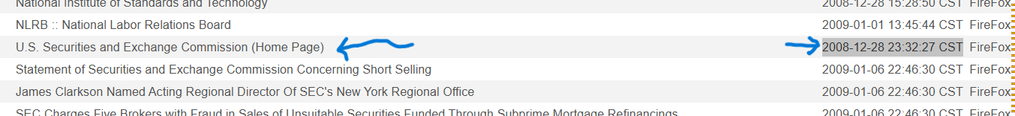

* Time and date when the Managing_Information_Risk.pdf file was modified.

|  |  |  |  |  |  |  |  |  |  |  |  |  |  |  |  |  |  |  |  |  |  |  |  |  |  |  |  |  |  |
| --- | --- | --- | --- | --- | --- | --- | --- | --- | --- | --- | --- | --- | --- | --- | --- | --- | --- | --- | --- | --- | --- | --- | --- | --- | --- | --- | --- | --- | --- |
| | **Date Created** | **Date Modified** | **Last Printed Date** | **Organization** | **Owner** | **Program Name** | **User ID** | **Version** | **Source File** | | --- | --- | --- | --- | --- | --- | --- | --- | --- |  |  |  |  |  |  |  |  |  |  |  | | --- | --- | --- | --- | --- | --- | --- | --- | --- | --- | | 2003-06-06 16:59:45 CDT | 2003-06-10 16:38:29 CDT |  |  | Andy Black |  |  | 1.4 | /img_ubnist1.casper-rw.gen3.E01/home/ubuntu/Documents/Managing_Information_Risk.pdf |  | | 2003-06-06 16:59:45 CDT | 2003-06-10 16:38:29 CDT |  |  | Andy Black |  |  | 1.4 | /img_ubnist1.casper-rw.gen3.E01/home/ubuntu/Documents/hacks/Managing_Information_Risk.pdf |  | |

• What is the subject line of the email sent that was sent by [evolution@novell.com](mailto:evolution@novell.com)

• Which Web Search engine was used to search ‘Voice of America’.

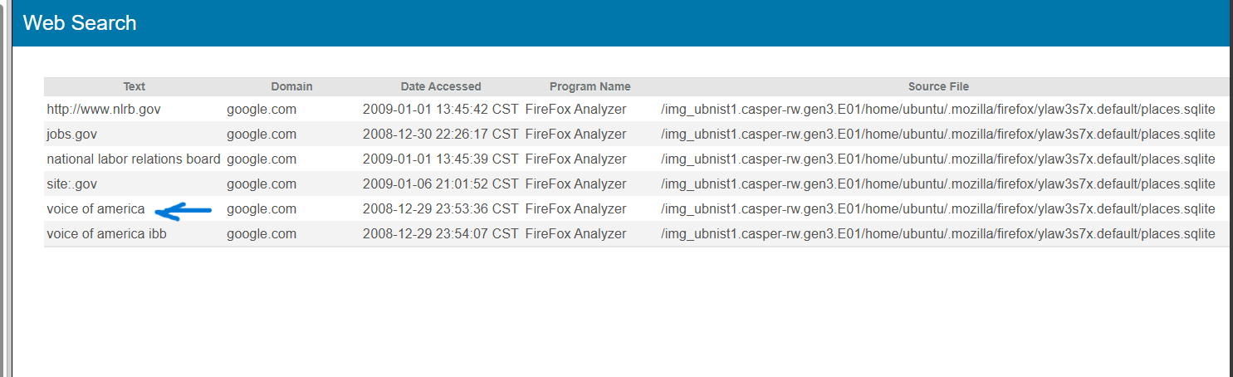

• What is the total number of web downloads in the sample case file?

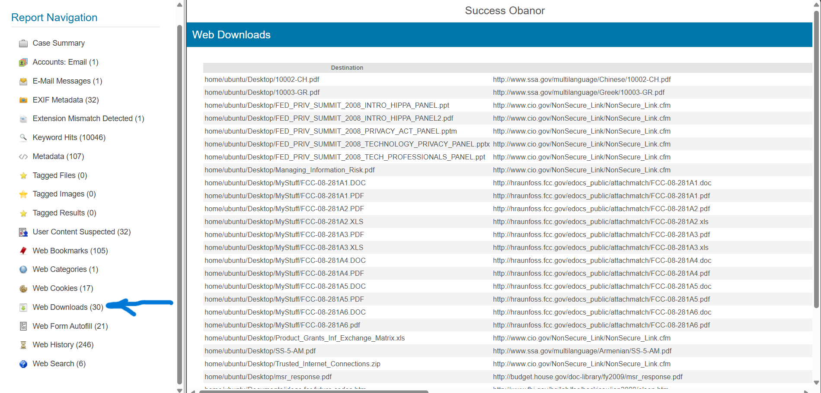

* Files show gaps between creation and modification dates, suggesting revisions or long-term archiving.A screenshot of a computer

  Description automatically generated