1. As southern hemisphere is closing to sun currently (summer), northern hemisphere has low temperature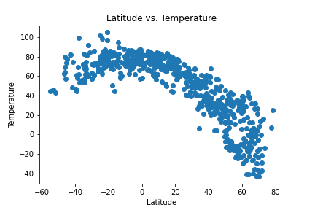
2. There is weak correlation between Latitude and Cloudiness

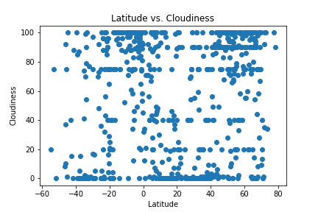

1. There is weak correlation between tempreture and wind speed for southern Hemisphere