

Assessment Cover Page
Student Full Name
Oscar Juárez Paz
Student Number
2026801
Module Title
Stats for Data Analytics
Assessment Title
Capstone Project
Lecturer/Supervisor
Taufique Ahmed
Assessment Due Date
01/11/2026
Date of Submission
01/11/2026
Link to GitHub Repository
oscar-juarez-cct/ambulance-incidents: Ambulance Incidents Analysis for Statistical Data Analysis Course
Use of AI Tools
Choose the statement that fits your work and delete the other.
I acknowledge the use of Anthropic’s Claude Models for the purpose of helping write jupyter notebooks for obtaining and cleaning the data from EirGrid Smart Grid Dashboard API. Claude helped identify the dashboard's data endpoint and its limits, and helped write a collector that runs hourly through GitHub Actions. I reviewed, tested and approved the code before using it. I also used Claude to check grammar and spelling, and to look up background information. The exact prompts and relevant outputs are included in the appendix and in the separate AI-use document.
Declaration
By submitting this assessment, I confirm that I have read the CCT policy on academic misconduct and understand the implications of submitting work that is not my own or does not appropriately reference material taken from a third party or other source.
I declare it to be my own work and that all material from third parties has been appropriately referenced.
I further confirm that this work has not previously been submitted for assessment by myself or someone else in CCT College Dublin or any other higher education institution.

Contents
Introduction 1
Dataset Summary 2
Data Preparation 2
Categorical Values 2
Numerical Values 2
Key Plots 2
Discrete Distributions 5
Binomial: Echo Calls Reached Within 18:59 5
Poisson: Echo Calls per Day 6
Normal Distribution: Calls per Day 8
Comparing the Distributions 9
Conclusion 10
References 11

Introduction
This report analyses the Dublin Fire Brigade (DFB) ambulance incident log for 2025, published by Dublin City Council on Ireland’s open data portal (Health Service Executive, 2025). The dataset records more than 80,000 ambulance incidents in 14 stations across Ireland, with each incident’s priority category, station, and the times at which the call was received. The analysis aims for two objectives: performance and demand. Performance in whether the DFB meets the Health Service Executive’s (HSE) National Ambulance Services 2025 targets 75% of Echo calls within 18 minutes and 59 seconds.

Dataset Summary

Data Preparation
The dataset has 12 columns, of which station, priority and call time have no missing values, but the vehicle timestamps do: the arrival time is missing for 12.6% of incidents and the hospital times for about a third. Dropping every incomplete row would bias the results, so all rows were kept and missing values were only excluded for when a specific variable was analysed. Three variables were created: dispatch delay, travel time and response time; these are measures used by the HSE targets. Data had to be corrected when a job crossed midnight, and when arrivals were logged before the call was treated as error.

Categorical Values
Priority, which contains six levels: from Echo, the most critical priority (cardiac or respiratory arrest) to Omega (minor illness), therefore it was summarized with counts and percentages. Delta calls has a higher rate than Echo calls, with 48.1% vs 2.5% respectively. Of the 14 stations, Tallaght and Tara Street are the busiest, with 16.9% and 13.2 respectively. Dun Laoghaire handled only 339 incidents through 2025, which is only 0.4% of the total.

Numerical Values
Response time has a mean of 51.8 minutes, a median of 27.3 and a standard deviation of 64.1. The gap between the mean and the median shows a positive skew: most calls are reached quickly, but slow responses pulls the mean up; which is why it’s more representative to use the median to analyse results. The IQR rule (upper fence ~129 minutes) flags 9.5% of responses as outliers. Echo calls have the lowest median, and Omega the highest with ~11 minutes vs ~40.8 minutes. By station, the median ranges from 14.9 minutes at Dun Laoghaire to 45 minutes at Skerries, showing that rural stations take about three times longer of response time. 78.4% of Echo calls were reached within 18:59, close to the HSE’s projected 2024 result for Dublin Fire Brigade of 80% (Health Service Executive, 2025). This suggest the response time calculation is reliable.

Key Plots
In figure 1, a histogram shows the shape of response time. From it, we can see the tallest bar is just below 18:59 target, but the median is about 8 minutes above it, and the right tail pulls to mean to 52 minutes.
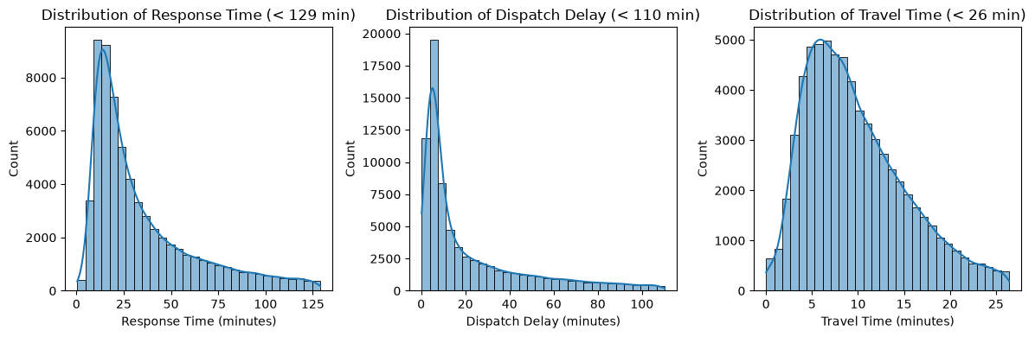
Figure 1. Distribution of Response Time, Dispatch Delay and Travel Time
In figure 2, a boxplot compares the six priority levels side by side. Only Echo has most of its box below the 18:59 line, which shows the service priorities cardiac arrests as intended. Every other level is mostly above it.
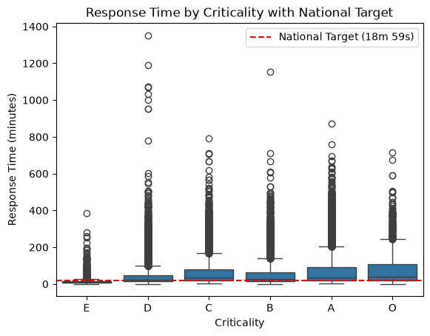
Figure 2. Boxplot of Response time by Priority Levels
In figure 3, a horizontal bar chart ranks stations by the share of Delta calls reached within 18:59. Only four inner city stations reach the 45% target, while Skerries and Balbriggan are far below, with an 11.6% and 15.4% of calls reached below the national target.
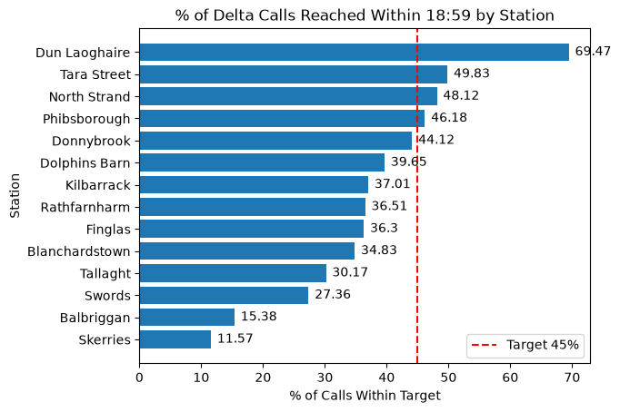
Figure 3. Horizontal bar chart of Delta within Target by Station
In figure 4, a line chart shows how demand changes through the day. Calls fall below 2,000 at 5:00am and peat at about 4,500 at 6:00pm, so the call rate is not constant within a day. This behaviour shows a good reason to use a Poisson model, using whole days rather than hours.
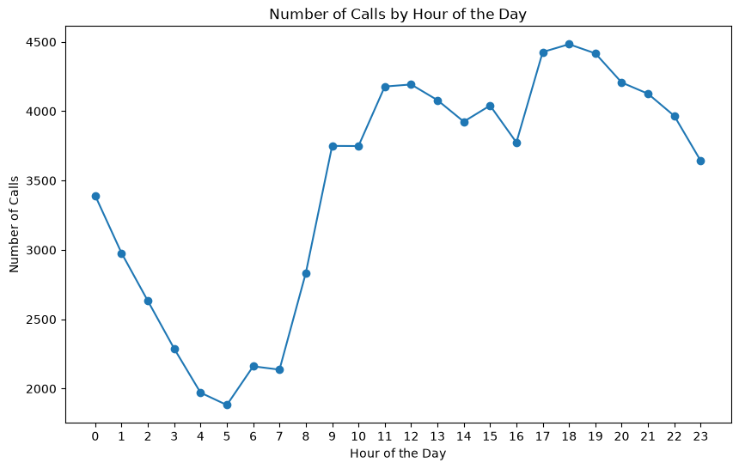
Figure 4. Line Chart of Number of Calls by Hour of the Day

Discrete Distributions

Binomial: Echo Calls Reached Within 18:59
For the binomial distribution, the outcomes of a call were used: Is the call reached within 18:59 or not. Our focus is Echo calls, so with a fixed number of calls n, each with the same probability p of success, the number reached in time follows a Binomial Distribution:
P(X = k) = nkpk(1 - p)n - k
From the data, p = 0.784, and n = 6, the median number of Echo calls per day. The probability that all six calls in a day are reached in time P(X = 6) = 0.784^6 = 0.232, so on 76.8% of days at least one cardiac-arrest patient waits longer than 18:59. This meets the target of 75% on a day with six calls.
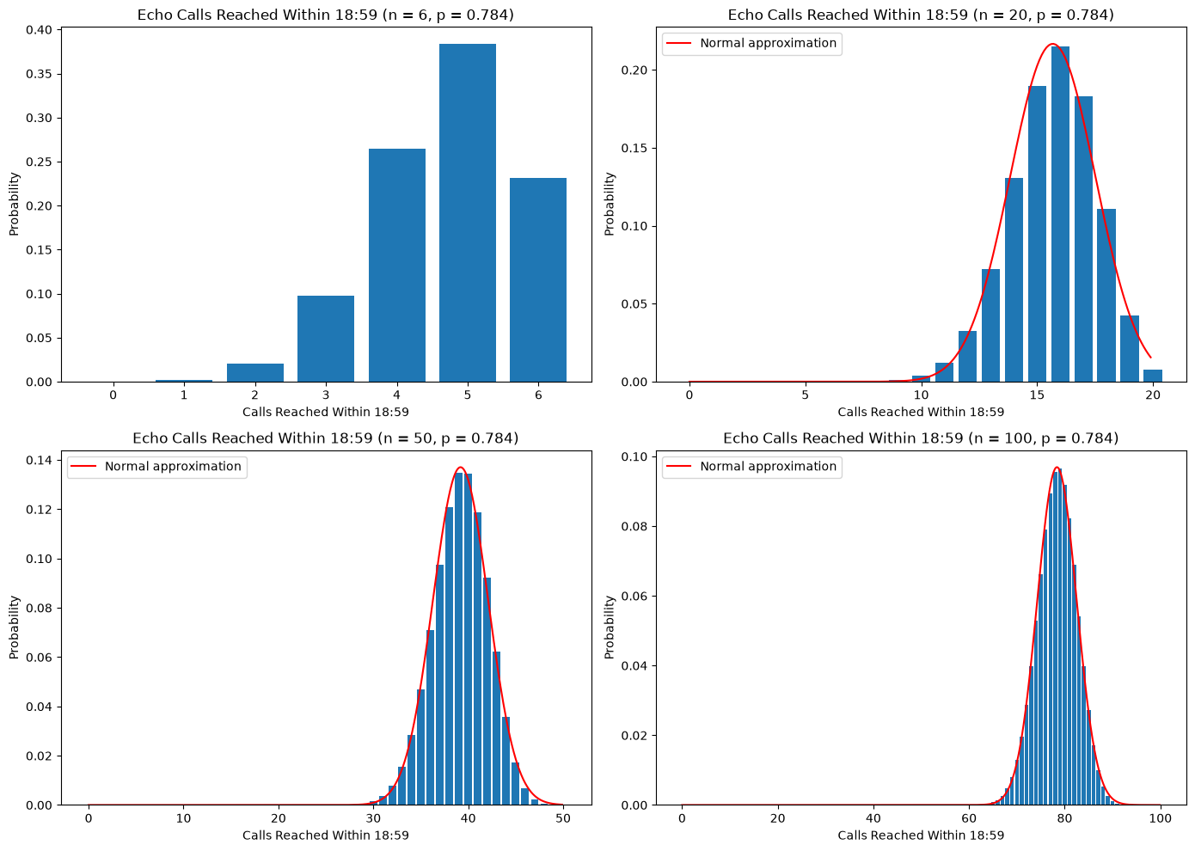
Figure 5. Binomial Distribution of Echo Calls Reached Within 18:59 as n Increases
Figure 5 shows what happens as n grows. At n = 6, the distribution is negatively skewed to the left because p is high. By n = 50 and n = 100, it becomes a symmetric bell and the Normal curve fits, as expected once np >= 10 and n(1 - p) >= 10 (at n = 50).

n | P(Echo >= 75%)
6 | 0.616
20 | 0.748
50 | 0.726
100 | 0.828
Table 1. Chance of Meeting 75% Target as n Grows
Table 1 shows that the chance of meeting the 75% target rises from 61.6% at n = 6 to 82.8% at n = 100. Because the true rate (of 78.4%) is above the target, the more calls are combined and the more reliably the target is met.

Poisson: Echo Calls per Day
The Poisson distribution models the number of events in a fixes time window when events occur at an average rate of lambda (λ)
P(X = k) = λk*e-λk!
Echo calls per day have a mean of 5.6 (λ) and a variance of 5.66. For example, the probability of a day with no Echo calls is
PX=0=e-5.6=0.004
Which means about one day a year, and 2025 had exactly one such day.
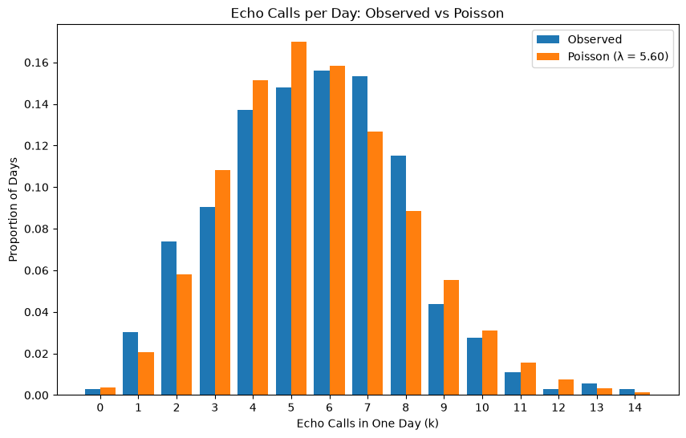
Figure 6. Observed vs Poisson Proportions
Figure 6 compares observed and Poisson proportions. Both have a very similar shape, which is centred in 5 and 6 calls, even though the data has one or two more days than predicted.
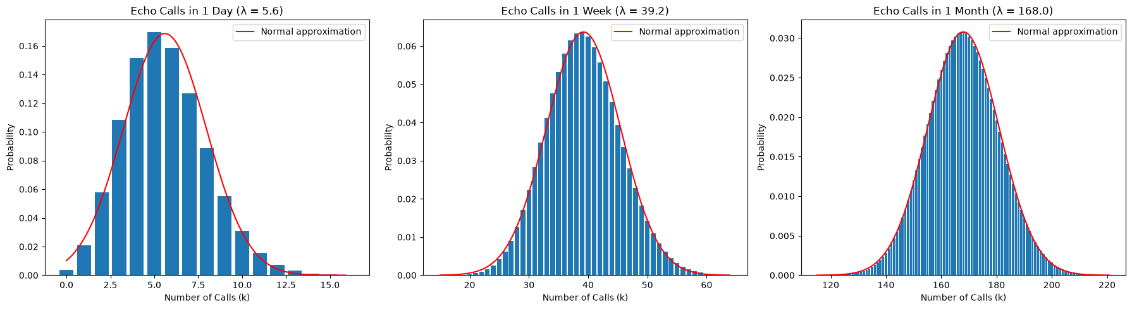
Figure 7. Distribution of Echo Calls Throughout a Day, Week and Year
Figure 7 shows a large-sample behaviour. As the time grows from a day, to a week and a month, the distribution becomes a symmetric bell and the Normal curve fits. Therefore, Echo counts should be modelled as Poisson, while weekly and Monthly can be treated as normal.

Normal Distribution: Calls per Day
For the normal distribution I chose calls per day, since for a large lambda the data seems to behave like a Normal Distribution, with a mean of 228.04 and a standard deviation of 16.59.
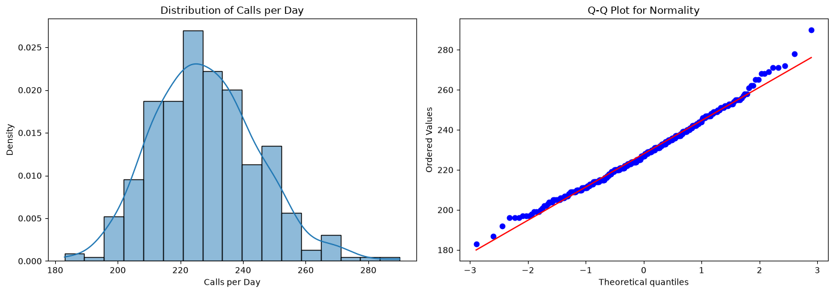
Figure 8. Histogram of Distribution of Calls per Day and Q-Q Plot for Normality.
The histogram on figure 8 supports the symmetric bell shape, the mean and the median are almost equal with 228 and 227 respectively. The skewness is 0.36, slightly positively skewed. The 68 – 95 – 99.7 rule holds: 67.7%, 95.9% and 99.5% of days fall within one, two and three standard deviations of the mean. The Q-Q plot follows the straight line, except at the top right where the busiest days are higher than what the normal predicts.
The probability of a day with more than 250 calls uses a z-score:
z =250 - 228.0416.59 = 1.32, so PX > 250= 1 - 0.907 = 0.093
This predicts 34 busy days a year, which is the number observed. The mean ± 2 standard deviations gives a range of 195 to 261 calls for 95% of days, so planning for about 261 calls cover all the busiest days.

Comparing the Distributions

Variable | Mean | Median | Skewness
Echo response time (minutes) | 18.08 | 11.12 | 6.1
Echo calls per day | 5.6 | 6 | 0.25
All calls per day | 228.04 | 227 | 0.36
Table 2. Shape of the variables used for each distribution
Each variable was matches to the distribution whose shape it has Table 2. Echo response time is positively skewed (6.10), so it was turned into a yes or no outcome for the Binomial. Echo calls per day are small counts with a variance close to the mean, which suits the Poisson, and there are many total calls per day and is almost symmetrical, which suits the Normal. Echo calls per day are less skewed (0.25) than total calls (0.36), but their small whole number values makes them discrete.
The discrete variables can’t be normal for a single day, since n(1 - p) = 1.3 at n = 6 and λ = 5.6 is below 10. Bar charts suit the discrete Binomial and Poisson, while a histogram with a KDE and a Q-Q plot show the shape of daily totals and test normality.

Conclusion
For performance, Dublin Fire Brigade meets the 75% Echo target overall, with 78.4%. On 76.8% of days, at least one cardiac arrest patient waits longer than 18:59. Delta performance is worse, with only four inner-city stations reached the 45% target, and the north county stations are the slowest for both priorities.
For demand, calls are stable and predictable. Echo calls follow a Poisson distribution at about 5.6 a day, and total calls follow a Normal distribution, with 95% of days between 195 and 261 calls. Therefore, the main problem is Delta’s response speed, specially north county stations.

References
Dublin City Counsil, 2026. DFB Fire and Ambulance Incident Data: Dublin Fire Brigade Ambulance (DA) annual incident activity logs for 2025. [Online]
Available at: https://data.gov.ie/dataset/fire-brigade-and-ambulance
[Accessed 29 October 2026].
Health Service Executive, 2025. HSE National Service Plan 2025, Dublin: Health Service Executive.

