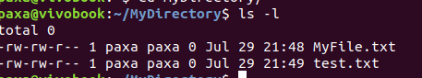
1.

2.

3.
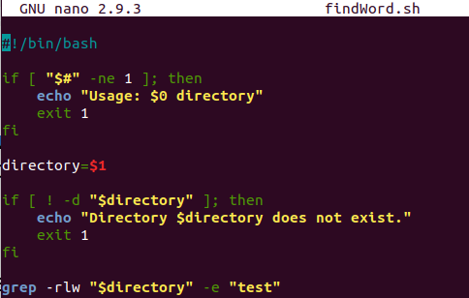

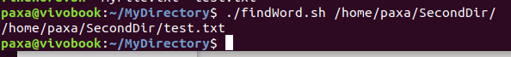

4.
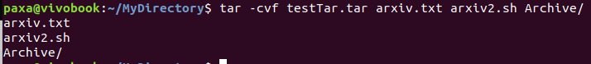
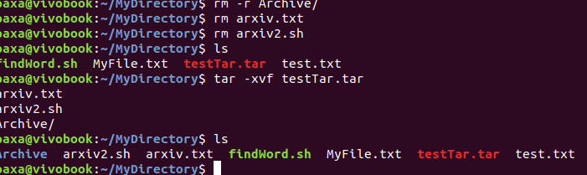

5.
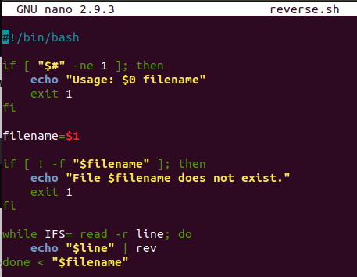

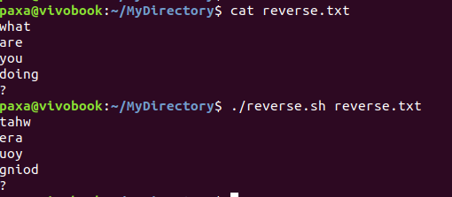

6.
#!/bin/bash

directories=(
"/home/paxa/MyDirectory"
)

backup_dir="/home/paxa/backup_dir"

date=$(date +"%Y-%m-%d_%H-%M-%S")

for dir in "${directories[@]}"; do
if [ -d "$dir" ]; then
base_name=$(basename "$dir")
tar_file="$backup_dir/${base_name}_backup_$date.tar.gz"
tar -czvf "$tar_file" "$dir"

echo "Backup of $dir created as $tar_file"
else echo "Directory $dir does not exist."
fi
done

// then in crontab crontab -e
0 2 * * 0 home/paxa/backup.sh (every sundat @2a.m.)

7.

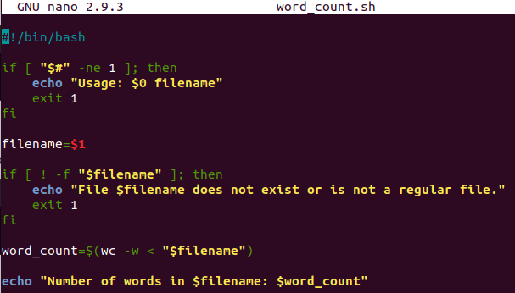

8.
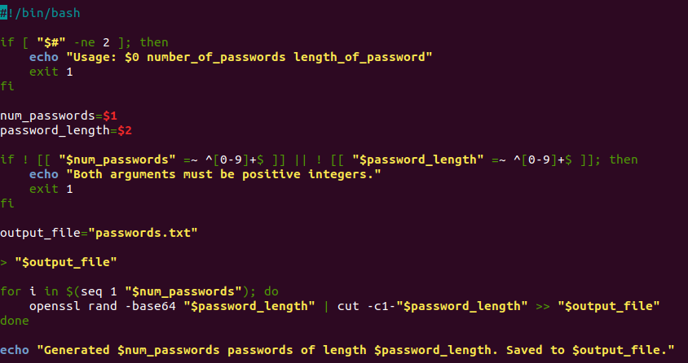

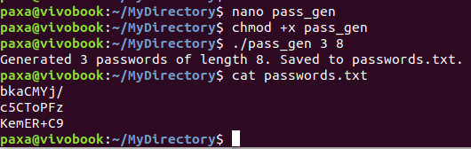

9.
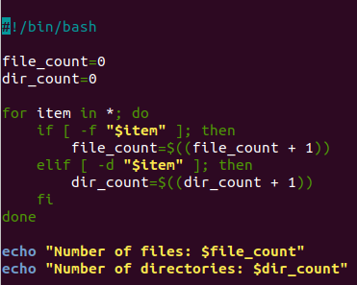

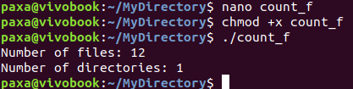

10.
