Houses Prices Prediction using XGBOOST

Steps taken

1. Business Understanding

Understanding the data

1. Data Understanding

Loading the data

Getting information about the data the columns data types etc

1. Data Preparation

Checking and handling missing values

Checking for consistency by checking duplicates

Checking for Unifomity in the data types of the column

Checking for validity by checking and handling outliers

Handling the catagerical columns by label encoding

Scaling the data

Splitting the data into X_train and y_train

1. Modelling

Baseline XGBOOST model with a score of 87%

Hyperparameter tuning using gridSearchCv to get the best parameters  
Tuned XGBOOST model with a better score of 89%

1. Model Evaluation

Testing the test data

Plots 1

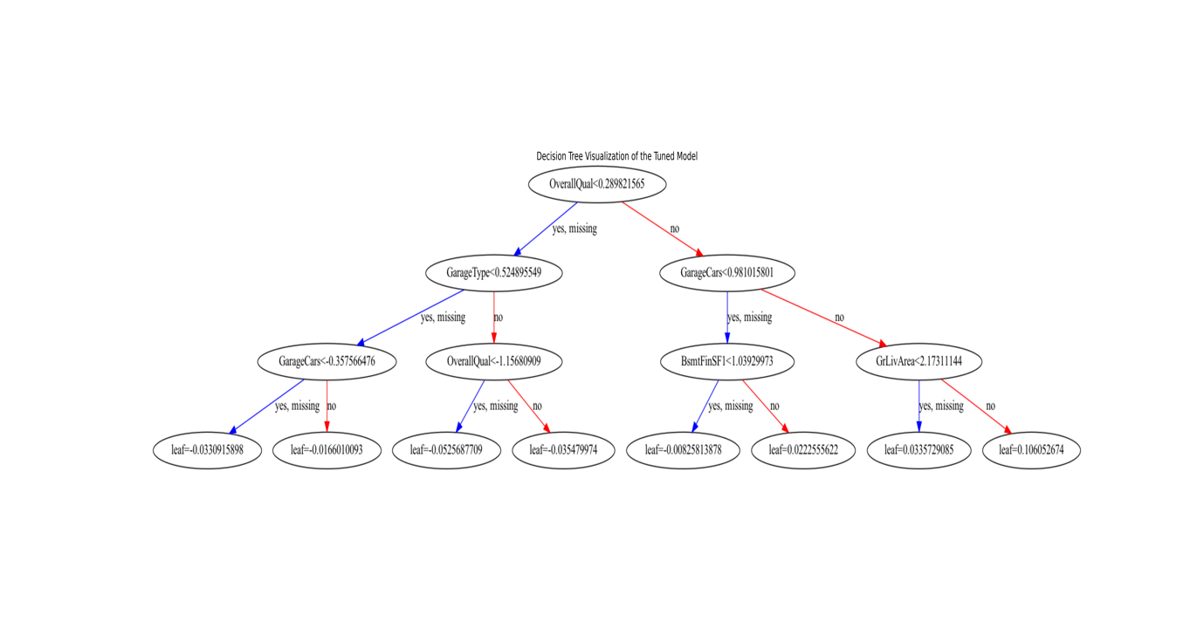

Plot 2 for the tuned model   
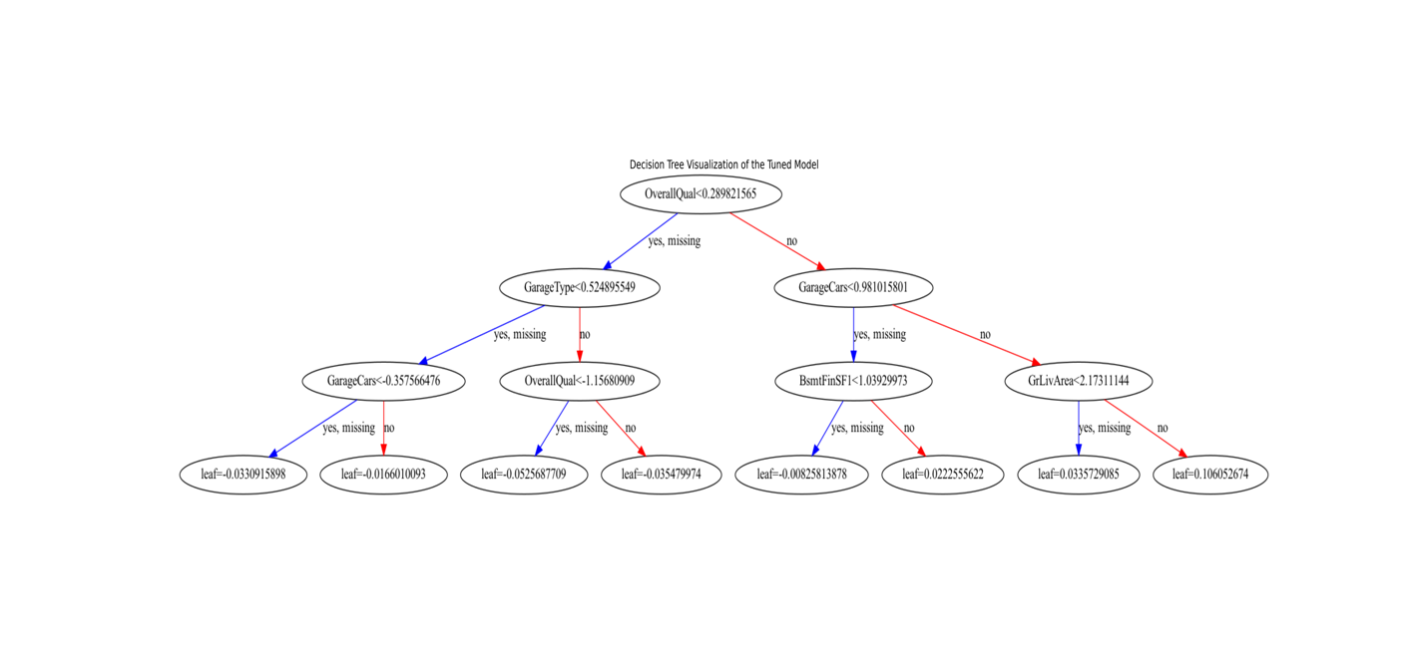

Plot 3

