Table of Contents

GitHub 1

Composer 2

Propel 3

Slim 3

Works Cited 4

# GitHub

**Overview**

GitHub is a web-based hosting service for version control using git. It is mostly used for computer code. It offers all of the distributed version control and source code management functionality of Git as well as adding its own features [1].

**Installation**

To install git on your machine follow the instructions from <https://git-scm.com/downloads>. Once it’s installed, run the command *git* in the terminal, and you should receive instructions on how to use the commands.

**Important commands**

|  |  |
| --- | --- |
| Command | Explanation |
| git init . | Initialize a Git repository in the current directory |
| git clone repo_url.git | Create a local copy of a remote repository |
| git status | Check status since last pull |
| git add [file] | Add a file to the staging area |
| git add –A | Add all new and changed files to the staging area |
| git commit –m “commit message” | Commit your messages |
| git push -u origin [branch name] | Push a branch to your remote repository (almost always master) and remember the branch |
| git push | Push changes to remote repository of remembered branch |
| git pull | Update local repository to the newest commit |
| git remote add origin repo_url.git | Add a remote repository |
| git rm –r [file] | Remove a file or directory |

**Github notes**

These commands will be mostly used while working in a project, if you encounter a problem or would like to learn more, go to <https://try.github.io/>. Unlimited private remote repositories are available through a fee, or by registering as a student, which is recommended. Merge conflicts can be a pain to deal with, and therefore should be resolved with atom/sublime or be avoided completely. Make sure to **always pull before you push**, and therefore obligating you to commit any changes.

# Composer

**Overview**

Composer is an application-level package manager for the PHP programming language that provides a standard format for managing dependencies of PHP software and required libraries [2].

**Installation**

Composer can be installed following the guide in <https://getcomposer.org/doc/00-intro.md>; make sure it’s a global installation. Once it’s installed, run *composer* in the terminal, and you should receive the composer screen. In case of an error, make sure you follow the steps correctly with admin privileges (e.g. using sudo on a Unix machine).

**Important composer commands**

|  |  |
| --- | --- |
| Command | Explanation |
| composer require package/library | Will update composer.json with the new dependency or create a new composer.json and composer.lock if they don’t exist |
| composer install | Installs the vendor packages according to composer.lock (or creates composer.lock if not present) |
| composer update | Will regenerate composer.lock with the new composer.json dependencies and versions, no matter if composer.lock exists or not |
| composer dump-autoload -o | Regenerates the list of all classes that need to be included in the project (vendor/composer/autoload_classmap.php). |

**Example composer.json file**

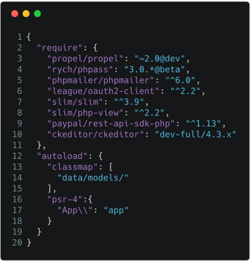

*Explanation of composer.json:*

**require**: {…} lists the dependencies required for the project (propel, slim, etc...)

**autoload**: {…} lists extras to be included when *composer dump-autoload –o* is ran. classmap allows directories to be included in the autoload process. The psr-4 autoload is used to define the mapping from namespaces to directories. The example filename would be app/hello.php containing an App\Hello class.

**Composer notes**

Make sure that any of the composer commands are ran in the same directory as the composer.json, or the commands will fail. Composer will download the dependencies into a vendor/ directory, which it will create if it doesn’t exist. Every dependency will have a directory, for example, propel will be inside vendor/propel. *composer dump-autoload –o* will **not** work in the previously shown composer.json example if data/models and app/ directories don’t exist. If you want to test it, simply remove everything except require: {…}.

# Propel

**Overview**

Propel is a free, open-source object-relational mapping toolkit written in PHP. It is also an integral part of the PHP framework Symfony and was the default ORM up to, and including version 1.2 [3].

**Installation**

Require it in composer.json:

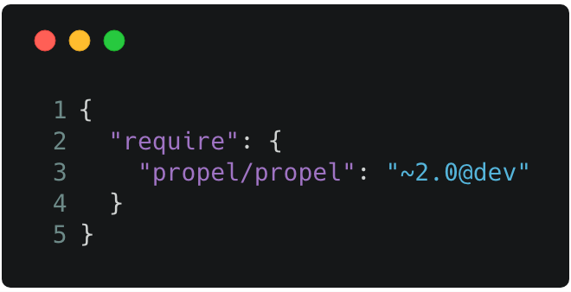

**Important Propel commands**

|  |  |
| --- | --- |
| Command | Explanation |
| vendor/bin/propel init | Initialize propel installation |
| vendor/bin/propel reverse | Create a new schema.xml with the updated database information (inside generated-reversed-database directory) |
| vendor/bin/propel model:build | Rebuild the models according to schema.xml |

# Slim

**Overview**

Slim is a PHP micro framework that helps you quickly write simple yet powerful web applications and APIs. At its core, Slim is a dispatcher that receives an HTTP request, invokes an appropriate callback routine, and returns an HTTP response. That’s it [4].

**Installation**

Require it in composer.json:

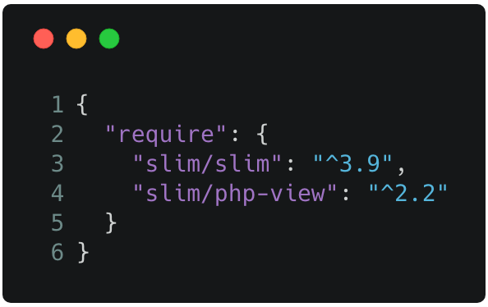

Run composer update to download slim and its dependencies. The dependencies will be downloaded into the vendor/ directory; if you see a slim directory in vendor/ you’re set.

**Getting started**

Create an index.php file and type the following:

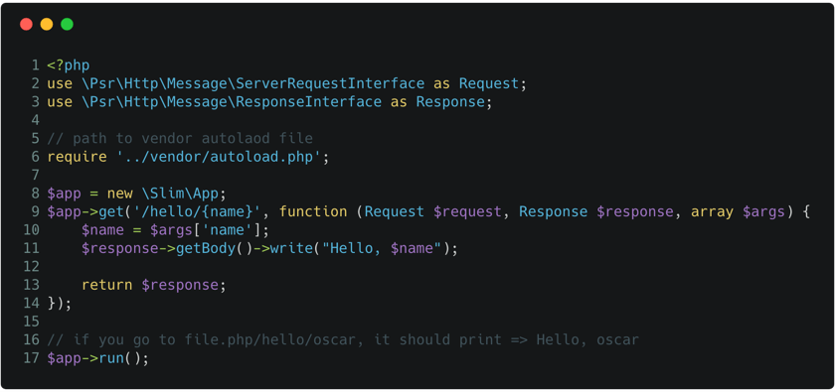

# Works Cited

[1] Wikipedia. March 23, 2018. Github. <https://en.wikipedia.org/wiki/Composer_(software)>

[2] Wikipedia. March 24, 2018. Composer. <https://en.wikipedia.org/wiki/Composer_(software)>

[3] Wikipedia. March 12, 2018. Propel (PHP). <https://en.wikipedia.org/wiki/Propel_(PHP)>

[4] Slim Framework. March 26, 2018. Documentation. <https://www.slimframework.com/docs/>