**第一題**

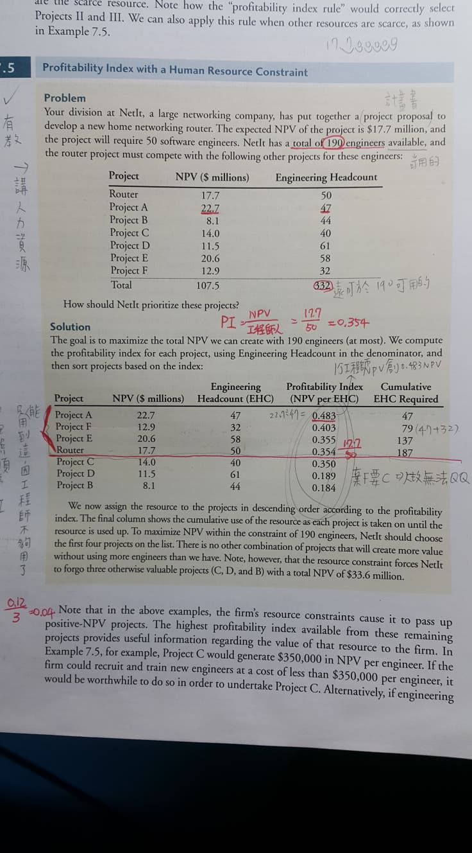

**第二題**

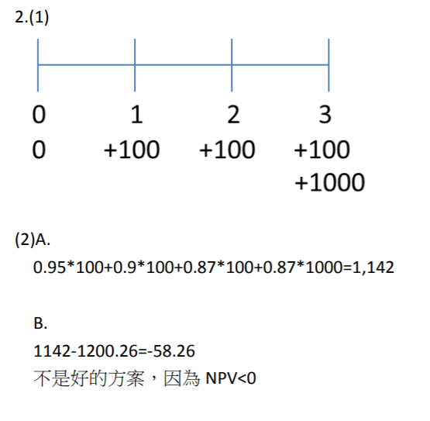

**第三題**

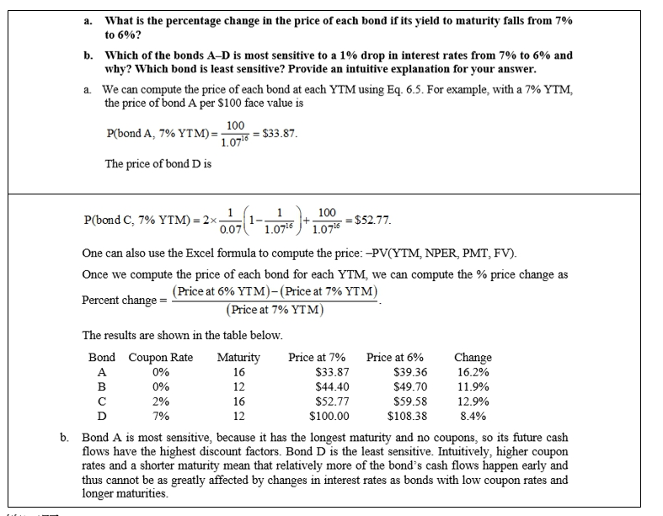

**第四題**

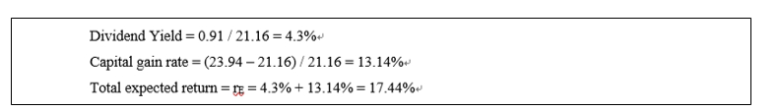

**第五題**

The price in one year is P(t+1) = Div(t+2)/(r – g) = 0.25/(.10 – .02) = $3.13

The price today is P(t) = P(t+1)/(1+r) = $3.125/1.1 = $2.84

**第六題**

Estimate rE: rE = Div Yield + g = 4.07 / 50.31 + 2.8% = 10.89%

New Price: P = 2.47/(10.89% – 4.9%) = $41.24

In this case, cutting the dividend to expand is not a positive NPV investment.

**第七題**

兩年前採行5年方案，所以從第3年開始算

300,000 *PVIF10%,1+350,000* PVIF10%,2+550,000* PVIF10%,3=975,185

終止投資可得1,000,000 > 不終止投資 975,185

最終決定:終止投資

**第八題**

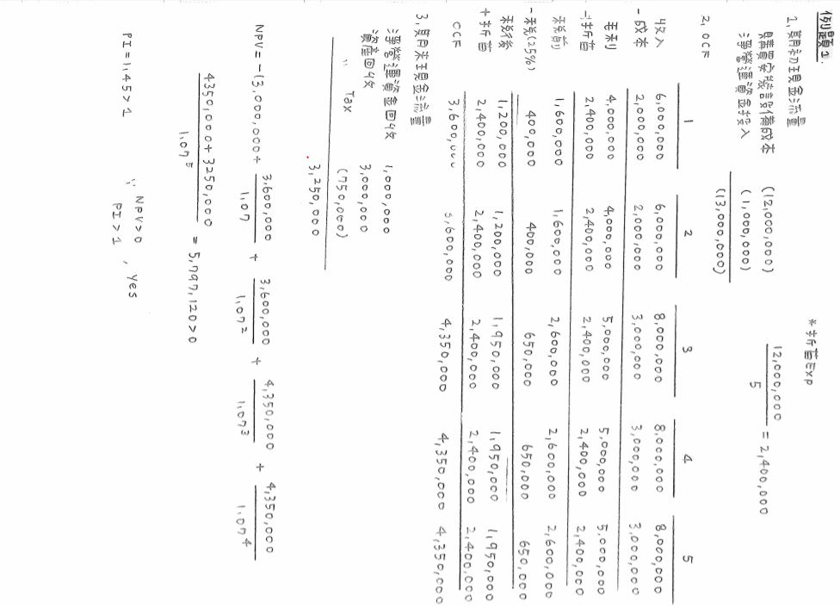

**第九題**

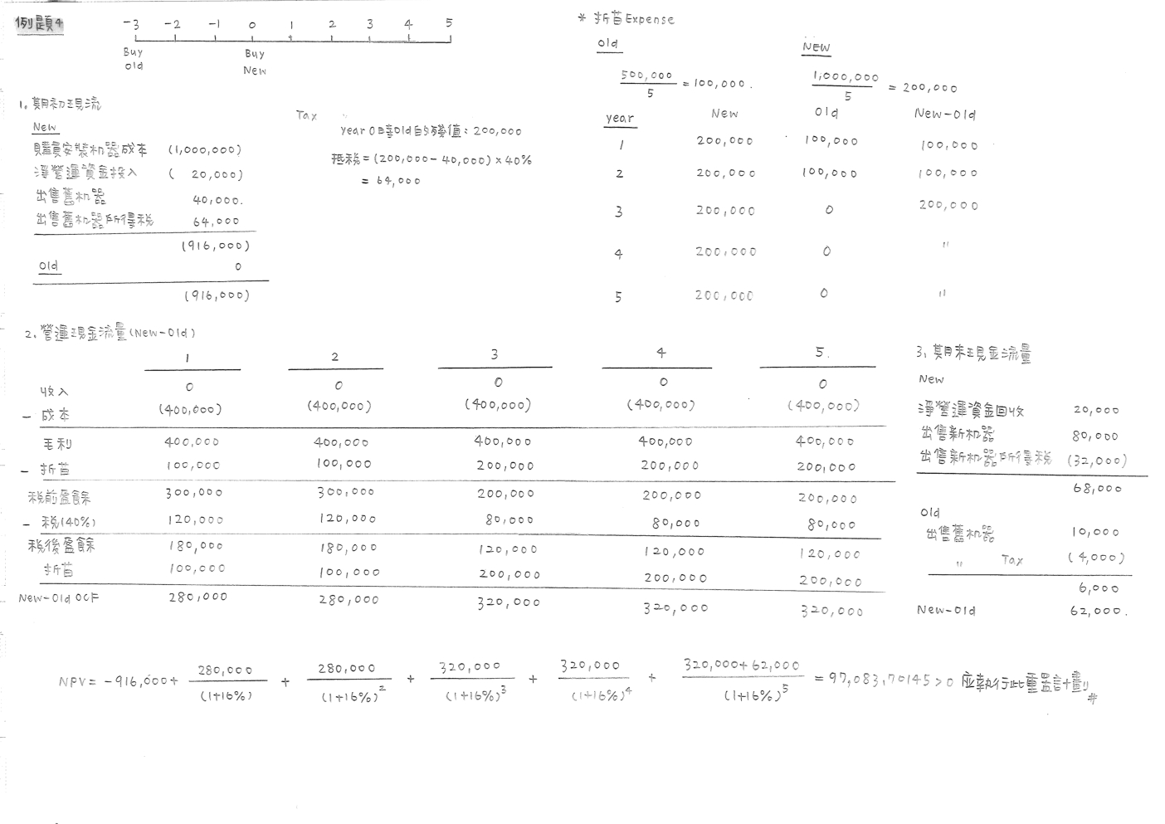

**詳見pdf檔**