**第一題**

(1)股東

(2)股東對公司所負債務清償責任僅以出資額為限

(3)因公司的經營權和所有權分離

(4)**代理成本**：

Perquisites (Perks)：特權消費。

Shirking：不認真工作。

Empire building：管理者有使公司的成長超越最適規模的動機。隨著可控制資

源的增加，管理者權力與報酬都會增加。

過度投資：管理當局投資於不賺錢 (NPV<0) 的投資計畫。(常有高額採購

案公司的現金流量愈高，經理人受到資本市場的監督較少，往往未謹慎使用。)

放棄有利公司的投資案（NPV>0）。(放棄誘人卻有相當風險的投資方案，因為他們只擔心個人的職位是否安穩甚于公司潛在可觀的利潤)

監督成本

(5)**要如何利用公司治理機制的大股東以及專家的監督來解決股東和經理人之間的代理問題？**

**獨立董事**:應以獨立超然的立場監督公司運作，通常為具備專門學識或專業能力者擔任。

**不是管理當局的大股東**:大股東有較大的動機和能力去收集公司的內部資訊，瞭解管理者是否確實保障股東的利益及監督管理者的行為，並利用其持有的大額投票權來影響管理者的決策。

**機構投資人**:機構投資人通常擁有雄厚的資金基礎，持股比例具有相當影響程度。

**並請說明公司治理中 free rider 的現象**

不是管理當局的大股東有較大的動機和能力去收集公司的內部資訊，瞭解管理者是否確實保障股東的利益及監督管理者的行為，但是小股東則沒有能力和動機，因此會搭非管理當局的大股東監督的便車，即是公司治理的 free rider 問題。

(6) **What does the phrase hostile takeover mean?**

管理當局不喜歡的接管皆為敵意接管

**Are hostile takeovers necessarily bad for firms or their investors?Explain.**

No. They are a way to discipline managers who are not working in the interests of shareholders.有敵意接管才會是公司管理當局為股東財富著想，因為管理當局若不為股東財富努力而讓股票價格過低，公司將可能被敵意接管而使自己沒有工作。

(7) **事前防禦策略**：

驅鯊條款 (shark repellent):如:每次只改選一席董事

毒藥丸 (poison pills):被併購時全部負債同時到期

**事後防禦策略**：

說服股東:不要賣股票給併購商、發行新股:稀釋股權、買回庫藏股:增加自己的股權、法律手段:控告併購公司違反反托拉斯法、焦土策略 (scorched earth

policy):增加大量與經營無關的資產，大量舉債，把公司的價值降低以降低併購者收購的意願（把公司弄爛）

賣掉皇冠鑽石:賣掉公司最有價值資產、反購併 (counter tender offer):收購併購者股份、尋找白馬騎士 (white knight):把公司賣給善意第三者(經理人已和併購人講好條件)、黃金降落傘:帶走大量的錢退休、給予綠色郵件 (green mail):向併購人買回股票(贖金)

**第二題(12分)**

1. Operating Incomes÷Sales (營業利潤÷銷貨收入)
2. 造成operating margin的差異可能為：策略的不同、經營效率。

使用策略的不同：Ｗalmart擁有較低的operating margin並不是由於經營效率差，而是因為Walmart的策略為以大量銷售便宜的產品所導致。

Nordstrom擁有好的operating margin是應為經營效率好，由於較好的經營效率可能會擁有較高的operating Incomes進而擁有高的operating margin。

1. Wal-Mart Stores (WMT) 的營業利潤率較低不是因為經營不效率，而是因為公司策略為薄利多銷，也就是藉由低價策略來賣出高數量商品。因此營業利潤率雖較低，但是銷貨收入很大，使得整體的營業利潤很高。

**第三題**

**Consider two securities that pay risk-free cash flows over the next two years and that have the current market prices shown here:**



**a. What is the no-arbitrage price of a security that pays cash flows of $200 in one year and $200 in two years?**

**b. What is the no-arbitrage price of a security that pays cash flows of $200 in one year and $1600 in two years?**

**c. Suppose a security with cash flows of $100 in one year and $200 in two years is trading for a price of $260. What arbitrage opportunity is available?**

**a. This security has the same cash flows as a portfolio of one share of B1 and one share of B2. Therefore, its no-arbitrage price is 192 + 176 = $368. 3分**

**b. This security has the same cash flows as a portfolio of one share of B1 and eight shares of B2. Therefore, its no-arbitrage price is 192 + 8 × 176 = $1,600 3分**

**c. One should buy two shares of the security at $260/share and sell one share of B1 and two shares of B2. 3分 Total profit would be $24 (–260 × 2 + 192 + 176 × 2). 3分**

**第四題**

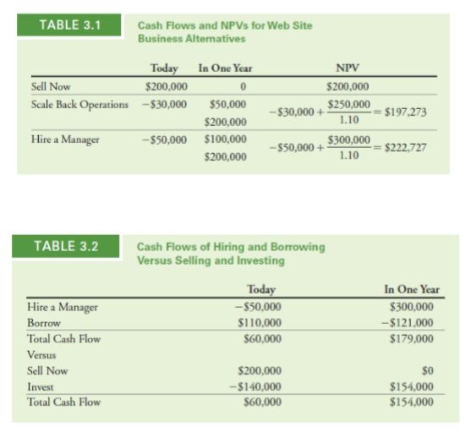

1. 選方案三，因為方案三的NPV>0且最大
2. 不是，還是要選方案三。

因為方案三的NPV=179,000，方案一的NPV=154,000。

方案三的NPV>方案一的NPV。

**第五題**

Suppose a risky security pays an expected cash flow of $79 in one year. The risk-free rate is 4.4%, and the expected return on the market index is 9.6%.

a.If the returns of this security are high when the economy is strong and low when the economy is weak, but the returns vary by only half as much as the market index, what risk premium is appropriate for this security?

b.What is the security’s market price?

a.If the security is half as variable, it should only earn half the risk premium of the market. The risk premium of the market is

Market risk premium = 9.6% – 4.4% = 5.2%.

Thus, the security’s risk premium must equal 2.6%

b. 

**第六題**

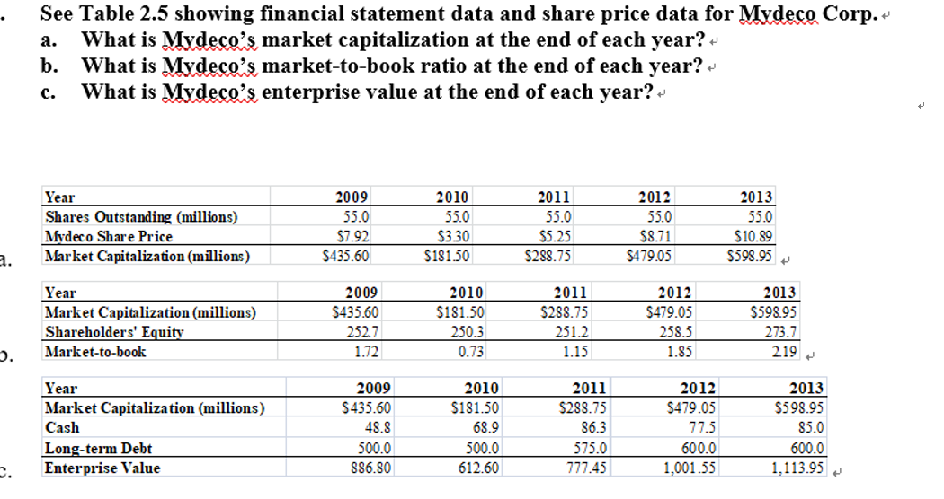

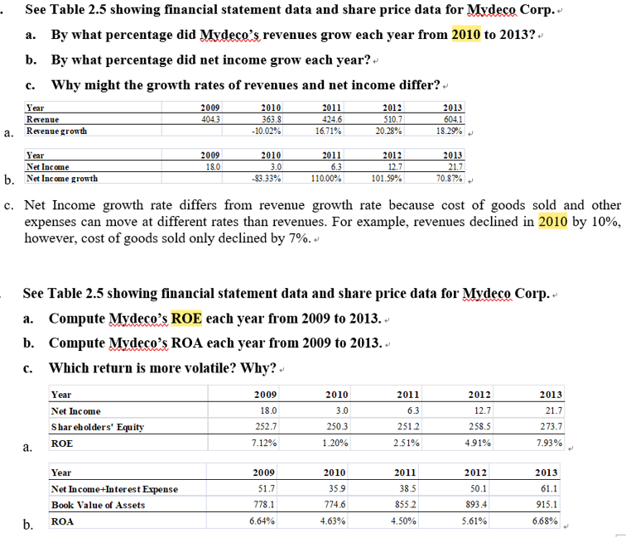

第七題

Your grandfather put some money in an account for you on the day you were born. You are now 18 years old and are allowed to withdraw the money for the first time. The account currently has $3247 in it and pays a 6% interest rate.

a. How much money would be in the account if you left the money there until your 25th birthday?

b. What if you left the money until your 65th birthday?

c. How much money did your grandfather originally put in the account?

a. FV = $3,247 × 1.067 = $4,882.29

b. *FV* = $3,247 × 1.0647 = $50,217.83

c. 

**第八題**

The British government has a consol bond outstanding paying £300 per year forever. Assume the current interest rate is 4% per year.

a. What is the value of the bond immediately after a payment is made?

b. What is the value of the bond immediately before a payment is made?

Timeline:

|  |  |  |  |  |  |  |  |  |
| --- | --- | --- | --- | --- | --- | --- | --- | --- |
| 0 | | 1 | | 2 | | 3 | |  |
|  |  |  |  |  |  |  |  |  |
|  |  |  |  |  |  |  |  |  |
|  | | £300 | | £300 | | £300 | |  |

a. The value of the bond is equal to the present value of the cash flows. By the perpetuity formula:

$\frac{£300}{0,04}=£7,500$

b. The value of the bond is equal to the present value of the cash flows. The cash flows are the perpetuity plus the payment that will be received immediately.

PV  300/0.04  300  £7,800

**第九題**

You are 23 years old and decide to start saving for your retirement. You plan to save $5000 at the end of each year (so the first deposit will be one year from now), and will make the last deposit when you retire at age 68. Suppose you earn 9% per year on your retirement savings.

a. How much will you have saved for retirement?

b. How much will you have saved if you wait until age 32 to start saving (again, with your first deposit at the end of the year)?

a. Timeline:

|  |  |  |  |  |  |  |  |  |  |  |  |  |
| --- | --- | --- | --- | --- | --- | --- | --- | --- | --- | --- | --- | --- |
| 23 | | 24 | | 25 | | 26 | |  |  |  | 68 | |
| 0 | | 1 | | 2 | | 3 | |  | |  | 45 | |
|  |  |  |  |  |  |  |  |  |  |  |  |  |
|  |  |  |  |  |  |  |  |  |  |  |  |  |
|  | | $5,000 | | $5,000 | | $5,000 | |  |  |  | $5,000 | |

$FV=\$5,000×\frac{1}{0.09}\left({\left(1+0.09\right)}^{45}-1\right)=\$2,629,293.67$ 公式

電腦的數字：2,865,930.1

查表的數字：2,882,415

b. Timeline:

|  |  |  |  |  |  |  |  |  |  |  |  |  |
| --- | --- | --- | --- | --- | --- | --- | --- | --- | --- | --- | --- | --- |
| 32 | | 33 | | 34 | | 35 | |  |  |  | 68 | |
| 0 | | 1 | | 2 | | 3 | |  | |  | 36 | |
|  |  |  |  |  |  |  |  |  |  |  |  |  |
|  |  |  |  |  |  |  |  |  |  |  |  |  |
|  | | $5,000 | | $5,000 | | $5,000 | |  |  |  | $5,000 | |

$FV=\$5,000×\frac{1}{0.09}\left({\left(1+0.09\right)}^{36}-1\right)=\$1,180,623.61$

電腦的數字：1,286,879.74

查表的數字：1,180,625