410823001 電機三許哲瑜

Hw2-1:

Plot the monthly real and nominal interest rate (six-month treasury bill rate, 國庫券-初級市場-92-182天) for Taiwan for the longest possible time span.

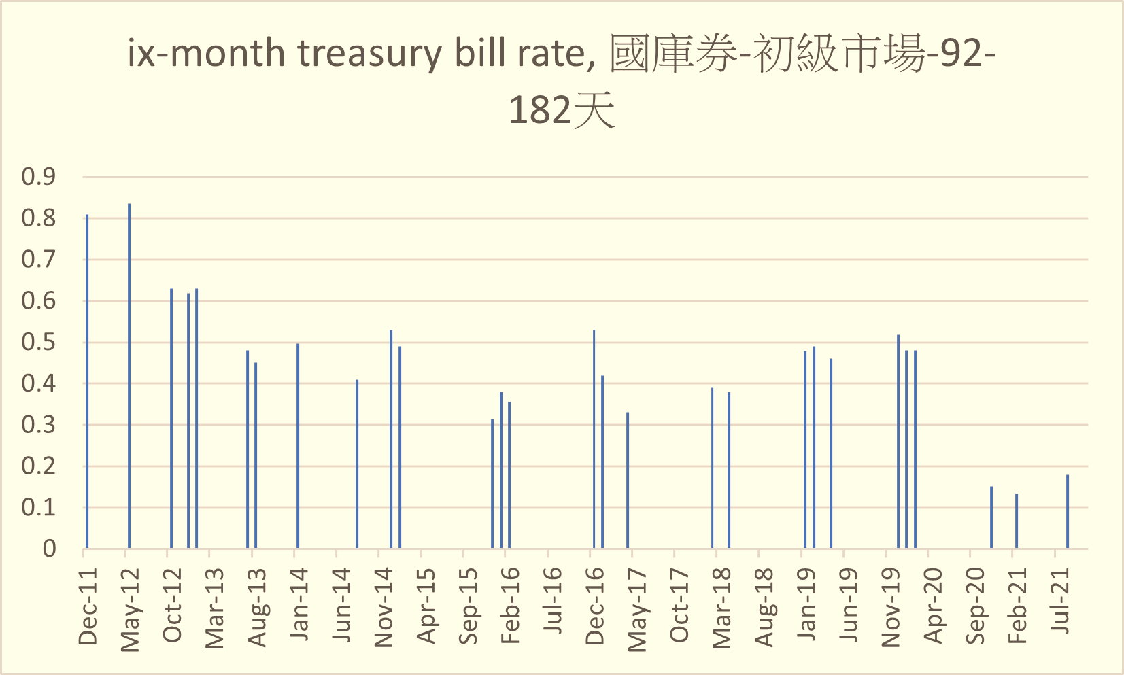

Hw2-2 :

Plot the real and nominal interest rate (one-year deposit rate, 五大銀行平均一年期存款牌告利率 ) for Taiwan for the longest possible time span.

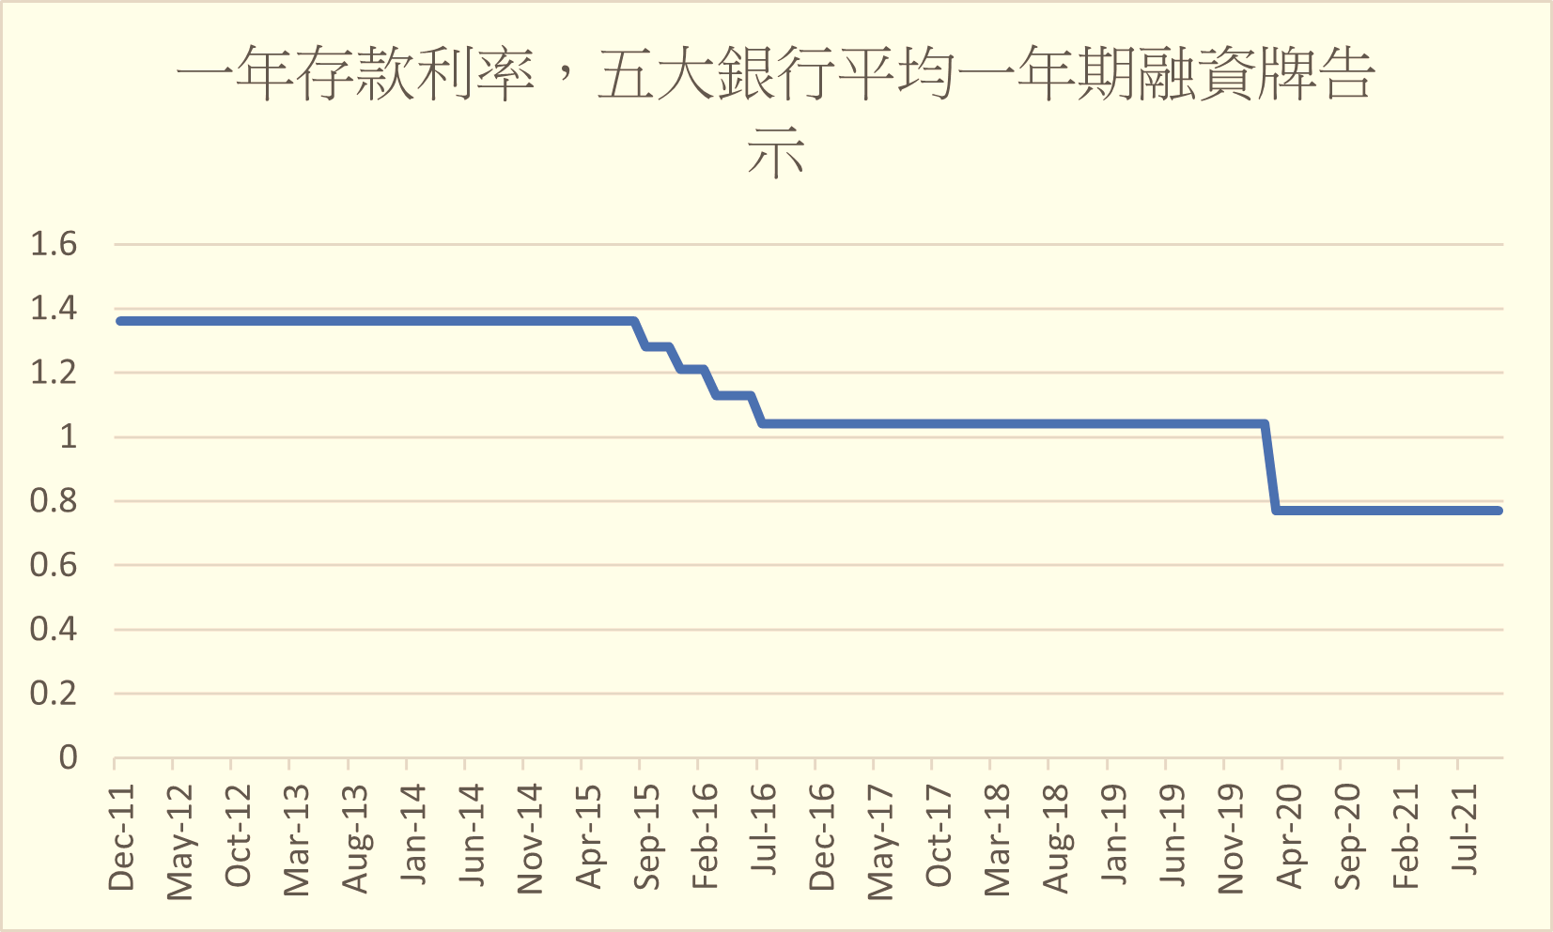

Hw2-3

Plot the monthly transaction volumn for Short-term Transactions Instruments (短期票券市場)，bond market (債券市場)，and stock market （股市）for Taiwan for the longest possible time span.

