Can Large Language Models Predict Listener-Preferred Music Mix Balance from Semantic Listening Contexts?
Oscar Alejandro Gallegos Villarreal
250851715
Georgios Velissaridis
MSc Data Science and Artificial Intelligence

Abstract - Music mixing decisions alter the perceptual balance of a recording, but the mix judged most suitable by a listener may depend on the listening situation. This work reports the completed design and validation work for an MSc project testing whether large language models (LLMs) can predict listener-preferred mix balance from semantic listening contexts. In the primary LLM experiment, text-based models do not receive the audio waveform directly; each anonymous candidate mix is represented using interpretable objective audio descriptors. The study uses four songs from the Mix Evaluation Dataset and twelve 28-second loudness-normalised stimuli selected from 92 candidate mixes. Selection combined manually approved excerpts with objective descriptors adapted from Diff-MST: root-mean-square energy, crest factor, stereo width, stereo imbalance and a 24-band mid/side Bark-spectrum representation. Bayesian mixed-effects baselines were developed on synthetic repeated-measures data and a 20-replication simulation compared sample sizes from 20 to 80 analysable participants across three scenarios. The current evidence supports a target of at least 60 analysable participants, while acknowledging that N=40 remains informative under moderate and smaller-effect assumptions. Human listening data, final LLM predictions and the LLM-vs-baseline comparison remain pending; the study therefore separates completed development results from planned empirical results.
Keywords - large language models, music mixing, listener preference, semantic context, intelligent music production, Bayesian modelling

I. Introduction
Recorded music is normally released as a single mix, even though listeners encounter the same track in different situations: relaxing, focusing, seeking motivation, using music as a distraction, or listening for enjoyment. Music-production research has long studied mixing practice and automatic mixing, but less attention has been paid to whether semantic listening context can be used to predict which alternative mix balance listeners prefer (De Man and Reiss, 2017; De Man, Reiss and Stables, 2017).

This project asks whether a text-based LLM can use a description of the listening situation and neutral objective descriptors of three candidate mixes to predict the human-preferred alternative. In the primary LLM experiment, the models do not receive the audio waveform directly. Instead, each anonymous candidate mix is represented using interpretable objective audio descriptors, allowing the study to test whether semantic reasoning over listening context and mix characteristics can predict human preference. The contribution of this work is methodological rather than empirical: it finalises the stimulus set, defines the listening task, validates statistical baselines on synthetic data, justifies a recruitment target, and specifies a reproducible LLM evaluation protocol.

The primary research question is:

RQ1: Can large language models predict listener-preferred music mix balance from semantic listening contexts, and how do their predictions compare with human preferences?

The secondary research questions are:

RQ2: Do listener preferences for alternative music mixes differ across semantic listening contexts?

RQ3: Can LLMs predict the human-preferred mix at a level above the 1/3 chance baseline?

RQ4: How does LLM prediction performance compare with the statistical mixed-effects baseline? Sample-size determination is treated as methodological design work used to justify recruitment, not as a substantive research question.

The hypotheses to be tested after human and LLM data are available are H1: listener preferences for alternative mixes will differ across semantic listening contexts; H2: LLM predictions will identify the human-preferred mix above the 1/3 chance baseline; and H3: LLM prediction performance will be comparable to or better than the statistical mixed-effects baseline.

II. Related Work
The Mix Evaluation Dataset provides ecologically grounded alternative mixes and perceptual evaluations collected from real mixing practice, making it a suitable source for studying mix-balance preference without creating artificial mixes from scratch (De Man and Reiss, 2017). Automatic and intelligent mixing research has shown that music production can be formalised using objective signal descriptors and machine-learning systems, but the present project differs by asking whether semantic listening context changes the preferred balance rather than optimising a single reference mix (De Man, Reiss and Stables, 2017).
Diff-MST motivates the descriptor set used here because it represents mixing style using interpretable audio-production features, including energy, dynamics, stereo descriptors and mid/side spectral summaries (Vanka et al., 2024). The current project does not use Diff-MST to generate audio; it adapts its objective feature philosophy for stimulus selection and statistical modelling. The five listening contexts are motivated by functional accounts of music listening in which emotional and practical uses of music are tied to episodes rather than isolated acoustic preference (Eerola, Kirts and Saarikallio, 2025).

Recent work on foundation models for audio and music motivates a careful distinction between audio understanding and prediction of human judgements. Contrastive language-audio systems such as CLAP learn joint audio-text representations from natural-language supervision and support zero-shot audio tasks, while later large-scale contrastive language-audio pretraining extends this idea with larger audio-text corpora and feature-fusion strategies (Elizalde et al., 2023; Wu et al., 2023). These systems show that text can be a useful interface for audio concepts, but they do not by themselves establish that a language-centred model can predict listener preference for alternative music mixes.

That distinction is central to this dissertation. Marjieh et al. (2024) show that LLMs can predict human sensory judgements across several perceptual modalities, suggesting that language encodes useful regularities about perception. More directly, Velissaridis et al. (2025) evaluate foundation-model families on timbre-related cognitive tasks, compare LLMs with audio-language models, use structured prompts, and test alignment with human perceptual and cognitive responses. Their hybrid pipeline, in which intermediate semantic descriptors support LLM inference, provides an important methodological precedent for the present design. This project does not use CLAP or an audio-language model in the primary experiment; instead, it tests whether semantic prompting over listening context plus objective mix descriptors can predict human mix preference.

For statistical analysis, the project uses Bayesian hierarchical models because the planned study contains repeated ratings nested within participants, songs, stimuli and listening contexts. Bambi and PyMC provide the modelling interface, while approximate leave-one-out model comparison is used where model choice is required (Capretto et al., 2022; Salvatier, Wiecki and Fonnesbeck, 2016; Vehtari, Gelman and Gabry, 2017).

III. Study Design
Participants complete an online listening task. Each trial presents one semantic listening vignette and three anonymous candidate versions of the same song. Participants rate each version from 0 to 100 for contextual suitability. The human preference target used later for LLM evaluation is derived from the highest group-level expected suitability rating, not from an LLM explanation or from source mix identity.
The study uses five listening contexts: relaxation, distraction, enjoyment, focus and motivation. In repository terminology the statistical factor is named episode; in participant-facing language and in this paper it is described as listening context. To reduce fatigue, the twelve stimuli are arranged into two participant groups of two songs each, with three candidate mixes per song.

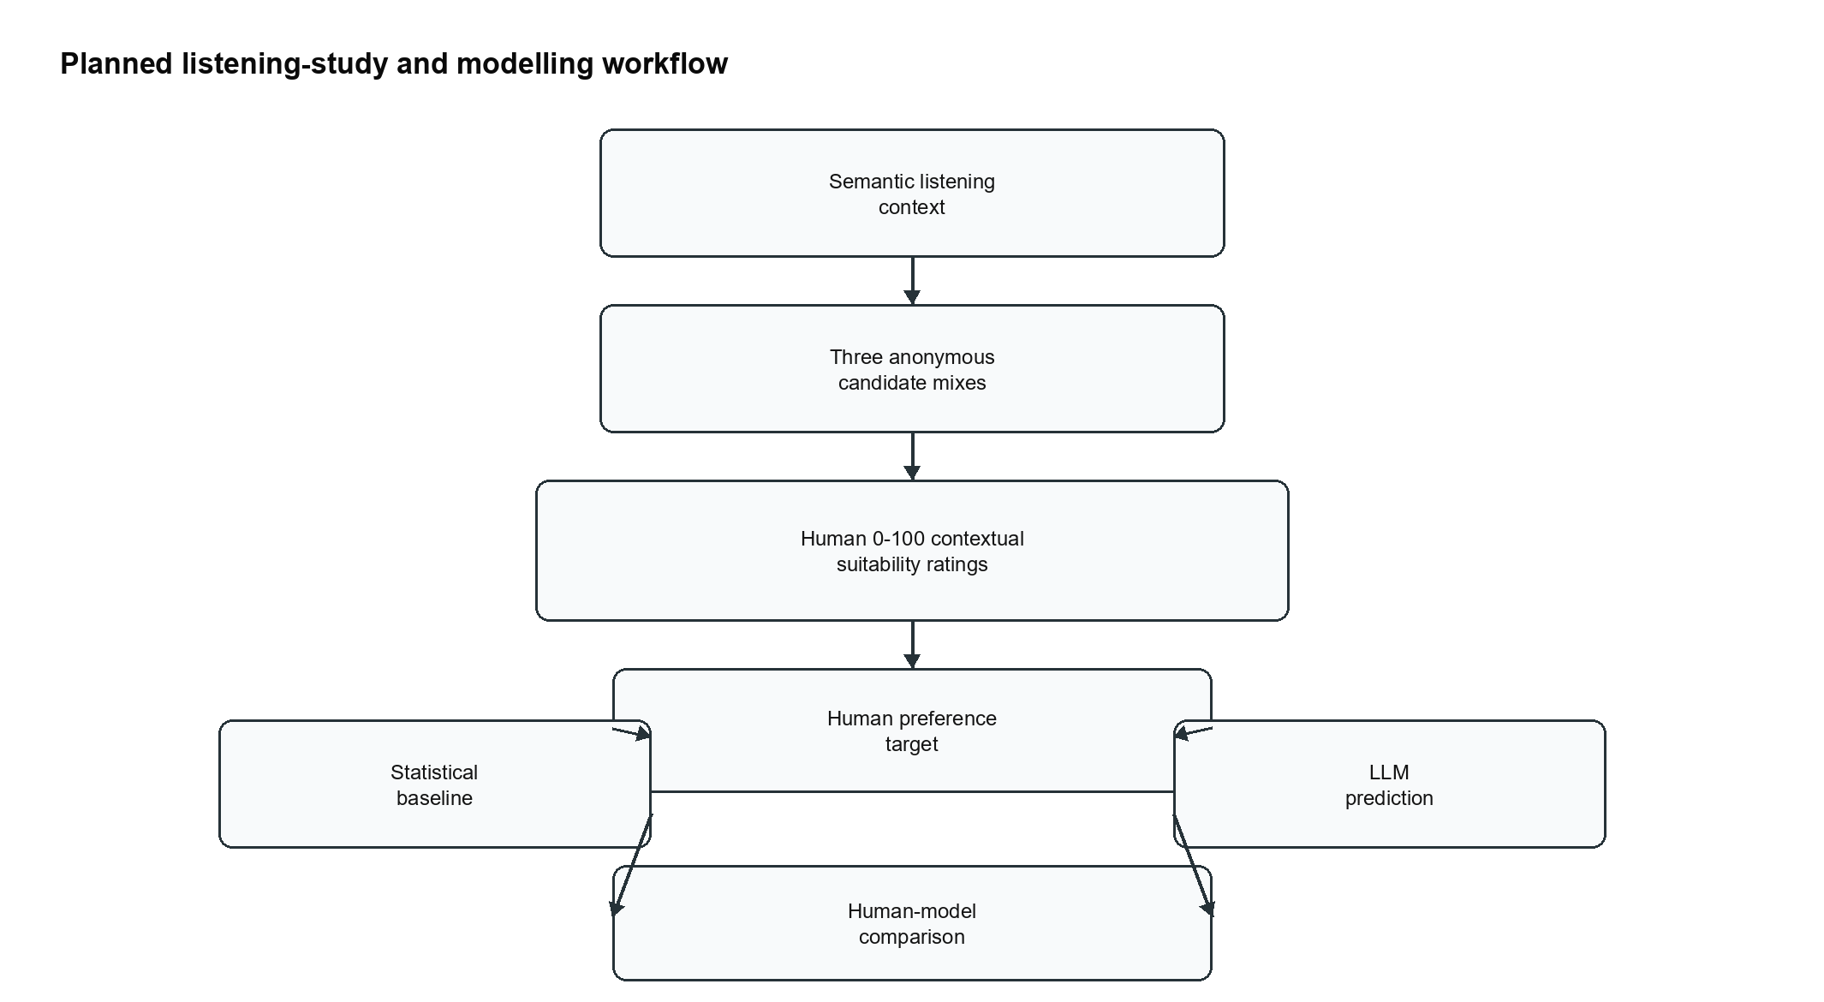
- Fig. 1. Planned workflow from semantic listening context and anonymous mix alternatives to human ratings, statistical baseline, LLM prediction and human-model comparison.

IV. Stimulus Selection
The final stimulus set contains four selected songs and twelve mix alternatives from 92 candidate mixes: Lead Me (37 candidates), In The Meantime (36), Red To Blue (10) and Pouring Room (9). Each stimulus is a 28.000-second stereo WAV excerpt at 44.1 kHz, 24-bit PCM, loudness-normalised to -20.8 LUFS with no clipping according to the final stimulus report.
Candidate feature extraction used RMS, crest factor (CF), stereo width (SW), stereo imbalance (SI) and a Bark-spectrum representation. RMS is computed as the square root of mean squared amplitude; CF is the peak-to-RMS ratio in dB; SW is side-energy relative to total mid/side energy; SI is the left-right energy imbalance. The Bark representation contains 24 Bark bands for mid and side channels. For selection, scalar features were robust-scaled within song and Bark features were reduced by PCA to retain at least 95% variance before block-weighted Euclidean distances were used to identify representative and contrast alternatives.
Group | Song | Excerpt | Mix 1 | Mix 2 | Mix 3
Group 1 | Lead Me | 9.57-37.57 s | McG-A | PXL-L1 | DU-D
Group 1 | Red To Blue | 3.01-31.01 s | McG-A | McG-B | McG-F
Group 2 | In The Meantime | 35.30-63.30 s | UCP-A4 | DU-J | QUT-B
Group 2 | Pouring Room | 23.02-51.02 s | McG-Q | McG-pro1 | McG-X
- Table I. Final stimulus set. Mix identifiers are researcher-facing labels from the source dataset; participant-facing Version A/B/C labels are randomised and anonymous.
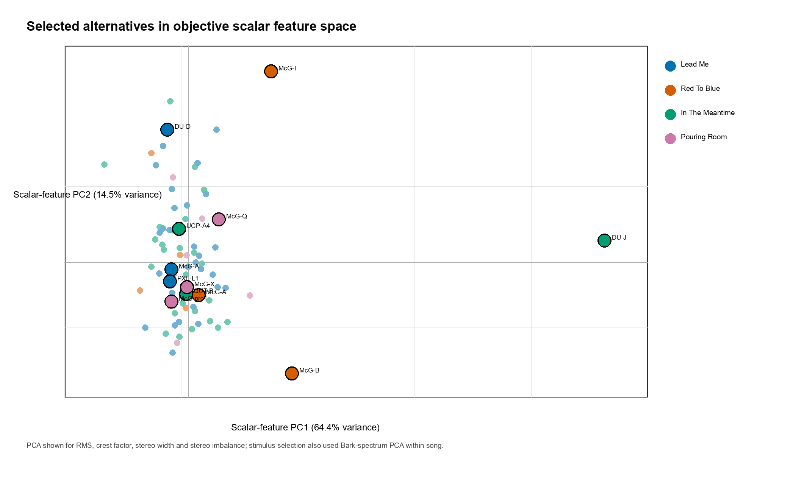
- Fig. 2. Selected alternatives in scalar objective feature space. The visualisation uses RMS, CF, SW and SI; the actual selection pipeline also used within-song Bark-spectrum PCA and manual review.

V. Methods

A. Statistical Analysis Framework
The planned primary human data are 0-100 contextual suitability ratings. The analysis distinguishes participant-level ratings, group-level expected ratings and the derived preferred alternative. The baseline models are Bayesian mixed-effects models with participant-level random intercepts. Synthetic data were used only for pipeline validation and design analysis; they are not treated as evidence about real listener preferences.

B. Categorical Stimulus Baseline
The categorical baseline estimates rating as a function of listening context, stimulus_id and their interaction: rating ~ episode * stimulus_id + (1 | participant_id). A comparison intercept-only model was also fitted. The synthetic validation fit used four chains, 1000 tuning iterations and 1000 posterior draws with target_accept=0.95 and the nutpie inference backend. Diagnostics were acceptable in the validation run: 0 divergences, maximum R-hat 1.012 and minimum ESS 498.7. Cell-mean RMSE was 2.1659 and 94% HDI coverage was 0.95.

C. Objective Feature-Based Baseline
The feature baseline uses z_RMS, z_CF, z_SW and z_SI rather than raw mix identity. The selected interaction model is rating ~ episode + z_RMS + z_CF + z_SW + z_SI + episode:z_SW + episode:z_SI + (1 | participant_id). Priors in the validation model were Normal(65,20) for the intercept, Normal(0,8) for context and main feature effects, Normal(0,5) for the two interaction terms, HalfNormal(10) for participant SD and HalfNormal(15) for residual SD. The validation fit used four chains, 1000 tuning iterations and 1000 posterior draws with target_accept=0.95 and nutpie. It had 0 divergences, maximum R-hat 1.01 and minimum ESS 345.0. Cell-mean RMSE was 1.9458 and 94% HDI coverage was 0.80.
model | formula | diagnostics | prediction
Categorical stimulus baseline | rating ~ episode * stimulus_id + (1 | participant_id) | div=0; Rhat=1.012; ESS=498.7 | RMSE=2.1659; coverage=0.95
Feature interaction baseline | rating ~ episode + z_RMS + z_CF + z_SW + z_SI + episode:z_SW + episode:z_SI + (1 | participant_id) | div=0; Rhat=1.01; ESS=345.0 | RMSE=1.9458; coverage=0.8
- Table II. Synthetic-validation diagnostics for the two statistical baselines.

D. Sample-Size Design Analysis
A simulation-based design analysis evaluated N=20, 30, 40, 50, 60 and 80 analysable participants across three scenarios: moderate effects, smaller effects and higher-noise moderate effects. Each scenario-by-N condition used 20 replications, giving 360 attempted and completed fits. The final operational diagnostics were intentionally conservative: 181 fits failed the operational success rule and 355 failed the strict convergence rule, even though the design decision was based on recovery adequacy and a separate confirmation fit.
The final recommendation is at least 60 analysable participants. At N=60 in the higher-noise scenario, mean cell-mean RMSE was 1.5606, mean cell-mean coverage was 0.9492, winner accuracy was 0.8925 and the mean probability assigned to the true winner was 0.8693. N=40 remains informative under moderate and smaller-effect assumptions, so the recommendation is not that lower samples are useless; rather, N=60 gives a more robust buffer under the hardest scenario. A confirmation fit at N=60 under the moderate-effects scenario used four chains, 1000 tuning iterations and 1000 posterior draws, with 0 divergences, maximum R-hat 1.01, minimum ESS 211 and strict convergence passing.
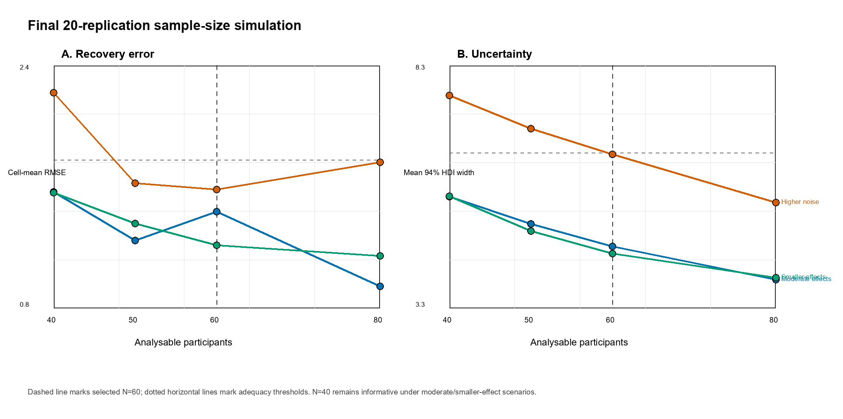
- Fig. 3. Final 20-replication sample-size simulation. The vertical line marks N=60; horizontal dotted lines mark adequacy thresholds. N=40 remains informative under some scenarios.

E. Large Language Model Evaluation

1) Models Evaluated
The planned primary comparison will use approximately three strong LLM families/providers: an OpenAI GPT-family model, an Anthropic Claude-family model and a Google Gemini-family model. The scientific purpose is cross-family comparison, not a large benchmark. An open-weight Llama-family or comparable instruction model may be included as a secondary sensitivity analysis if reproducible inference is feasible. Exact commercial model identifiers, API endpoints, provider snapshots and access dates will be frozen immediately before evaluation and logged; this draft therefore does not claim final exact versions.

2) Mix Representation Supplied to LLMs
Each LLM receives the semantic listening vignette and anonymised Version A/B/C descriptors. The primary representation uses within-song standardised scalar descriptors z_RMS, z_CF, z_SW and z_SI, plus a neutral glossary. The model does not receive human ratings, human preferences, original mix identities, filenames, source engineer identity, representative/contrast roles, selection rationales or statistical-baseline predictions. The raw 48-dimensional Bark vector is excluded from the primary text-LLM experiment because it is high-dimensional, hard to express neutrally in text and likely to invite unstable interpretations; a reduced Bark/PCA sensitivity analysis may be added only if frozen before final comparison.

3) Prompt Design
The prompt is zero-shot and mirrors the human task: given a listening situation and three alternative mixes of the same song, predict which version human listeners are most likely to consider most suitable. The response must be valid JSON containing preferred_label, ratings for A/B/C on a 0-100 scale, confidence from 0 to 1 and a one-sentence brief_rationale. The rationale is logged for interpretation only; the evaluated prediction is the selected label and, secondarily, the ranking of predicted ratings.

4) Inference and Randomisation Protocol
Primary inference will use deterministic or near-deterministic decoding where supported: temperature 0 or the lowest available setting, top-p 1 or provider default, fixed seed where supported and a short maximum-token limit sufficient for JSON. The visible A/B/C labels will be permuted so the same underlying alternatives are presented in multiple orders. All six permutations will be used if cost permits; otherwise three balanced permutations will be pre-specified. Logs will include model identifier, timestamp, rendered prompt, descriptor values, permutation, decoding parameters, raw response and parsed response.

5) Human Preference Targets
The human target is derived after data collection from contextual suitability ratings. Participant-level ratings remain the raw data. Group-level expected ratings by context/song/stimulus define the preferred alternative as the highest-rated candidate. Ties will be handled by a pre-specified rule and reported transparently.

6) Metrics and Statistical Comparison
The primary metric is agreement between the LLM-predicted preferred alternative and the human-preferred alternative, with 1/3 chance accuracy as the reference for the three-alternative task. Secondary metrics include rank correlation between LLM-predicted ratings and human group-level ratings, context-specific accuracy, song-specific accuracy, label-order sensitivity, invalid-output rate and confidence calibration if model confidence is treated quantitatively. LLM and statistical-baseline predictions will be compared on the same held-out target units using paired accuracy differences or bootstrap/permutation intervals.

Leakage Control and Reproducibility

Prompts, descriptor rounding, model set, parsing rules, invalid-output handling and tie handling will be frozen before inspecting final human outcomes for LLM comparison. Invalid JSON will be logged, retried once under the same settings with a format reminder if pre-registered, and then marked invalid if still unparsable. The companion protocol file docs/llm_evaluation_protocol.md contains the full pre-registration-style procedure.

VI. RESULTS
Completed development/design results are reported here. First, the final stimulus set contains four songs, twelve approved 28-second stimuli and loudness-normalised WAV exports. Second, synthetic validation confirms that the
categorical and feature-based baseline pipelines run with acceptable diagnostics under the simulated data-generating assumptions. Third, the sample-size simulation supports targeting at least 60 analysable participants while transparently reporting operational and strict diagnostic failures.
Pending empirical results are reserved for the final analysis. No human listening responses have yet been analysed, and no LLM predictions have been generated. The Results section will be expanded after data collection to report human context-dependent preference estimates, LLM predictions, LLM-vs-chance results and LLM-vs-statistical-baseline comparisons after protocol freezing is complete.

VII. Discussion
The project is designed to test a narrow but meaningful claim: whether semantic context and objective mix descriptors contain
enough information for an LLM to anticipate human mix preference. Its strength is the combination of ecologically sourced mixes, objective feature extraction, anonymous candidate presentation and pre-specified statistical and LLM baselines. Its main limitation at this stage is that all performance claims remain prospective. Synthetic data validate workflow behaviour and design adequacy, but they cannot establish real listener effects or LLM competence.
The LLM evaluation is intentionally small. Comparing three strong model families is more defensible for an MSc dissertation than testing many systems without a clear rationale. Cross-family comparison also reduces the risk that any positive or negative result is over-interpreted as a property of one provider. The descriptor representation is similarly conservative: scalar z-features are interpretable and repository-supported, whereas Bark-spectrum vectors are better suited to audio models or secondary sensitivity analysis.

VIII. Conclusion
This work establishes the experimental and computational framework for testing whether LLMs can predict listener-preferred mix balance from semantic listening contexts. The completed repository evidence supports the stimulus set, feature pipeline, baseline models and N=60 recruitment target. The remaining dissertation work is to collect human ratings, freeze the final LLM model snapshots, execute the pre-specified LLM protocol and compare LLM predictions against human-derived preferences, chance and the statistical baseline.

IX. acknowledgment

Empty

IX. References
Anthropic (2026) Models overview. Claude API Docs. Available at: https://platform.claude.com/docs/en/about-claude/models/overview (Accessed: 28 July 2026).
Capretto, T., Piho, C., Kumar, R., Westfall, J., Yarkoni, T. and Martin, O.A. (2022) Bambi: A simple interface for fitting Bayesian linear models in Python. Journal of Statistical Software, 103(15), pp. 1-29. doi:10.18637/jss.v103.i15.
De Man, B. and Reiss, J.D. (2017) The Mix Evaluation Dataset. Proceedings of the 20th International Conference on Digital Audio Effects (DAFx-17), Edinburgh.
De Man, B., Reiss, J.D. and Stables, R. (2017) Ten years of automatic mixing. Proceedings of the 3rd Workshop on Intelligent Music Production (WIMP 2017).
Eerola, T., Kirts, C. and Saarikallio, S. (2025) Episode model: The functional approach to emotional experiences of music. Psychology of Music, 53(4), pp. 590-615. doi:10.1177/03057356241279763.
Elizalde, B., Deshmukh, S., Al Ismail, M. and Wang, H. (2023) CLAP learning audio concepts from natural language supervision. Proceedings of ICASSP 2023 - IEEE International Conference on Acoustics, Speech and Signal Processing, pp. 1-5. doi:10.1109/ICASSP49357.2023.10095889.
Google (2026) Gemini API reference. Google AI for Developers. Available at: https://ai.google.dev/api (Accessed: 28 July 2026).
Marjieh, R., Sucholutsky, I., van Rijn, P., Jacoby, N. and Griffiths, T.L. (2024) Large language models predict human sensory judgments across six modalities. Scientific Reports, 14, 21445. doi:10.1038/s41598-024-72071-1.
Meta (2026) Get started with Llama. Llama AI. Available at: https://ai.meta.com/llama/get-started/ (Accessed: 28 July 2026).
OpenAI (2026) All models. OpenAI API documentation. Available at: https://developers.openai.com/api/docs/models/all (Accessed: 28 July 2026).
Salvatier, J., Wiecki, T.V. and Fonnesbeck, C. (2016) Probabilistic programming in Python using PyMC3. PeerJ Computer Science, 2, e55. doi:10.7717/peerj-cs.55.
Vanka, S.S., Steinmetz, C.J., Rolland, J.-B., Reiss, J.D. and Fazekas, G. (2024) Diff-MST: Differentiable Mixing Style Transfer. Proceedings of the 25th International Society for Music Information Retrieval Conference, San Francisco, United States. Available at: https://arxiv.org/abs/2407.08889.
Vehtari, A., Gelman, A. and Gabry, J. (2017) Practical Bayesian model evaluation using leave-one-out cross-validation and WAIC. Statistics and Computing, 27(5), pp. 1413-1432. doi:10.1007/s11222-016-9696-4.
Velissaridis, G., Athwal, R., Musharaf, M., Fazekas, G. and Saitis, C. (2025) Evaluating foundation models on timbre-related cognitive tasks. Proceedings of the 26th International Society for Music Information Retrieval Conference, Daejeon, South Korea.
Wu, Y., Chen, K., Zhang, T., Hui, Y., Berg-Kirkpatrick, T. and Dubnov, S. (2023) Large-scale contrastive language-audio pretraining with feature fusion and keyword-to-caption augmentation. Proceedings of ICASSP 2023 - IEEE International Conference on Acoustics, Speech and Signal Processing. doi:10.1109/ICASSP49357.2023.10095969.

