Abstract:

Intro

Data sets
Pandas

Titanic data set
The titanic data set is comprised of the records collected from the sinking of the RMS Titanic, the data was obtained from the Kaggle site[1]. I find this data set particularly interesting as it highlights some of the social norms that were in place at the time. In particulars, as we will see from the data set later on, woman, children the wealthy were more likely to survive. The data set information is comprise of rows representing each passenger and columns representing the passenger information. The columns are described in Table 1.

Variable | Definition | Key
survival | Survival | 0 = No, 1 = Yes
pclass | Ticket class | 1 = 1st, 2 = 2nd, 3 = 3rd
sex | Sex
Age | Age in years
sibsp | # of siblings / spouses aboard the Titanic
parch | # of parents / children aboard the Titanic
ticket | Ticket number
fare | Passenger fare
cabin | Cabin number
embarked | Port of Embarkation | C = Cherbourg, Q = Queenstown, S = Southampton
Table 1: Titatic Data set columns description

The raw data obtained from Kaggle site contained a lot of missing information in the form empty columns for each row, this data would show it self as nan after loading with pandas. Though the class lectures described different methods of dealing with empty or missing values, for the decision tree I decided to keep this as a separate class. For numerical values, like fare and age, this proved to be difficult, after experimentation I manage to accomplish this by setting missing values to -100, the choice is completely arbitrary but a large negative value will suffice. Table 2 shows an excerpt from raw data set.

Table 2: Excerp from raw Titanic dataset.

ID3 Decision Tree:
I implemented the decision tree in python, using the following libraries: Numpy [3], Pandas [4] and Graphviz[5]. Graphviz was used to create a graph of the tree to allow for easier visualization. Numpy contains a set of mathematical algorithms that allow for easier implementation of my tree. Since Pandas was my main data transport mechanism I decided to continue working with it. Pandas made my work in sorting and separating columns and row data simpler.
The file ID3.py contains a decision tree based algorithms described in the class book [2]. Also shown in figure 1 for further details. The algorithm starts as usual by inspecting the current examples and stopping if all the labels on the current examples data are the same or if there are not further attributes to inspect, the attributes in this case being the columns.
The algorithms continues by inspecting the data and deciding which attribute, from the ones currently left, to split on. It decides this by looking at the remaining data and finding the gain for each attribute. The attribute with the highest gain is selected. For each attribute the gain is calculated as follows:

Where is H is entropy of the examples passed in, the sum is performed over each value in the current attribute, and examples_{v} is the set of examples with a particular attribute value. Entropy can be calculated using the following formula:

Where P_{p} and P_{n} are the ratios of positive and negative outcomes respectively. From class we learned this Gain is the amount of information gain from that particular attribute.
For each label, or value, in the current selected attribute a new child node is created and added to the current node. The current examples data are subdivided into the different values for the current attribute. This data along the with remaining attributes, those that have not been selected, are passed on to the algorithm to continue the decision tree building. Thus the algorithm is called recursively until the desired stopping condition is reached:
- Stop if all remaining examples are same, positive or negative
- Stop if there are no more attributes left
- Stop if the desired depth is reached
The last stopping criterion was briefly described in class as method for constraining the decision tree to keep it from over-fitting. This step does keep the tree from over-fitting but it also added another step of complexity since deciding which depth was needed became another parameter to investigate. The latter may not sound like much but considering that this further subdivided the data so that we could have a validation data for the depth parameter.

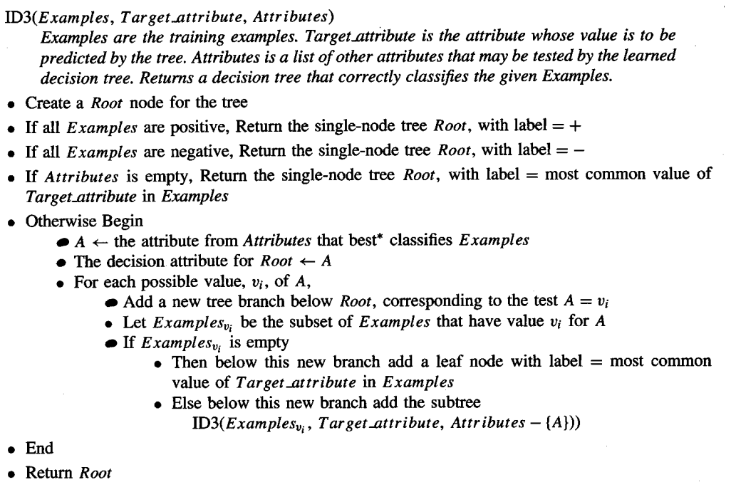Figure 1: ID3 Decision tree algorithm[2]

Bibliography:

[1] Titanic: Machine Learning from Disaster | Kaggle
https://www.kaggle.com/c/titanic/data
[2] Mitchell, T. M. (1997). Machine learning. New York: McGraw Hill.
[3] NumPy, Retrieved from http://www.numpy.org/
[4] Python Data Analysis Library, Retrieved from https://pandas.pydata.org/
[5] Graphviz Retrieved from https://www.graphviz.org/

