|  |  |  |
| --- | --- | --- |
|  | Traditional Chinese | English |
|  | 關於HEARGO | About HEARGO |
| 品牌故事 | 品牌故事 | Brand Story |
| 聲音．連繫生活 | Connect you to the world, right here. |
| HEARGO網上聽力服務預約平台專為有需要人士配對專業的聽力護理家，將個人化的聽力護理服務直接帶到府上，幫助聽障人士重拾聽力，跨越溝通障礙。  透過聲音，重新連繫你的生活。 | HEARGO is a pioneering online hearing care platform that brings hearing care professionals straight to your door. By helping hearing impaired patients reconnect to their family and friends, HEARGO aims to enrich people's life via meaningful and valuable connections. |
| 使命 | 使命 | Mission |
| HEARGO的使命以「連繫」為重心，將即時、全面的聽力護理服務帶到聽障人士家中，幫助他們打破聽障造成的溝通隔膜，改善生活，重新與家人、朋友和世界接軌。 | HEARGO aspires to build a better world by connections. HEARGO strives to reach out to connecting those in need and suffering from hearing disabilities by providing immediate, comprehensive and accessible hearing care solution. |
| 打破距離界限，超越您所想所聽！ | Go beyond！Bring better hearing to your door. |
| 了解HEARGO的服務流程 | Learn more about HEARGO’s service process. |
| 你的聽力護理專家團隊 | 你的聽力護理專家團隊 | Our Professional Team |
| Vincent Yau臨床聽力學家 | Vincent Yau – Clinical Audiologist |
| 「不只是你的聽力護理專家，更想成為你的朋友，細心聆聽你的需要，帶給你貼心、可靠、專業的服務。」 | "More than just your audiologist - but also your close friend, catering to your needs to make you feel at home." |
| Cherry Chan臨床聽力學家 | Cherry Chan - Clinical Audiologist |
| 「生命的意義不只在乎尋找快樂，更要盡力為他人的生命帶來正面的改變。」 | “The purpose in life is not just to be happy–but also to matter, to make a difference in someone’s life” |
| Eugena Kok臨床聽力學家 | Eugena Kok - Clinical Audiologist |
| 「真正貼心的服務除了提供專業知識和技能，更是細心聆聽，與你同行。」 | "Serve not only with professional skills, but also with listening ears and a caring heart.” |
| Alanna Siu 助聽器驗配師 | Alanna Siu - Hearing Instrument Specialist |
| 「設身處地，走多一步，讓你自信地聆聽世界」 | "Empower people by stepping into their shoes and see beyond their needs." |
| 品牌價值 | HEARGO品牌價值 | Core Values |
| 打破傳統聽力護理概念，帶來嶄新體驗 | HearGo, revolutionising the hearing care industry with technology |
| HEARGO將科技融入聽力護理，創立香港首個聽力服務網上預約平台，提供個人化的上門服務及遙距支援，為聽障人士及其家人帶來最方便及舒適的體驗。 | With digitalisation, personalisation and convenience as the foundation, HEARGO strives to improve hearing care services with technology and innovation. This is the first-ever online platform in Hong Kong, providing comprehensive home visit service and remote support for those suffering from hearing loss. |
| 關懷 | Caring |
| 優先考慮你的需要，以專業的態度，用心服務。 | As a professional hearing care provider, your needs is always our top priority. |
| 專業 | Professional |
| 我們的專家團隊成員已獲得專業認證，將全面、個人化、專業的聽力護理服務帶給更多有需要的人士。 | With a team of Hearing Care Professionals, we bring convenience, personalized, and high-standard hearing care service to those in need. |
| 連繫 | Connect those in need |
| 為你配對聽力專家，幫助你與家人建立更緊密的關係。 | With the help of our hearing care professionals, you can enjoy a better relationship with family. |
| 聯絡我們 | 我們的初心由服務香港超過33年的甘峰醫療保健集團全力支持 | With the full support from KAM Healthcare Group, serving Hong Kong for over 33 years. |
| 聯絡我們 | Contact us |
| HEARGO 客戶服務熱線 | HEARGO Service Hotline |
| (852) 2893 1102 | (852) 2893 1102 |
| Whatsapp 按此對話 | WhatsApp us here |
| 星期一至五：上午10時至下午6時 | Monday - Friday: 10:00 am - 6:00 pm |
| 星期六：上午10時至下午5時 | Saturday: 10:00am - 5:00 pm |
| 星期日及公眾假期除外 | Except Sundays and Public Holidays |
| 電郵查詢 | E-mail us |
| info@heargo.com.hk | info@heargo.com.hk |
| Facebook | Facebook |
| HEARGO 支援服務中心 | HEARGO Service Centre |
| (僅供預約) | (For reservations only) |
| 地址： | Address |
| 香港九龍尖沙咀加連威老道2-6號愛賓商業大廈13樓 | 13/F, Albion Plaza, 2-6 Granville Rd, Tsim Sha Tsui, Kowloon, Hong Kong |
| 尖沙咀地鐵站B1出口 | Tsim Sha Tsui MTR Exit B1 |
| 姓名 | Name |
| 電話 | Phone number |
| 電郵 * | E-mail |
| 咨詢類別 * | Type of inquiry |
| 可在下方輸入詳細資料及查詢: | Provide details of your inquiry below |
| 選擇聯絡方式 | Contact method |
| 電子郵件/聯絡電話/Whatsapp (可多選) | E-mail / Phone / WhatsApp (Multiple selection) |
| 點擊“提交”即表示你同意我們的使用條款、隱私政策和免責聲明。 | By clicking "submit", you agree to our Terms of Use, Privacy Policy and Disclaimer. |
| 加入我們 | 加入我們 | Join us |
| 想成為HEARGO的自由合作伙伴，為更多聽障人士上門服務？ | Become a partner of HEARGO. Expand our hearing health coverage. |
| HEARGO需要更多聽力護理專家加入我們的團隊，擴展服務網絡，讓更多聽障人士足不出戶都可以享受專業、貼心的聽力護理。 | We are looking for hearing care professionals to join HEARGO Team. With a bigger team, we can bring our best hearing care sevices to more homes. |
| 如果你已經獲得專業認證，我們期待盡快與你會面！ | Already a certified hearing care professional? We can’t wait to meet you! |

Commented:

Alanna Eugena Vincent Cherry Charmaine(KAM)

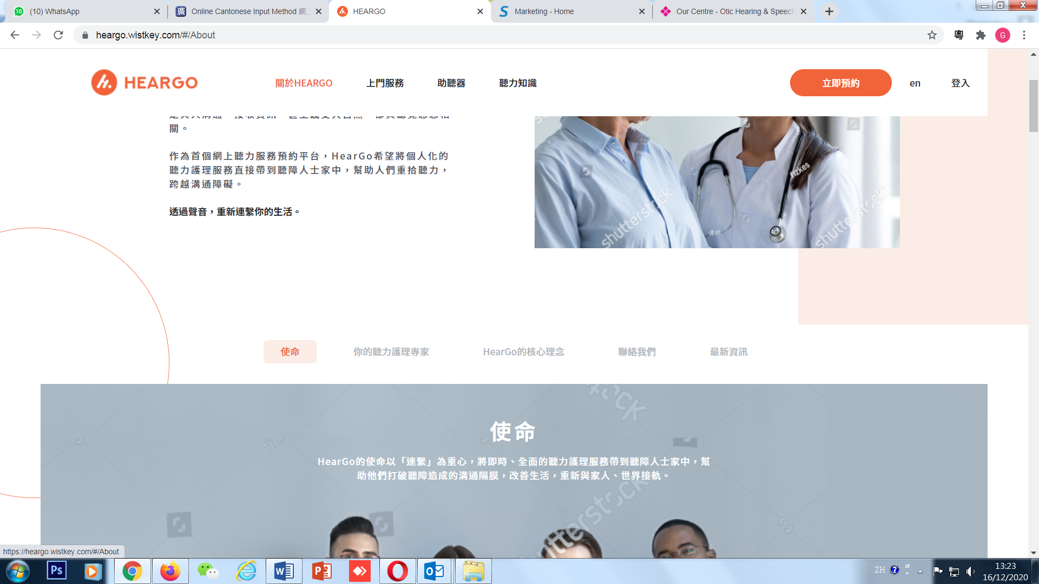

1. 關於HearGo 加返dropdown menu bar

使命

你的聽力護理專家

HearGo的核心理念

聯絡我們

最新資訊

Mission

Our Professional Team

HearGo Core Values

Contact us

Latest news

1. Enquiry form右上角加返X

+ 可多選 multiple selection

諮詢類別係dropdown box:

|  |  |
| --- | --- |
| 上門聽力服務  助聽產品  合作查詢  其他查詢 | Home Visit Hearing Test  Hearing Product  Cooperation Enquires  Other Enquiries |

