|  |  |  |
| --- | --- | --- |
|  | Traditional Chinese | English |
|  | 立即預約 | Book now |
| 選擇服務 | Choose a service |
| 選擇日期及時間 | Choose a date and time |
| 提供聯絡資料 | Contact info |
| 輸入付款方式 | Payment method |
| 確認預約 | Confirm booking |
| 第一步 | 第一步 | Step 1 |
| 請問您需要甚麼服務？ | Which service do you require? |
| 聽力護理專家到診 | Hearing Care Professional visiting consultation |
| 聽力評估及助聽器驗配 | Hearing assessment and hearing aid(s) fitting with trial |
| $3000/ 120 分鐘 | $3000/120 min. |
| 聽力護理專家到診 | Hearing Care Professional visiting consultation |
| 聽力評估及諮詢 | Hearing assessment and consultation |
| $1800/ 60 分鐘 | $1800/60 min. |
| 聽⼒護理專家到診 | Hearing Care Professional visiting consultation |
| 助聽器調較 | Hearing aid(s) fine-tuning |
| $1800/ 60 分鐘 | $1800/60 min. |
| 第二步 | 第二步 | Step 2 |
| 選擇日期及時間 | Choose a date and time |
| 2020年9月9日，星期三 | 2020/09/09, Wednesday |
| 已預約120分鐘 | Booked: 120 min. |
| 第三步 | 第三步 | Step 3 |
| 提供聯絡資料 | Contact information |
| 登入以繼續 | Sign in to continue |
| 或以訪客⾝份繼續 | Continue as guest |
| 稱謂 | Title |
| 姓名 | Last name |
| 名字 | Surname |
| 手提電話 | Mobile phone number |
| 電郵 | Email |
| 地址 | Address |
| 上一步 | Back |
| 第四步 | 第四步 | Step 4 |
|
| 信用卡付款  立即支付 | Credit card  Pay now |
| 信用卡 | Credit card |
| 持卡人姓名 | Name on card |
| Card Details  Visa □  Master Card 萬事達卡 □ | Card details |
| 信用卡號碼 | Card number |
| 信用卡到期日: (MM/YY) | Expiry date: (MM/YY) |
| 地址 | Address |
| 與通訊地址相同 | Same as corresponding address |
|
| 信用卡付款  立即支付 | Credit card  Pay now |
|  | 其他付款方式  我們接受FPS轉數快/ 銀行轉帳、payme轉帳及支票付款 | Other payment method  We accept FPS transfer/bank transfer, payme transfer and cheque |
|  | 需要協助？請致電2893 1102 | Need more help? Please call 2893 1102 |
| form | 地點 | Location |
| 服務種類 | Service type |
| 日期和時間 | Date and time |
| 聽力護理專家到診  XXX專家 | Hearing Care Professional visiting consultation |
| 助聽產品驗配及安裝試聽 | Hearing aids fitting and trial |
| 售後跟進及調較 | Follow up service and adjustment |
| 2020年9月9日，星期三 17 : 00 | 2020/09/09, Wednesday, 5:00 pm |
| 共120 分鐘服務 | Total duration: 120 min. |
| 付款方式 | Payment method |
| 備註 | Remarks |
| 同意上門服務 | I agree to the visiting service |
| 謹此聲明本人已年滿18 歲 | I certify that I am at least 18 years of age |
| 沒有正接受家居檢疫人士 | No person under compulsory home quarantine |
| 確認預約 | Confirm booking |
| confirmation | 預約完成， 你將會收到確認電郵。 | Booking completed. You will receive a confirmation e-mail. |
| 請填寫問卷， 讓專家為您提供更精準的服務 | Fill in the form |
| 點擊這裡查看預約紀錄 | Click here to view your booking record |
| questionnaire | 聽⼒問卷 | Hearing Questionnaire |
| 1.你曾否穿耳膜或做過耳部手術？ | 1. Have you had a perforated eardrum or any medical/surgical treatment for your ears? |
| 2.測試者手指活動正常? | 2. Is the participant dexterous? |
| 3. 聽力程度 | 3. Hearing ability? |
| 寧靜環境下聽不清楚 | Cannot hear well in quiet environment. |
| 聽電話有困難 | Cannot hear well during phone calls |
| 嘈吵環境中聽不清楚 | Cannot hear well in noisy environment |
| 對話有困難 | Difficulty making conversations |
| 感謝提供資料， 請耐心等待。 | Thank you for your information. Please wait. |
| 聽力專家將於一個工作天內致電確認 | You will receive a confirmation call from our audiologist within 1 business day. |

Commented:

Alanna

Vincent

Eugena

Cherry

Charmaine (KAM)

1. Steps

擺下面 /放大: 返回步驟1:選擇服務

2. select cut左張圖，可唔可以唔好郁張圖

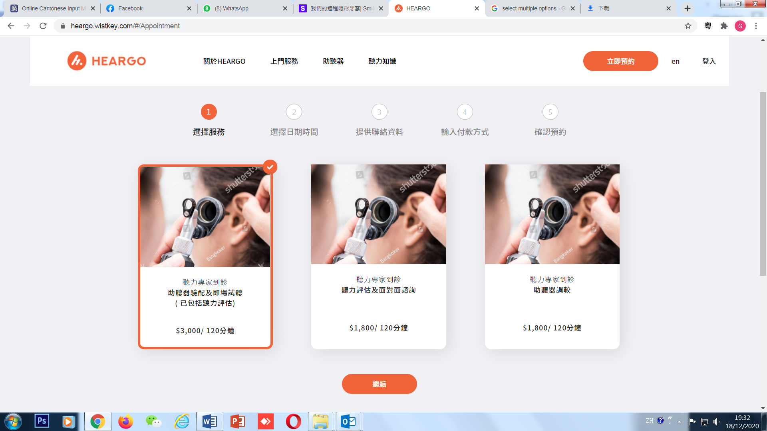

3.

|  |  |
| --- | --- |
| 姓名 | Last name |
| 名字 | Surname |

