|  |  |  |
| --- | --- | --- |
|  | Traditional Chinese | English |
| Heading Slider 1 | 全方位上門聽力護理服務  聲音．連繫世界 | Home Visit Service for Hearing Solution  Connect you to the world, right here. |
| Heading Slider 2 | 輕鬆、全面、即時的聽力護理體驗，就在HEARGO | HEARGO believes hearing care should be accessible, comprehensive and instant. |
| Heading Slider 3 | 遙距支援服務即將推出 | Remote support is coming soon |
| testimonial | Carrie (102歲林婆婆的女兒) : 註冊聽力學家: Vincent游生  “專家好人，講解清晰 上門服務方便老人家及照顧者 會推介給朋友” | Carrie (Daughter of 102-year-old Mrs. Lam) Audiologist: Vincent “Vincent is kind and explained everything clearly. Home visit service makes life easier for elderly and caretakers. I will recommend it to my friends!” |
| CTA | 預約上門服務 網上預約，3分鐘完成！ 登入HEARGO網上預約平台，選好所需服務、日期及時間後，便可安坐家中，等候聽力護理專家上門為你服務。 | Service at your doorstep - 3-min easy online booking Pick a service, schedule a date and time,  then sit back and wait for our hearing care professionals to knock on your door. |
| HearGo好處 | 免費諮詢專家 - 保證1個工作天內回覆 | Free Consultation with our hearing care professional  - Leave your enquiry here and we will get back to you within 1 business day |
| 主要服務項目 | 為何選用HEARGO？ 1: 毋需出門，全程安坐家中 傳統聽力中心集中於市區，路程不短，加上往往需要來回數次做不同的檢查、調校，費時又不便。HEARGO提供上門服務，由聽力護理專家親自來訪，為你提供全面、個人化的聽力護理。 >服務流程  2: 預約日期時間，任你選擇 網上預約簡單方便，只需選擇服務種類、日期及時間，最快3分鐘便可完成！專家會於1個工作天內致電回覆，確認預約。 >如何5步完成預約  3. 先問專家，後預約  預約上門服務前，可先透過電話或WhatsApp諮詢HEARGO聽力護理專家的意見，費用全免。專家會針對你的問題或需要，建議最適合的服務方案。 >免費電話諮詢 >HearGo團隊   4. 價目清晰，網上支付簡易快捷 服務收費一目了然，可全程網上預約支付。預先支付費用，或於完成服務後支付。電子帳單清晰記錄所有帳目，讓你隨時查看，遇到問題可即時聯絡客服。  >付款方式  5. 登入平台，隨時管理電子報告 想查看聽力狀況，以後毋須左問右問，只需登入HEARGO即可隨時隨地查看自己的聽力狀況及報告、預約詳情、產品保養期限等資訊。 >登入/註冊 | Why HEARGO? 1. Stay home. Stay safe Travelling to and from traditional hearing centres for hearing tests, hearing aids fine-tuning can be a hustle. HEARGO sends experts to your door. Enjoy an all-round personalized hearing care service at the comfort of your home. > Service procedures   2. Schedule an appointment at your convenience Online booking is as simple as ABC - pick your service, date and time - voilà! You will receive a confirmation call within 1 business day. > How to make a booking in 5 steps  3. One-to-one service. Consult a Hearing Care Professional for free  Hearing Care Professionals are always unreachable? Not necessarily! If you are unsure what kind of service you need, you can reach HEARGO certified Hearing Care Professional by phone or WhatsApp for a free consultation. They will suggest the most suitable service according to your needs. > Free phone consultation > HEARGO Professional Team  4. Transparent pricing. Can pay online with a single click From viewing pricing details to final payment, all can be done on HEARGO’s online platform. You can also enjoy the flexibility to pay instantly when you make the booking, or after the service is completed. Digital receipts help you keep track of all payments. You can always contact customer support right away when you have any problems. > Payment method  5. Digitised audiology reports at your fingertips No more fumbling around for health records- they are accessible anytime, anywhere online. Hearing health data, product warranty, booking records… all in one place. >Log in / Register |
| Service | 一站式上門服務——檢查、驗配、調較 1 Tick過！ 1.聽力檢查-了解自己的耳道狀況及聽力程度 2.選配助聽器-根據自己的喜好及需要，專家協助選配助聽器 3.試戴助聽器-於真實環境中即場配戴及試聽助聽器 4.調校跟進及維修保養-保養期可長達4年  >更多服務種類 | One-go home visit solution: hearing assessment, hearing aid fitting and adjustment services:  1. Hearing test –Access your ear conditions and hearing level 2. Hearing aid selection - Select the appropriate hearing aid(s) according to your preference and needs with the help of an expert 3. Instant Trial - Try out the hearing aids in your living environment 4. Fine-tuning and repair plan - up to 4 years warranty period  > More service |
| Product | 多款最新型號助聽器，等你體驗！ >助聽器品牌  探索不同配戴款式：耳內式／耳背式／單側聽損  熱賣：HANSATON AQ Sound XC Pro R >查看更多 | Explore the latest models from our selected hearing aids provider >Hearing aid brands  Best seller: HANSATON AQ Sound XC Pro R Explore different styles of hearing aids in-the-ear / behind-the-ear / Single-sided deafness >Learn more |
| 查詢表格 | 不清楚自己是否需要聽力服務？免費諮詢專家問清楚！ 致電2893 1102聯絡我們，所有查詢保證1個工作天內回覆。 >立即諮詢 | Not sure whether you need a hearing care service? Ask our hearing care professional!  Call us at 2893 1102. All enquiries will be followed up within 1 business day. >Contact us now |
|  | 馬上諮詢！ 請留下你的姓名、聯絡電話、電郵及回覆方法。  姓名  聯絡電話  電郵地址  選擇回覆方法 (dropdown box) | Consult with us now! Please leave your name, phone number, e-mail and your preferred method of contact below.  Name  Phone number  Email address  Preferred reply method (dropdown box) |

Commented:

Alanna Eugena Vincent Cherry

charmaine(KAM)

**Other comment:**

1. 全個網最細隻字體，要放大Font size!
2. 想deactivate testimonial box先:
3. Banner想自己CMS改字

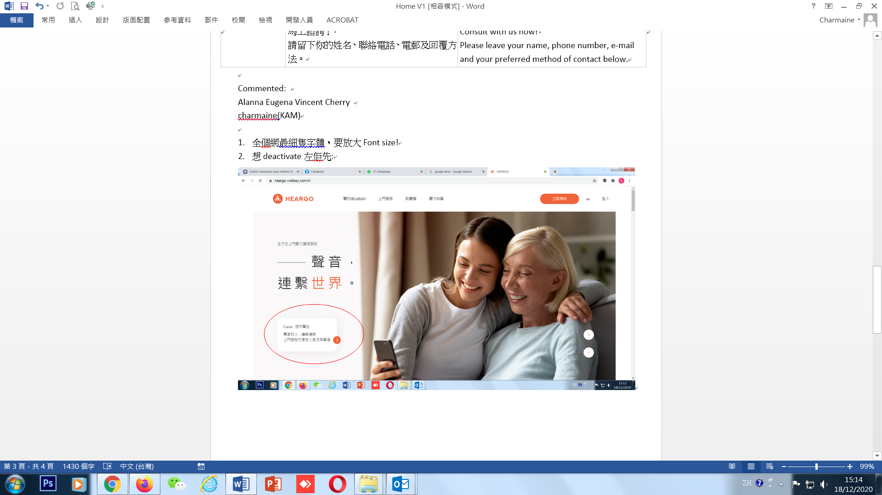

1. 個effect令到本身啲圖壓扁左，啲字唔係好睇到

可唔可以轉個另一個effect?

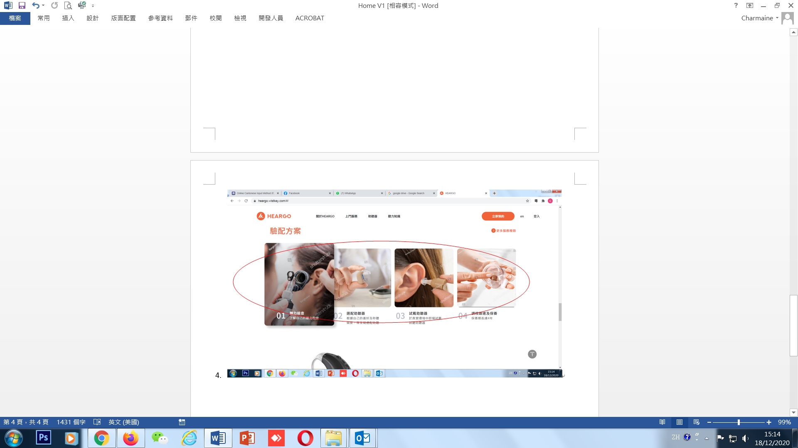

5.

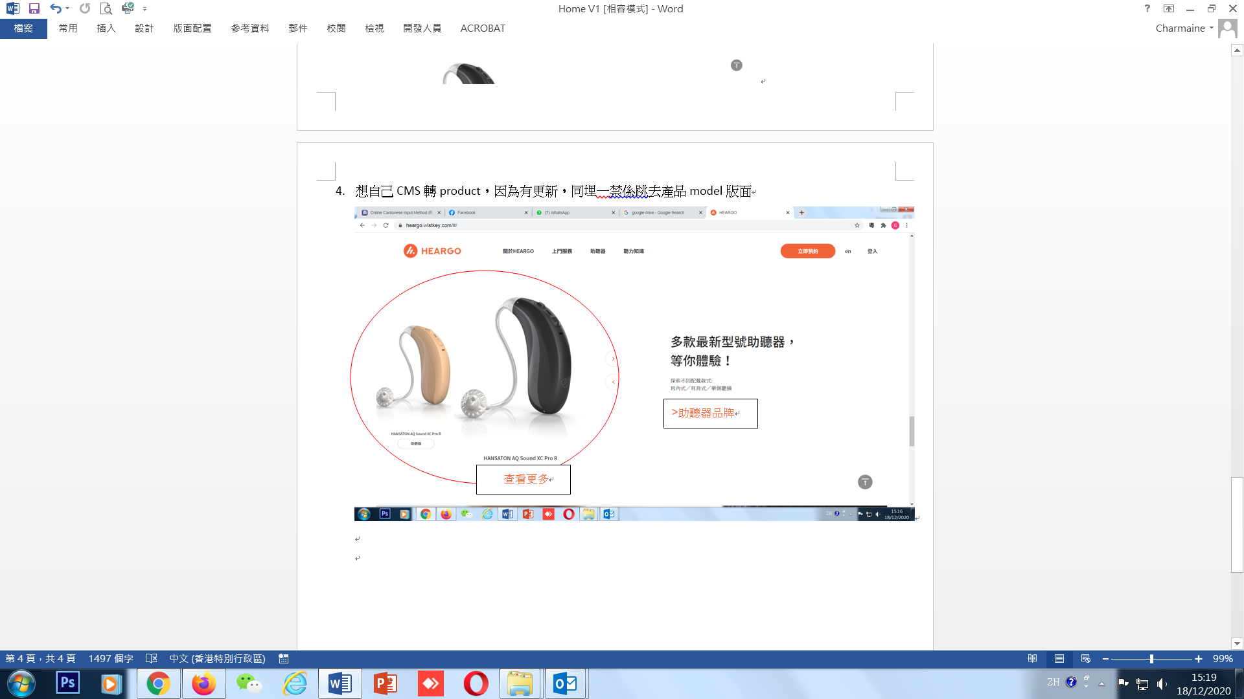

1. 姓名

聯絡電話

電郵地址

選擇回覆方法 (dropdown box)

