|  |  |
| --- | --- |
| Traditional Chinese | English |
| 上門服務 | Visiting service |
| 個人化的聽力護理體驗 | A personalized hearing health service |
| 為自己或家人尋找全面快捷的聽力檢測或助聽器驗配服務？HEARGO為你提供專業上門服務，貼心照顧你的聽力健康，讓你輕鬆迎接每天精彩生活。 | Searching for convenient and comprehensive hearing test or hearing aid fitting service? HEARGO offers home visit service so that you can enjoy professional hearing care to the best of your convenience. |
| 服務對象 | Suitable for |
| 行動不便 或 無法外出 | Disabled / homebound patients |
| 正處於治療休養期 | Patients in recovery |
| 家人未能抽空陪診 | Those without a companion to visit the clinic |
| 工作繁忙需要時間靈活的服務 | Those who require a flexible service due to work or busy schedule |
| 為何選用HEARGO？ | Why HEARGO? |
| 專家團隊 : 所有HEARGO聽力專家均已獲得專業認證，並經過嚴格的評估及挑選。 | Professional team: All HEARGO hearing care professionals are certified |
| 安全便捷：由專家上門為你提供服務，無須到醫院或診所輪候。 | Safe and convenient: Hearing care professionals visit your home––avoid waiting at hospitals or clinics |
| 最真實產品體驗：即場體驗助聽器在日常生活中的聆聽效果 | Best trial experience: Try hearing aids in the comfort of your home |
| 服務種類及流程 | Type of service and procedure |
| 了解病歷及聽力檢查 | Hearing health history and audiological assessment |
| 了解你的聽力損失狀況或相關病史，與及日常的聽力困擾與需求。 為你進行純音測驗及中耳阻抗測驗，確定弱聽成因、類型及程度。若有需要，會為你轉介合適的專科醫生。 | Understanding your hearing health history, current condition and hearing difficulties you are experiencing in everyday life. A hearing assessment composed of Pure Tone Audiometry (PTA) and Impedance Audiometry (IA) will be performed to identify the types of hearing loss and the possible causes and also the severity of your hearing loss. A referral to other professionals will be issued depending on the condition. |
| 選擇助聽器 | Hearing aids selection |
| 依據聽力評估結果及個人需求，為你選配適合的助聽器。 | Select the most suitable hearing aids according to the assessment results and your personal needs. |
| 試戴助聽器 | Hearing aids trial |
| 專家會讓你即場體驗助聽器在日常生活中的聆聽效果，並為你調校助聽器至最佳狀態。如需要耳模或指定機型，需支付訂金訂製助聽器。 | On-the-spot hearing aids tuning and listening trial ensure that the device is adjusted to your satisfaction. If you need any ear moulds or a specific device model, a deposit is required. |
| 售後調校跟進 | Hearing aids adjustment and follow up service |
| 提供免費清潔保養, 免費遙距調校*及本地維修服務。 定期跟進聽力狀況，並提供一對一聽力護理專家諮詢。  *特定機款 | Free cleaning, remote adjustment* and local repairing service are available. Regular hearing health follow-up and one-to-one audiologist consultations are also available.  *for specific models |
| 其他服務 | Other service |
| 安裝無線藍牙配件 | Installation of digital wireless accessories |
| 配合家居環境及生活需要為你接駁助聽器到電視、電話和其他配件。 | Connect your hearing aids to other devices such as TV or other accessories for you. |
| 助聽器保養使用教學 | Guidance on hearing aids usage and maintenance |
| 教導用家及照顧者如何適當使用和保養助聽器，~~以助你有效地利用有限的聽力，重建溝通能力。~~ | Instruct user and caretaker the usage and maintenance of your hearing aids ~~make full use of their device and rebuild their communication skills.~~ |
| 速遞收件維修及產品配送 | Shipping for repair and delivery |
| 可使用順豐速遞到付自取服務。相關費用視符貨品重量 (若要寄付，請先聯絡我們)。 | You can pay in cash on Receiver service from SF Express. Shipping cost depends on the package weight. (If you require Cash on Delivery, please contact us) |
| **服務收費** | Pricing |
| 聽力~~護~~專家到診 - 助聽器驗配及即場試聽 (已包括聽力評估) | Visiting service - Hearing aids selection and instant trial (hearing test included) |
| 聽力專家到診 - 聽力評估及面對面諮詢 | Visiting service - Hearing test and consultation |
| 聽力專家到診 - 助聽器調較 | Visiting service - Hearing aids adjustment |
| 以上價格從2021年1月1日開始生效，如有修改恕不另行通知。 | Above pricing are in effect from 1 January 2021 onwards, and are subject to change without prior notice. |
| *服務地區如屬偏遠地區，會額外收取附加費。 | *Extra fee will be charged for service at remote areas. |
| **服務收費根據實際時間的長短而作調整。 | **Service charge will be adjusted according to the duration of the service. |
| **15分鐘免費諮詢聽力專家** | 15-min Free Hearing Care Consultation with our Professional |
| 只需提供個人資料預約時間，專家會親自致電回覆 | Leave your information and preferred time - our hearing care professional will call you back . |
| 立即聯絡我們諮詢服務！ | Contact us now to learn more about our service! |
| 2893 1102 Whatsapp按此 | 2893 1102 Click here to WhatsApp us |
| 如何預約 | How to book |
| 1.選擇服務時間 | Pick a date and time |
| 登上HEARGO網上預約平台，選擇上門服務種類，日期及時間。 | Go on HEARGO’s online booking platform, pick the interested visiting service, preferred date and time. |
| 2. 提交個人資料 | Submit personal information |
| 提交資料後，HEARGO會為你配對合適的聽力護理專家。專家會於1個工作天內親自致電聯絡，即時確認收費及服務。 | Upon submission of your details, HEARGO will match you with a suitable hearing care professional, who will contact you by phone to confirm the booking and fees within 1 business day. |
| 3. 上門進行服務 | Visiting service |
| 服務當日，HEARGO的聽力護理專家將親臨指定地點提供服務，讓你無論是在家中、診所或酒店，都可舒適地享受專業聽力服務。 | Whether your selected venue is your home, a clinic or a hotel room, you just need to sit back and wait for our hearing care professional to come visit and provide you with professional hearing care services. |
| 管理電子聽力報告 | Digitised audiology report |
| 預約HEARGO服務時，你同時亦需註冊一個網上賬戶。登入HEARGO網上平台後，即可檢視你所持有的預約記錄、聽力報告及帳單。 | You are required to register a free account on HEARGO when booking our service. Once you log in, you will be able to access all booking details, hearing test report and payment record. |
| **支付方式** | Payment method |
| 你可於預約時選擇付款方式，並在完成服務後支付協定費用。所有服務費用均於確認預約詳情時一同確認。未經你的同意前，HEARGO不會進行任何轉賬。 | You can choose your preferred payment method when booking the service. Payment will be made after the service is fulfilled. The amount of payment will be confirmed during booking confirmation. No charge will be made without your consent. |
| 方法一：信用卡付款 | Method 1: Credit card |
| 方法二：FPS轉數快/ 銀行轉帳 | Method 2: FPS / Bank transfer |
| 方法三：Payme轉帳 | Method 3: Payme |
| 方法四：支票 | Method 4: Cheque |
| **常見問題** | **FAQ** |
| **Q：上門服務提供的聽力測試，符合一般診所聽力測試的標準嗎？** | **Q: Does the hearing test conducted during the visiting service reach the standard of those at a clinic?** |
| A：符合。我們所有便攜式專門儀器都達到一般檢測儀器的標準，上門進行的聽力測試步驟亦與一般測試相同。為確保測試準確度，我們在開始測試前亦會即場進行環境評估，確保環境聲量不會超出可接受範圍；有需要時聽力專家亦會採用入耳式耳筒，將環境聲音的影響減至最低。 | A: Yes. All our specialised portable equipment meet the performance and calibration requirements of the relevant standards. The test procedures are the same as any standard hearing test at the clinic. We also ensure the ambient noise of the test environment is within accepted limits, and use insert earphones when necessary to minimise the effect of ambient noise and ensure test accuracy. |
| **Q：選用上門服務對我來說有壞處／不足之處嗎？** | **Q: Are there any drawbacks to a visiting service compared to a traditional clinic visit?** |
| A：沒有。相反，讓我們上門為你進行聽力服務的好處更多。若聽力測試結果顯示你需要配戴助聽器，你可即場於家中熟悉的生活環境試聽效果。不少用家都反映，在家中進行測試令他們感覺更輕鬆。 | No. In fact, there are plenty of advantages for a visiting service. If the test determines that you are suffering from hearing loss and hearing aids are recommended, a hearing aids trial will be provided right away. This will give you the most accurate demonstration of how well the hearing aids function for your everyday activities. Our patients have also reflected that being in the comfort of their home makes the experience more relaxing. |
| **Q：服務所需時間有多久？** | **Q:How long will the appointment last?** |
| A：視乎服務內容，最長每次180分鐘。 | A: Depending on the service type, with up to 180 minutes per session. |
| **Q：我應該多久預約檢查一次？** | **Q: How often should I book an appointment?** |
| A：如果你是正在配載助聽器的聽障人士，我們建議你每年進行一次聽力測試，監察聽力受損程度有否惡化，並確保助聽器的設定調校至最佳。 | If you are a hearing aid user suffering from hearing loss, we recommend annual hearing test to monitor any decline to your hearing and to keep the settings on your hearing aids updated. |
| **Q: 到診費用包括什麼？** | **Q: What does the service fee cover?** |
| A: 聽力專家到診費用已包括上門諮詢及服務費用、交通費用，及電子簡易聽力報告。 | A: Service fee covers visiting consultation and service charge, transportation fee and electronic Simplified hearing test report. |
| **Q: 上門服務是否只會有一位專家到診？** | **Q: Will there be only one visiting specialist for the service?** |
| A: 上門專家人數根據服務種類而定。例如，驗配助聽器時，我們會派出兩位專家到診。 | A: The number of visiting specialist per session depends on the service type. For example, 2 specialists will be sent for a hearing aids fitting service. |
| **Q：如果我想預約於同一地點為兩人提供服務，你們如何收費？** | **Q: How will you charge if two people require your visiting service at the same location?** |
| A: 我們提供單對單專屬服務，因此服務時間和診金會因應服務項目及人數而有所增加。例如，同一地點為兩位客人進行聽力檢查，總費用為$1800 (60分鐘) x 2 = $3200 (共120分鐘)。請於預約時表明服務人數。 | A: Our service is one-to-one. Therefore, service duration and charge depends on the number of people that require the service. For example, two people requiring hearing test at the same location, the total charge will be $1800 (60 min.) x 2 = $3200 (120 min. in total). Please specify the number of people requiring service at the time of booking. |
| 歡迎院舍、外展機構或醫院、診所致電查詢合作計劃！ | Collaborations are welcome for elderly homes, outreach service, hospitals and clinics. Give us a call! |
| 查詢表格 | Inquiry form |

Other comments:

* 1. 服務收費 pricing: Mobile version need to add an arrow in the side to indicate that it can be swipe 呢度無箭嘴係側邊可能唔知有得swipe (>>)
* 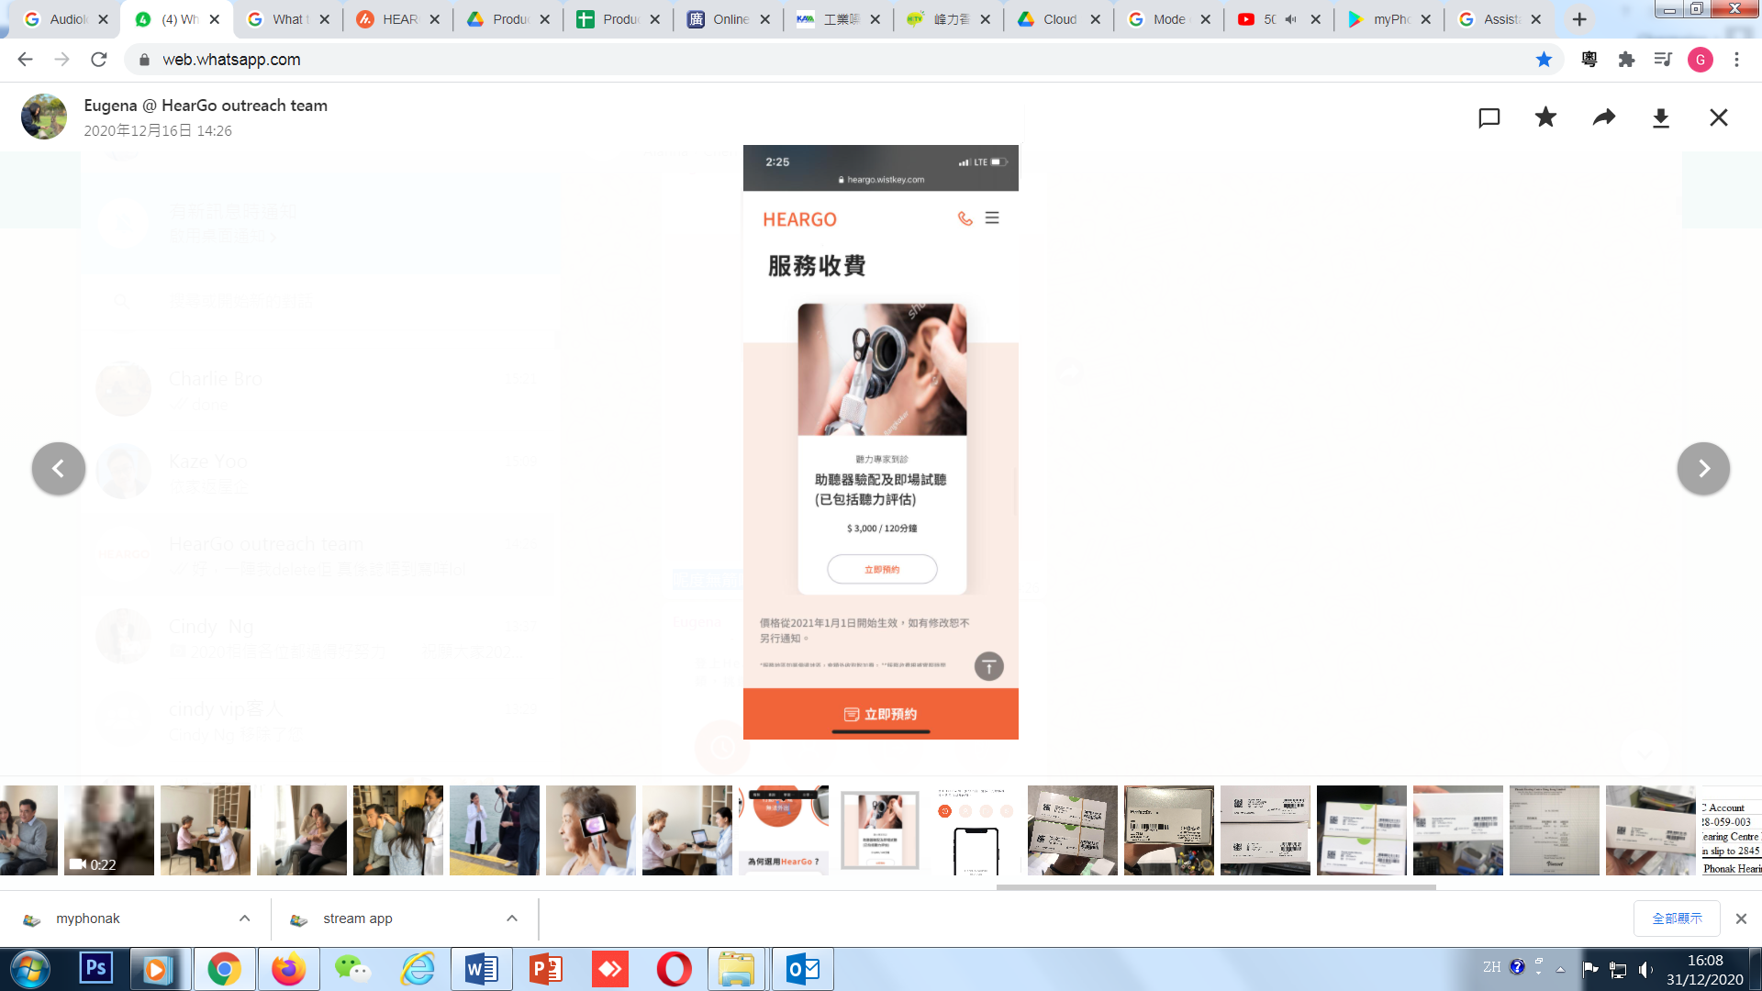
* 2. 如何預約How to book要自動播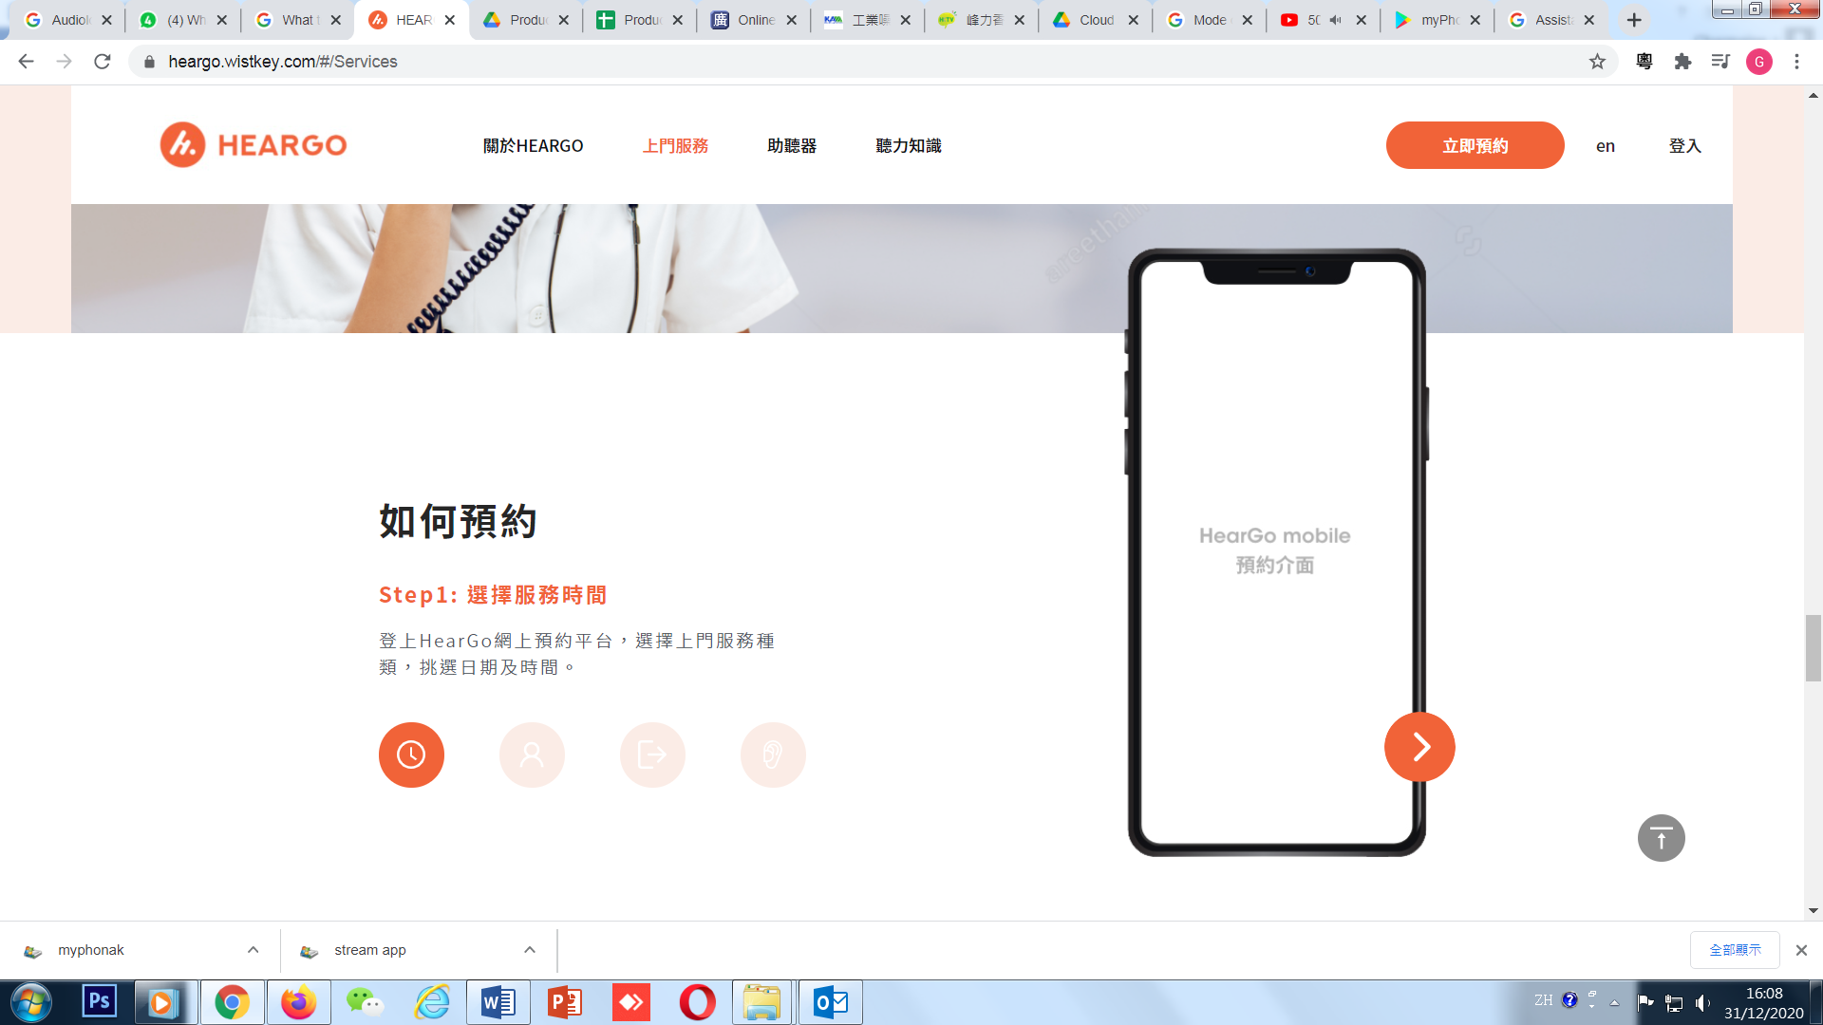
* 3. Smallest font for eng version seems a bit too thin…

4. 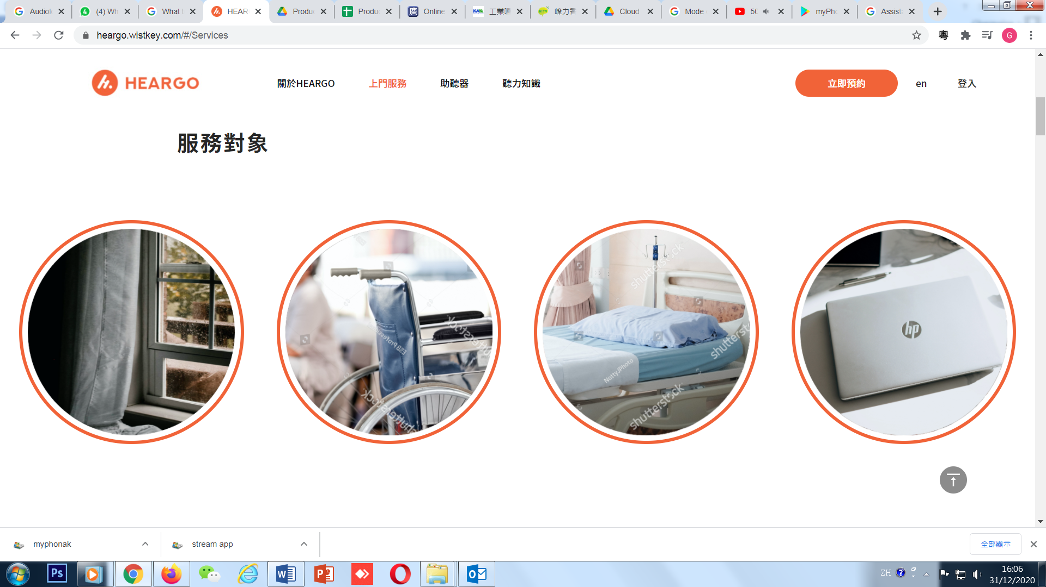

一開始有一個已經show左字出黎

按住會彈出啲字，mobile版可能轉做圖片format以避免一按就出現上面情況？一按就彈呢啲出黎好煩

5. 間距統一 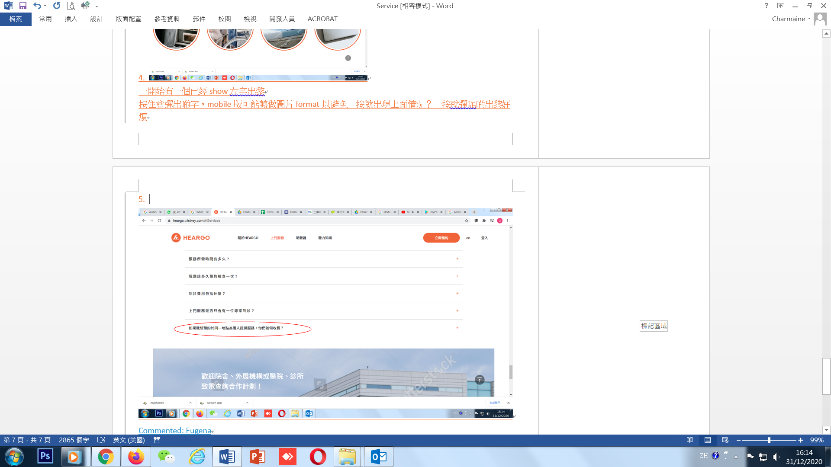

Commented: Eugena

Cherry

Alanna

Charmaine (KAM)

Vincent