# Result analysis

## Intramolecular-reverse-cope-4F



Figure Intramolecular reverse cope 4F

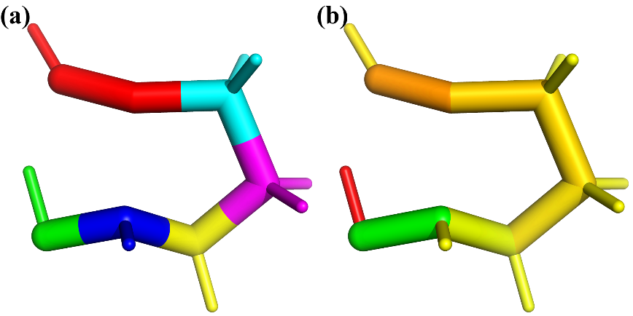

Figure (a) Fragmentation scheme of intramolecular-reverse-cope-4F using different colors. (b) Difference of bond length relative to the reactant (color bar green to red: red positive, green negative, yellow: no change)

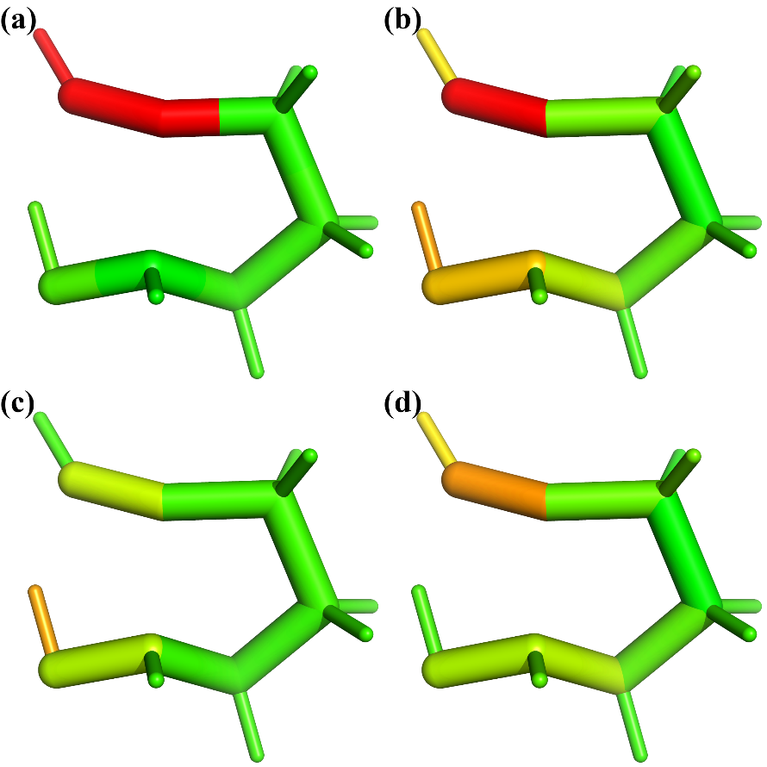

Figure Strain energy distribution (log10 scale) of intramolecular-reverse-cope-4F by DFT method (b3lyp/6-31g(d)): (a) using M1, (b) total strain energy using M2, (c) bond contribution of M2, (d) angle contribution of M2.

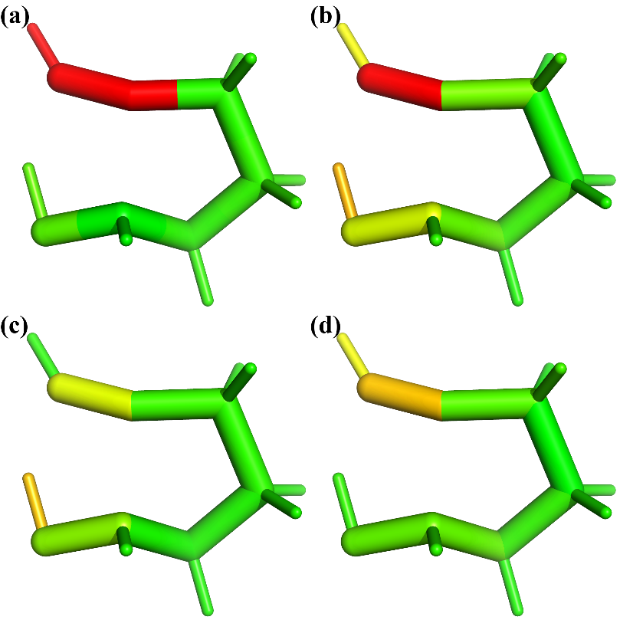

Figure 4 Strain energy distribution (log10 scale) of intramolecular-reverse-cope-4F by GFN2-xTB method: (a) using M1, (b) total strain energy using M2, (c) bond contribution of M2, (d) angle contribution of M2.

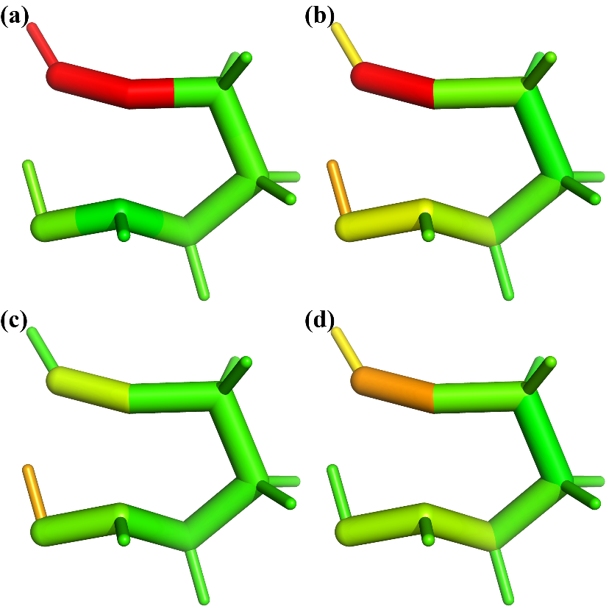

Figure 5 Strain energy distribution (log10 scale) of intramolecular-reverse-cope-4F by ANI-2x method: (a) using M1, (b) total strain energy using M2, (c) bond contribution of M2, (d) angle contribution of M2.

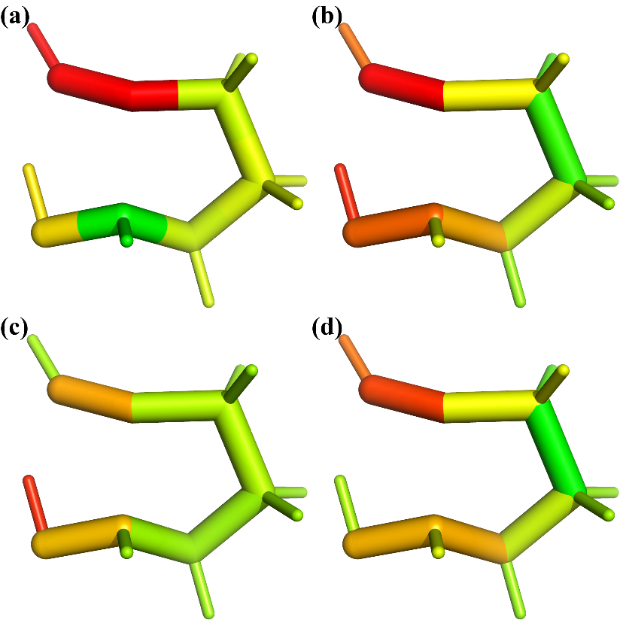

Figure 6 Strain energy distribution (log10 scale) of intramolecular-reverse-cope-4F by AIQM1 method: (a) using M1, (b) total strain energy using M2, (c) bond contribution of M2, (d) angle contribution of M2.

## S-Se

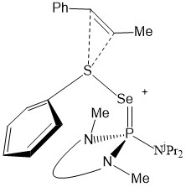

Figure 7 S-Se@@重画

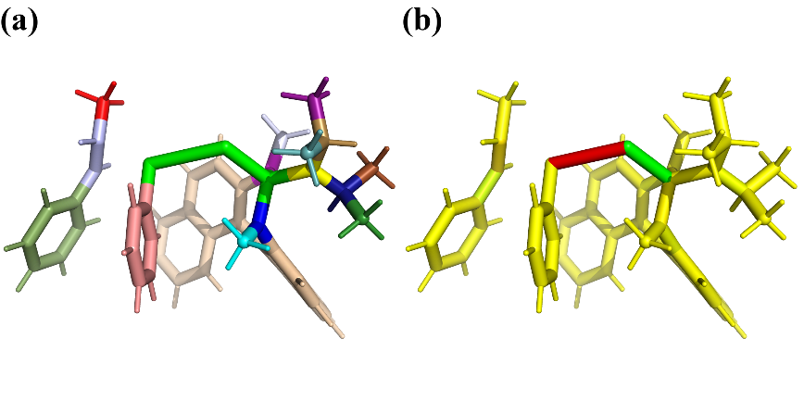

Figure 8 (a) Fragmentation scheme of @@S-Se using different colors. (b) Difference of bond length relative to the reactant (color bar green to red: red positive, green negative, yellow: no change)

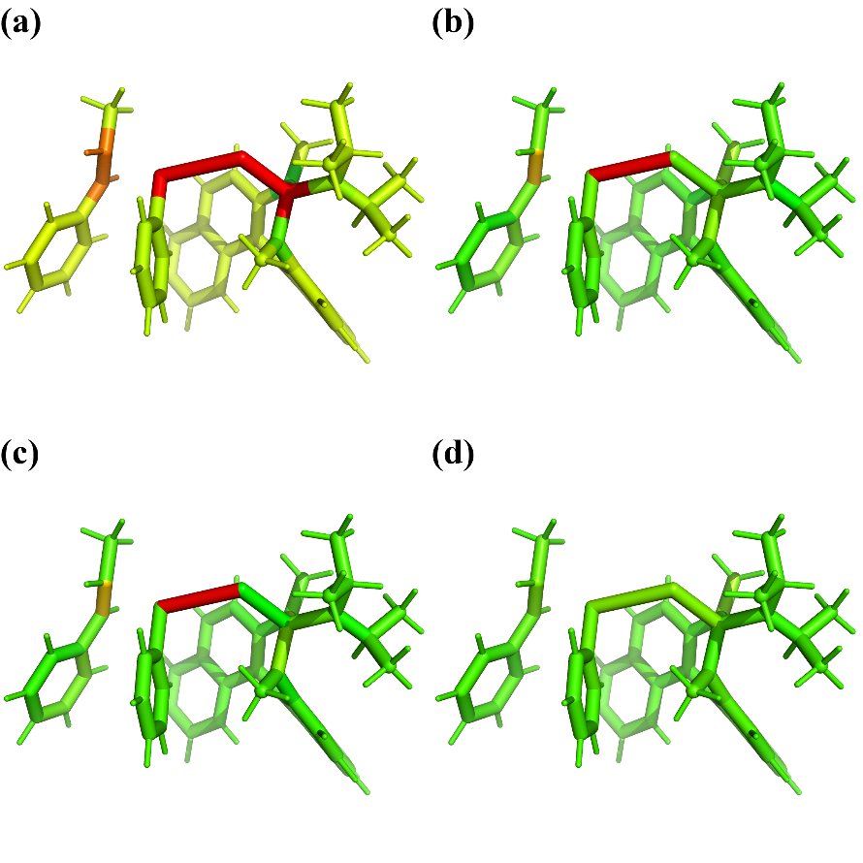

Figure 9 Strain energy distribution (log10 scale) of @@S-Se by DFT method (b3lyp/6-31g(d), SMD): (a) using M1, (b) total strain energy using M2, (c) bond contribution of M2, (d) angle contribution of M2.

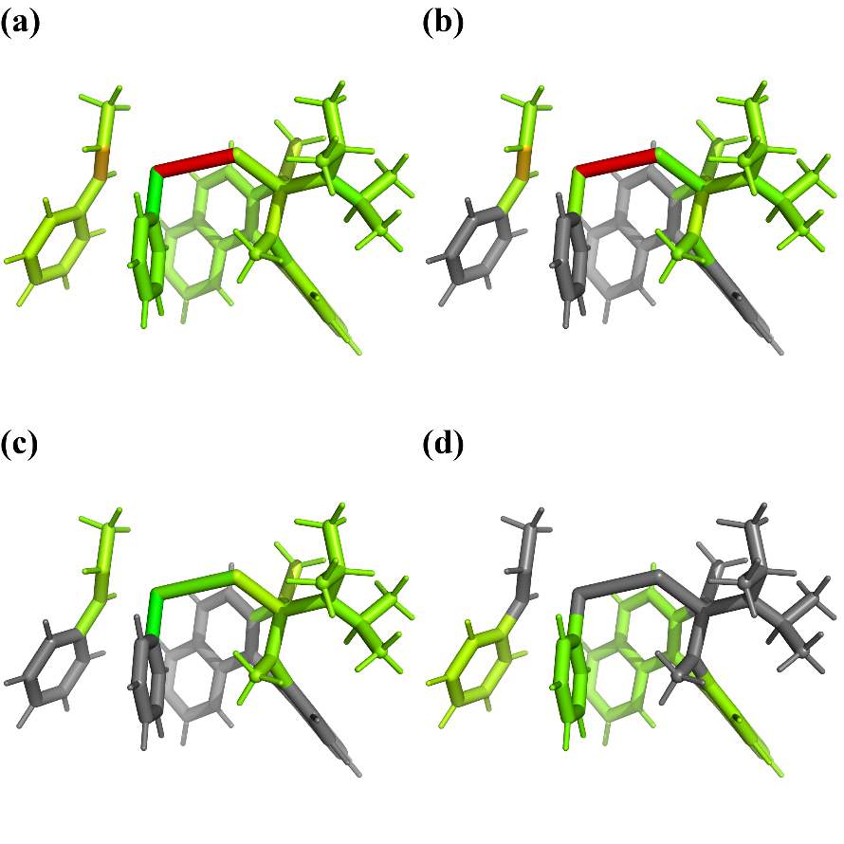

Figure 10 Strain energy distribution (log10 scale) of @@S-Se by DFT method (b3lyp/6-31g(d), SMD): (a) total strain energy using M3, (b) bond contribution of M3, (c) angle contribution of M3 and (d) fragment contribution of M3.

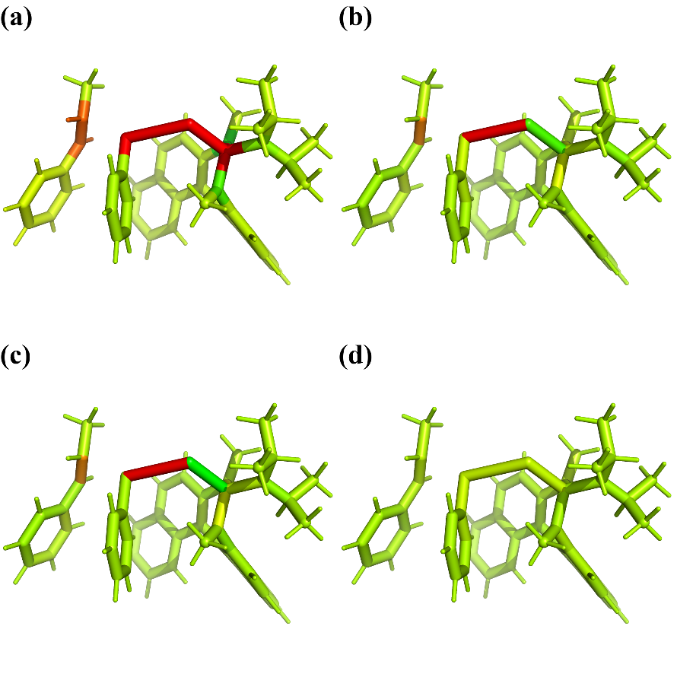

Figure 11 Strain energy distribution (log10 scale) of @@S-Se by GFN-xTB: (a) using M1, (b) total strain energy using M2, (c) bond contribution of M2, (d) angle contribution of M2.

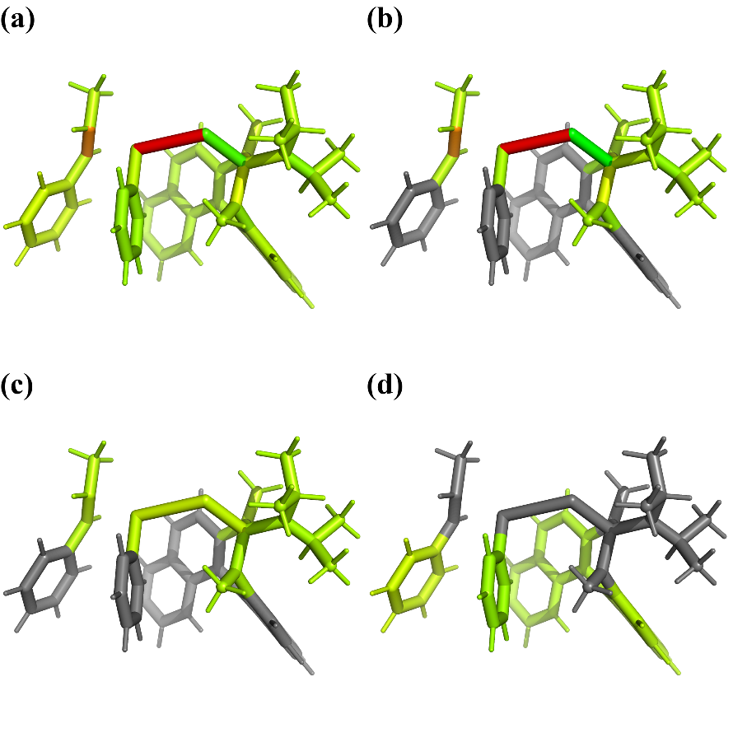

Figure 12 Strain energy distribution (log10 scale) of @@S-Se by GFN-xTB: (a) total strain energy using M3, (b) bond contribution of M3, (c) angle contribution of M3 and (d) fragment contribution of M3.