**Tutorial for D2AF**



**Using the reverse Cope elimination as example**

**Structure file: Ref**: 4F-reactant.gjf & **Tar**: TS-4F.gjf

4F-reactant.gjf contains the **connectivity** information

**1. M1:**

Input file: 4F_M1.inp

Pre-define the Gaussian 16 (or other calculators) environment then run:

***D2AF -inp 4F_M1.inp > 4F_M1.log***

Outputs as:

**2. M2:**

Input file: 4F_M2.inp

Pre-define the Gaussian 16 (or other calculators) environment then run:

***D2AF -inp 4F_M2.inp > 4F_M2.log***

Outputs as:

**3. M3:**

Input file: 4F_M3.inp

Pre-define the Gaussian 16 (or other calculators) environment then run:

***D2AF -inp 4F_M3.inp > 4F_M3.log***

Outputs as:

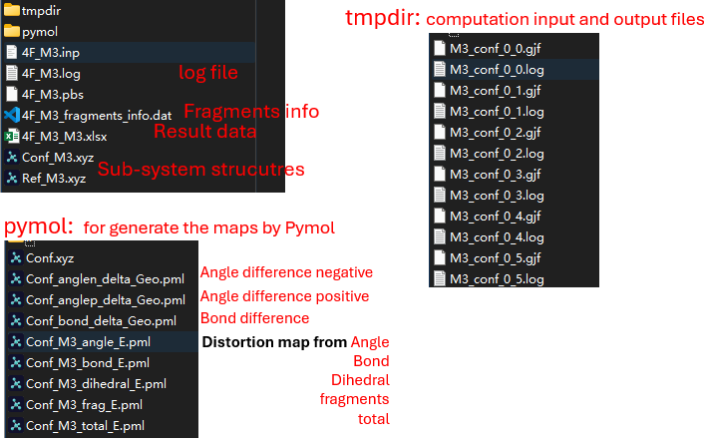

**3. Energy computation by user (here use M2 as example)**