**INTERVIEW 1**

**Examiner:** Good morning. My name is ……………………….. Could you tell me your full name, please?

**Candidate:** ……………………………………………………

**Examiner**: And what shall I call you?

**Candidate:** ……………………………………………………

**PART 1**

**Examiner**: OK. Now, in this first part of the exam I´m going to ask you some questions about yourself. Let´s talk about Free time.

* What do you enjoy doing in your free time?

**Candidate:** ……………………………………………………

* How much time do you have each week for doing these things?

**Candidate:** ……………………………………………………

* Why do you like doing these activities?

**Candidate:** ……………………………………………………

* How did you start doing this activity at first?

**Candidate:** ……………………………………………………

Let’s move on and talk about being on time for appointments.

* Is being late acceptable in your culture?

**Candidate:** ……………………………………………………

* Are you ever late for appointments?

**Candidate:** ……………………………………………………

* What type of excuses do you think are alright for lateness?

**Candidate:** ……………………………………………………

* How do you feel when someone is late for an appointment with you?

**Candidate:** ……………………………………………………

**PART 2**

**Examiner**: Now, let´s move on to the second part of the exam. I´m going to give you a topic and I´d like you to talk about it for 1 to 2 minutes. Before you start, you will have 1 minute to think about what you are going to say. You can make some notes if you want. Do you understand?

**Candidate**: ……………………………………………………

**Examiner**: I would like you to describe a beautiful place in your country (*1 minute to prepare; make sure candidate can see the card during the 1-minute preparation*)

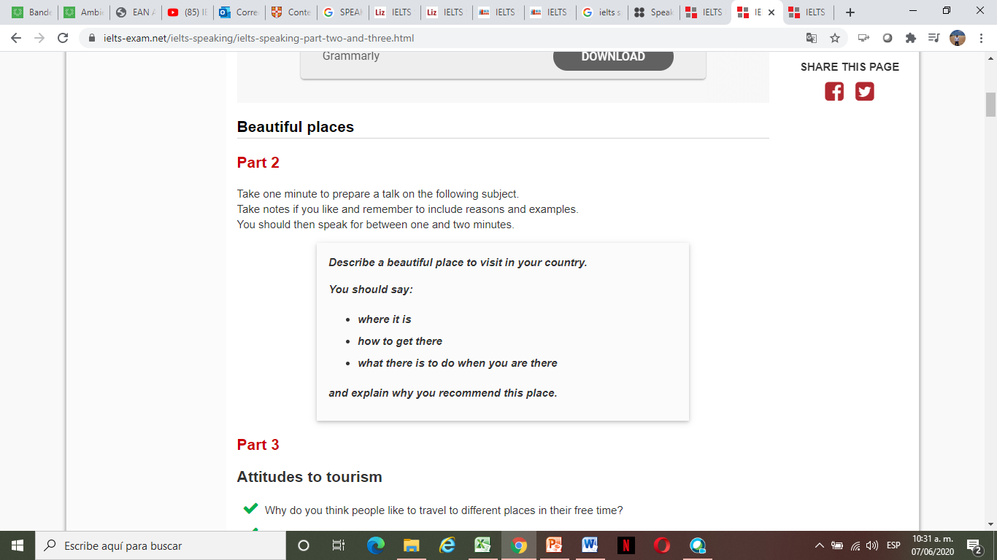

**Examiner**: Al right. Remember, you have 1 to 2 minutes for this, so don´t worry if I stop you. I will tell you when the time is up. Can you start speaking now, please? (*start* *timing 2 minutes and stop candidate ONLY if the 2 minutes have passed; do not establish conversation or interrupt him/her while he/she is speaking; if candidate finishes before 2 minutes, continue with the test*).

**Candidate** ……………. (a two-minute speech)

**Examiner**: Thank you. Would you like to go there in the future?

**Candidate**: ……………………..

**PART 3**

**Examiner**: Now, we have been talking about a place you have recently visited, and I would like to ask you some more general questions related to the topic. First of all, let´s talk about places and tourism. Why do you think people like to travel to different places in their free time?

* How do you see tourism changing in your country in the future?

**Candidate**: ……………………..

* Why is it important to protect the countryside?

**Candidate**: ……………………..

* In what ways is the countryside in danger in your country?

**Candidate**: ……………………..

* Why are historic buildings and monuments important to a city?

**Candidate**: ……………………..

**Examiner**: Thank you. That is the end of the speaking test.