**INTERVIEW 2**

**Examiner:** Good morning. My name is ……………………….. Could you tell me your full name, please?

**Candidate:** ……………………………………………………

**Examiner**: And what shall I call you?

**Candidate:** ……………………………………………………

**PART 1**

**Examiner**: OK. Now, in this first part of the exam I´m going to ask you some questions about yourself.

* Are you a student or do you work now?

**Candidate:** ……………………………………………………

* What do you study?

**Candidate:** ……………………………………………………

* Why did you choose this major?

**Candidate:** ……………………………………………………

* Is there anything about your course/job you would like to change?

**Candidate:** ……………………………………………………

**Examiner**: I’d like to move on and ask you some questions about shopping.

* Who does most of the shopping in your household?

**Candidate:** ……………………………………………………

* What type of shopping do you like? (Why?)

**Candidate:** ……………………………………………………

* Is shopping a popular activity in your country? (Why/why not?)

**Candidate:** ……………………………………………………

* What type of shops do teenagers like best in your country?

**Candidate:** ……………………………………………………

**PART 2**

**Examiner**: Now, let´s move on to the second part of the exam. I´m going to give you a topic and I´d like you to talk about it for 1 to 2 minutes. Before you start, you will have 1 minute to think about what you are going to say. You can make some notes if you want. Do you understand?

**Candidate**: ……………………………………………………

**Examiner**: I would like you to describe an important event in your life. (*1 minute to prepare; make sure candidate can see the card during the 1-minute preparation*)

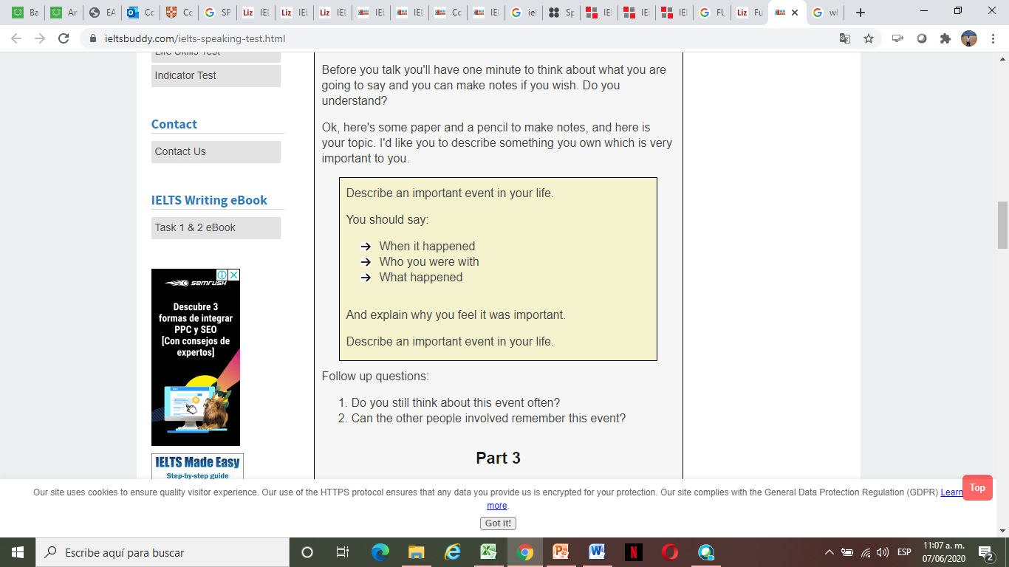

**Examiner**: Al right. Remember, you have 1 to 2 minutes for this, so don´t worry if I stop you. I will tell you when the time is up. Can you start speaking now, please? (*start* *timing 2 minutes and stop candidate ONLY if the 2 minutes have passed; do not establish conversation or interrupt him/her while he/she is speaking; if candidate finishes before 2 minutes, continue with the test*).

**Candidate** ……………. (a two-minute speech)

**Examiner**: Thank you. Do you still think about this event often?

**Candidate**: ……………………..

Do you think the other people involved remember this event?

**Candidate**: ……………………..

**PART 3**

**Examiner**: We've been talking about an important event in your life, and I'd now like to ask you some questions related to this.

* What days are important in your country?

**Candidate**: ……………………..

* Why is it important to have national celebrations?

**Candidate**: ……………………..

* How is the way your national celebrations are celebrated now different from the way they were celebrated in the past?

**Candidate**: ……………………..

* Are there any celebrations from other countries that you celebrate in your country?

**Candidate**: ……………………..

**Examiner**: Thank you. That is the end of the speaking test.