Tank Inspection Copilot
Product Report
Generated: April 13, 2026
Project: tank-inspection-coplilot
Target: mobile and tablet field use; this prototype is implemented as a mobile-only single-column UI.
Core workflow: tank setup -> surface -> grid location -> defect -> evidence -> validation.
Executive Summary
Tank Inspection Copilot is a mobile-first field data-capture app for tank inspection defects. It records each defect against a repeatable spatial coordinate using a flattened 2D matrix for tank surfaces.
The current prototype focuses on the detailed location capture workflow: select tank context, choose a surface, tap or enter a location, capture defect details, attach required photo evidence, review validation warnings, and prepare a report-ready dataset.
Product Scope
- Mobile-only field workflow with single-column layout and large touch targets.
- Offline draft persistence through local storage with draft, unsynced, and synced status badges.
- Guided inspection setup for site, client, tank ID, inspection type, inspector, and date context.
- Surface selection for bottom, shell, roof, annular ring, nozzle area, and weld zone.
- Primary tap-on-grid location capture plus manual X/Y entry and plate ID fallback modes.
- SVG grid map with disabled cells outside circular tank footprint for bottom and roof surfaces.
- Shell view uses an unwrapped rectangular grid with lower-left origin behavior.
- Layer toggles for plate IDs, grid labels, prior defects, and repair overlays.
- Defect details capture for type, subtype, severity, extent, description, measurements, and photo evidence.
- Validation panels for missing photos, missing subtype, annular review, required surfaces, and invalid coordinates.
- Report-ready structured data model for InspectionSession, SurfaceInspection, GridLocation, DefectRecord, and EvidenceItem.
At-a-Glance Workflow
Phase | Screens | Purpose
Start | Home, Inspection Setup, Tank Overview | Open or create the inspection draft and choose the tank surface.
Location | Location Mode, Grid Map, Manual X/Y, Plate ID, Location Confirmation | Capture a repeatable surface, X, Y, grid ID, and optional plate ID.
Defect Capture | Defect Type, Defect Details, Measurements, Evidence | Record defect type, severity, measurements, notes, and required photo evidence.
Review | Defect Saved, Surface Map, Surface Review | Confirm the saved record, review spatial markers, and run surface-level QA.
Submit | Inspection Validation, Submission Success | Run whole-inspection QA, block invalid submission, and close the workflow.
Screenshot Gallery
Screenshot 1: Mobile Home
Entry screen with sync status, active draft context, and actions to start, resume, or view inspections.
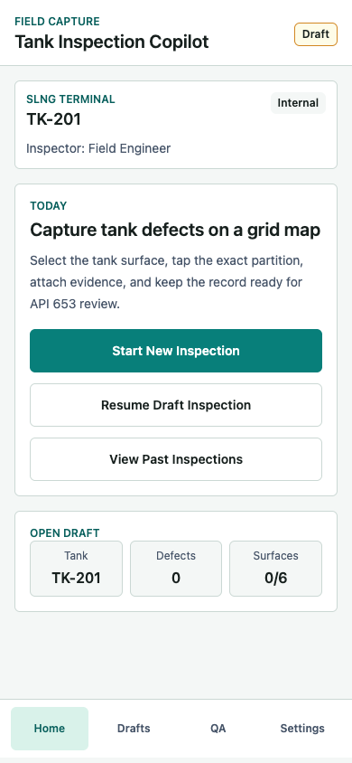
Screenshot 2: Tank Overview and Surface Selection
Surface cards for bottom, shell, roof, annular ring, nozzle area, and weld zone with completion state.
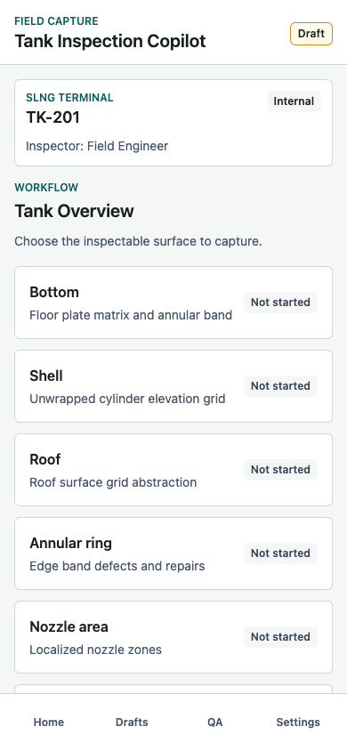
Screenshot 3: Grid Map Location Picker
Primary location capture screen with plate IDs, repair overlays, prior defects, grid labels, disabled cells, and selected X/Y summary.
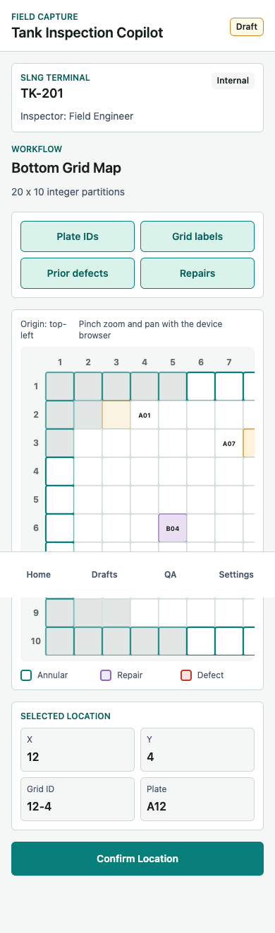
Screenshot 4: Location Confirmation
Locked location review before defect typing, with location summary and a mini map preview.
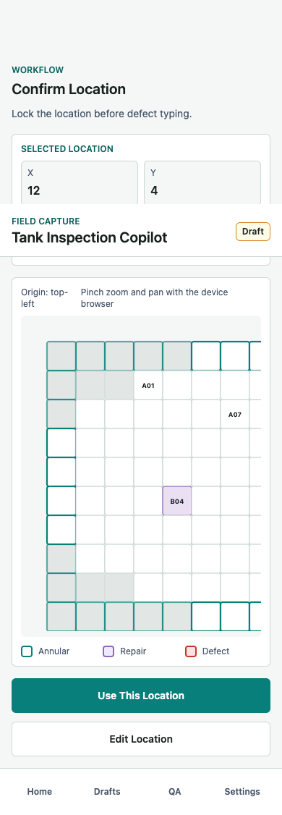
Screenshot 5: Defect Type Selection
Location-linked defect taxonomy picker for corrosion, crack, deformation, coating failure, leakage, weld defect, repair observation, or other.
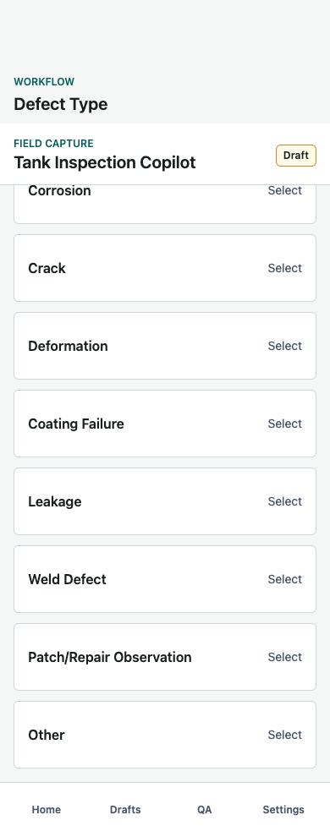
Screenshot 6: Defect Details
Structured defect details with subtype, severity, extent, and field note capture.
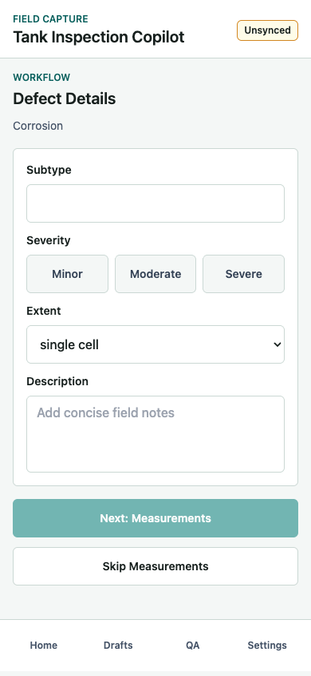
Screenshot 7: Measurement Capture
Dynamic measurement fields and defect-specific warning logic, shown here for corrosion without UT thickness.
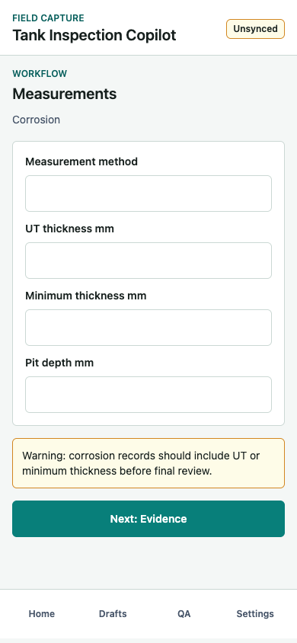
Screenshot 8: Evidence Required
Evidence capture screen blocks save until at least one photo is attached.
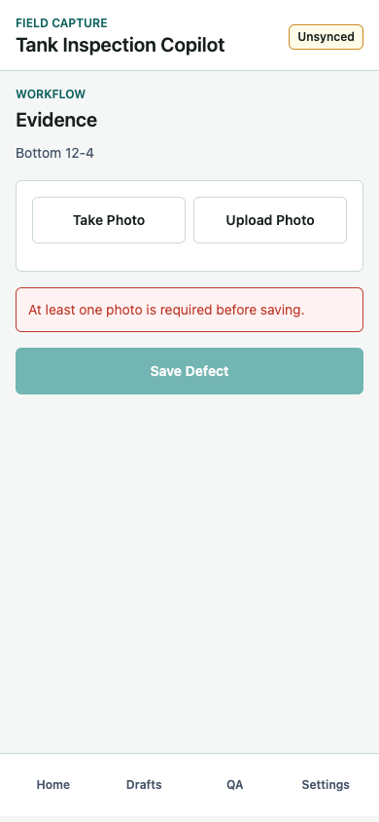
Screenshot 9: Evidence Attached
Mock photo evidence linked to tank, surface, and X/Y location, with delete control.
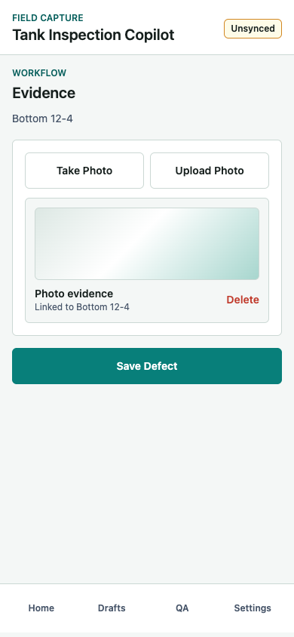
Screenshot 10: Defect Saved
Saved defect summary showing type, severity, location, photo count, and next actions.
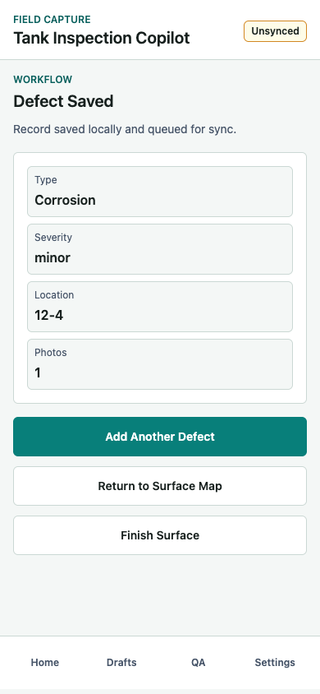
Screenshot 11: Saved Defect Map
Surface map with saved defect marker, layer toggles, legend, and finish surface action.
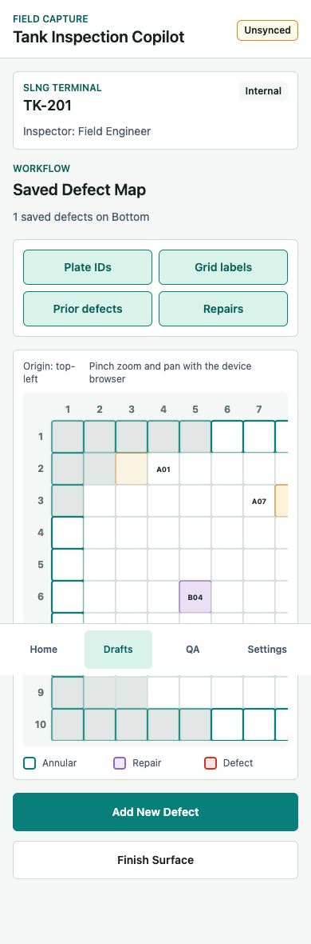
Screenshot 12: Surface Completion Review
Surface-level QA summary with defect count, photo count, grid size, status, and warnings.
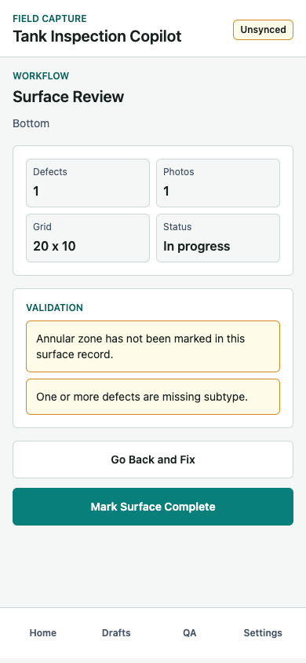
Screenshot 13: Inspection Validation
Whole-inspection QA blocks submission until required surfaces and defect records pass validation.
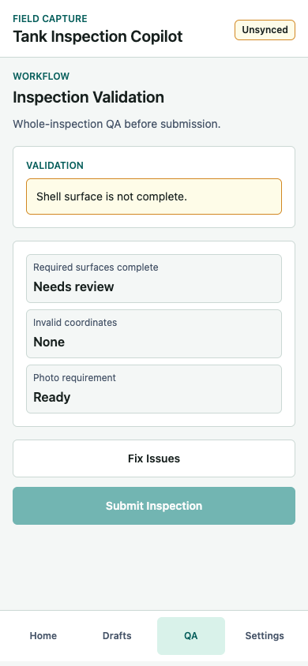
Complete Screen-by-Screen Function and Feature Description
Screen 01 - Home
Purpose: Entry point for the field engineer and quick access to the active draft.
Functions and features:
- Shows app name, field capture context, and sync status badge.
- Shows active draft header with site, tank ID, inspection type, and inspector.
- Provides Start New Inspection, Resume Draft Inspection, and View Past Inspections actions.
- Shows open draft metrics for tank, defect count, and completed surfaces.
- Bottom navigation provides Home, Drafts, QA, and Settings access.
Validation: No blocking validation on this screen.
Output: Routes to Inspection Setup for a new inspection or Tank Overview for an existing draft.
Screen 02 - Inspection Setup
Purpose: Create or update the inspection context before location capture begins.
Functions and features:
- Captures site, client, tank ID, and inspection type.
- Inspection type supports routine, external, internal, and special.
- Inspection date and inspector are treated as auto-filled context for the draft.
- Continue saves the inspection context and moves to Tank Overview.
- Save Draft writes the inspection context locally and returns to Home.
Validation: Continue is disabled until site, tank ID, and inspection type are present.
Output: Updates the InspectionSession object and sets sync status to unsynced.
Screen 03 - Tank Overview
Purpose: Select the inspectable surface for the next defect capture operation.
Functions and features:
- Shows inspection header with site, tank ID, inspection type, and inspector.
- Lists bottom, shell, roof, annular ring, nozzle area, and weld zone.
- Each surface card includes a short operational description.
- Each surface card shows Not started, defect count, or Complete state.
- Selecting a surface initializes a default draft location for that surface.
Validation: No blocking validation on this screen.
Output: Routes to Location Mode Selection with the chosen surface.
Screen 04 - Location Mode Selection
Purpose: Let the engineer choose the most practical location capture method.
Functions and features:
- Tap on Grid Map is marked as the recommended method.
- Manual X,Y Entry supports checklist-driven or difficult touch conditions.
- Plate ID Entry supports engineers working directly from a plate map drawing.
- Each option explains when to use the method.
Validation: No blocking validation on this screen.
Output: Routes to Grid Map Location Picker, Manual X,Y Entry, or Plate ID Picker.
Screen 05A - Grid Map Location Picker
Purpose: Primary location capture screen for selecting the exact X/Y partition.
Functions and features:
- Displays tank header, surface name, and grid size such as 20 x 10.
- Renders an SVG rectangular grid with every valid cell tappable.
- Disables cells outside the valid circular footprint for bottom and roof surfaces.
- Shows the active origin convention: top-left for bottom/roof and lower-left for shell.
- Supports plate ID, grid label, prior defect, and repair overlay toggles.
- Highlights annular edge cells on the bottom surface.
- Highlights selected cell and updates X, Y, grid ID, and plate ID summary.
- Shows a map legend for annular, repair, and defect states.
- The scrollable SVG supports device browser zoom and pan behavior.
Validation: Confirm Location is disabled until a valid cell is selected.
Output: Creates a GridLocation with surface, x, y, gridId, optional plateId, locationMode, and isAnnular.
Screen 05B - Manual X,Y Entry
Purpose: Fallback location entry for known coordinates or poor map interaction conditions.
Functions and features:
- Shows the selected surface as context.
- Captures X partition and Y partition as integer inputs.
- Provides a live valid or invalid partition message.
- Preview on Map returns to the grid map for visual confirmation.
- Confirm Location accepts only valid inspectable coordinates.
Validation: X and Y must be integers, within grid bounds, and inside the valid surface footprint.
Output: Creates the same GridLocation object as tap-on-grid mode with locationMode set to manual_xy.
Screen 05C - Plate ID Picker
Purpose: Capture location by plate number when working from a floor plate drawing.
Functions and features:
- Searches available plate IDs by typed query.
- Shows plate cards with plate ID, subzone, and mapped X/Y coordinate.
- Selecting a plate auto-fills the mapped location.
- Show on Map returns to the grid map if the engineer wants visual confirmation.
Validation: Only listed mapped plates can be selected in the MVP.
Output: Creates a GridLocation with locationMode set to plate_id and the mapped plateId.
Screen 06 - Location Confirmation
Purpose: Lock the selected location before defect type and details are entered.
Functions and features:
- Shows location summary for surface, X, Y, grid ID, and optional plate ID.
- Shows mini grid preview with the selected location highlighted.
- Use This Location advances to defect typing.
- Edit Location returns to the original location capture mode.
Validation: Use This Location is disabled if no location is available.
Output: Confirms the location for the draft defect record.
Screen 07 - Defect Type Selection
Purpose: Start a defect record linked to the confirmed location.
Functions and features:
- Shows selected surface and grid ID in the screen subtitle.
- Offers corrosion, crack, deformation, coating failure, leakage, weld defect, patch/repair observation, and other.
- Each type is a large touch target for field use.
Validation: The user must select one defect type to continue.
Output: Stores defectType on the draft record and routes to Defect Details.
Screen 08 - Defect Detail Form
Purpose: Capture structured qualitative defect details.
Functions and features:
- Shows defect type as the context heading.
- Captures subtype as free text.
- Captures severity as minor, moderate, or severe.
- Captures extent as single cell, multi-cell region, or edge/annular.
- Captures a concise description or field note.
- Supports Next: Measurements and Skip Measurements actions.
Validation: Next: Measurements requires defect type and severity.
Output: Updates draft defect subtype, severity, extent, and description.
Screen 09 - Measurement Capture
Purpose: Capture numeric NDE or visual measurement values when relevant.
Functions and features:
- Captures measurement method.
- For cracks, captures crack length and crack width.
- For deformation, captures deformation dimension.
- For corrosion and other default cases, captures UT thickness, minimum thickness, and pit depth.
- Shows defect-specific warning text when important measurement values are missing.
Validation: Corrosion without UT/min thickness, crack without size, and deformation without dimension produce warnings.
Output: Updates the DefectMeasurement object and routes to Evidence.
Screen 10 - Evidence Capture
Purpose: Attach required proof to the defect before saving.
Functions and features:
- Shows selected surface and grid ID as context.
- Provides Take Photo and Upload Photo actions in the MVP.
- Displays attached evidence in a gallery-style strip.
- Each evidence item is linked to surface, X, and Y metadata.
- Delete removes an attached evidence item before saving.
- The data model can represent photo, video, and audio evidence, but the current UI implements photo flows first.
Validation: Save Defect is disabled until at least one photo is attached.
Output: Creates evidence metadata and enables local defect save.
Screen 11 - Defect Saved Summary
Purpose: Confirm local save and let the engineer choose the next field action.
Functions and features:
- Shows that the record is saved locally and queued for sync.
- Summarizes defect type, severity, location, and photo count.
- Add Another Defect keeps the same location context for rapid capture.
- Return to Surface Map shows spatial defect context.
- Finish Surface moves to surface completion review.
Validation: This screen is reached only after required defect fields and photo evidence pass save rules.
Output: Adds a DefectRecord to the active SurfaceInspection and sets sync status to unsynced.
Screen 12 - Surface Map with Saved Defects
Purpose: Review recorded defects spatially on the selected tank surface.
Functions and features:
- Shows the selected surface map with saved defect markers on top of the grid.
- Shows the number of saved defects on the surface.
- Keeps plate ID, grid label, prior defect, and repair overlay toggles available.
- Provides Add New Defect and Finish Surface actions.
- Keeps annular, repair, and defect legend visible below the map.
Validation: No blocking validation on the map itself.
Output: Routes back to location capture for a new defect or to Surface Completion Review.
Screen 13 - Surface Completion Review
Purpose: Run surface-level QA before marking a surface complete.
Functions and features:
- Summarizes defect count, photo count, grid size, and surface status.
- Shows validation panel for surface-specific warnings.
- Warns when saved defects are missing photos or subtype.
- Warns when bottom surface has no saved defects or no annular zone record.
- Go Back and Fix returns to the surface map.
- Mark Surface Complete marks the current surface complete and moves to inspection validation.
Validation: Warnings are shown for QA review; the current prototype still allows Mark Surface Complete.
Output: Updates the SurfaceInspection completed flag and sets sync status to unsynced.
Screen 14 - Inspection Validation
Purpose: Whole-inspection QA before submission.
Functions and features:
- Shows all blocking inspection warnings in one validation panel.
- Checks required surfaces, currently bottom and shell.
- Checks defect photo requirement across saved defects.
- Checks saved defect locations against the surface grid validity rule.
- Shows readiness summaries for required surfaces, invalid coordinates, and photo requirement.
- Fix Issues returns to the tank overview.
- Submit Inspection is disabled until blocking warnings are resolved.
Validation: Submission is blocked if required surfaces are incomplete, defects have no photo, or defects have invalid coordinates.
Output: When valid, sets sync status to synced and routes to Submission Success.
Screen 15 - Submission Success
Purpose: Close the inspection workflow after a successful submit.
Functions and features:
- Shows submitted state and report-ready dataset confirmation.
- View Defect Map returns to the saved defect map.
- Start Another Inspection creates a fresh session.
- Return Home goes back to the mobile home screen.
Validation: Only reachable after inspection validation allows submission.
Output: Ends the current workflow and leaves the dataset available for review.
Location Capture Model
Each defect location is stored as a structured grid coordinate:
{ "surface": "bottom", "x": 12, "y": 4, "gridId": "12-4", "plateId": "A12", "locationMode": "tap_map", "isAnnular": false }
Bottom and roof surfaces use a circular validity mask inside a rectangular grid abstraction. Shell, nozzle, and weld surfaces use rectangular unwrapped grids. The MVP uses integer partitions only.
Data Model Summary
- InspectionSession: inspection ID, site, client, tank ID, inspection type, inspector, surfaces, and syncStatus.
- SurfaceInspection: surface type, grid columns, grid rows, completion state, and saved defects.
- GridLocation: surface, x, y, gridId, optional plateId, locationMode, and isAnnular.
- DefectRecord: inspection ID, tank ID, location, defect type, subtype, severity, extent, description, measurements, evidence, creator, and timestamp.
- EvidenceItem: local URI, type, timestamp, optional GPS, linked surface, linked X, and linked Y.
Validation and Offline Behavior
- Location requires a valid surface, X, and Y.
- Selected grid cells must be inside the valid tank footprint.
- Defect type is required.
- Severity is required.
- At least one photo is required before saving a defect.
- Corrosion without UT or minimum thickness produces a warning.
- Crack without length or width produces a warning.
- Deformation without dimension produces a warning.
- Submission is blocked when a required surface is incomplete, a saved defect has no photo, or a saved defect has an invalid location.
Drafts are persisted locally in the browser prototype. Every draft change marks the inspection as unsynced. For a production mobile app, this should move to durable mobile storage with a sync queue for evidence files and retryable upload state.
Recommended Next Steps
1. Freeze grid calibration rules per tank and surface.
2. Define the source of plate ID to X/Y mapping from drawings like TK 201.
3. Replace mock photo entries with real native camera and offline file storage.
4. Add a durable sync queue with retry state per evidence item.
5. Add region selection for multi-cell defects.
6. Import prior repairs, replacements, and historical defects as map overlays.
7. Move from browser localStorage to a mobile-grade persistence layer such as SQLite, AsyncStorage, or IndexedDB in a Capacitor shell.

