Project Proposed Features & Requirements

**Table of Contents**

1. **Problem Statement 3**
2. **Vision Statement 3**
3. **Personas 3**
4. **User Stories 3**
5. **Functional Requirements 4**

*5.1 Functional Requirement 1 4*

*5.2 Functional Requirement 2 4*

*5.3 Functional Requirement 3 4*

*5.4 Functional Requirement 4 5*

*5.5 Functional Requirement 5 5*

*5.6 Functional Requirement 6 5*

*5.7 Functional Requirement 7 5*

*5.8 Functional Requirement 8 5*

*5.9 Functional Requirement 9 6*

*5.10 Functional Requirement 10 6*

*5.11 Functional Requirement 11 6*

1. **Quality Requirements 6**

*6.1 Quality Requirement 1 6*

*6.2 Quality Requirement 2 6*

*6.3 Quality Requirement 3 7*

1. **Data Source Requirements 7**

*7.1 Item Price Data 7*

*7.2 User Shopping Data 8*

1. **Grocery Recommender System Requirements 8**

*8.1 Introduction 8*

*8.1 Collaborative filtering (CF) approaches 8*

*8.2 Content-based filtering (CB) approaches 8*

*8.3 System Requirements 8*

1. **Problem Statement**

The current grocery shopping experience is often frustrating and time-consuming for shoppers who are looking for discounted products from multiple grocery stores. In today's economy, saving money is more important than ever, and shoppers are constantly seeking ways to reduce their grocery bills. However, the process of finding discounted products across multiple stores is often a daunting task. Users are forced to search through various circulars and ads from different grocery stores, making it difficult to compare prices and find the best deals. This results in a tedious and inefficient shopping experience that can lead to overspending and wasted time. As a result, shoppers may feel discouraged and give up on their quest to save money on groceries. This problem highlights the need for a more streamlined and efficient way for shoppers to find discounted products from multiple grocery stores.

1. **Vision Statement**

Our vision is to create a mobile app that revolutionises the way people shop for groceries by providing a personalised and intelligent recommendation system for discounted items. We believe that grocery shopping should be both affordable and convenient, and our app is designed to make that a reality. We envision a world where users can effortlessly find the best deals on groceries, based on their personal preferences and shopping habits. Our recommendation system is powered by machine learning algorithms that analyse user data to suggest the most relevant and discounted items for each individual. We strive to create a user-friendly platform that is accessible to all, regardless of their technical skills, ages and education level. Our ultimate goal is to help users save money on groceries while also promoting healthier and more sustainable food choices. We are committed to creating a community of informed and empowered shoppers who can make informed decisions about their food purchases.

1. **Personas**

Sarah, 35: Sarah is a busy working mother who tries to save money wherever she can. She shops for groceries weekly but finds it difficult to keep track of which stores have the best deals on the items she needs. She is looking for an app that can help her quickly and easily find the cheapest grocery items near her.

John, 25: John is a recent college graduate who is just starting his career. He is on a tight budget and needs to save money on his grocery shopping. He often shops at discount stores but doesn't always know which items are the best deals. He is looking for an app that can help him find the cheapest grocery items and save him money.

1. **User Stories**

As Sarah, I want to be able to search for grocery items by store, so I can quickly find the best deals on the items I need. I want to be able to save my favourite items to a shopping list, so I can quickly find them the next time I need to buy groceries. I want to be able to compare prices of the same item at different stores, so I can find the cheapest option. I want to be able to see the availability of the item at the store, so I can plan my shopping accordingly. I want to be able to leave reviews and ratings of the stores and products, so I can help others make better purchase decisions.

As John, I want to be able to see which grocery items are on sale at nearby stores, so I can save money on my grocery shopping. I want to be able to filter my search results by category, so I can easily find the cheapest items in the categories I need. I want to be able to set price alerts for specific items, so I can be notified when they go on sale. I want to be able to see the location of the store on the map, so I can easily navigate there. I want to be able to create multiple shopping lists, so I can separate my needs based on frequency of purchase.

1. **Functional Requirements**

## 5.1 Functional Requirement 1

The system must enable users to view all grocery stores products with up to date catalogue, and all current promotions.

Rationale: In order to catch every chance of sales, users should be able to browse all grocery products from catalogue with all the current promotions. This is the key foundation function of the system.

## 5.2 Functional Requirement 2

The system must enable users to search for products by varying identifiers, included name, brand, price and promotions.

Rationale: Search is a key function for the usage of the system. Users with an idea of their target to buy a product could find out the item quickly from the system. That largely reduces the time users need to find the product from browsing the full product list.

## 5.3 Functional Requirement 3

The system should auto suggest a list of the recommended product when users types in a product name in the search function.

Rationale: The auto suggestion function is part of the recommendation system in the backend which produce recommended product to users based on machine learning algorithm that learned from user shopping habit and shopping transaction records in the system. This function is important in assisting users shopping process.

## 5.4 Functional Requirement 4

The system must present a search result with the display of a thumbnail of every relevant product together with a brief product description.

Rationale: It is very important to provide product image and description for their information on their buying choice.

## 5.5 Functional Requirement 5

The system must require users to create a profile if they don’t have before they could save their shopping list in the system.

Rationale: Users without this information filled in the system must not be allowed to save any shopping list.

## 5.6 Functional Requirement 6

The system must require the following detail when the customer creates a profile: a username; a password which must be at least 8 characters in length.

Rationale: Users must enter their username and password for their login to the system.

## 5.7 Functional Requirement 7

The system should provide functions for login users to create, to modify, to save and to delete multiple shopping list. The system should allow login users to load the saved shopping list for them to check the individual item price and total shopping list price of multiple grocery stores in the system

Rationale: The function allow users to compare their interested product price of multiple grocery stores in a time saving, regularly basis. It could greatly reduce the tedious work of selecting the same list of products from time to time.

## 5.8 Functional Requirement 8

The system should provide functions for login users to add and to remove multiple items in the shopping list.

Rationale: Users could add, remove item in the shopping list according to their need.

## 5.9 Functional Requirement 9

The system should provide rating function for users to give rate and comment to an item. Existing rating and comment of an item is public to all users.

Rationale: Users could check the rating and comment for their shopping decision. The system will make use of the rating in the machine learning algorithm to calculate the recommendation item list for each of the user.

## 5.10 Functional Requirement 10

The system should provide a list of recommendation items when user add an item into the shopping list. The list is generated by the machine learning algorithm on the fly.

Rationale: To provide best buying option for users to save money and make better shopping decision.

## 5.11 Functional Requirement 11

The system should provide a map function that use users real time location to search and display the route to get to the nearest Woolworth or Coles stores which is still open at the time.

Rationale: Once users compared the price and decision to go one of the grocery store, this function save their time by preventing them leaving the app to open the map routing app separately.

1. **Quality Requirements**

## 6.1 Quality Requirement 1

The system must be user-friendly, easy to use and self-explained on system functions.

Rationale: The key of success for the system is users found it is easy to use and can save their time on the shopping decision. User-friendly and easy to use are the most important factors. Self-explained system functions help users to reduce the learning time on the system. Therefore it is also a key quality requirement.

## 6.2 Quality Requirement 2

The system must be fast in response time for all users action including displaying user search result and users clicked in item detail.

Rationale: User experience is largely depends on how easy to use the system and how smooth is every click action. Response time of the system is the key to provide a good user experience on this service.

## 6.3 Quality Requirement 3

The system must provide a very clear confirmation on item detail for users.

Rationale: it is very important for users to review clearly the item information they are going to buy. This ensures they will not easily make wrong decision and improve their overall experience with the use of the system.

1. **Data Source Requirements**

## 7.1 Item Price Data

For a sustainable product maintenance, API is recommended to use to retrieve grocery item price data. Due to the restricted access of data from the grocery stores, third party API is proposed to use for this project development purpose.

In this project we are proposing the free tier of SerpApi (https://serpapi.com/) as one of the data source of weekly item price data. It provide API service to retrieve result from Google Shopping API that contained multiple stores price data in a single request.

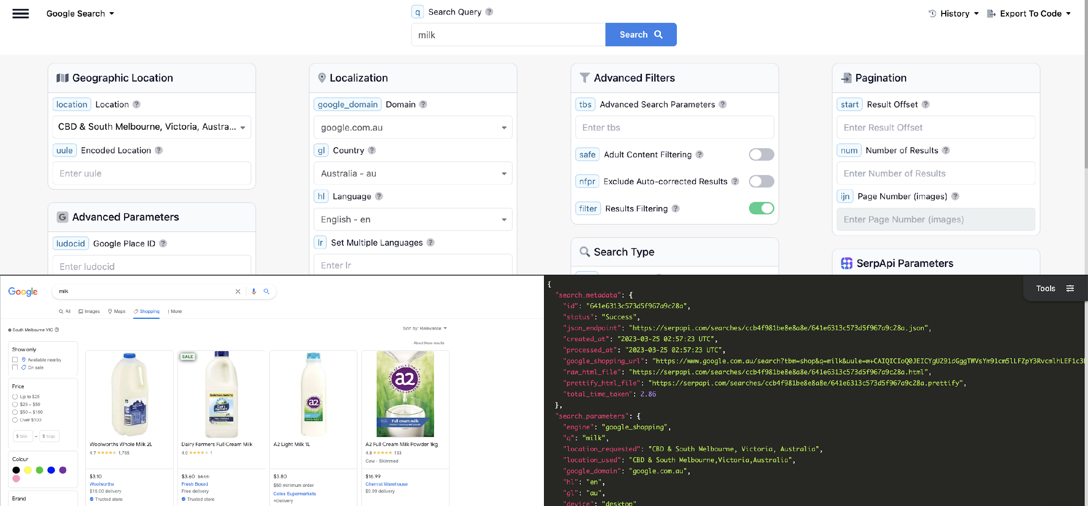

Due to the limitation of the API request number in free tier, the rest of the weekly item price data will be extracted using Web Parsing tool like Octoparse orPython scripting.

## 7.2 User Shopping Data

The major data source of user shopping data will be user saved shopping list, user item search records and item rating input by users in the system. For the machine learning model training purpose, a sample shopping dataset is downloaded from a research web site and are loaded into the backend database initially.

1. **Grocery Recommender System Requirements**

## 8.1 Introduction

Recommender systems (RS) have been an increasingly important field of study since the first research papers on Collaborative Filtering in the mid-90s. A grocery recommender system can be a useful tool for both consumers and grocery stores. Here are some of the benefits:

* Personalisation: A grocery recommender system can help users discover products that they may be interested in based on their shopping history, discounted price and preferences. This can make the shopping experience more personalised and convenient.
* Efficiency: Recommender systems can save time for users by suggesting products that meet the users needs, reducing the time spent searching for specific items.

In this project we will be trying to use the RS techniques of below two approaches.

## 8.1 Collaborative filtering (CF) approaches

Collaborative filtering is one of the most popular and efficient RS techniques. It is based on the word-of-mouth concept and admits that a user trusts another user with similar reasoning and taste. It also makes the assumptions that two similar users have similar interests, and that two similar items have similar ratings.

## 8.2 Content-based filtering (CB) approaches

Content-based filtering, tends to recommend items whose features and characteristics are similar to other items in which a given user showed positive interest in the past. This approach requires the use of metadata relative to each considered item what can sometimes represent a challenge.

## 8.3 System Requirements

The recommender systems in this project will try to apply the most appropriate ML or DL prediction model (see below figure) to provide a given users with a weekly grocery list that suits him/her best as well as the list of stores in which the customer should purchase each product being recommended. The system will takes into account several features related to the users purchase history as well as features related to the current price. One of the advantages of the Recommender System is that it can recommend to each customer the products he/she has never bought before, which can be helpful to discover new relevant products or be aware of limited-time deals.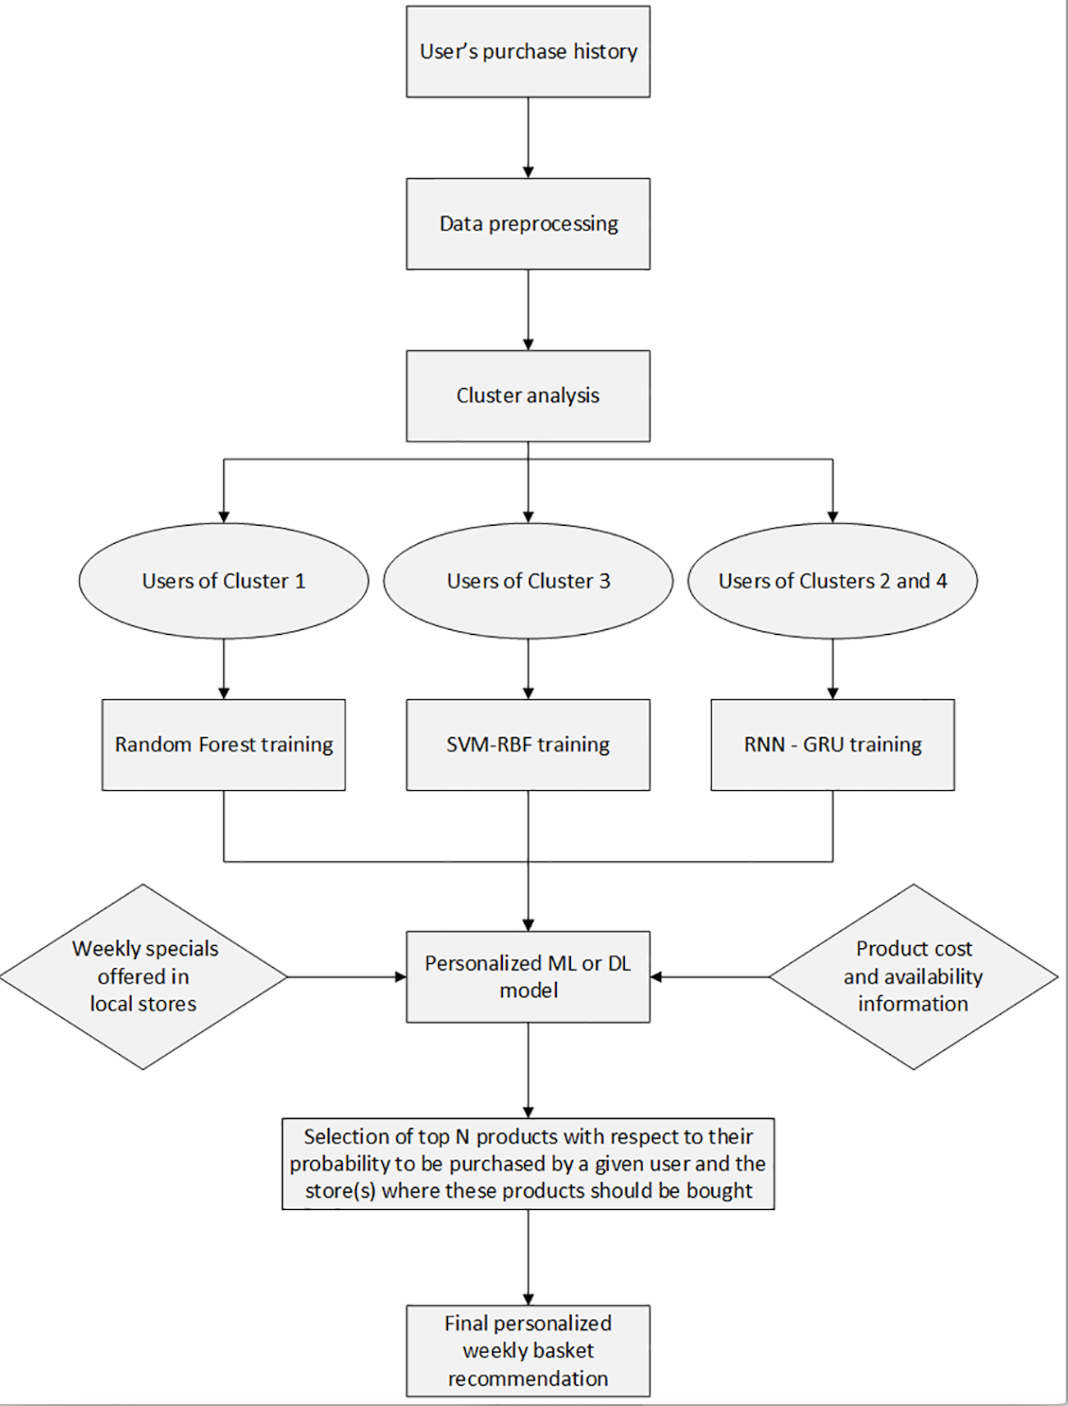

Reference:

1. Chabane, N., Bouaoune, A., Tighilt, R., Abdar, M., Boc, A., Lord, E., Tahiri, N., Mazoure, B., Acharya, U.R. and Makarenkov, V. (2022). Intelligent personalized shopping recommendation using clustering and supervised machine learning algorithms. PLOS ONE, 17(12), p.e0278364. <<https://journals.plos.org/plosone/article?id=10.1371/journal.pone.0278364>>
2. Hafez, M.M., Redondo, R.P.D., Vilas, A.F. and Pazó, H.O. (2021). Multi-Criteria Recommendation Systems to Foster Online Grocery. Sensors, 21(11), p.3747. <<https://www.ncbi.nlm.nih.gov/pmc/articles/PMC8198858/>>
3. Xu, L. and Sang, X. (2022). E-Commerce Online Shopping Platform Recommendation Model Based on Integrated Personalized Recommendation. Scientific Programming, 2022, pp.1–9. <<https://www.hindawi.com/journals/sp/2022/4823828/>>