## 3.4 How to Manage Time

|  |
| --- |
| Estimated completion time: 25 minutes. |

**Questions to consider:**

* How can I use time-on-task estimates to improve time management?
* What behaviors can help or hinder when it comes to managing time?

In this next section you will learn about managing time and prioritizing tasks. This is not only a valuable skill for pursuing an education, but it can become an ability that follows you through the rest of your life, especially if your career takes you into a leadership role.

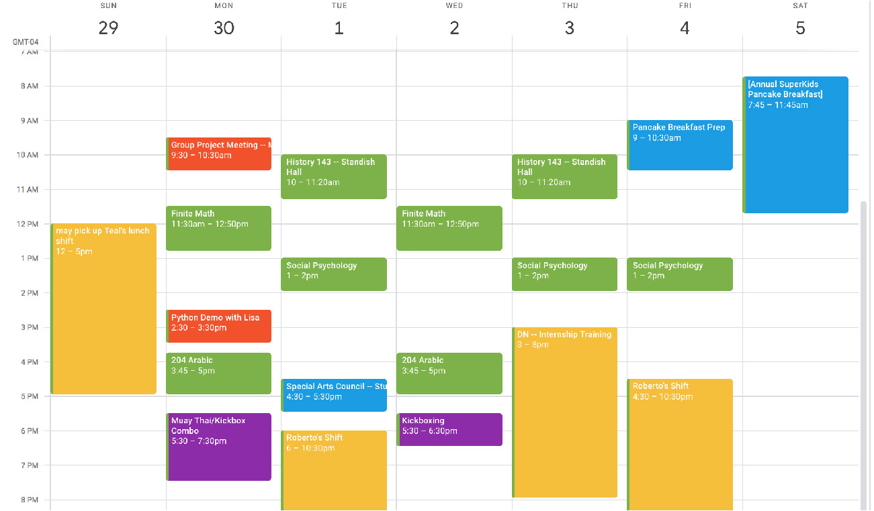

Figure 3.7 An online calendar is a very useful tool for keeping track of classes, meetings, and other events. Most learning management systems contain these features, or you can use a calendar application.

Analysis Question

Read each statement in the brief self-evaluation tool below, and check the answer that best applies to you. There are no right or wrong answers.

|  |  |  |  |  |  |
| --- | --- | --- | --- | --- | --- |
|  | Always | Usually | Sometimes | Rarely | Never |
| I like to be given strict deadlines for each task. It helps me stay organized and on track. |  |  |  |  |  |
| I would rather be 15 minutes early than 1 minute late. |  |  |  |  |  |
| I like to improvise instead of planning everything out ahead of time. |  |  |  |  |  |
| I prefer to be able to manage when and how I do each task. |  |  |  |  |  |
| I have a difficult time estimating how long a task will take. |  |  |  |  |  |
| I have more motivation when there is an upcoming deadline. It helps me focus. |  |  |  |  |  |
| I have difficulty keeping priorities in the most beneficial order. |  |  |  |  |  |

Table 3.3

This exercise is intended to help you recognize some things about your own time management style. The important part is for you to identify any areas where you might be able to improve and to find solutions for them. This chapter will provide some solutions, but there are many others that can be found by researching time management strategies.

After you have decided your best response to each statement, think about what they may mean in regard to potential strengths and/or challenges for you when it comes to time management in college. If you are a person that likes strict deadlines, what would you do if you took a course that only had one large paper due at the end? Would you set yourself a series of mini deadlines that made you more comfortable and that kept things moving along for you? Or, if you have difficulty prioritizing tasks, would it help you to make a list of the tasks to do and order them, so you know which ones must be finished first?

### How to Manage Time

The simplest way to manage your time is to accurately plan for how much time it will take to do each task, and then set aside that amount of time. How you divide the time is up to you. If it is going to take you five hours to study for a final exam, you can plan to spread it over five days, with an hour each night, or you can plan on two hours one night and three hours the next. What you would not want to do is plan on studying only a few hours the night before the exam and find that you fell very short on the time you estimated you would need. If that were to happen, you would have run out of time before finishing, with no way to go back and change your decision. In this kind of situation, you might even be tempted to “pull an all-nighter,” which is a phrase that has been used among college students for decades. In essence it means going without sleep for the entire night and using that time to finish an assignment. While this method of trying to make up for poor planning is common enough to have a name, rarely does it produce the best work.

Activity

Many people are not truly aware of how they actually spend their time. They make assumptions about how much time it takes to do certain things, but they never really take an accurate account.

In this activity, write down all the things you think you will do tomorrow, and estimate the time you will spend doing each. Then track each thing you have written down to see how accurate your estimates were.

Obviously, you will not want to get caught up in too much tedious detail, but you will want to cover the main activities of your day—for example, working, eating, driving, shopping, gaming, being engaged in entertainment, etc.

After you have completed this activity for a single day, you may consider doing it for an entire week so that you are certain to include all of your activities.

Many people that take this sort of personal assessment of their time are often surprised by the results. Some even make lifestyle changes based on it.

|  |  |  |
| --- | --- | --- |
| Activity | Estimated Time | Actual Time |
| Practice Quiz | 5 minutes | 15 minutes |
| Lab Conclusions | 20 minutes | 35 minutes |
| Food shopping | 45 minutes | 30 minutes |
| Drive to work | 20 minutes | 20 minutes |
| Physical Therapy | 1 hour | 50 minutes |

Table 3.4 Sample Time Estimate Table

Of all the parts of time management, accurately predicting how long a task will take is usually the most difficult—and the most elusive. Part of the problem comes from the fact that most of us are not very accurate timekeepers, especially when we are busy applying ourselves to a task. The other issue that makes it so difficult to accurately estimate time on task is that our estimations must also account for things like interruptions or unforeseen problems that cause delays.?

When it comes to academic activities, many tasks can be dependent upon the completion of other things first, or the time a task takes can vary from one instance to another, both of which add to the complexity and difficulty of estimating how much time and effort are required.

For example, if an instructor assigned three chapters of reading, you would not really have any idea how long each chapter might take to read until you looked at them. The first chapter might be 30 pages long while the second is 45. The third chapter could be only 20 pages but made up mostly of charts and graphs for you to compare. By page count, it might seem that the third chapter would take the least amount of time, but actually studying charts and graphs to gather information can take longer than regular reading.?

To make matters even more difficult, when it comes to estimating time on task for something as common as reading, not all reading takes the same amount of time. Fiction, for example, is usually a faster read than a technical manual. But something like the novel *Finnegan’s Wake* by James Joyce is considered so difficult that most readers never finish it.

Activity

To better understand how much time different kinds of material can take to read, try this experiment. You will use two examples of famous texts that are very close to being the same number of words: *The Gettysburg Address* and the opening paragraphs from *A Christmas Carol*. Before you begin, estimate how long it will take you to read each, and predict which you think will take longer. When you do the reading, use a stopwatch function on a device such as a phone or some other timer to see how long it actually takes.

Make certain that you are reading for understanding, not just skimming over words. If you must reread a section to better comprehend what is being said, that is appropriate. The goal here is to compare reading of different texts, not to see how fast you can sight-read the words on a page.

After you have finished *The Gettysburg Address*, read and time *A Christmas Carol* and compare both of your times.

**The Gettysburg Address**  
 **Abraham Lincoln**  
 **Gettysburg, Pennsylvania November 19, 1863**  
 **Word count: 278**

Four score and seven years ago our fathers brought forth on this continent, a new nation, conceived in Liberty, and dedicated to the proposition that all men are created equal.

Now we are engaged in a great civil war, testing whether that nation, or any nation so conceived and so dedicated, can long endure. We are met on a great battle-field of that war. We have come to dedicate a portion of that field, as a final resting place for those who here gave their lives that that nation might live. It is altogether fitting and proper that we should do this.

But, in a larger sense, we can not dedicate -- we can not consecrate -- we can not hallow -- this ground. The brave men, living and dead, who struggled here, have consecrated it, far above our poor power to add or detract. The world will little note, nor long remember what we say here, but it can never forget what they did here. It is for us the living, rather, to be dedicated here to the unfinished work which they who fought here have thus far so nobly advanced. It is rather for us to be here dedicated to the great task remaining before us -- that from these honored dead we take increased devotion to that cause for which they gave the last full measure of devotion -- that we here highly resolve that these dead shall not have died in vain -- that this nation, under God, shall have a new birth of freedom -- and that government of the people, by the people, for the people, shall not perish from the earth.

**A Christmas Carol**  
 **Charles Dickens**  
 **Chapman & Hall, 1843**  
 **Word count: 260**

Marley was dead: to begin with. There is no doubt whatever about that. The register of his burial was signed by the clergyman, the clerk, the undertaker, and the chief mourner. Scrooge signed it: and Scrooge’s name was good upon ’Change, for anything he chose to put his hand to. Old Marley was as dead as a door-nail.

Mind! I don’t mean to say that I know, of my own knowledge, what there is particularly dead about a door-nail. I might have been inclined, myself, to regard a coffin-nail as the deadest piece of ironmongery in the trade. But the wisdom of our ancestors is in the simile; and my unhallowed hands shall not disturb it, or the Country’s done for. You will therefore permit me to repeat, emphatically, that Marley was as dead as a door-nail.

Scrooge knew he was dead? Of course he did. How could it be otherwise? Scrooge and he were partners for I don’t know how many years. Scrooge was his sole executor, his sole administrator, his sole assign, his sole residuary legatee, his sole friend, and sole mourner. And even Scrooge was not so dreadfully cut up by the sad event, but that he was an excellent man of business on the very day of the funeral, and solemnised it with an undoubted bargain.

The mention of Marley’s funeral brings me back to the point I started from. There is no doubt that Marley was dead. This must be distinctly understood, or nothing wonderful can come of the story I am going to relate.

In comparing the two, was one or the other easier to understand or faster to read? Was it the piece you predicted you would read faster?

It is important to note that in this case both readings were only three paragraphs long. While there may have only been half a minute or so between the reading of each, that amount of time would multiply greatly over an entire chapter.

### Knowing Yourself

While you can find all sorts of estimates online as to how long a certain task may take, it is important to know these are only averages. People read at different speeds, people write at different speeds, and those numbers even change for each individual depending on the environment.

If you are trying to read in surroundings that have distractions (e.g., conversations, phone calls, etc.), reading 10 pages can take you a lot longer than if you are reading in a quiet area. By the same token, you may be reading in a quiet environment (e.g., in bed after everyone in the house has gone to sleep), but if you are tired, your attention and retention may not be what it would be if you were refreshed.

In essence, the only way you are going to be able to manage your time accurately is to know yourself and to know how long it takes you to do each task. But where to begin?

Below, you will find a table of common college academic activities. This list has been compiled from a large number of different sources, including colleges, publishers, and professional educators, to help students estimate their own time on tasks. The purpose of this table is to both give you a place to begin in your estimates and to illustrate how different factors can impact the actual time spent.

You will notice that beside each task there is a column for the *unit*, followed by the average *time on task*, and a column for notes. The *unit* is whatever is being measured (e.g., pages read, pages written, etc.), and the *time on task* is an average time it takes students to do these tasks. It is important to pay attention to the notes column, because there you will find factors that influence the time on task. These factors can dramatically change the amount of time the activity takes.

|  |  |  |  |
| --- | --- | --- | --- |
| Time on Task |  |  |  |
| Activity | Unit | Time on task | Notes |
| General academic reading (textbook, professional journals) | 1 page | 5–7 minutes | Be aware that your personal reading speed may differ and may change over time. |
| Technical reading (math, charts and data) | 1 page | 10–15 minutes | Be aware that your personal reading speed may differ and may change over time. |
| Simple Quiz or homework question: short answer—oriented toward recall or identification type answers | Per question | 1–2 minutes | Complexity of question will greatly influence the time required. |
| Complex Quiz or homework question: short answer—oriented toward application, evaluation, or synthesis of knowledge | Per question | 2–3 minutes | Complexity of question will greatly influence the time required. |
| Math problem sets, complex | Per question | 15 minutes | For example, algebra, complex equations, financial calculations |
| Writing: short, no research | Per page | 60 minutes | Short essays, single-topic writing assignments, summaries, freewriting assignments, journaling—includes drafting, writing, proofing, and finalizing |
| Writing: research paper | Per page | 105 minutes | Includes research time, drafting, editing, proofing, and finalizing (built into per-page calculation) |
| Study for quiz | Per chapter | 60 minutes | 45–90 minutes per chapter, depending upon complexity of material |
| Study for exam | Per exam | 90 minutes | 1–2 hours, depending upon complexity of material |

Table 3.5 Time on task for common college activities.

Again, these are averages, and it does not mean anything if your times are a little slower or a little faster. There is no “right amount of time,” only the time that it takes you to do something so you can accurately plan and manage your time.

There is also another element to look for in the table. These are differentiations in the similar activities that will also affect the time you spend. A good example of this can be found in the first four rows. Each of these activities involves reading, but you can see that depending on the material being read and its complexity, the time spent can vary greatly. Not only do these differences in time account for the different types of materials you might read (as you found in the comparative reading exercise earlier in this chapter), but also they also take into consideration the time needed to think about what you are reading to truly understand and comprehend what it is saying.

Get Connected

Which apps help you best prepare for success when managing your time?

Do you have trouble keeping track of multiple tasks over the course of a term?

[Trello](http://www.trello.com) lets you organize all your obligations in helpful boards. You can share them with others (project collaborators), set alerts as reminders, and mark tasks off as you complete them.

Do you use a particular app to help you manage your time?

Sticky note apps are available for PC, Mac, and mobile devices. They let you post quick reminders, reorganize them as needed, and view them separately or as a full to-do list.

What do you wish you could improve about your time management skills?

[Toggl](https://toggl.com) helps you keep track of how and where you are spending your time so you can budget better and make time management changes that free you up for the really important stuff.