## 6.2 Studying

|  |
| --- |
| Estimated completion time: 27 minutes. |

**Questions to consider:**

* How do you prepare yourself and your environment for successful studying?
* What study strategies will be most beneficial to you?
* What are learning preferences and strategies, and how can you leverage those to your advantage?

### Preparing to Study

Studying is hard work, but you can still learn some techniques to help you be a more effective learner. Two major and interrelated techniques involve avoiding distractions to the best of your ability and creating a study environment that works to help you concentrate.

#### Avoiding Distractions

We have always had distractions—video games, television shows, movies, music, friends—even housecleaning can distract us from doing something else we need to do, like study for an exam. That may seem extreme, but sometimes vacuuming is the preferred activity to buckling down and working through calculus problems! Cell phones, tablets, and portable computers that literally bring a world of possibilities to us anywhere have brought *distraction* to an entirely new level. When was the last time you were with a large group of people when you didn’t see at least a few people on devices?



Figure 6.6 Video games are a common distraction, but we need to be aware that even tedious activities like cleaning can be a distraction from studying.

When you study, your biggest challenge may be to block out all the competing noise. And letting go of that connection to our friends and the larger world, even for a short amount of time, can be difficult. Perhaps the least stressful way to allow yourself a distraction-free environment is to make the study session a definite amount of time: long enough to get a significant amount of studying accomplished but short enough to hold your attention.

You can increase that attention time with practice and focus. Pretend it is a professional appointment or meeting during which you cannot check e-mail or texts or otherwise engage with your portable devices. We have all become very attached to the ability to check in—anonymously on social media or with family and friends via text, chat, and calls. If you set a specific amount of time to study without interruptions, you can convince your wandering mind that you will soon be able to return to your link to the outside world. Start small and set an alarm—a 30-minute period to review notes, then a brief break, then another 45-minute study session to quiz yourself on the material, and so on.

When you prepare for your optimal study session, remember to do these things:

* Put your phone out of sight—in another room or at least some place where you will not see or hear it vibrate or ring. Just flipping it over is not enough.
* Turn off the television or music (more on that in the next section).
* Unless you are deliberately working with a study group, study somewhere alone if possible or at least away from others enough to not hear them talking.

If you live with lots of other people or don’t have access to much privacy, see if you can negotiate some space alone to study. Ask others to leave one part of the house or an area in one room as a quiet zone during certain hours. Ask politely for a specific block of time; most people will respect your educational goals and be willing to accommodate you. If you’re trying to work out quiet zones with small children in the house, the bathtub with a pillow can make a fine study oasis.

#### Study Environment

You may not always be in the mood or inspired to study. And if you have a long deadline, maybe you can blow off a study session on occasion, but you shouldn’t get into the habit of ignoring a strong study routine. Jane Austen once wrote in a letter, “I am not at all in a humor for writing; I must write on till I am.” Sometimes just starting is the hard part; go ahead and begin. Don’t wait around for your study muse; start working, and she’ll show up.

Sometimes you just need to plop down and study whenever and wherever you can manage—in the car waiting for someone, on the bus, at the Little League field as you cheer on your shortstop. And that’s OK if this is the exception. For long-term success in studying, though, you need a better study setting that will help you get the most out of your limited study time. Whatever your space limitations, carve out a place that you can dedicate to reading, writing, note taking, and reviewing. This doesn’t need to be elaborate and expensive—all you truly need is a flat surface large enough to hold either your computer or writing paper, book or notes, pens/pencils/markers, and subject-specific materials you may need (e.g., stand-alone calculators, drawing tools, and notepads). Your space should be cool or warm enough for you to be comfortable as you study. What do you have now that you consider your study space? Is it set up for your optimal success?



Figure 6.7 Which is before, and which is after? (Credit: Ali West / Flickr / Attribution 2.0 Generic (CC-BY 2.0))

If it is at all possible, try to make this area exclusive to your study sessions and something you can leave set up all the time and a place out of the way of family or roommate traffic. For example, Martina thought setting up her study station on the dining room table was a good idea at first. The view was calming, and the table was big enough to spread out and could even hold all her materials to study architectural drawings, her favorite subject. But then she needed the table for a small family dinner party, so she had to find a cubbyhole to hide away her supplies with some needing to go into a closet in the next room. Now she was spread out over multiple study spaces. And the family TV was in an adjacent room, not visible from the table but certainly an auditory distraction. Martina ultimately decided to forgo her view and create a smaller station in an unused bedroom so she could leave her supplies out and have a quieter area. You may have to try out numerous places to determine what works best for you.

Wherever you study, try to make it a welcoming place you want to be in—not an uncomfortable environment that makes you want to just do the minimum you must complete and leave. You should include the basics: a good chair, a work surface, and whatever materials, books, notes, and other supplies you need for the subject you are studying. If you want to make it even more of a productive place, you can look in magazines for ideas or search the web to see how others have set up simple areas or more elaborate arrangements. Don’t let decorating your workspace be an excuse to get out of studying!

You don’t need an elaborate setting, but you may want to consider including a few effective additions if you have the space:

* small bulletin board for often-used formulas
* encouraging quotes or pictures of your goal
* whiteboard for brainstorming
* sticky notes for reminders in texts and notes
* file holder for most-used documents
* bookshelf for reference books

Activity

Describe every element in your ideal study environment and explain why it’s there as well as how it will make more efficient use of your time, limit distractions, or in some other way strengthen your ability to study.

After you have described your ideal study environment, think about how you can adapt that environment if you cannot be in your favorite place to study. How do you *make your own space* in the library, a student lounge, or a dedicated space on campus for student studying?

#### Debunking Study Myths

**MYTH #1: You can multitask while studying.**

How many times do you eat in the car? Watch TV while you write out a grocery list? Listen to music while you cook dinner? What about type an e-mail while you’re on the phone with someone else and jot down notes about the call? The common term for this attempt to do more than one thing at a time is multitasking, and almost everyone does it at some point. On some days, you simply cannot accomplish all that you want to get done, so you double up. The problem is, multitasking doesn’t really work. Of course, it exists, and we do it. For instance, we walk and chew gum or drive and talk, but we are not really thinking about two or more distinct things or doing multiple processes simultaneously.

**MYTH #2: Highlighting main points of a text is useful.**

Another myth of studying that seems to have a firm hold is that the idea of highlighting text—in and of itself—is the best way to review study material. It is one way, and you can get some benefit from it, but don’t trick yourself into spending too much time on this surface activity and consider your study session complete. Annotating texts or notes is a first-step type of study practice. If you allow it to take up all your time, you may want to think you are fully prepared for an exam because you put in the time. Actually, you need much more time reviewing and retrieving your lessons and ideas from the text or class lecture as well as quizzing yourself to accomplish your goal of learning so you can perform well on the exam. Highlighting is a task you can do rather easily, and it makes you feel good because you are actively engaging with your text, but true learning needs more steps.

**MYTH #3: Studying effectively is effortless.**

There is nothing effortless, or even pleasant at times, about studying. This is why so many students don’t put in the time necessary to learn complex material: it takes time, effort, and, in some cases, a little drudgery. This is not to say that the outcome, learning—and maybe making an A—is not pleasant and rewarding. It is just that when done right, learning takes focus, deliberate strategies, and time. Think about a superstar athlete who puts in countless hours of drills and conditioning so that she makes her work on the field look easy. If you can also *enjoy* the studying, the skill development, and the knowledge building, then you will most likely be more motivated to do the work.

Analysis Question

When are you most liable to multitask? How could you be more aware of this practice and try to eliminate it, especially when it comes to studying? How can you make your initial text highlighting more time efficient so you can include other study practices?

### Study Strategies

Everyone wishes they had a better memory or a stronger way to use memorization. You can make the most of the memory you have by making some conscious decisions about how you study and prepare for exams. Incorporate these ideas into your study sessions:

Practicing effective memorization is when you use a trick, technique, or strategy to recall something—for another class, an exam, or even to bring up an acquaintance’s name in a social situation. Really whatever works for you to recall information is a good tool to have. You can create your own quizzes and tests to go over material from class. You can use mnemonics to jog your memory. You can work in groups to develop unique ways to remember complex information. Whatever methods you choose to enhance your memory, keep in mind that repetition is one of the most effective tools in any memory strategy. Do whatever you do over and over for the best results.

#### Using Mnemonics

Mnemonics (pronounced new-monics) are a way to remember things using reminders. Did you learn the points of the compass by remembering NEWS (north, east, west, and south)? Or the notes on the music staff as FACE or EGBDF (every good boy does fine)? These are mnemonics. When you’re first learning something and you aren’t familiar with the foundational concepts, these help you bring up the information quickly, especially for multistep processes or lists. After you’ve worked in that discipline for a while, you likely don’t need the mnemonics, but you probably won’t forget them either.

Here are some familiar mnemonics you may find useful:

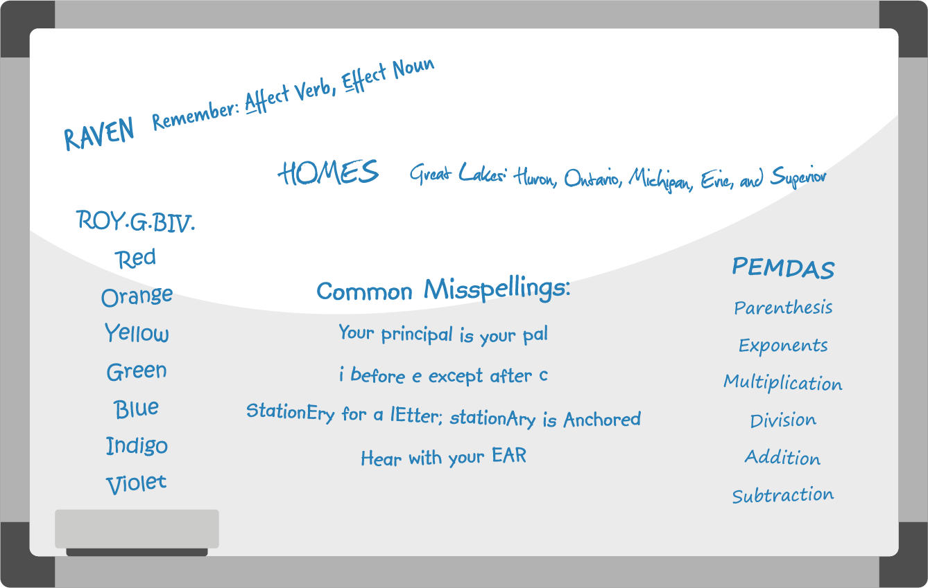

Figure 6.8

You can certainly make up your own mnemonics, but be careful that your reminder isn’t so complex and convoluted that it is more difficult to remember than the information you were relating it to!

Analysis Question

Do you have other mnemonics that help you remember difficult material? What are they? How have they helped you with remembering important things?

#### Practicing Concept Association

When you study, you’re going to make connections to other things—that’s a good thing. It shows a highly intelligent ability to make sense of the world when you can associate like and even somewhat unlike components. If, for instance, you were reading Martin Luther King Jr.’s “Letter from a Birmingham Jail,” and you read the line that he had been in Birmingham, you may remember a trip you took with your family last summer through Alabama and that you passed by and visited the civil rights museum in Birmingham. This may remind you of the different displays you saw and the discussions you had with your family about what had happened concerning civil rights in the 1950s,’60s, and ’70s in the United States.

This is a good connection to make, but if your assignment is to critique the literary aspects of King’s long epistle, you need to be able to come back to the actual words of the letter and see what trends you can see in his writing and why he may have used his actual words to convey the powerful message. The connection is fine, but you can’t get lost in going down rabbit holes that may or may not be what you’re supposed to be doing at the time. Make a folder for this assignment where you can put things such as a short summary of your trip to Alabama. You may eventually include notes from this summary in your analysis. You may include something from a website that shows you information about that time period. Additionally, you could include items about Martin Luther King Jr.’s life and death and his work for civil rights. All of these elements may help you understand the significance of this one letter, but you need to be cognizant of what you’re doing at the time and remember it is not usually a good idea to just try to keep it all in your head. The best idea is to have a way to access this information easily, either electronically or in hard copy, so that if you are able to use it, you can find it easily and quickly.

#### Generating Idea Clusters

Like mnemonics, idea clusters are nothing more than ways to help your brain come up with ways to recall specific information by connecting it to other knowledge you already have. For example, Andrea is an avid knitter and remembers how to create complicated stitches by associating them with nursery rhymes she read as a child. A delicate stitch that requires concentration because it makes the yarn look like part of it is hiding brings to mind Red Riding Hood, and connecting it to that character helps Andrea recall the exact order of steps necessary to execute the design. You can do the same thing with song lyrics, lines from movies, or favorite stories where you draw a connection to the well-known phrase or song and the task you need to complete.

Application

Choose one of the following, and create an idea cluster to group and organize:

* Example A: aviation jobs in North America
* Example B: the use of analytics in sports to determine team rosters
* Example C: how social media affects political campaigns

Start the idea cluster with the topic circled in the middle of the page. For Example A, you might make one cluster off the main circle for specific positions; you could add another cluster for salary ranges and another for geographic regions.

#### Three Effective Study Strategies

There are more than three study strategies, but focusing on the most effective strategies will make an enormous difference in how well you will be able to demonstrate learning (also known as “acing your tests”). Here is a brief overview of each of the three strategies:

* Spacing—This has to do with *when* you study. Hint: Don’t cram; study over a period of days, preferably with “breaks” in between.
* Interleaving—This has to do with *what* you study. Hint: Don’t study just one type of content, topic, chapter, or unit at a time; instead, mix up the content when you study.
* Practice testing—This has to do with *how* you study. Hint: Don’t just reread content. You must quiz or test your ability to retrieve the information from your brain.

##### Spacing

We all know that cramming is not an effective study strategy, but do we know why? Research on memory suggests that giving yourself time in between study sessions actually helps you forget the information. And forgetting, which sounds like it would be something you *don’t* want to do, is actually good for your ability to remember information long-term. That’s because every time you forget something, you need to relearn it, leading to gains in your overall understanding and “storage” of the material. The table below demonstrates how spacing works. Assume you are going to spend about four hours studying for a Sociology exam. Cramming would have you spending most of those four hours the night before the exam. With spacing, on the other hand, you would study a little bit each day.

Spacing

|  |  |  |  |  |  |  |  |
| --- | --- | --- | --- | --- | --- | --- | --- |
|  | Sunday | Monday | Tuesday | Wednesday | Thursday | Friday | Saturday |
| Cramming |  |  |  | Study for 1 hour | Study for 3 hours | **Sociology Test** |  |
| Spacing | Study for 1 hour |  | Study for 30 minutes | Study for 1 hour | Study for 90 minutes | **Sociology Test** |  |

Table 6.1

##### Interleaving

One particular studying technique is called interleaving, which calls for students to mix up the content that is being studied. This means not just spending the entire study session on one sort of problem and then moving on to a different sort of problem at a later time.

If you take the schedule we used for the spacing example above, we can add the interleaving concepts to it. Notice that interleaving includes revisiting material from a previous chapter or unit or revisiting different types of problems or question sets. The benefit is that your brain is “mixing up” the information, which can sometimes lead to short-term forgetting but can lead to long-term memory and learning.

Interleaving

|  |  |  |  |  |  |
| --- | --- | --- | --- | --- | --- |
| Sunday | Monday | Tuesday | Wednesday | Thursday | Friday |
| Reread Sociology, Chapter 1.  Reorganize notes |  | Reread Sociology, Chapter 1 and 2  Take Ch 1 online quiz.  Create Chapter 2 concept map | Reread Sociology, Chapters 1-3.  Take online quizzes for chapters 2 and 3.  Reorganize notes.  Create practice test | Reread notes.  Review items missed on online quizzes.  Take practice test and review challenge areas. | **TEST in sociology, Chapters 1-3** |

Table 6.2

##### Practice Testing

You can do a practice “test” in two ways. One is to test yourself as you are reading or taking in information. This is a great way to add a little variety to your studying. You can ask yourself what a paragraph or text section means as you read. To do this, read a passage in a text, cover up the material, and ask yourself, “What was the main idea of this section?” Recite aloud or write down your answer, and then check it against the original information.

Another, more involved, way to practice test is to create flashcards or an actual test by writing a test. This takes more time, but there are online programs such as Quizlet that make it a little easier. Practice testing is an effective study strategy because it helps you practice *retrieving* information, which is what you want to be able to do when you are taking the real test.

One of the best ways to learn something is to teach it to someone else, so ask a friend or family member if you can explain something to them, and *teach* them the lesson. You may find you know more about the subject than you thought . . . or you may realize quickly that you need to do more studying. Why does teaching someone else rank as one of the most effective ways to learn something? It is a form of practice testing that requires you to demonstrate you know something in front of someone else! No one wants to look like they don’t know what they are talking about, even if it your audience is another classmate.

#### Recognizing Strengths/Weaknesses of Preferred Study Approaches

Most children don’t learn to ride a bicycle by reading a manual; they learn by watching other kids, listening to instructions, and getting up on the seat and learning to balance—sometimes with training wheels or a proud parent holding on, but ultimately without any other support. They may fall over and feel insecure, but usually, they learn to make the machine go. Most of us employ multiple methods of study all the time. You usually only run into trouble if you stubbornly rely on just one way to learn or study and the material you’re studying or the task you want to accomplish doesn’t lend itself to that preference. You can practice specific strategies to help you learn in your preferred learning approach. Can you think of a time when the way you usually study a situation didn’t work?

When deciding on a study approach, consider what you know about the material and the type of knowledge it involves. Is it a group of concepts related to problem-solving methods, such as those you’d find in a physics class? Or is it a literary analysis of a novel? Consider as many elements as possible about the material -- and the way the material will be assessed -- to help choose a study approach.

You should also consider your instructor’s preferred method of teaching and learning. Watching the way they teach lessons or convey necessary course information to the class. Do they almost always augment lessons with video clips to provide examples or create a memorable narrative? Do they like to show you how something works by demonstrating and working with their hands—for instance, assembling a piece of equipment by taking it apart and putting it back together again? Echoing their teaching approach may help your study. That doesn’t mean you have to change your entire learning approach to match your instructors’ methods. Many instructors understand that their students will have different ways of learning and try to present information in multiple ways.

#### Practicing Active Continuous Improvement for All Preferences

You can certainly learn through specific approaches or according to specific preferences, but you will also need to adapt to different situations, skills, and subject areas. Don’t limit yourself to thinking you can *only* learn one way or another. That mindset induces anxiety when you encounter a learning situation that doesn’t match your preference. What if your instructor *only* uses a spoken lecture to teach concepts in your chemistry class, and you consider yourself a visual learner? Or what if the only method presented to you for learning mathematical computations is to see videos of others working problems, and you’re more hands-on? You may have to concentrate in a different way or devise other strategies to learn, but you can do it. In fact, you should sometimes work on the styles/preferences that you feel are your least favorite; it will actually strengthen your overall ability to learn and retain information.10

10

Newton, Phillip M., & Miah, Mahallad. “Evidence-Based Higher Education—Is the Learning Style ‘Myth’ Important?” *Frontiers in Psychology* 8:444 (2017) DOI: 10. 3389/FPSYG. 2017.00444.

Dr. Stephen Covey, famous leadership coach and businessman, called this attention to knowing and honing all your skill sets, not just your favorites, *sharpening the saw.* He advised that people should be aware of their strengths but should always hone their weaknesses by saying, “We must never become too busy sawing to take time to sharpen the saw.”11 For instance, in the chemistry lecture example, you may need to take good notes from the spoken lecture and then review those notes as you sketch out any complex ideas or formulas. If the math videos are not enough for you to grasp difficult problems, you may ask for or find your own problems for additional practice covering that particular mathematical concept to solve on your own.

11

Covey, Stephen. The 7 Habits of Highly Effective People ® https://www.franklincovey.com/the-7-habits.html