# Appendix C Activities and Artifacts From the Book

This appendix provides reproductions of tables, forms, and related materials from throughout the book. You can print them or copy them for completion and inclusion in your records or to turn in and use in class.

## Chapter 1 Welcome to College

The Five Whys: Your Turn

|  |  |
| --- | --- |
| *Why are you in college?* | I am in college to . . . |
| *Why do you* . . . | I . . . |
| *Why do you* . . . | I . . . |
| *Why do you* . . . | I . . . |
| *Why do you* . . . | I . . . |

Table C1

## Chapter 2 Knowing Yourself as a Learner

|  |  |  |
| --- | --- | --- |
| Parts of the learning process | Growth characteristic | What will you do to adopt a growth mindset? |
| Challenges | Embraces challenges |  |
| Obstacles | Persists despite setbacks |  |
| Effort | Sees effort as a path to success |  |
| Criticism | Learns from criticism |  |
| Success of Others | Finds learning and inspiration in the success of others |  |

Table C2

|  |  |  |  |
| --- | --- | --- | --- |
| Does it …? | Yes | No | What you can do to turn the assignment into something that is better suited to you as a learner? |
| Does it allow you to make decisions about your own learning? |  |  | In essence, you are doing this right now. You are making decisions on how you can make your assignment more effective for you. |
| Does it allow you to make mistakes without adversely affecting your grade? |  |  | Hints: *Are there ways for you to practice? Can you create a series of drafts for the assignment and get feedback?* |
| Is it centered on solving a problem? |  |  | Hint: *Can you turn the assignment into something that solves a problem? An example would be making a presentation that actually educated others rather than just covered what you may have learned.* |
| Is it related to your chosen occupation in any way? |  |  | Hint: *Can you turn the assignment into something you might actually do as a part of your profession or make it about your profession? Examples might be creating an informative poster for the workplace or writing a paper on new trends in your profession.* |
| Does it allow you to manage the time you work on it? |  |  | *More than likely the answer here will be “yes,” but you can plan how you will do it. For more information on this, see the chapter on time management.* |
| Does it allow interaction with your instructor as a learning partner? |  |  | Hint: *Talking to your instructor about the ideas you have for making this assignment more personalized accomplishes this exact thing.* |

Table C3

## Chapter 3 Managing Your Time and Priorities

|  |  |  |  |  |  |
| --- | --- | --- | --- | --- | --- |
|  | Always | Usually | Sometimes | Rarely | Never |
| I like to be given strict deadlines for each task. It helps me stay organized and on track. |  |  |  |  |  |
| I would rather be 15 minutes early than 1 minute late. |  |  |  |  |  |
| I like to improvise instead of planning everything out ahead of time. |  |  |  |  |  |
| I prefer to be able to manage when and how I do each task. |  |  |  |  |  |
| I have a difficult time estimating how long a task will take. |  |  |  |  |  |
| I have more motivation when there is an upcoming deadline. It helps me focus. |  |  |  |  |  |
| I have difficulty keeping priorities in the most beneficial order. |  |  |  |  |  |

Table C4

## Chapter 4 Planning Your Academic Pathways

Application

Take a moment to practice setting long- and short-term goals. Your short-term goal should help you progress toward your long-term goal. Include a plan for when and how you will know if you’re on track or if you need to adjust your goals to match new priorities.

|  |
| --- |
| **My Long-Term Goal:** |
| **My Short-Term Goal:** |
| **My Plan for Checking My Progress:** |

Table C5

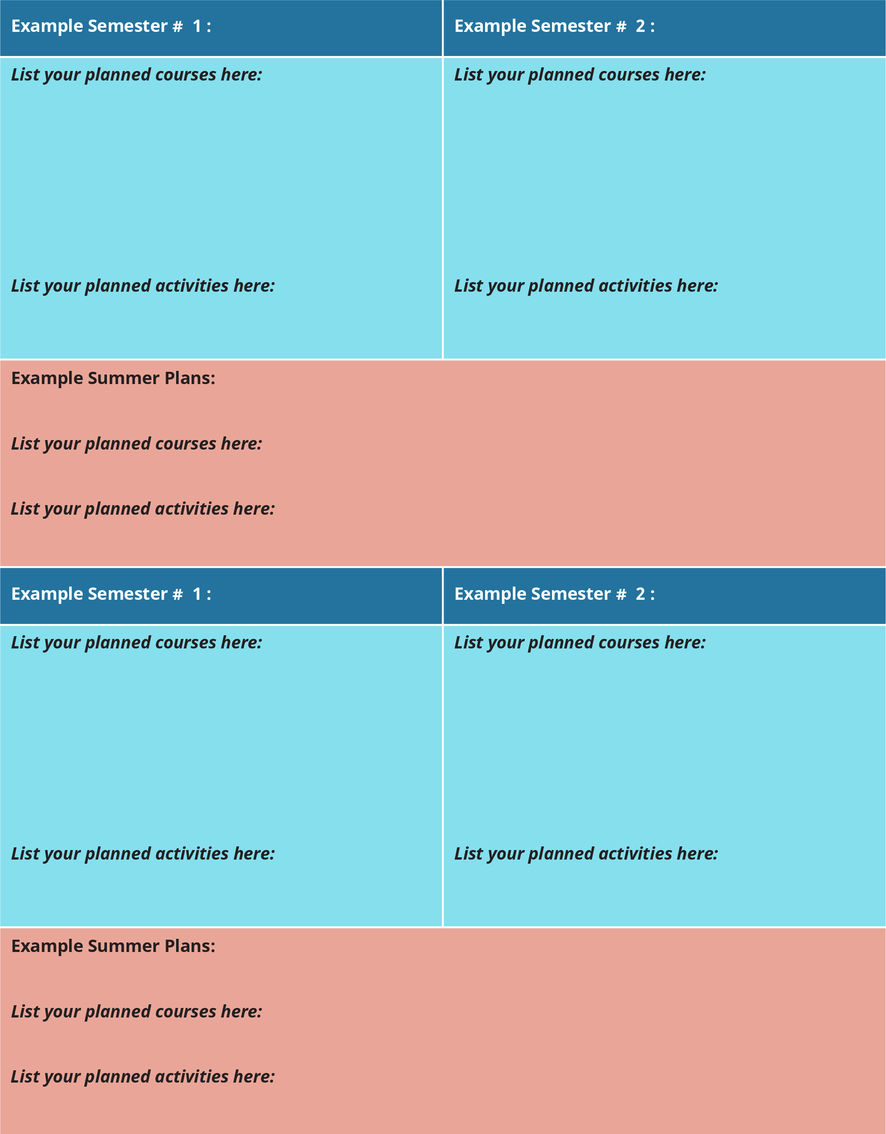

Figure C1 This two-year version of the planning document may need to be adopted for colleges operating on a quarter, trimester, or other schedule. (Downloadable versions are available at OpenStax.org.)

## Chapter 5 Reading and Notetaking

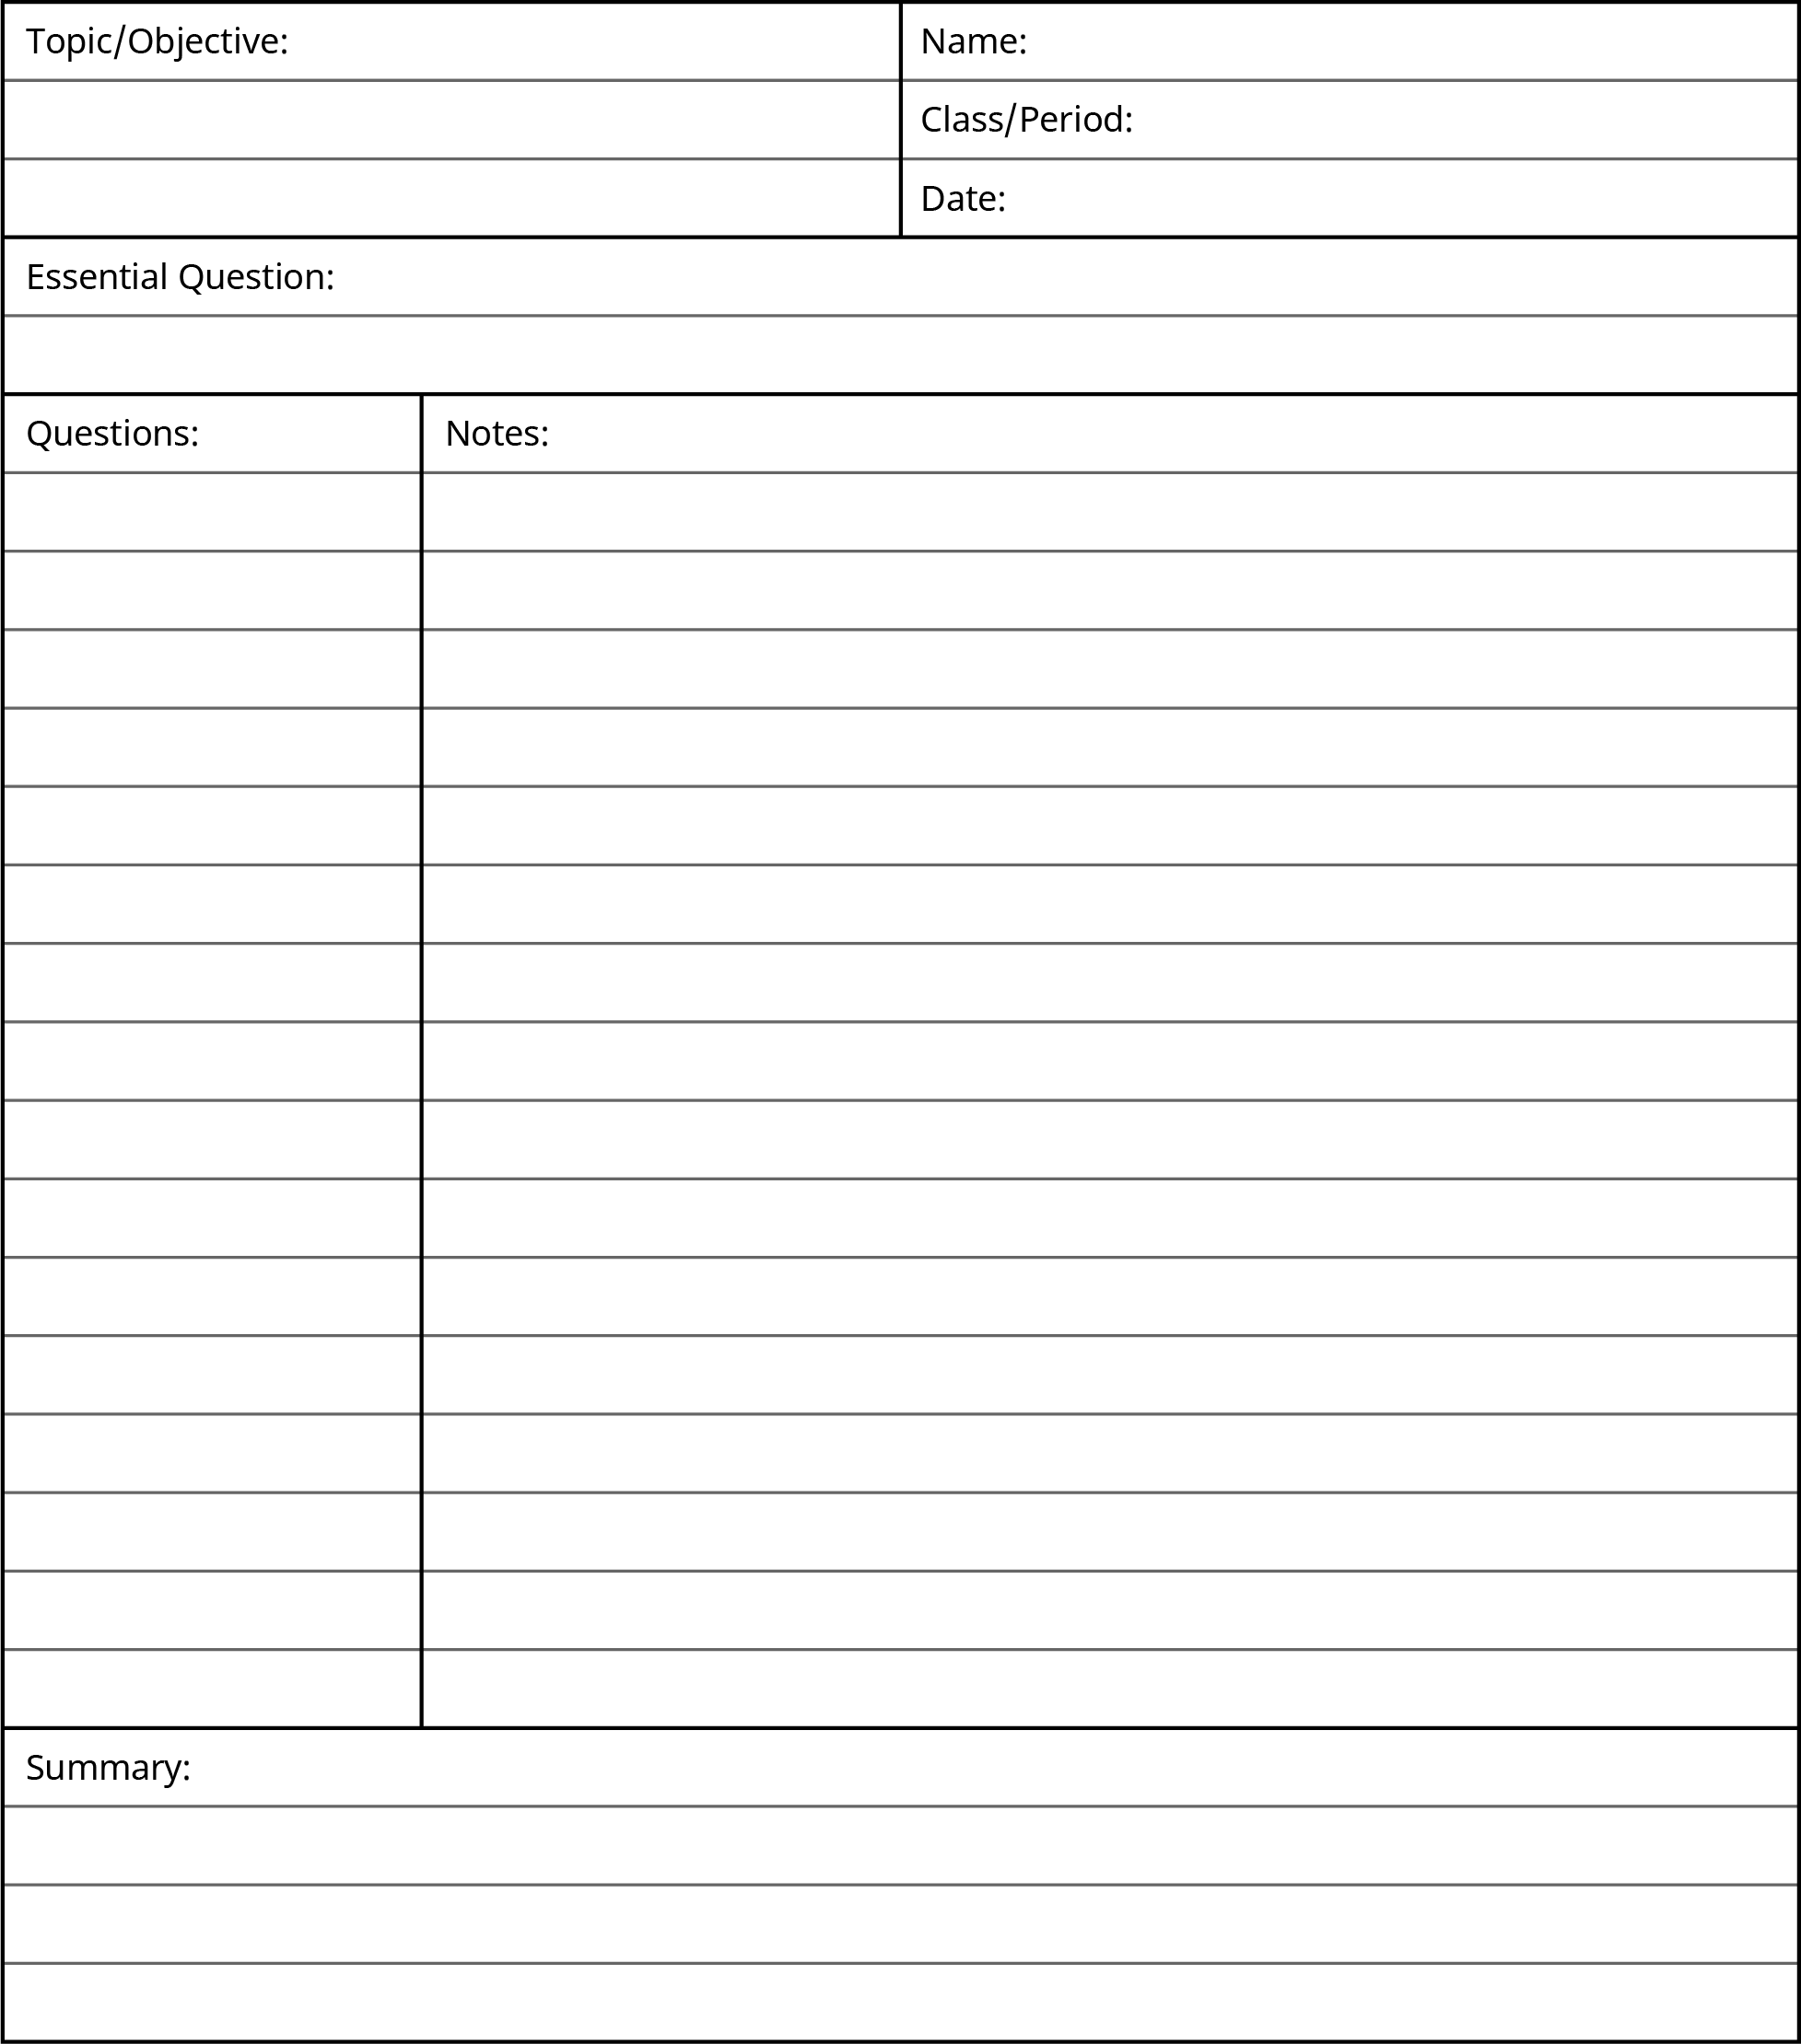

Figure C2 The Cornell Method provides a straightforward, organized, and flexible approach

## Chapter 8 Communicating

|  |  |
| --- | --- |
| **Form of Communication** | **Rules for This Form** |
| Face-to-face |  |
| Phone |  |
| Printed letters |  |
| Email |  |
| Texting |  |
| Instant messaging/group chat |  |
| Social media |  |

Table C6

|  |  |  |  |
| --- | --- | --- | --- |
|  | Challenges | Opportunities | Communication Methods and Tools |
| Group project for an on campus (traditional) course. |  |  |  |
| Group project for an online-only course. |  |  |  |
| Planning an event with your extended family. |  |  |  |
| Planning an event with your friends/peers. |  |  |  |

Table C7

|  |  |  |  |
| --- | --- | --- | --- |
|  | Describing a sporting event you watched. | Describing an argument you got into on social media. | Describing a night out with friends. |
| An eight-year-old |  |  |  |
| A 20-year-old woman |  |  |  |
| A middle-aged man |  |  |  |
| An elderly person |  |  |  |

Table C8

|  |  |  |  |  |  |  |  |
| --- | --- | --- | --- | --- | --- | --- | --- |
|  | Face-to-Face | Email | Letter | Phone | Facebook | Instagram | Snapchat |
| Parent |  |  |  |  |  |  |  |
| Peer |  |  |  |  |  |  |  |
| Sibling |  |  |  |  |  |  |  |
| Boss |  |  |  |  |  |  |  |
| Doctor |  |  |  |  |  |  |  |
| Professor |  |  |  |  |  |  |  |
| Waitress |  |  |  |  |  |  |  |
| Office assistant |  |  |  |  |  |  |  |
| Significant other |  |  |  |  |  |  |  |

Table C9