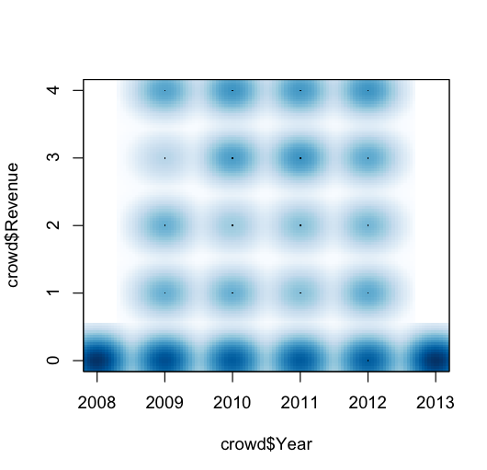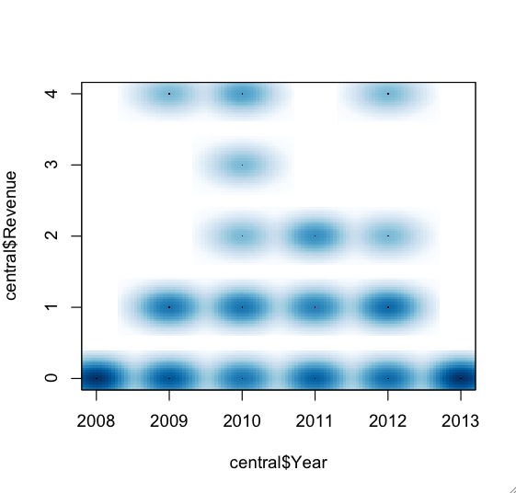

**REVENUE GROWTH.**

**Up: Crowdsourced, Bottom: Centralized**

4 is for explosive growth (>=100% annual)

3 is for Rapid growth (60-100% anual)

2 is for steady growth (40-60% anual)

1 is for declining growoth (0-40% annual)

**0 is for ‘no data point in here’. Please disregard visually ☺**

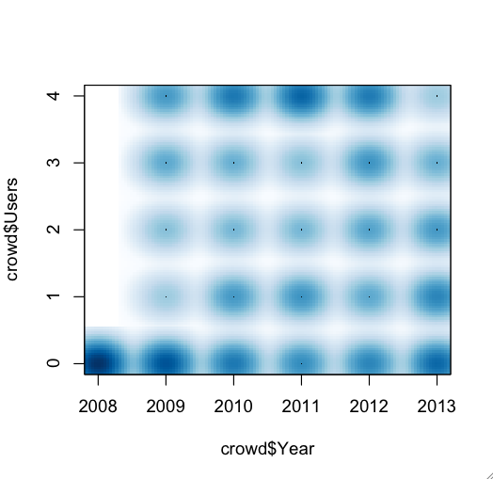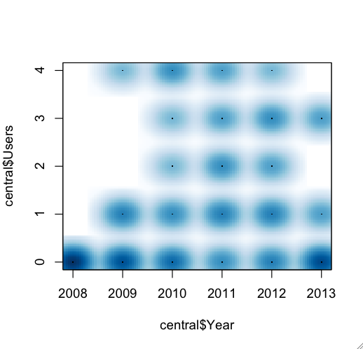

**USERBASE GROWTH.**

**Up: Crowdsourced, Bottom: Centralized**

4 is for explosive growth (>=100% annual)

3 is for Rapid growth (60-100% anual)

2 is for steady growth (40-60% anual)

1 is for declining growoth (0-40% annual)

**0 is for ‘no data point in here’. Please disregard visually ☺**

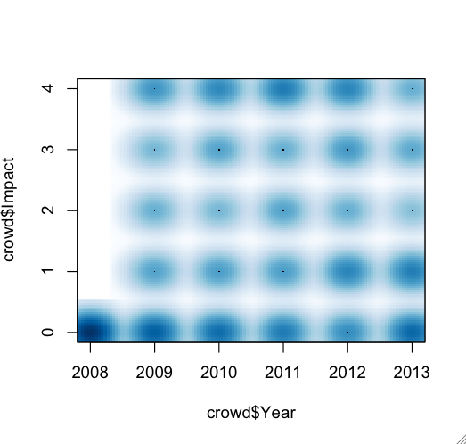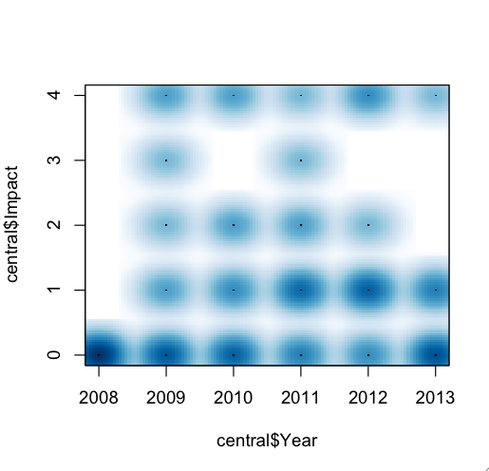

**IMPACT GROWTH.**

**Up: Crowdsourced, Bottom: Centralized**

4 is for explosive growth (>=100% annual)

3 is for Rapid growth (60-100% anual)

2 is for steady growth (40-60% anual)

1 is for declining growoth (0-40% annual)

**0 is for ‘no data point in here’. Please disregard visually ☺**

**Question: Is there a strange drop in impact growth for Crowdsourced tag around 2012? What do you think? Does it correlate with the data?**

Maybe I’m just going blind (which I’m almost) but I see a clear dominance of explosive growth in the three types (impact, revenue and user) in crowdsourced tag, and declining growth in centralized tag.

Don’t worry about the accuracy/easiness on the eye of the plots. There will be a nicer way to plot this ☺

To explore more in detail, based on **any** tag combination (not just centralized vs distributed), there’s this kind of graphic called ‘pairs’; in which for every posible combination you draw a scatterplot. This way we can see at first sight the different animals based on growth **and** tags.