In the north a considerable avalanche danger will prevail

Edition: 7.12.2021, 17:00 / Next update: 8.12.2021, 17:00

# Avalanche danger

updated on 7.12.2021, 17:00

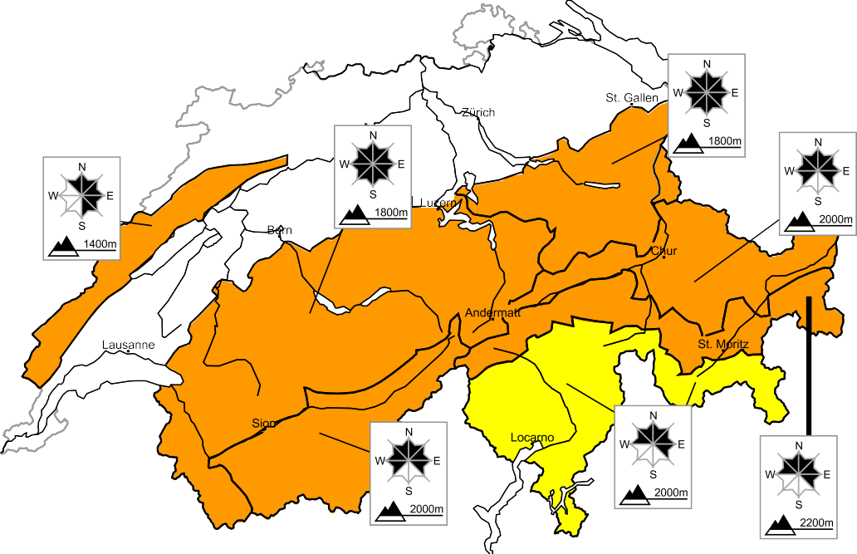

**Level 3, considerable**

**region A**

## Old snow, wind slabs

### Avalanche prone locations Danger description

The new snow of last week is lying on top of a weakly bonded old snowpack. Avalanches can be released, even by a single winter sport participant. Remotely triggered and natural avalanches are possible.



Whumpfing sounds can indicate the danger. Avalanches can be triggered in near-ground layers and reach large size.

As a consequence of new snow and a sometimes strong wind from westerly directions, avalanche prone wind slabs will form.

Backcountry touring and other off-piste activities call for defensive route selection.

**region B**

**Level 3, considerable**

## Wind slabs, old snow

### Avalanche prone locations Danger description

As a consequence of new snow and a sometimes strong wind from westerly directions, avalanche prone wind slabs will form. The number and size of avalanche prone locations will increase as the day progresses. Individual natural avalanches are possible.



Avalanches can in isolated cases be triggered in near-ground layers and reach large size. This applies

especially on west, north and east facing slopes above approximately 2000 m.

Backcountry touring and other off-piste activities call for experience in the assessment of avalanche danger.

## Gliding avalanches

Below approximately 2000 m medium-sized gliding avalanches are possible.

**region C**

**Level 3, considerable**

## Old snow

### Avalanche prone locations Danger description

The new snow and wind slabs are lying on top of a weakly bonded old snowpack. Avalanches can be released, even by a single winter sport participant. Remotely triggered avalanches are possible. Whumpfing sounds can indicate the danger. Avalanches can be triggered in near-ground layers and reach large size.



Defensive route selection is important.

**region D**

**Level 3, considerable**

## Old snow

### Avalanche prone locations Danger description

The new snow and wind slabs are lying on top of a weakly bonded old snowpack. Avalanches can



be released by a single winter sport participant and reach medium size. Experience in the assessment of avalanche danger is important.

As a consequence of wind from westerly directions, wind slabs will form. They are to be evaluated with care and prudence in steep terrain.

**region E**

**Level 3, considerable**

## Wind slabs, old snow

### Avalanche prone locations Danger description

As a consequence of new snow and a sometimes strong wind from westerly directions, avalanche prone wind slabs will form. The number and size of avalanche prone locations will increase as the day progresses.



Avalanches can in very isolated cases be triggered in near-ground layers and reach large size. This applies especially on west, north and east facing slopes above approximately 2000 m.

Backcountry touring and other off-piste activities call for experience in the assessment of avalanche danger.

## Gliding avalanches

Below approximately 2000 m medium-sized gliding avalanches are possible.

**region F**

**Level 3, considerable**

## Wind slabs

### Avalanche prone locations Danger description

As a consequence of new snow and a sometimes strong westerly wind, avalanche prone wind slabs will form.



They are to be found in particular in gullies and bowls, and behind abrupt changes in the terrain. The wind slabs are to be bypassed in steep terrain.

**region G**

**Level 2, moderate**

## Old snow, wind slabs

### Avalanche prone locations Danger description

Avalanches can in isolated cases be released in deeper layers. They can reach medium size.



Fresh wind slabs are mostly small but can in some cases be released easily. The number and size of avalanche prone locations will increase as the day progresses.

Careful route selection is recommended.

# Snowpack and weather

updated on 7.12.2021, 17:00

## Snowpack

Last week 150 to 200 cm of snow fell above approximately 2000 m over a wide area of the north and of the far west; elsewhere 40 to 100 cm fell over a wide area. The fresh snow and snow drift accumulations originating from this period are settling to an increasing extent. This snow is lying on a shallow, soft old snowpack containing faceted snow crystals. The structure of the snowpack is least favourable in places where the weak old snow layer is covered by only a shallow layer of snow. This applies in particular on west, north and east facing slopes. Most avalanches of recent days were released in this weak old snow. Fresh snow and sometimes strong wind will give rise to snow drift accumulations on Wednesday. In many cases these will be prone to triggering.

**Observed weather** on Tuesday, 07.12.2021

On Monday night snow fell in the north over a wide area, even at low altitudes. In the course of the morning it became increasingly sunny from the west. The south was dry and mostly sunny during the day.

### Fresh snow

From Monday night until Tuesday midday:

* Central and eastern parts of the northern flank of the Alps: 15 to 20 cm
* Western part of the northern flank of the Alps and Valais, as well as northern Grisons: 5 to 15 cm
* Elsewhere: a few centimetres or none

### Temperature

At midday at 2000 m: between -4 °C in the west and -9 °C in the east

### Wind

* Moderate to strong from the west to northwest
* Easing as the day progresses

**Weather forecast** through Wednesday, 08.12.2021

On Tuesday night, precipitation will arrive from the west. The snowfall level during the night will be 1200 m for a while, otherwise approximately 800 m. During the day, snow will fall over a wide area; in some cases the snowfall will be heavy.

### Fresh snow

From Tuesday evening until Wednesday afternoon:

* Western and central parts of the northern flank of the Alps, as well as the extreme west of Lower Valais and the Jura: 20 to 30 cm, but up to 40 cm in the far west
* Eastern part of the northern flank of the Alps, rest of Valais, southern flank of the Alps: 10 to 20 cm
* Elsewhere: a few centimetres

### Temperature

* Falling during the day
* At midday at 2000 m: between -7 °C in the west and -4 °C in the east

### Wind

* In the north:
  + During the night, moderate to strong from the southwest
  + In the valleys exposed to the foehn wind, the foehn will persist until the morning
  + During the day, light to moderate from the west
* In the south:
  + Light to moderate, at elevated altitudes sometimes strong, from southerly directions

**Current avalanche bulletin**

Internet [www.slf.ch](http://www.slf.ch/)

App White Risk (iPhone, Android)

**Feedback to avalanche warners** (Avalanche released? Bulletin inaccurate?) Questionnaire [www.slf.ch](http://www.slf.ch/)

E-Mail [bulletin@slf.ch](mailto:bulletin@slf.ch)

**Additional specialized federal departments** MeteoSwiss (weather) / [www.meteoswiss.ch](http://www.meteoswiss.ch/) FOEN (flood, forest fire) / [www.bafu.admin.ch](http://www.bafu.admin.ch/) SED (Earthquakes) / [www.seismo.ethz.ch](http://www.seismo.ethz.ch/)

WSL Institute for Snow and Avalanche Research SLF

**Outlook** through Friday, 10.12.2021

### Thursday

On Wednesday night the precipitation will cease. During the day it will remain frequently cloudy; in the south and Upper Valais bright spells are possible. In the north the wind will be moderate to strong from northwesterly directions, in the south it will be strong from the north.

The avalanche danger will increase a little in the east, but not change significantly elsewhere.

### Friday

On Friday, variable to dense cloud cover will prevail. During the afternoon, snow will begin to fall again from the west. The westerly wind will be moderate to strong.

As a consequence of renewed snowfall, the avalanche danger is likely to increase in the west in particular.

**Current avalanche bulletin**

Internet [www.slf.ch](http://www.slf.ch/)

App White Risk (iPhone, Android)

**Feedback to avalanche warners** (Avalanche released? Bulletin inaccurate?) Questionnaire [www.slf.ch](http://www.slf.ch/)

E-Mail [bulletin@slf.ch](mailto:bulletin@slf.ch)

**Additional specialized federal departments** MeteoSwiss (weather) / [www.meteoswiss.ch](http://www.meteoswiss.ch/) FOEN (flood, forest fire) / [www.bafu.admin.ch](http://www.bafu.admin.ch/) SED (Earthquakes) / [www.seismo.ethz.ch](http://www.seismo.ethz.ch/)

WSL Institute for Snow and Avalanche Research SLF