**What is a ViewPager?**

A ViewPager is used when you want to swipe between different fragments.

**Threes things when using ViewPager**

1. ViewPager 2. Fragment 3. FragmentPagerAdapter

From my perspective, it looks like this :

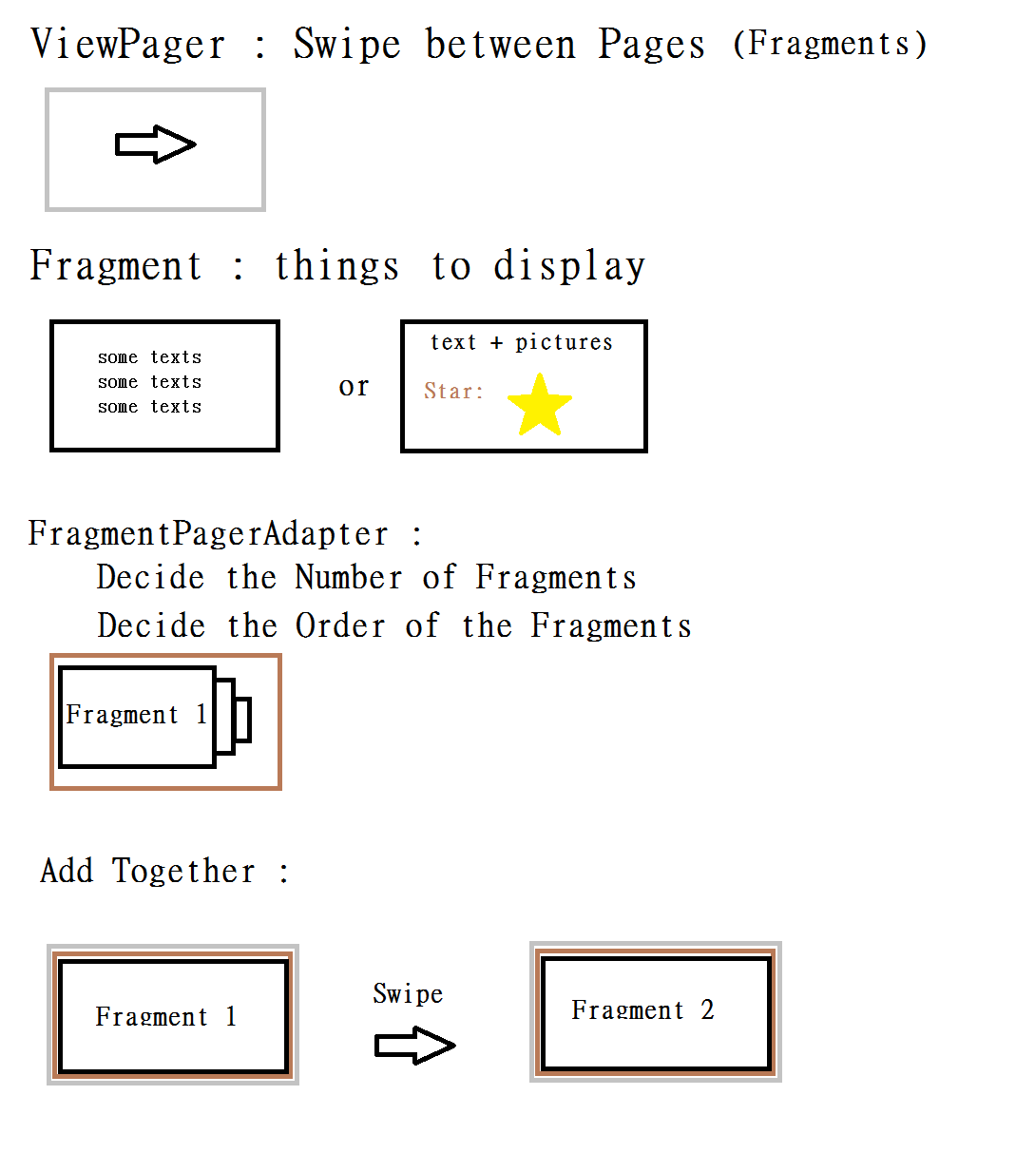

**How to use ViewPager?**

Step 1. Add ViewPager in your .xml file

<**android.support.v4.view.ViewPager  
 android:id="@+id/myViewPager"  
 android:layout_width="match_parent"  
 android:layout_height="wrap_content"**>  
</**android.support.v4.view.ViewPager**>

Step 2. Define the Fragments which you want to use

Here is an example

public class FirstFragment extends Fragment {

// Store instance variables

private String title;

private int page;

// newInstance constructor for creating fragment with arguments

public static FirstFragment newInstance(int page, String title) {

FirstFragment fragmentFirst = new FirstFragment();

Bundle args = new Bundle();

args.putInt("someInt", page);

args.putString("someTitle", title);

fragmentFirst.setArguments(args);

return fragmentFirst;

}

// Store instance variables based on arguments passed

@Override

public void onCreate(Bundle savedInstanceState) {

super.onCreate(savedInstanceState);

page = getArguments().getInt("someInt", 0);

title = getArguments().getString("someTitle");

}

// Inflate the view for the fragment based on layout XML

@Override

public View onCreateView(LayoutInflater inflater, ViewGroup container,

Bundle savedInstanceState) {

View view = inflater.inflate(R.layout.fragment_first, container, false);

TextView tvLabel = (TextView) view.findViewById(R.id.TextView);

tvLabel.setText(page + " -- " + title);

return view;

}

}

The .xml layout for FirstFragment :

*<?*xml version="1.0" encoding="utf-8"*?>*<LinearLayout xmlns:android="http://schemas.android.com/apk/res/android"  
 android:orientation="vertical" android:layout_width="match_parent"  
 android:layout_height="match_parent">  
 <TextView  
 android:layout_width="wrap_content"  
 android:layout_height="wrap_content"  
 android:textAppearance="?android:attr/textAppearanceLarge"  
 android:text="Large Text"  
 android:id="@+id/textView"  
 android:layout_gravity="center_horizontal" />  
</LinearLayout>

Step 3. Setup your FragmentPagerAdapter (Adapter:接合器)

It determines **how many pages exist** and **which fragment to display for each page**

Here is an example:

public class MainActivity extends AppCompatActivity {

// ...

public static class MyPagerAdapter extends FragmentPagerAdapter {

private static int NUM_ITEMS = 3; // total number of pages

public MyPagerAdapter(FragmentManager fragmentManager) {

super(fragmentManager);

}

// Returns total number of pages

@Override

public int getCount() {

return NUM_ITEMS;

}

// Returns the fragment to display for that page

@Override

public Fragment getItem(int position) {

switch (position) {

case 0: // Fragment # 0 - This will show FirstFragment

return FirstFragment.newInstance(0, "Page # 1");

case 1: // Fragment # 0 - This will show FirstFragment different title

return FirstFragment.newInstance(1, "Page # 2");

case 2: // Fragment # 1 - This will show FirstFragment

return FirstFragment.newInstance(2, "Page # 3");

default:

return null;

}

}

// Returns the page title for the top indicator

@Override

public CharSequence getPageTitle(int position) {

return "Page " + position;

}

}

}

Last step: Apply the Adapter

public class MainActivity extends AppCompatActivity {

FragmentPagerAdapter adapterViewPager;

@Override

protected void onCreate(Bundle savedInstanceState) {

super.onCreate(savedInstanceState);

setContentView(R.layout.activity_home);

ViewPager mViewPager = (ViewPager) findViewById(R.id.myViewPager);

FragmentPagerAdapter mfragmentPagerAdapter =

new MyPagerAdapter(getSupportFragmentManager());

mViewPager.setAdapter(mfragmentPagerAdapter);

}

// ...

}

Reference website :

https://github.com/codepath/android_guides/wiki/ViewPager-with-FragmentPagerAdapter