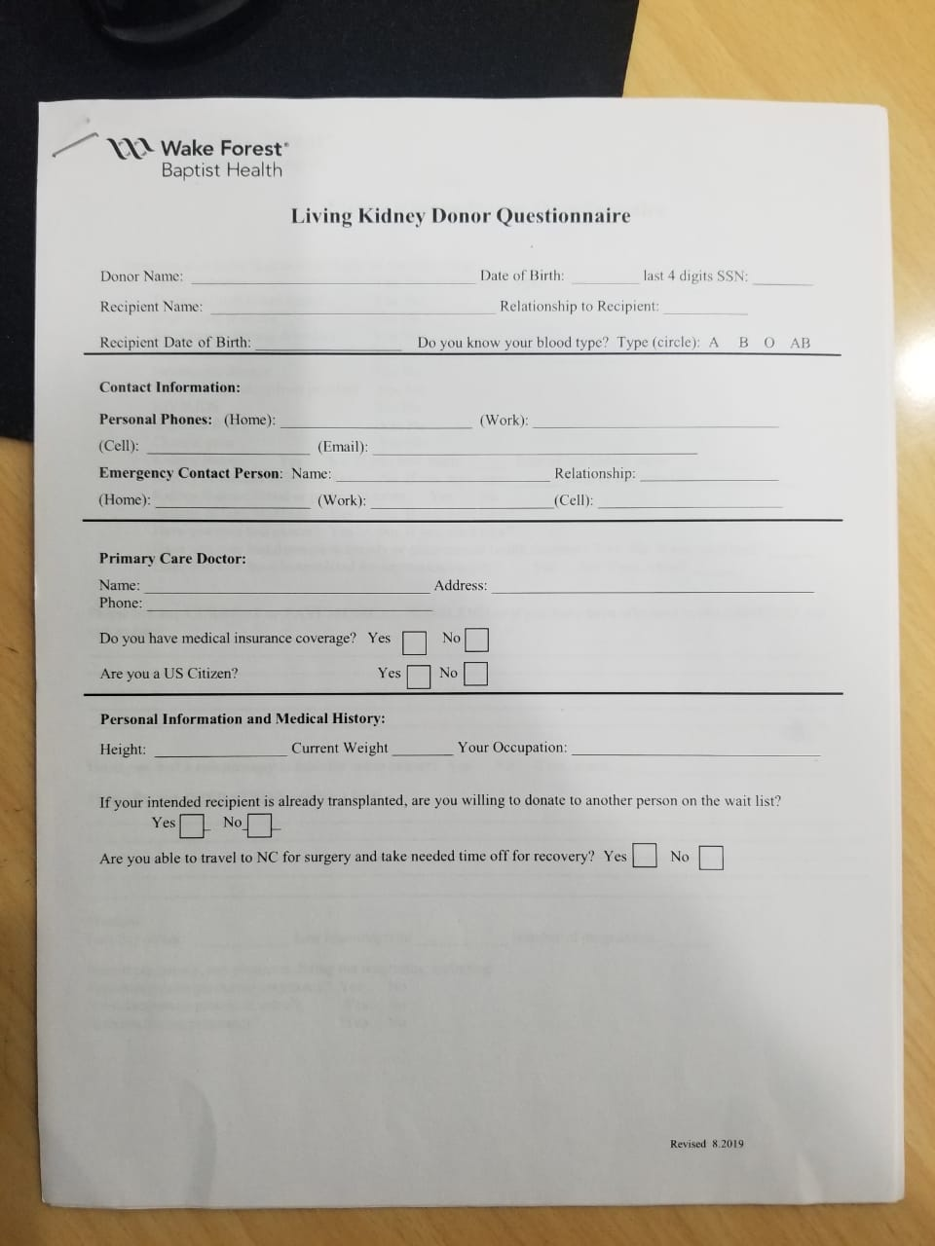

Oscar Valdivia

24/12/92

Nephew

My blood O

Personal phones: 684249000

If you intented recipient is already transplanted, are you willing to donate to another persono n the wait list   
  
No, only for Bernaola

Are you able to travel to NC for sugerí and take needed time off for recovery?

**Yes, i can.**

Have you ever been diagnosed with any of the following?

**Heart problems : No**

**Diabetes : No**

**Bleeding or clotting disorders : no**

**Autoimmune discase : no**

**Neurologic discase: no**

**Stomach bowel, or liver problem:**

**Constipation / Diarrhea / colon**

**HIV / AIDS : No  
  
Hepatitis :**

**Hepatitis A**

**Chronic pain : no   
  
Kidney stones : i dont know**

**Kidney or bladder infection :**

**No**

**Kidney disease, blood or protein in urine: No**

**Asthma or lung problems :  
Yes , Mild asthma and sinusitis.**

**have your ever bad cancer? :  
No**

**have you ever had depression/ anxiety or other mental health disorder?  
  
No**

**Have you ever been hospitalized for depression anxiety?  
  
No  
  
PLease list any current or past medical problems ori f you have been admitted to the Hospital for any reason:**

I had Hepatitis A in adolescence. Asthma since age 12, high cholesterol. uric acid a little high. I'm allergic to penicillin. I have acne and dermatological problems.

**Have you had a colonoscopy to look for colon cancer?**

No

Please list any operations you have had:

Nothing

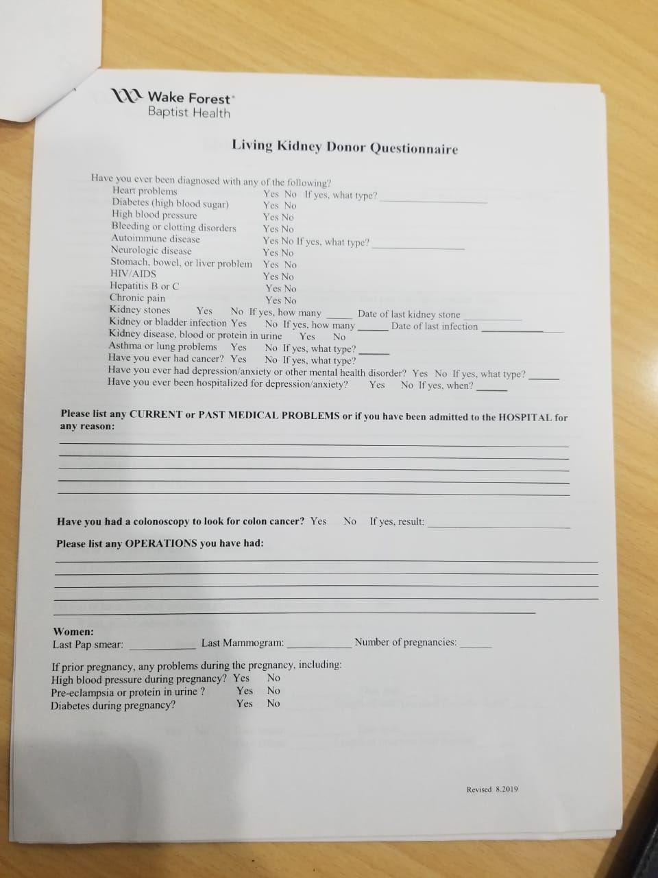

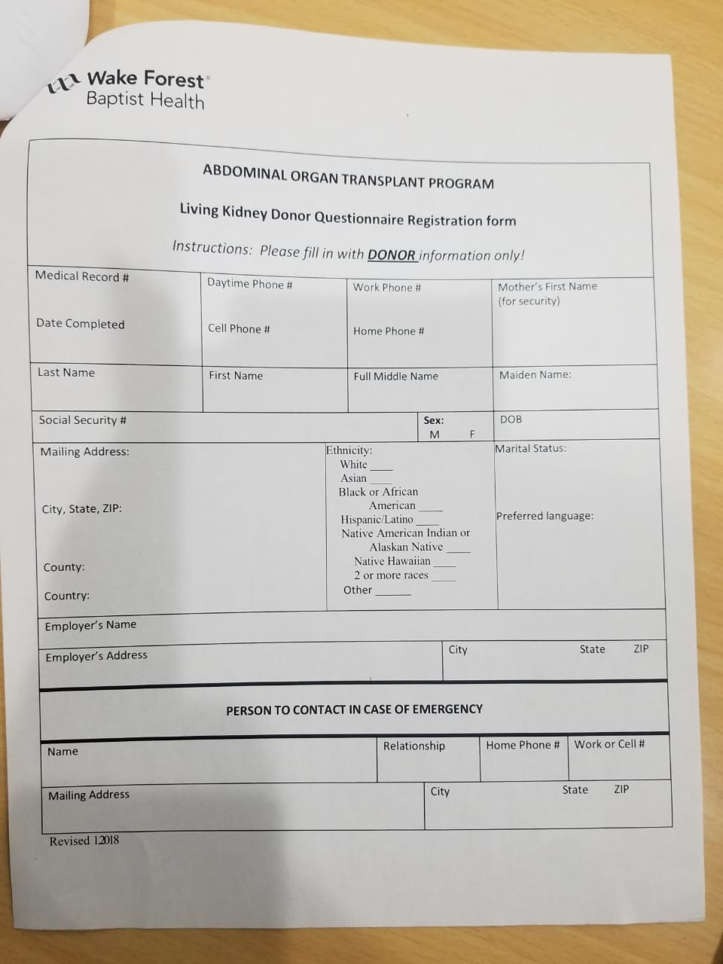

[Oscarb.valdivia@gmail.com](mailto:Oscarb.valdivia@gmail.com)

28018, Madrid

Hispanie / Latino

Marital Status: Single

Preferred language: Spanish   
  
Ocupation: Student

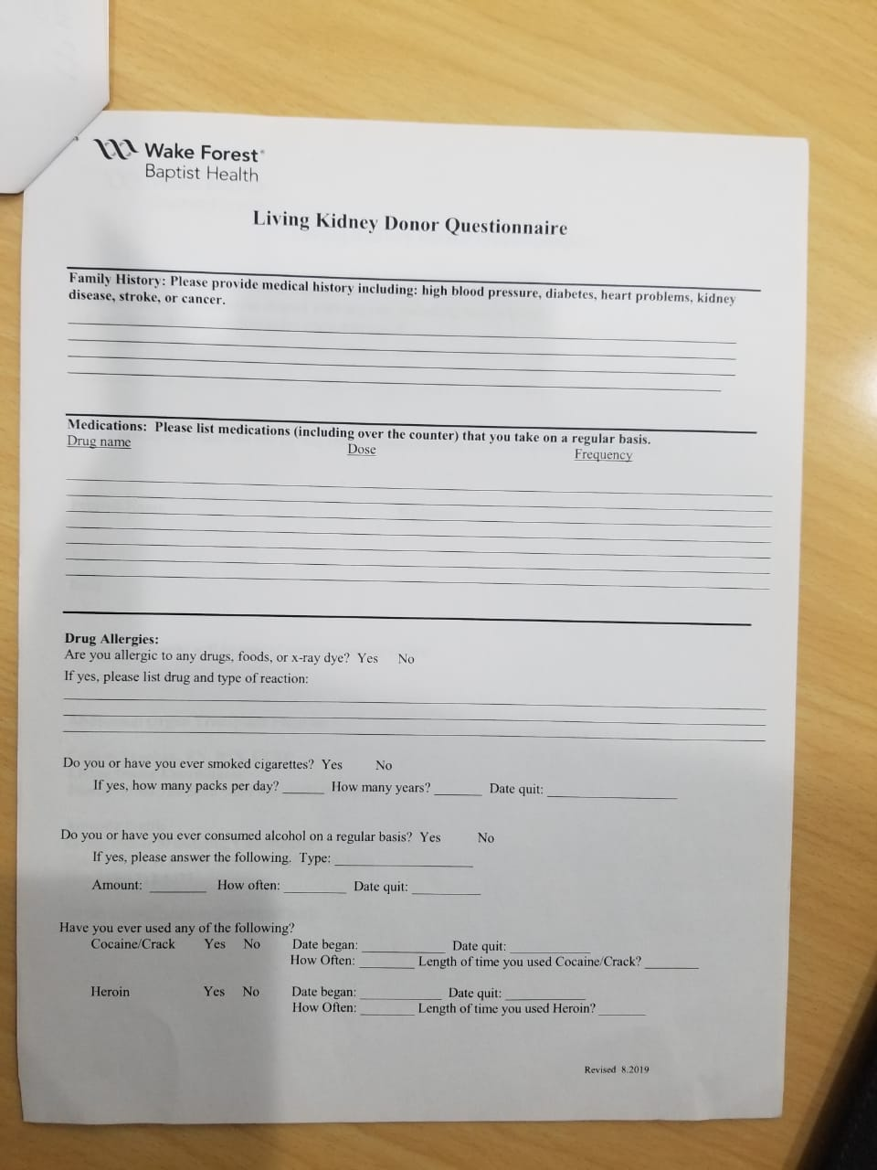

Do you or have you ever consumed alcohol on a regular basis?   
**Yes ,** If yes please answer the following type: **beer and vodka**

**Amount: 1 - 4 beers**

**hof often: weekends**

**date quit: since about 2011**

Cocaine : **NO**

Heroine: **NO**

Family History: Please provide medical history including: high blood pressure, diabetes, heart problems, kidney disease, stroke, or cancer.

Medications: Please list medications (including over, the counter) that you take on a regular basis.  
**Nothing**

Drug Allergies :

Are you allergic to any drugs, foods, or x-ray dye?   
**Yes, Allergic to chocolate and hazelnuts.**

**It gets red skin, I get red balls**

Do you or have ever smoked**?   
Not smoke**

Do you or have you ever consumed alcohol on a regular basis?