Bar Charts
Objective
To create a Bar Chart in R with the barplot function using categorical data, which is a collection of numbers that represent frequencies (or counts) of events or outcomes that fall into different groups or categories. (Note: If you are trying to display quantitative data, choose a histogram instead. Bar charts are for categorical data only. BAR CHARTS ARE NOT THE SAME AS HISTOGRAMS!)
Background
A bar chart uses rectangular segments to visualize categorical data. The lengths of the bars are proportional to the values they represent, and the bars can be oriented vertically or horizontally.
- Bar charts can be an especially suitable alternative to a pie chart when there are many categories to be compared. For me, it is never pleasant to examine a pie chart that has more than 10 slices, because the slices just overwhelm me.
- Good bar charts are labeled nicely, with a clear description of the categories that are being counted on the horizontal (x) axis, and a label on the vertical (y) axis that indicates whether frequencies or counts are displayed.
- Membership into each category should be mutually exclusive. That is, you don’t want an observation to appear in multiple bars.
- You will always have to consider whether a pie chart or a bar chart is a better way to display your data. If you are trying to illustrate a collection of items that naturally add up to 100%, a pie chart may be appropriate. However, if there are multiple categories where it may be difficult to distinguish which slice is bigger (such as one observation of 28% and another observation of 29%) a bar chart may be more appropriate. When small variations between categories should be communicated to your audience, bar charts are typically more effective than pie charts in presenting your data.
- If you want to display your data in terms of TWO categorical variables, you may want to choose a segmented bar chart (described in a separate chapter).

Even More Caution: There is a BIG DIFFERENCE between a bar chart and a histogram! Even though a bar chart looks really similar to a histogram at first glance, take a close look at what kind of data is on the horizontal (x) axis. In a bar chart, the horizontal axis lists categories. In a histogram, the horizontal axis will contain ranges of numbers that represent a continuum (e.g. 0-10, 10-20, 20-30 and so forth). Also, in a bar chart, there will be some space between the bars indicating that the categories are separate from one another - whereas with a histogram, there will be no space between the bars! The bars will be very cozy in a histogram, mashed up against one another like they're at a crowded party, whereas the bars in a bar chart need a little more breathing room, and thus are distanced from one another.
Data Format
To create a bar chart, all you need is 1) a vector (or array) of numbers OR 2) a column selected from a data frame.
1) The Vector Approach. Typically, your vector will contain counts of something in different categories. Here is an example of data generated by opening one package of regular M&Ms to investigate the distribution of colors, working with your data as a vector. In this case, I counted 12 blue ones, 6 brown ones, 8 green ones, and so forth:
mm.counts <- c(12,6,8,10,6,7)
names(mm.counts) <- c("blue","brown","green","orange", "red","yellow")
Note that even though I called my variable mm.counts, you can call your variable whatever you want. Just be sure to use that variable name in all future commands. For example, if you call your variable snakes, you want to make sure all future commands use that variable name, e.g. names(snakes).
We can also create a NEW variable to store the color names, so that we can use them to make colored bars in our bar chart that correspond to the M&M colors. I'm going to cal this new variable mm.colors:
mm.colors <- c("blue","brown","green","orange","red","yellow")
Now, you can check to make sure that your data was entered correctly:
> mm.counts
blue brown green orange red yellow
12 6 8 10 6 7
2) The Data Frame Approach. You can also enter your data into Excel, save it as a CSV (comma separated value) file, and read that CSV file into R. First, be sure you have recorded your data with ONE CASE PER ROW. Next, be sure you have used setwd() to set the working directory for R to the directory that contains your CSV file. Then, do this to load your data into R as a data frame:
mm.df <- read.csv("mnm-data.csv",header=T)
In the case above, I've saved my M&M data as a CSV file into a file called mnm-data.csv. The argument "header=T" means that the first row of my data file contains variable names. Once this command is executed, I'll have a data frame called mm.df that contains three variables: mnm (the order I pulled the M&Ms from the bag; first M&M pulled would be "1"), color, and defect. I have six color codes (BL = blue, BR = brown, G = green, Y = yellow, O = orange, R = red) and four defect codes (N = no defects, C = cracked or chipped, L = letter is missing or improperly printed on the M&M, and M = multiple defects).
Once your data frame is loaded into R, you can double check to make sure that the data frame was created correctly using the head command, which only displays the variable names and the top few rows of data:
> head(mm.df)
mnm color defect
1 1 BL N
2 2 BL N
3 3 BL N
4 4 BL N
5 5 BL N
6 6 BL M

Code and Results
Now it’s time to generate the bar chart.
If your data are stored as a VECTOR, or ARRAY, do this:
barplot(mm.counts,main="My M&M Color Distribution",xlab="M&M Colors",ylab="Number of M&Ms in Bag",col=mm.colors)
The result of this barplot command is shown in Figure X.1, where the colors of the bars correspond to the M&M colors. If you don't want to display colors, and would prefer that all the bars are displayed as gray, just leave out the col=mm.colors argument. If you don’t want percents in the labels, just omit the labels=my.labels option from your R command.
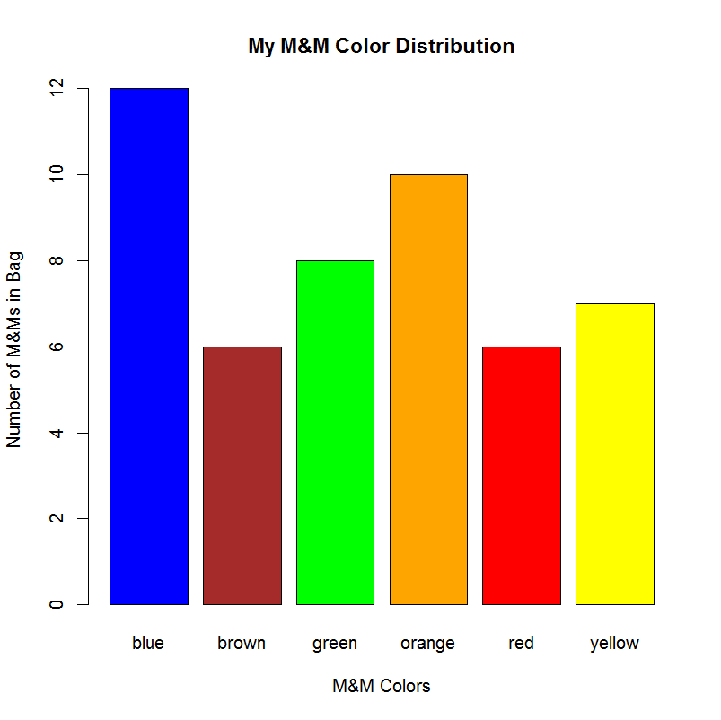
Figure X.1: Chart produced by barplot using the data in the vector mm.counts
If your data are stored as a DATA FRAME, do this:
Assuming you have already loaded a data frame called mm.df into R, containing information about each of the M&Ms you observed (with one case per row), you can produce a bar chart by tallying up the variable of interest using the table command:
> count.colors <- table(mm.df$color)
> count.colors

BL BR G O R Y
12 6 8 10 6 7

Although we won't use it to generate the bar chart, you may wish to see a contingency table where the data are tallied up according to each of the categorical variables:
> table(mm.df$color, mm.df$defect)

C L M N
BL 3 0 1 8
BR 1 0 0 5
G 0 2 0 6
O 1 0 1 8
R 0 0 0 6
Y 2 0 0 5

The table command takes all of the data collected describing the individual M&Ms and tallies them up according to the variable color. Once you have the tallied counts, you can generate the plot (shown in Figure X.2) like this:
barplot(count.colors,main="My M&M Color Distribution",
xlab="M&M Colors",ylab="Number of M&Ms in Bag",
col=mm.colors)

Or, you can roll up all the steps into one, by using table(mm.df$color) directly from within barplot, instead of creating that new variable count.colors first:
barplot(table(mm.df$color),main="My M&M Color Distribution",
xlab="M&M Colors",ylab="Number of M&Ms in Bag",
col=mm.colors)
Notice that this is EXACTLY the same code and both ways will produce exactly the same bar chart shown in Figure X.2. (As a practice exercise, you can repeat all of the steps above using the variable mm.df$defect instead of mm.df$count to generate bar charts of the defects.)
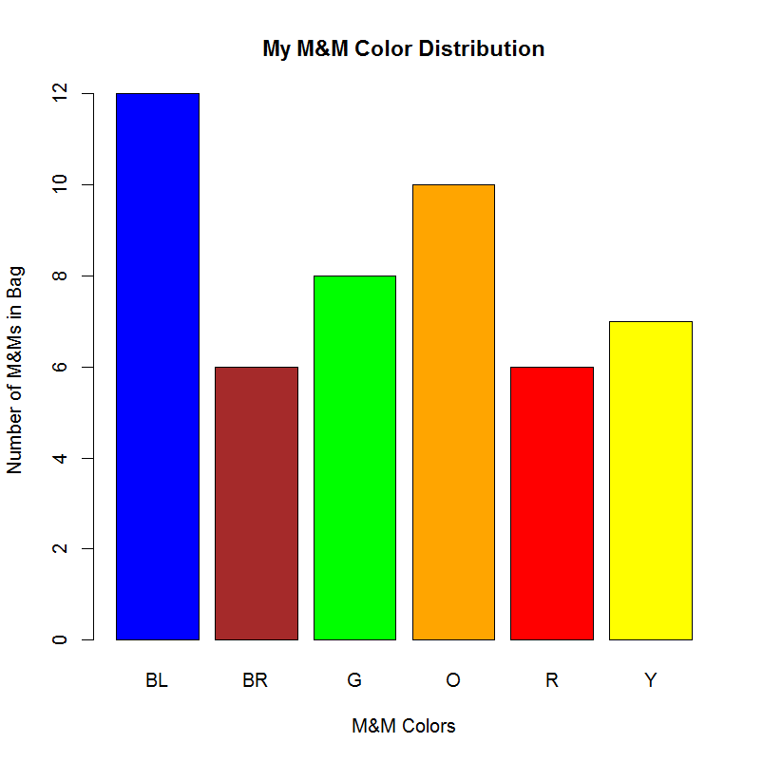
Figure X.2: Chart produced by barplot command executed on a data frame
There are many optional arguments that you can add to your bar chart using barplot, some of which you've seen in the examples above. My favorites are in Table X.1 below.
Option | What it does
main | Specify a main title to be displayed above chart
xlab | Specify text to describe the x-axis
ylab | Specify text to describe the y-axis
col=mm.colors | Sets the color palette to the colors that you have designated in the vector mm.colors
names.arg=mm.colors | Instead of labeling the x-axis with the categories from the raw data, this argument enables you to set up new labels for the bars, which can be useful if you are generating a bar chart from data within a data frame
legend.text=TRUE | Adds a box with a legend to the plot
horiz=TRUE | Orients the display of the bars horizontally instead of vertically
density=10 | Makes shaded bars instead of solid (I like to choose values between 8 and 22 here)
Table X.1: Optional arguments that can be used with barplot to make a prettier chart

Conclusions
Bar charts, like pie charts, can be useful to visualize the distribution of proportions (or counts) of an observation between categories. Whether you use counts or proportions on the vertical (y) axis for a given data set, your bar charts will look exactly the same! However, if you are using proportions, the bar chart has a different name - it's called a relative frequency bar chart.

The Pareto Chart, which is covered in another chapter, is a special kind of bar chart where the bars are ordered so that the most commonly represented category appears on the leftmost side of the plot.
Other Resources:
- http://en.wikipedia.org/wiki/Bar_chart
- http://www.forbes.com/sites/naomirobbins/2012/01/04/a-histogram-is-not-a-bar-chart/ - A Histogram is NOT a Bar Chart! From Forbes magazine

