**Assignment 10**

Zhu Jiajie 1155145692

●**Link**

<https://oscarzhu8.github.io/COMM5961/FinalProject/homepage.html>

●**DFD**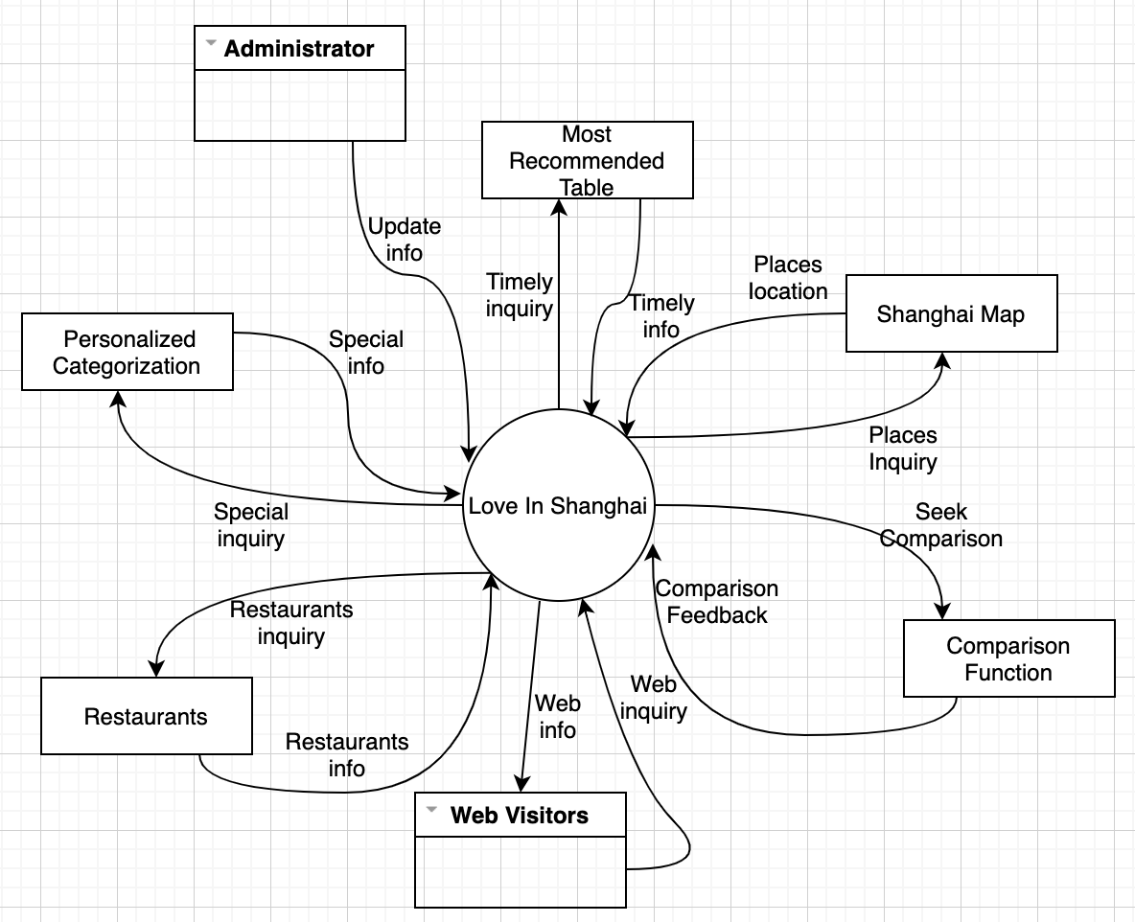

●**ER**

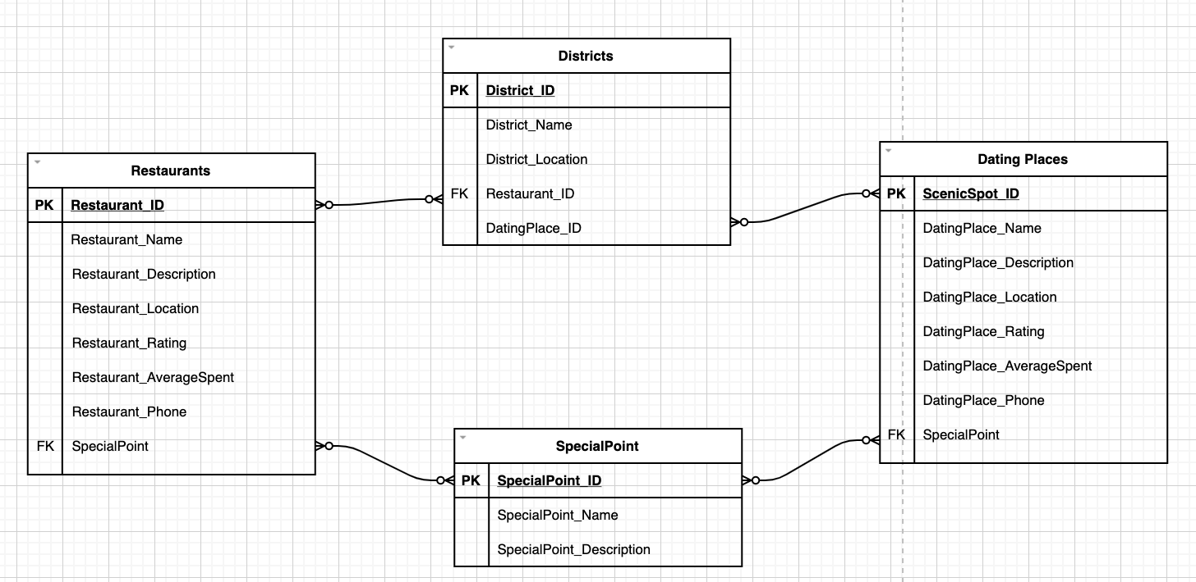

●**A/B Test**

I want to test whether a button with red text will attract users more. To see which design is better, I carried out an A/B test by Google Optimize for quantitative testing. The test has been lasted for about two weeks, and has gained much data to value the results.

Version A:

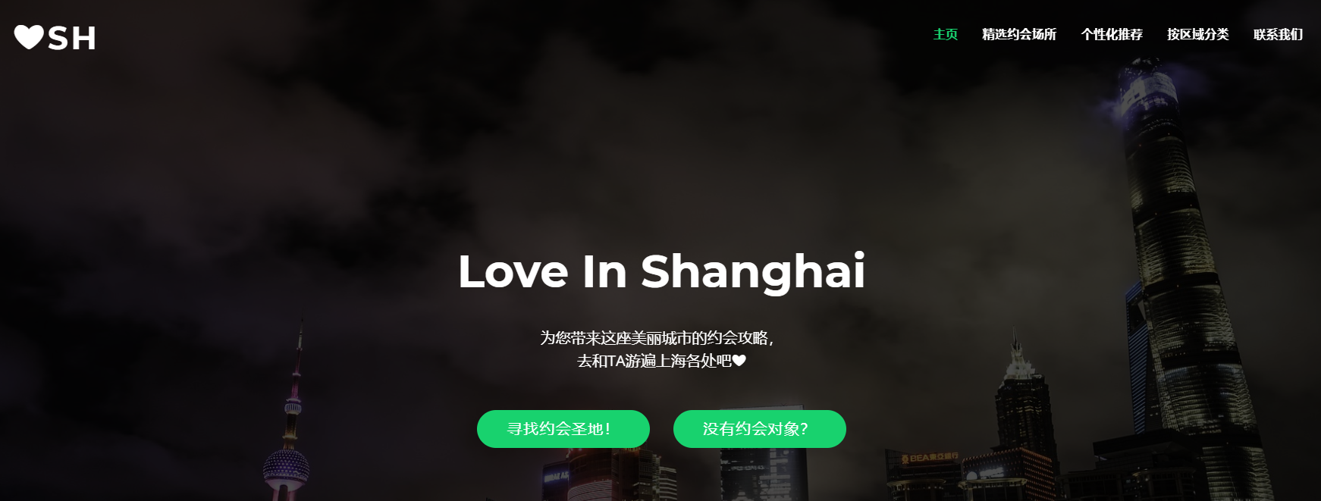

Version B:



After running the A/B test from November 27th to December 13th, we can see that the performances between the two versions are near, while the version B performed a little better than the version A, which gets more clicks (2.76 to 2.73) and longer page duration (47 seconds to 44 seconds). Therefore, I think the previous hypothesis was being supported, and I would to design a more eye-catching color button to attract users to take action.

The results of A/B test are in the following:

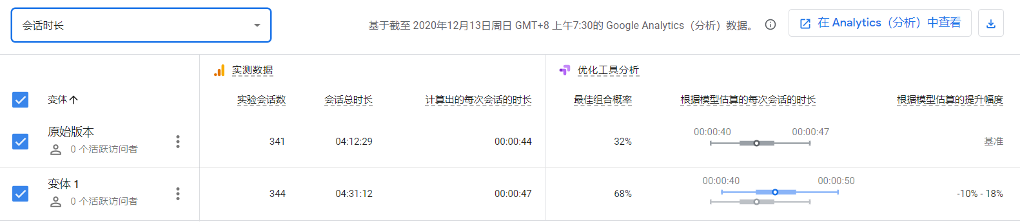

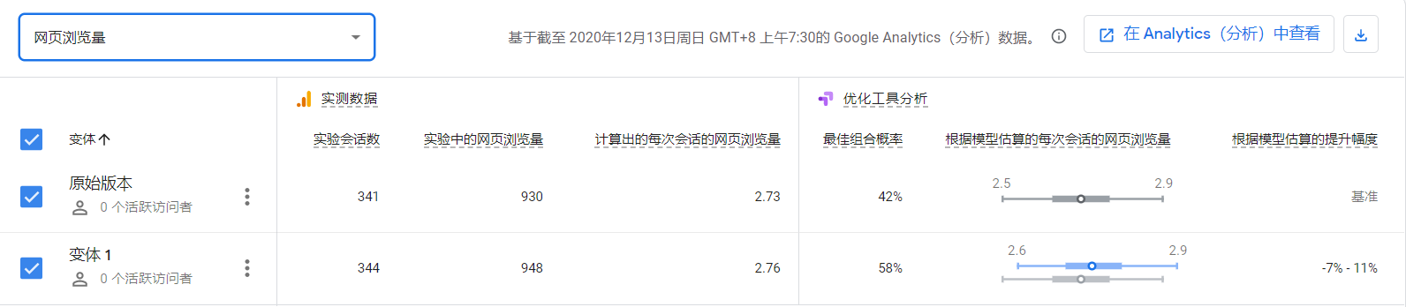

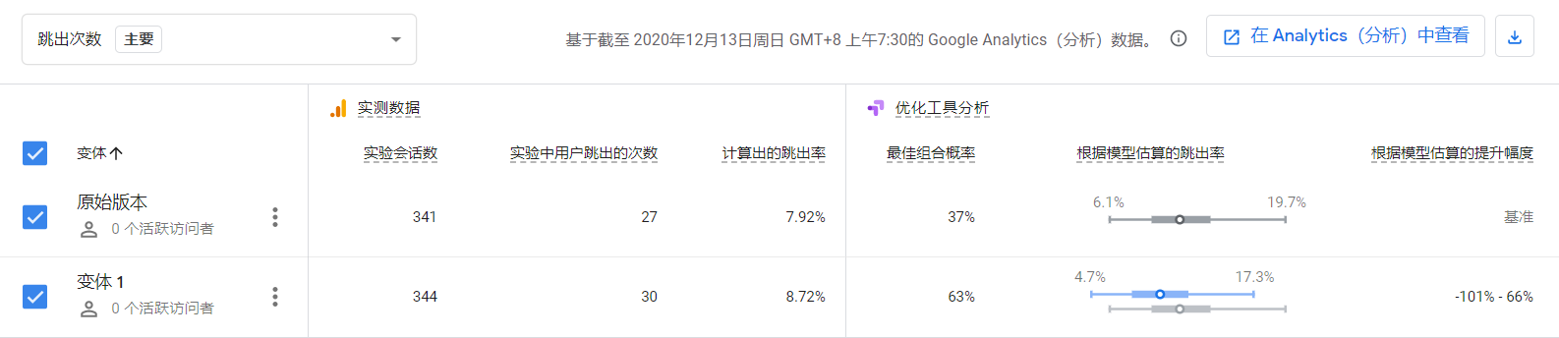

●**Google Account was added**

