**Assignment 8**

Zhu Jiajie 1155145692

●**Compare my prototype with competitor “Dianping”**

1. Homepage

First of all, the homepage of Dianping does not specifically have a navigation bar for dating places. According to the usability test on Dianping, users always wasted many times on searching the navigation bar on the left for dating, but no answer comes out.

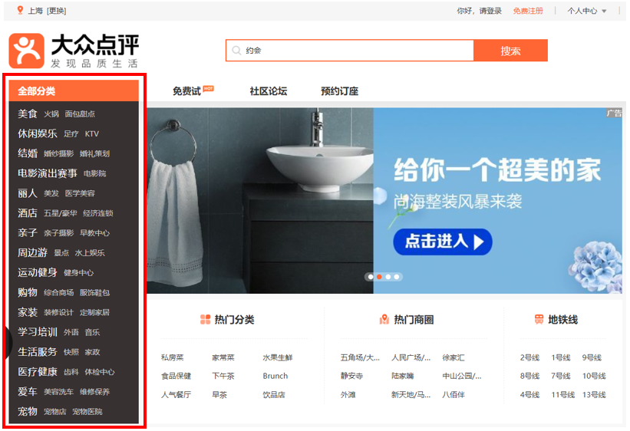

What’s more, when the users search “约会” in the search box of Dianping, the results come out are just some small places with the word “约会” in the shop name, such as “约会吧情侣吧”, “约会情侣空间”, but not the specific dating places like some parks or restaurants. In other words, for students who want to find a dating place, they will have difficulties in the beginning searching process of Dianping.

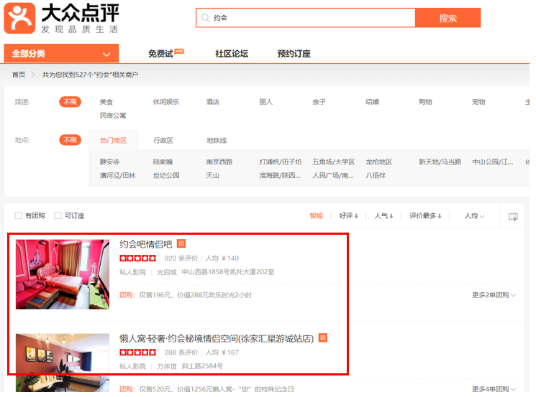

Therefore, my prototype just focuses on recommending the dating places in Shanghai, so that it is really suitable for students who want to find a place to date, which can save them a lot of time. In terms of the navigation bar, the prototype offers different views to see the dating places by recommendation, personalized choice, and districts. Users can easily find a dating place that suits their needs.

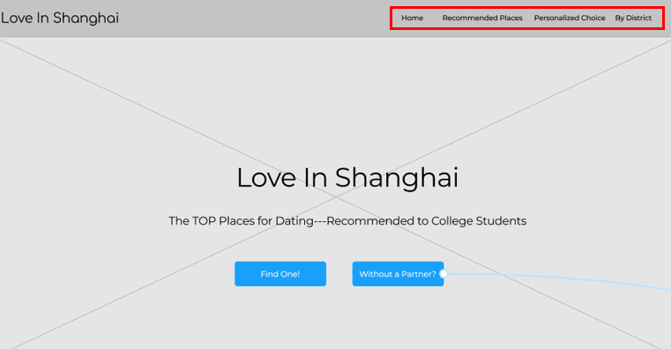

2. Content

The similar point of Dianping and my prototype is that users can both see the places by selecting different districts.

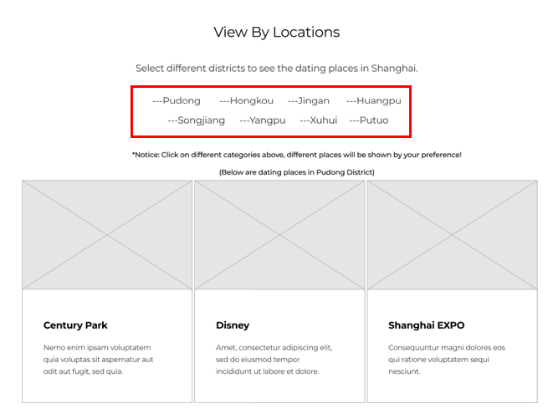

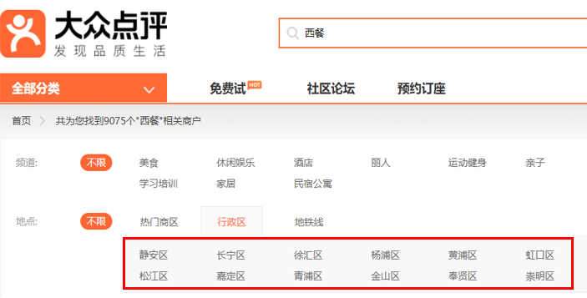

However, the other contents of Dianping focus simply on prices, rates and so on, while my prototype offers users to see the dating places by their personalized preference. Because when we are choosing a dating place, we should take many things into consideration, and commonly the girls have more requests, such as whether the place is quiet, private, suitable for taking pictures, etc. Consequently, my prototype categorizes the dating places into seven parts based on specific needs. It will be easier for users to find their ideal place.

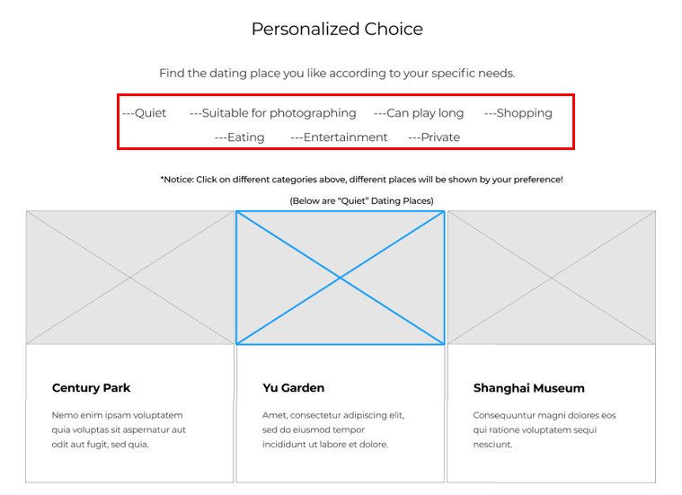

3. Detailed Page

Compared with Dianping, my prototype improves some visual feeling of the users. Dianping’s pictures of a detailed place is too small and not conspicuous, while my prototype designs the pictures in the middle, with the information on the side. In terms of information, my prototype not only has the basic information and comments like Dianping, but will also add some my own real experience of that place. Dianping only has the advice from the users.

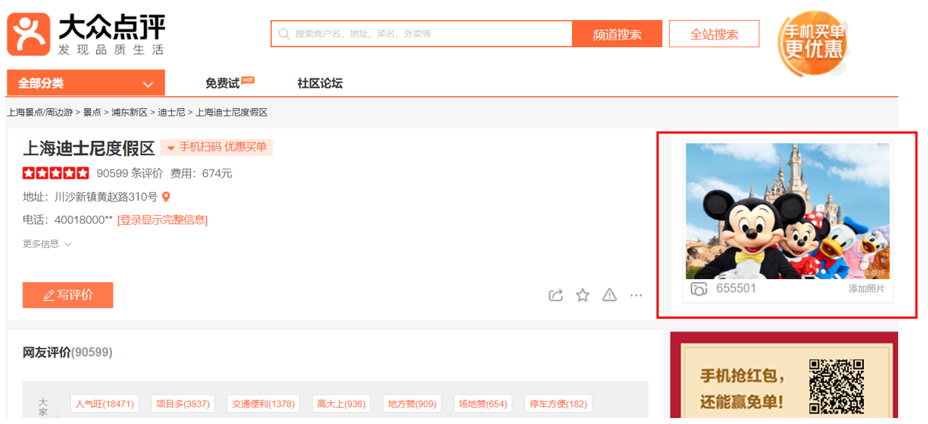

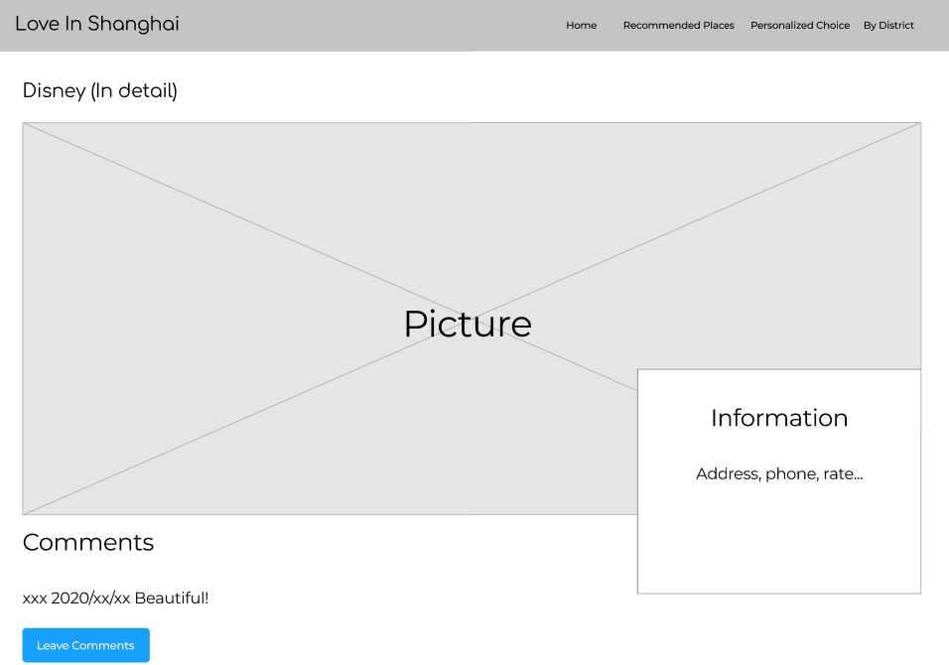

4. Social Page

Is my prototype only suitable for those who have a boyfriend or girlfriend? Absolutely not! In the homepage, there is the button “without a partner?” for finding one who is also single to play with you and go to the places recommended. Users can see the message on the box and find one interested in and add him or her. In addition, users can also publish their own information.

This function broadens the target users of my prototype, and increases the social activities between college student, some of which may even find their boyfriend or girlfriend here. In contrast, Dianping does not have this function.

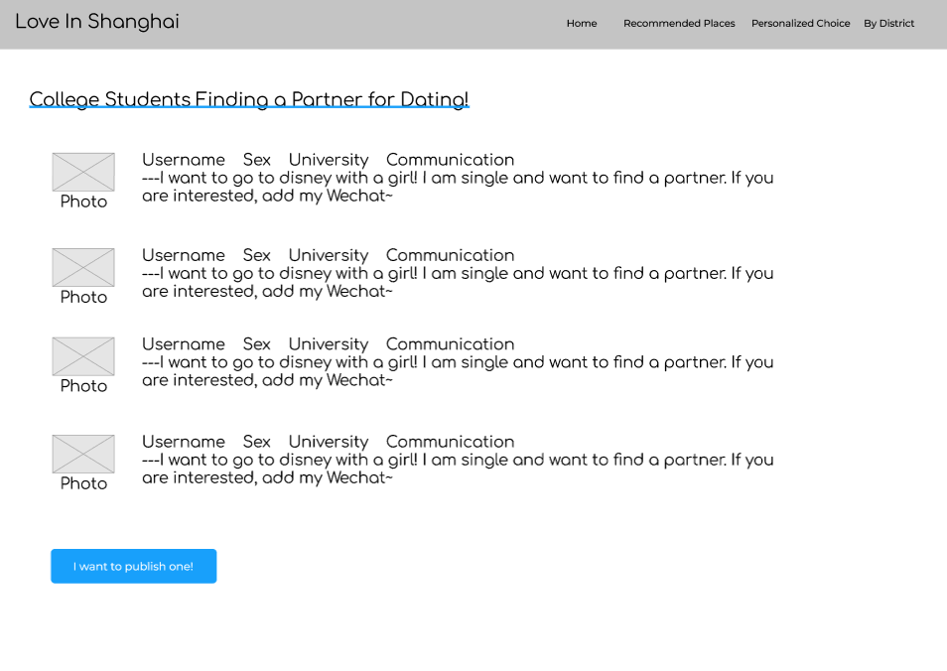

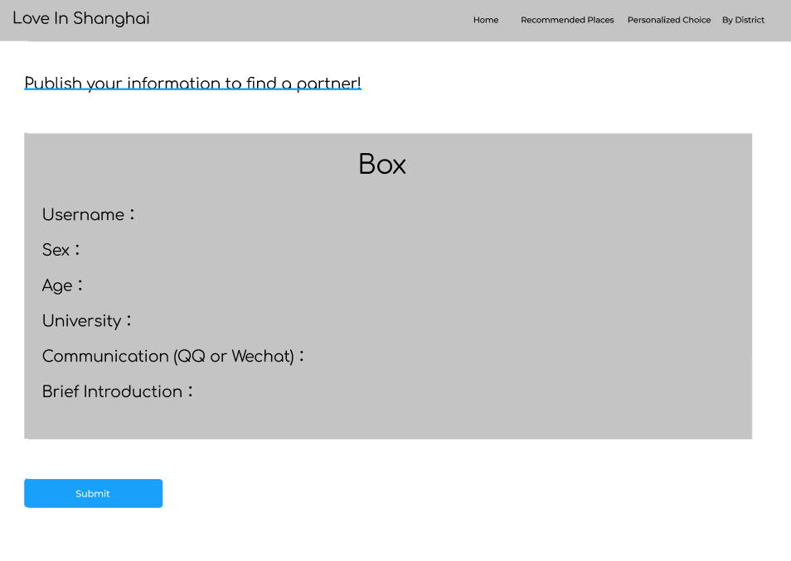

●**Usability Test Dashboard**

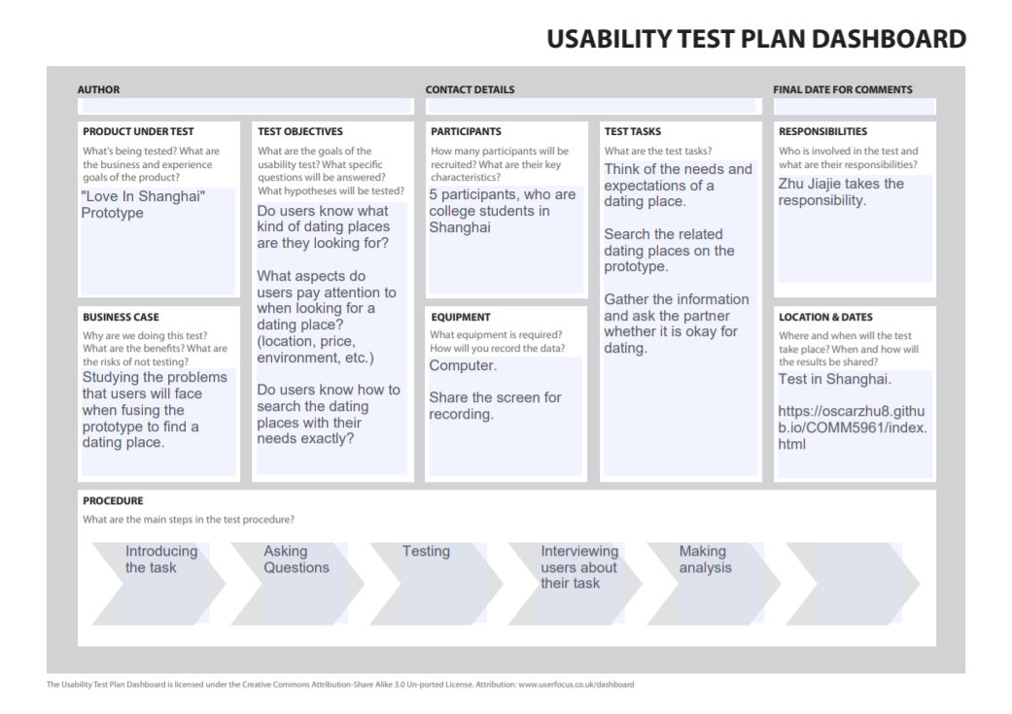

●**Analysis**

The usability test of the prototype was carried out for 5 new users: A, B, C, D and E who all have a boyfriend or girlfriend. A is a freshman who just comes to Shanghai for study this semester; B is a sophomore who lives in Shanghai; C is a junior who is preparing for the law test; D is a senior who is interning; and E is a postgraduate student who takes the online course in Shanghai.

Different from the result of the previous test on the competitor’s website, the users this time find easier to look for the dating places they want. When seeing the homepage of the prototype, all the five participants noticed the navigation bar on the top, which enables them to realize the basic structure of this prototype, and they can look for the places by different categories. For participant A, who is a newcomer of Shanghai, he is quite attracted by the “recommended places”, because he wants to first play the most well-known places of Shanghai. That area of the prototype performs this job, which serves for the users who do not have a specific need, but want to enjoy the landmarks of the city. For the other participants, B and E likes the “personalized choice”, which fulfills their different needs in finding the dating places. In addition, C and D, who are busy because of test or work, incline to choose a place near them, so that the dating places divided by districts are what they looking for. Although there is no much data on the prototype, all the participants give the feedback that they know where they are when start browsing this. Especially, some of the participants said the categories of the “personalized choice” are just the key aspects they think when finding a dating place, such as “privacy”, “is it beautiful for taking photos”, “where can we go shopping” and so on. This prototype responds to the different needs that the users might have in find a dating place.

What’s more, the task time 5 participants take are all below five minutes. Although a big part is because of the data are not that much in this simple prototype, the whole time they take is much less than the time the previous 5 participants took on the Dianping, which are 23, 25, 16, 24, 19 minutes.

Lastly, the five participants all notice the special function for finding a partner, and they said they are willing to recommend this website to their friends who are still single to use it after the final work is done. They think this function will attract more users to join this website and may even find their partner.