**Assignment 9**

Zhu Jiajie 1155145692

●**Feedback of high-fidelity prototype**

**User1:** The background image is really beautiful, which is the landmark of Shanghai, and the colors are harmonious.

**User2:** The pictures of every dating place are well-picked, and they are very nice.

**User3:** The navigation bar is quite clear. It shows the different functions and categories of the website, and after clicking them, the page will automatically be dragged to the right place.

**User4:** The functions of seeing the dating places by different personalized preference are well-designed, and I can find the place I want.

**User5:** Love the structure and design. Look forward to seeing more information on the detailed pages.

●**A/B Test**

**A**

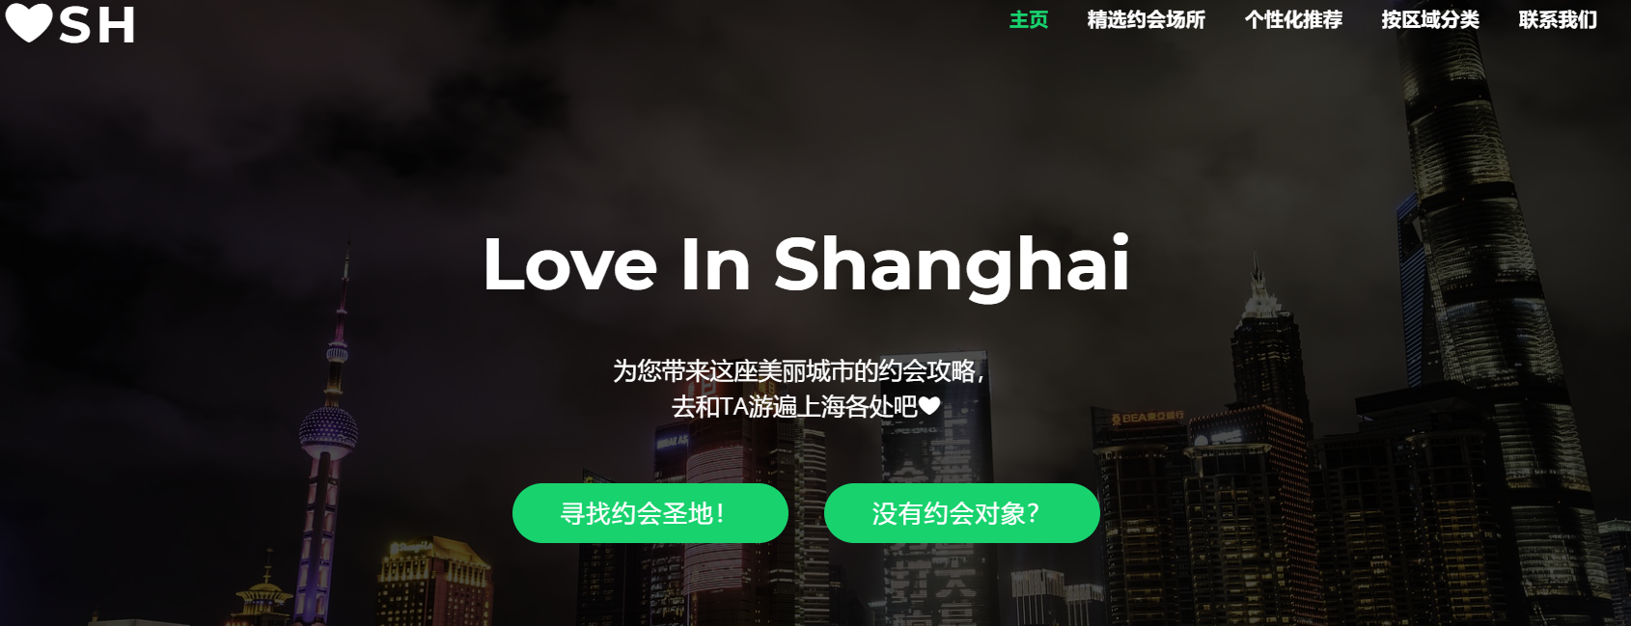

**B**

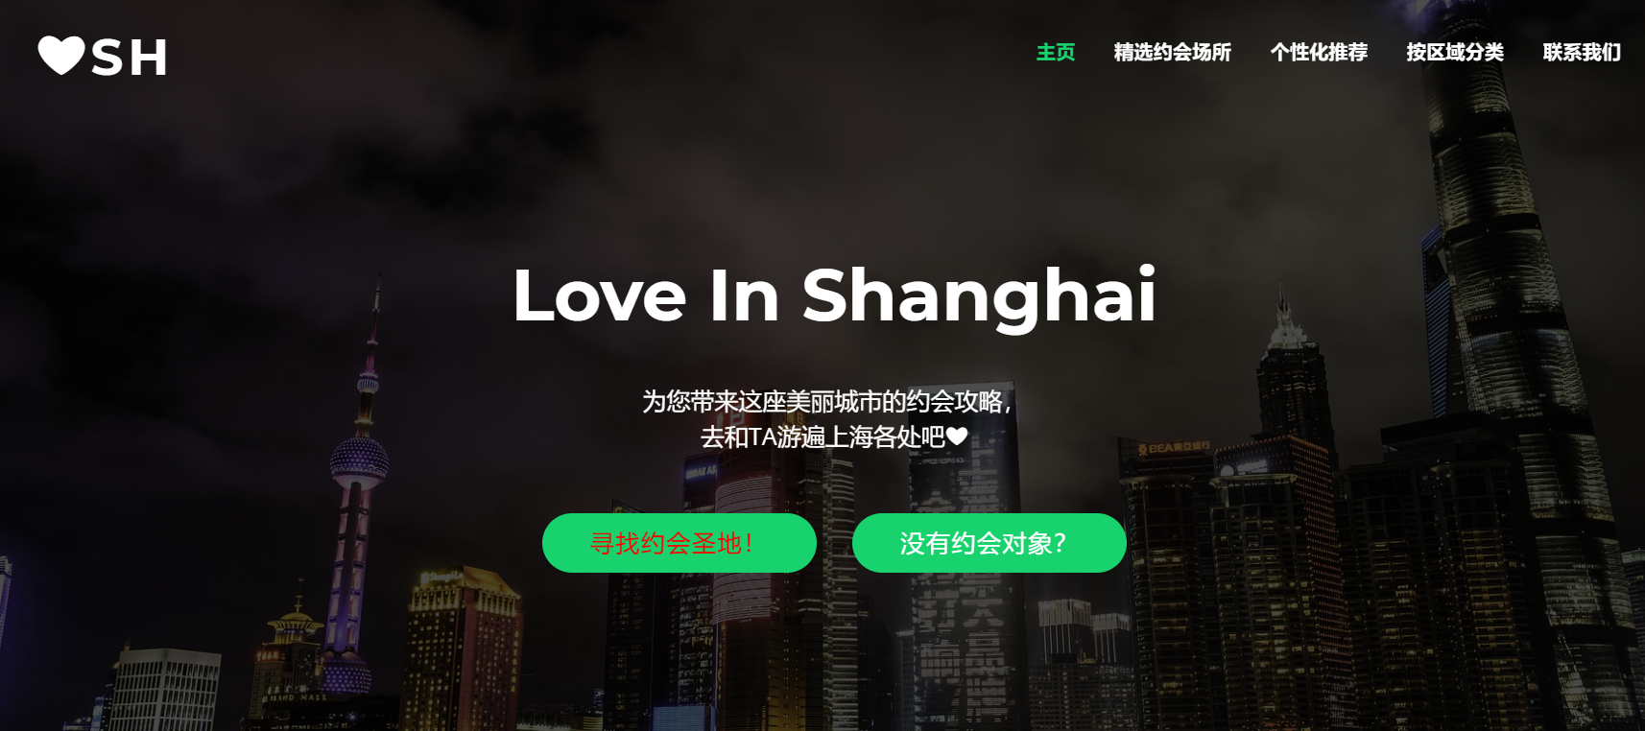

The variant of B version is that the button of “寻找约会圣地” is in red, which aims at testing whether the different color will attract uses to click the button and see more information.

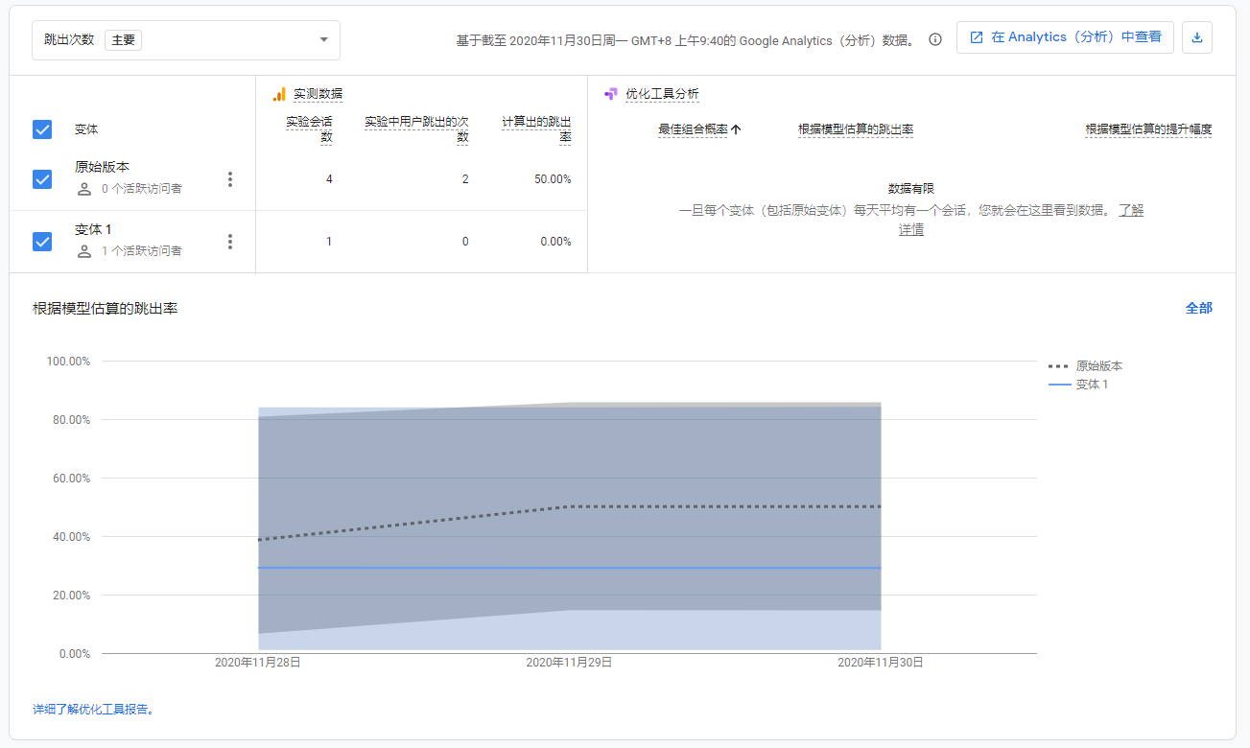

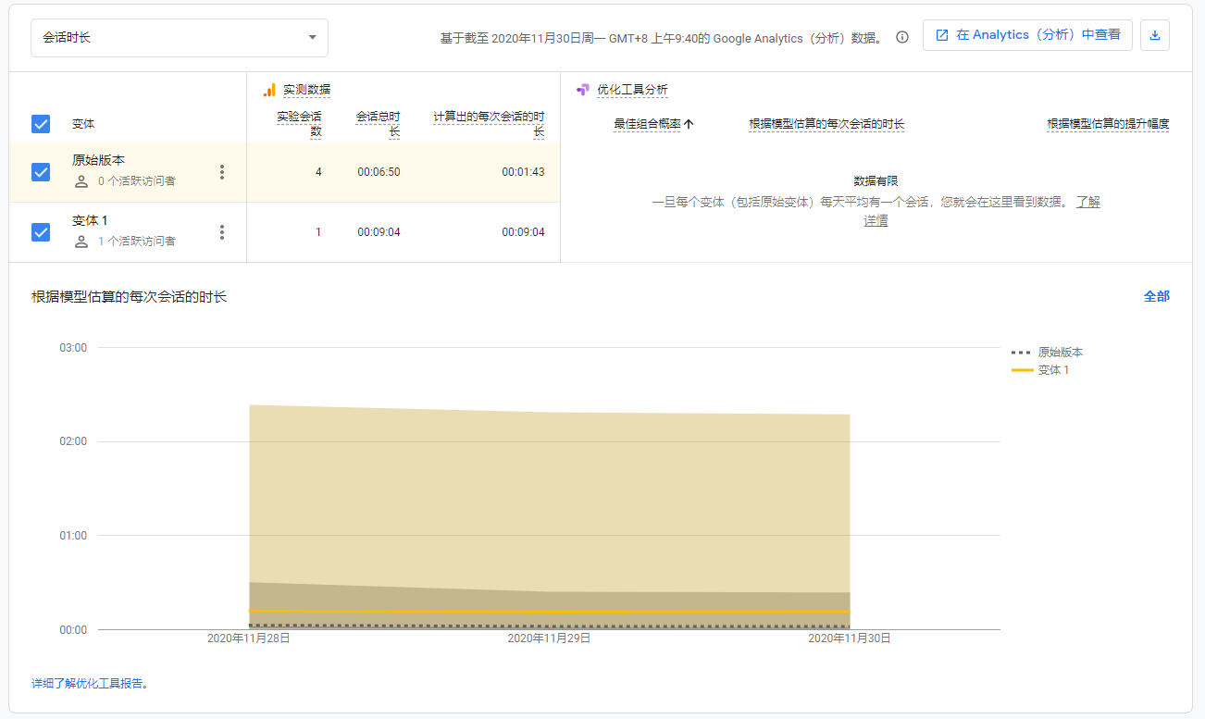

Here are some of the results, although the data is limited. What we can see that the bounce rate of Version A is 50%, and the time users spent and Version B is also higher than Version A.