
Artificial Intelligence
Lab5-6

Submitted By:
Saad Ali
SP23-BCS-051/8A
Submitted To:
Mam Syeda Rubab Javed
October 15, 2026

Lab 5
Task 1: Manhattan Distance Heuristic
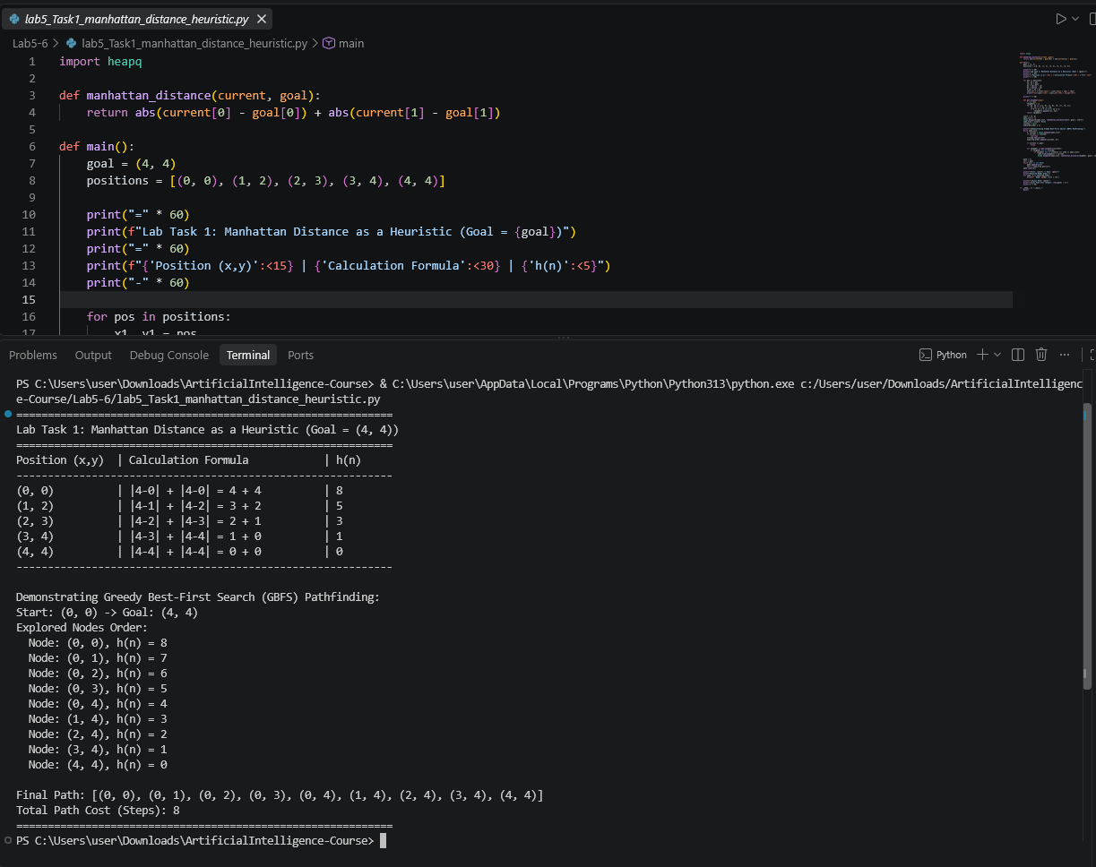
Task 2: 8 Puzzle Solver using GBFS
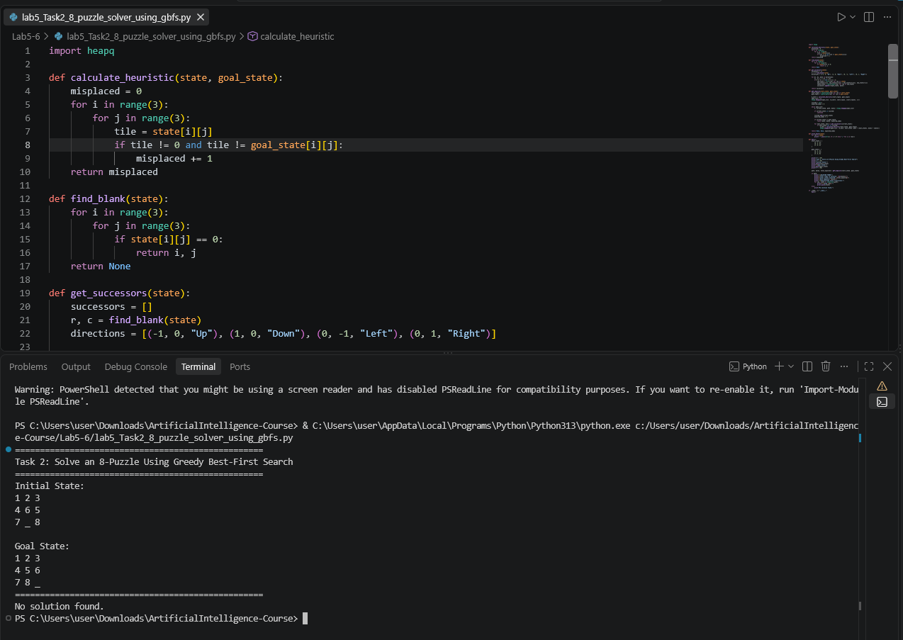
Task 3: 8 Puzzle User Input with Solvability Check
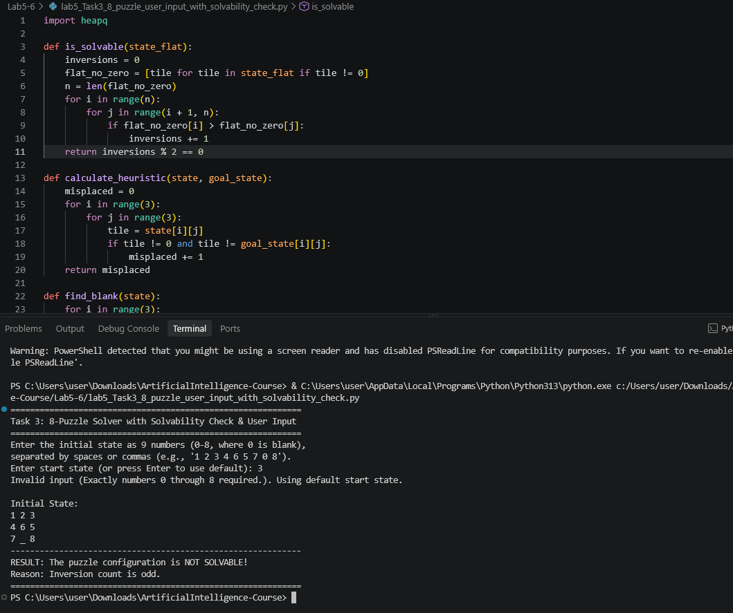
(The related python code files are added in zip)

Lab 6
Task 1: Romania Map A* Search
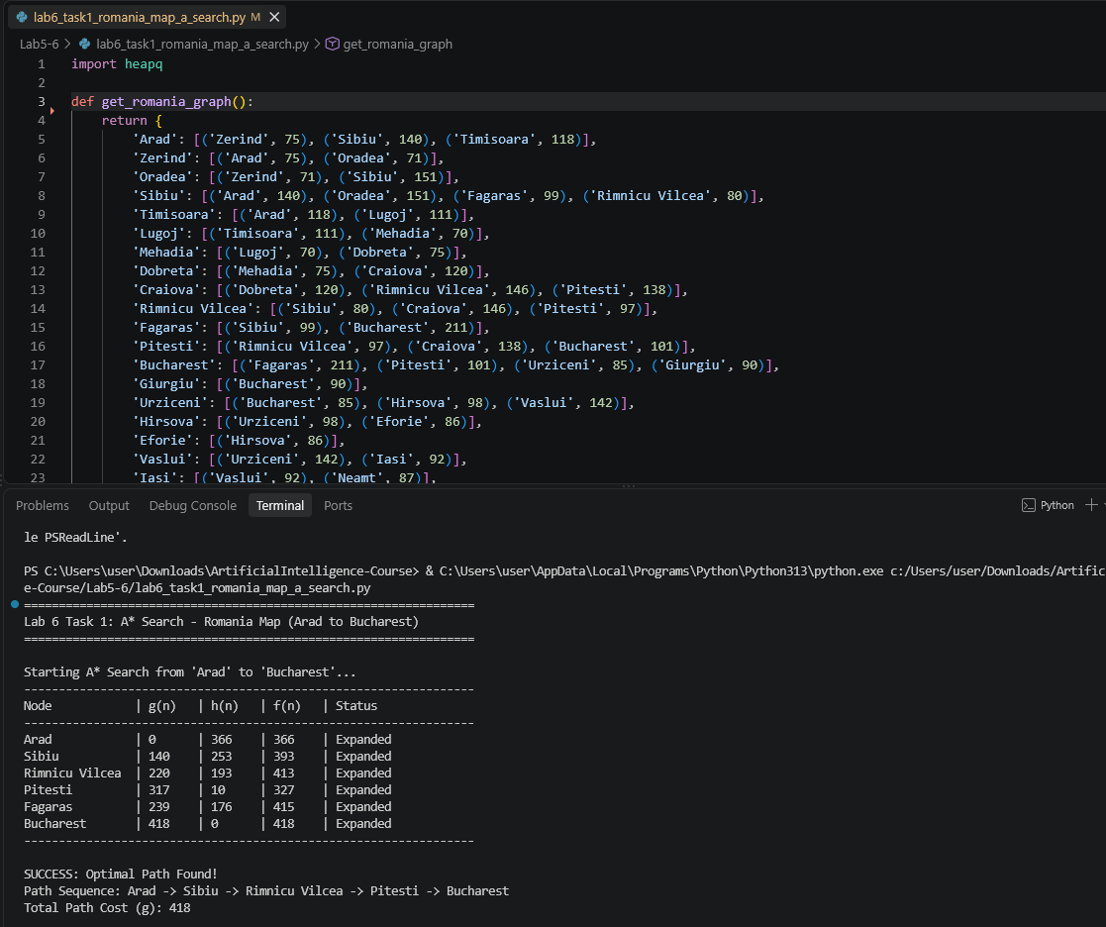
Task 2: 8 Puzzle A* Search
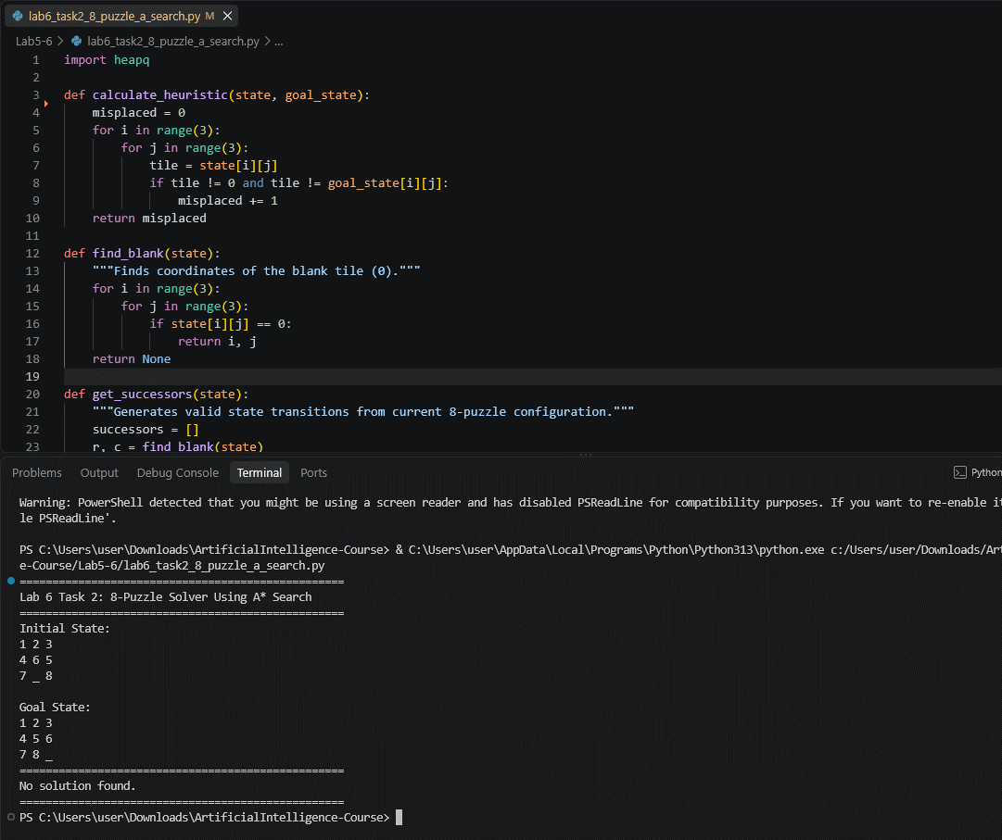
Task 3: Robot Maze A* Search
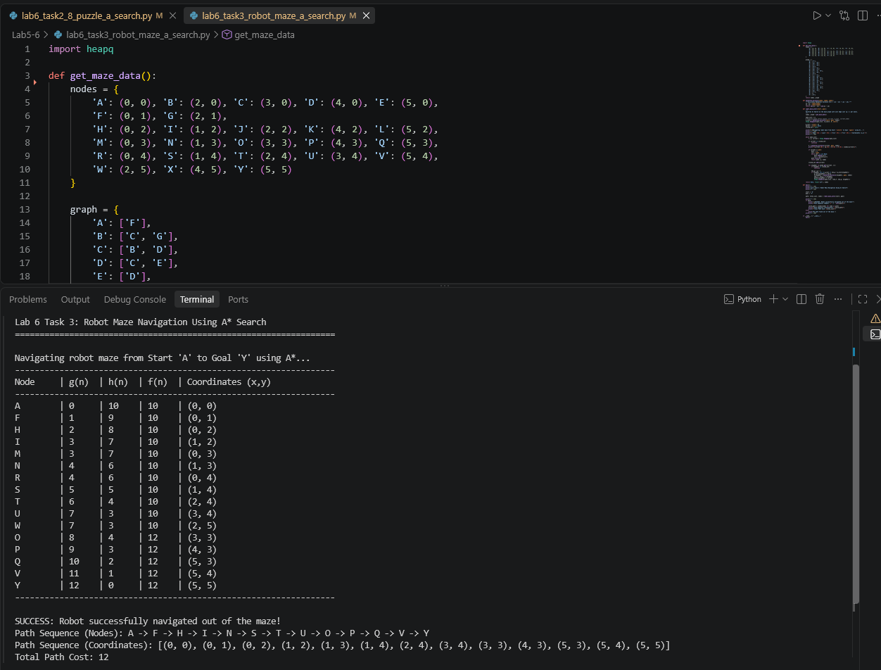
(The related python code files are added in zip)

