# Getting started Guide for „AnotherSc2Hack“

Requirements:

* StarCraft 2: WoL (1.5.4)
* .Net Framework 2.0
* Understanding the English language

**Content**

[Getting started Guide for „AnotherSc2Hack“ 1](#_Toc347662595)

[Requirements 1](#_Toc347662596)

[Start the Hack 2](#_Toc347662597)

[Welcome to the tool 3](#_Toc347662598)

[Settings 4](#_Toc347662599)

[Other settings 6](#_Toc347662600)

[Activate the panels 7](#_Toc347662601)

## Start the Hack

Okay. Before you can configure anything or use the hack you should start it.

That means go to your specific folder and run the hack (**AnotherSc2Hack.exe**).

One side note: I’d like to have my “evil” programs run with higher privileges. But you don’t have to.

Another side note: Don’t run the “**NewDownloaderDeamon.exe**”. Never do that. It requires specific input to run correct.

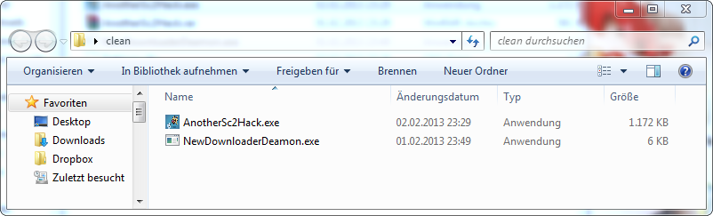

*Obviously starting the hack*

## Welcome to the tool

Now you are inside the tool. If StarCraft2 does not run, it will look like this:

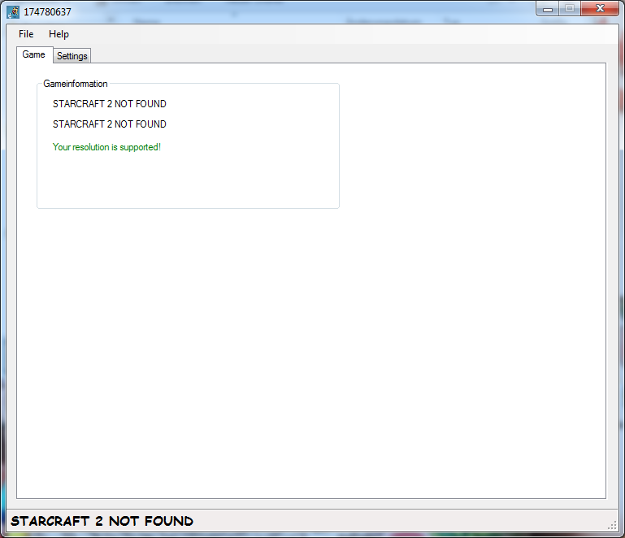

*StarCraft2 is not found – because it’s not started*

Basically, you have a small overview about “what’s going on”.

A lot information will be here in next versions. For now, you can only see the **Gametype** and the **FPS** of the SC2. And if your **resolution** is supported (it will adjust the panels automatically in the next versions).

Simply click on “**Settings**” if you want to configure your panels.

## Settings

Now you are in the settings.

Here you can adjust the specific filters and basic settings for each panel.

In this example we will focus on the resource panel.

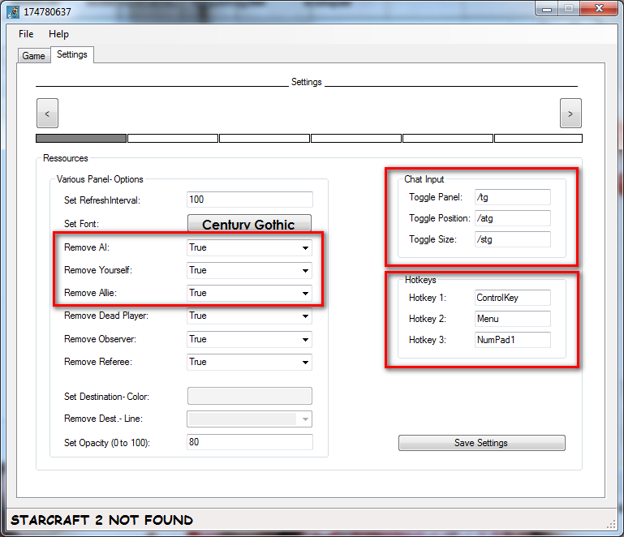

*The resource- panel – We didn’t configured anything yet*

The red boxes indicate critical settings. Sometimes, I also mess up with it.

I’m not gonna explain the left side. I just assume you have the skills to read and understand.

“**Chat Input**” tells us what we have to write if we want to do something.

To **active** the resource- panel write “/tg” in the **ingame chat**.

Changing the **position** is possible with “/atg”.

And the **size** gets changed with “/stg”.

The other box “**Hotkeys**” tells us what Hotkeys we have to press to activate a panel.

This works system- wide!

**Hotkey 1** is the first key.

**Hotkey 2** is the second one…

You have to **press all of those** keys if you want to start/ close a panel.

If you want to have only 2 keys to activate something just double a key.

(**Hotkey 1** is ControlKey and **Hotkey 2** is also ControlKey, **Hotkey 3** is Menu. Not you only have to press the Controlkey and the Menu!)

## Other settings

“**We just configured the resource- panel.**

**But how can we adjust the other panels?”**

Just check out the next screenshot:

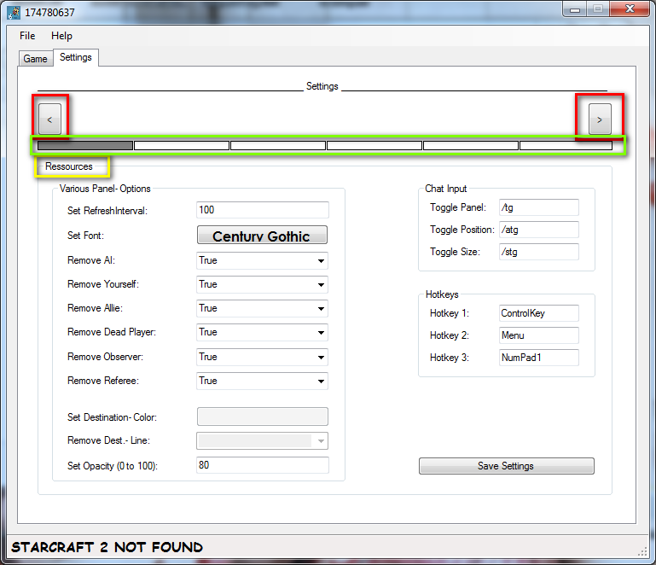

The red boxes allow us to tab through the settings of each panel.

In the green box you can see the current position.

In this case you can only go right (because left is blocked).

However, you should always keep an eye on the yellow box.

It shows you which panel you are about to configure.

Now you can configure all panels.

If you are done you should safe those values.

## Activate the panels

**One side note:** You should activate the panels in game. So you can see if they work.

**Another side note:** The test-game is done with Guest- pass. I play against an AI and show you the common problems with “**the hack doesn’t work**”.

Based on our settings of the resource- panel, the AI gets filtered.

We get filtered as well.

We have to change those settings to see us playing against an AI.

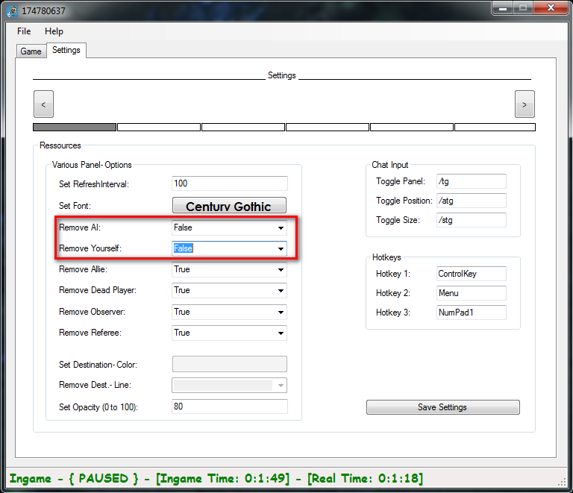

The red box just shows us what I changed.

Now, we will be able to see us and the AI in the resource- panel!

(You may notice the status- label in the bottom? It just shows useful information about the game- state)

To activate the panel, we have to type in “**/tg**” or press “**ControlKey**” + “**Menu**” + “**NumPad1**”.

(I use the key- combination since I can’t screen shot the chat- input)

See the result:

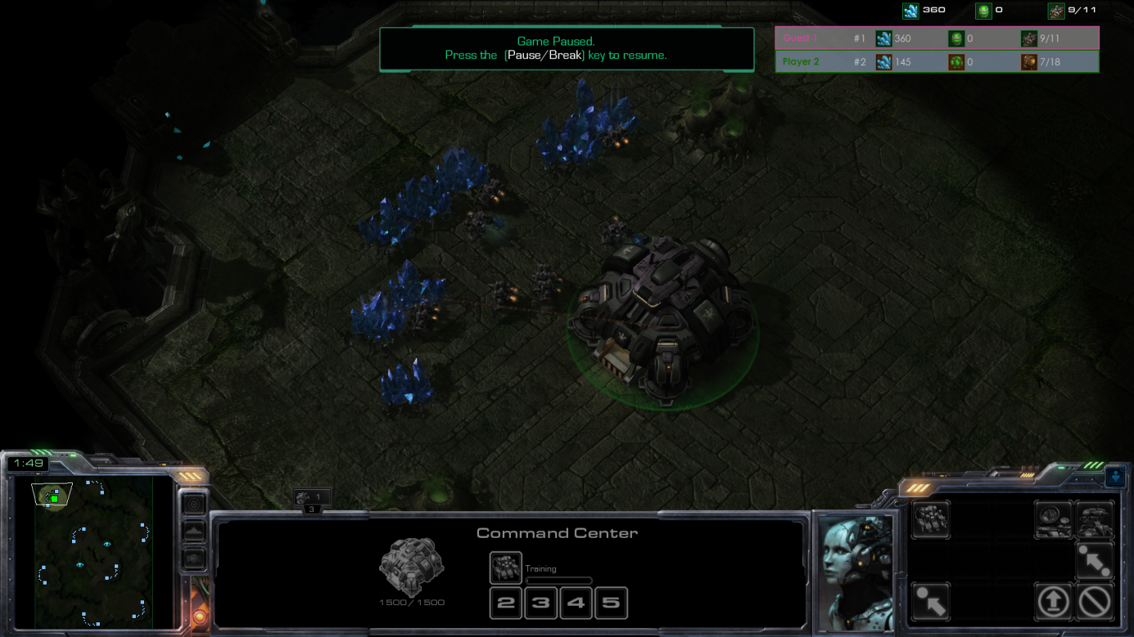

*The game – with the resource- panel*

If you can’t see the panel, check if you have more windows in the taskbar:

D:\Programmieren\AnotherSc2Hack\AnotherSc2Hack\AnotherGuide_SS\8_task.png

=>

D:\Programmieren\AnotherSc2Hack\AnotherSc2Hack\AnotherGuide_SS\9_task2.png

As you can see, there is another window hiding behind the Mainwindow.

Just click on it.

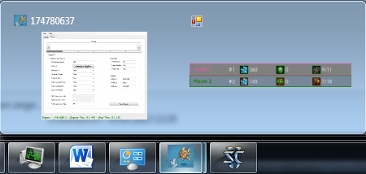

*That’s how it should look like.*

If the resource- panel is empty, check your filters or check if you are in game!