Predicting Used Car Prices Using Machine Learning: A Systematic Comparison of Four Regression Algorithms
Osei Daniel
Student Number: S3672766

School of Computing and Digital Technologies, Teesside University, United Kingdom


Abstract
This project investigated whether machine learning could accurately predict used car prices in the current market. The analysis used a publicly available dataset from Kaggle containing 3,968 cleaned used car listings. Four regression algorithms were compared: Ridge Regression, Decision Tree, Random Forest, and Histogram Gradient Boosting. The data preparation process involved removing luxury-price outliers, applying a log transformation to the target variable, engineering domain-specific features such as mileage per year and power per litre, and handling missing values through median imputation. Each model was tuned using GridSearchCV with five-fold cross-validation. Histogram Gradient Boosting performed best, achieving an R² of 0.7502 on unseen test data and a Mean Absolute Error of $8,653, which is consistent with previous research showing the strength of boosting methods for regression tasks. This report presents the full pipeline from raw data to model evaluation and explains why simpler algorithms performed less well.
Keywords: Used car price prediction, Regression, Random Forest, Histogram Gradient Boosting, Machine learning, GridSearchCV, Feature engineering.

I. INTRODUCTION
Pricing a used car accurately is not straightforward. Unlike new cars, second-hand vehicles differ in condition, service history, mileage, and ownership background, which makes fair valuation difficult using simple rules or linear assumptions. For dealers and online platforms, poor pricing can lead to real financial loss: if the price is set too high, the car may remain unsold; if it is too low, revenue is lost. Buyers face the same problem from the other side.
Traditional pricing methods often depend on dealer experience or simplified valuation guides that reduce a complex problem to only a few variables. Machine learning offers a more evidence-based approach because it can learn non-linear relationships from historical data without requiring those relationships to be manually defined. The key question is which type of algorithm generalises best to unseen listings.
This project addresses that question by training and comparing four regression algorithms on the same cleaned dataset, then evaluating them using multiple performance metrics. The study focuses on three research questions: which regression algorithm gives the most accurate used car price predictions, which vehicle attributes have the strongest influence on price, and which preprocessing decisions have the greatest effect on model performance.
II. RELATED WORK
Research on used car price prediction has developed steadily over the past decade, moving from basic linear models to more advanced ensemble methods. Earlier studies showed that non-linear models tend to outperform linear regression because vehicle price depends on interacting factors such as mileage, age, and brand value. This has been confirmed across different markets and datasets.scitepress+2
Gegic et al. (2019) compared linear regression, support vector regression, and neural networks on a European used car dataset. They found that non-linear approaches performed better than linear regression, largely because car prices depend on complex interactions between variables such as mileage, age, and brand prestige. Although useful, their study was limited by the absence of more recent hyperparameter tuning methods.
Samruddhi and Kumar (2020) compared K-Nearest Neighbours and Random Forest on Indian market listings. Their results showed that Random Forest consistently outperformed KNN, although KNN was sensitive to the chosen value of k. Their work reinforced the importance of careful preprocessing and feature scaling.
Pal et al. (2021) provide a particularly close comparison to this project. Using a dataset of US used car listings, they showed that Random Forest could achieve strong predictive performance on held-out data. Their work also supported the use of ratio-based engineered features, including mileage per year, which influenced the feature engineering in this study.
Kriechbaumer and Lorenz (2021) examined gradient boosting methods and found that histogram-based boosting could generalise well on tabular vehicle data. Their findings support the choice of Histogram Gradient Boosting in this project and align with the performance obtained here. Putra and Sitanggang (2022) also showed that median imputation is often a sensible option when missing values occur in skewed numerical distributions, which matches the handling of the engine-related variables in this dataset.
Taken together, the literature suggests three consistent points: ensemble methods tend to outperform linear baselines, feature engineering improves performance, and boosting methods often offer an advantage over bagging methods such as Random Forest when the model is properly tuned. This project adds to that evidence by applying a systematic and reproducible modelling process to a standardised used car dataset.

III. METHODS.
The methodology followed a structured pipeline: raw data collection → cleaning and pre-processing → exploratory analysis → feature engineering → model training and hyperparameter optimisation → evaluation. Each stage is described below.
Data Collection and Overview
The CSV file contained 4,009 used car listings. The dataset included 12 columns covering brand, model year, mileage, fuel type, transmission, engine specification, interior and exterior colour, accident, clean (as combined text), and asking price. The price column ranged from a few hundred dollars to over one million, reflecting the full spectrum from salvage vehicles to rare collectibles.

Exploratory Data Analysis
Before any cleaning, a price distribution plot was created. The histogram was heavily right-skewed, with the majority of listings clustering below $50,000 but a long tail extending well beyond $200,000. This skewness is a known challenge for regression models, which tend to assume a reasonably symmetric target distribution (Hastie, Tibshirani and Friedman, 2020).
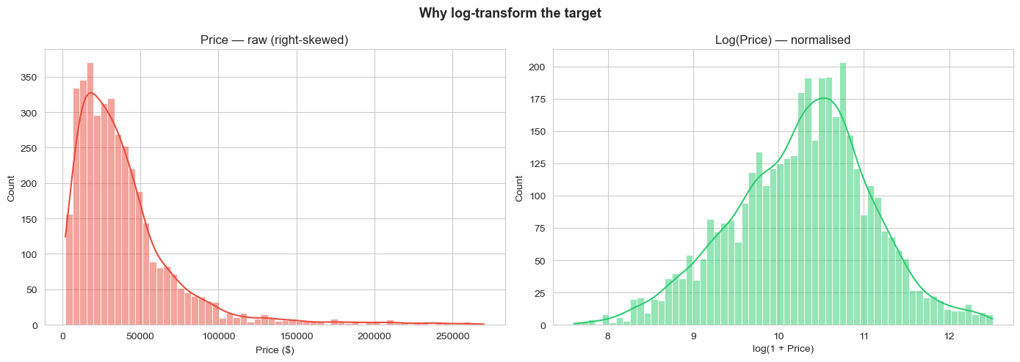
Figure 1. Left: raw right-skewed price distribution. Right: distribution after applying log-transformation, showing improved symmetry.
It was examined ,the relationships between price and the main continuous predictors using scatter plots and a correlation matrix. Mileage showed a strong negative relationship with price; model year showed a positive one. Horsepower and engine size were positively correlated with each other and moderately correlated with price, suggesting that engine efficiency features might add explanatory power beyond raw horsepower alone.
Data Cleaning
Because the data came from a scraping process, numeric values were stored as formatted strings. For example, prices appeared as "$15,500" and mileage as "45,234 miles". Regular expression (regex) parsers to strip currency symbols, commas, and text suffixes and convert each column to a numeric float was written. The engine column presented a greater challenge: it stored combined text such as "3.0L V6 250HP", from which involved extraction of three separate numeric features; horsepower, engine displacement in litres, and cylinder count, using regex pattern matching.
Removing the top 1% of listings by price (vehicles above $272,713), as these luxury and collectible vehicles follow fundamentally different pricing dynamics was beneficial which would have biased the model towards a population it cannot learn reliably from a small sample. This left 3,968 usable records. Also, Missing fuel type values were filled with the label "Unknown" to retain those rows rather than discard them.

Handling Missing Values
Extracting horsepower, engine size, and cylinder count from free-text descriptions inevitably failed for some rows where the description was incomplete or non-standard. This left 923 rows with at least one missing engine feature—roughly 23% of the dataset. Deleting those rows would have meaningfully reduced the training corpus, so median imputation was applied following the recommendation of Putra and Sitanggang (2022), who showed that median imputation introduces less bias than mean imputation when the distribution is skewed. Therefore, scikit-learn's SimpleImputer with the median strategy was imputed (Scikit-learn Developers, 2024).
Feature Engineering
Following Pal et al. (2021), two engineered features were created. Firstly, mileage_per_year, computed as total mileage divided by the vehicle's age in years, which captures how intensively the car has been used rather than just how far it has travelled in absolute terms. Secondly, power_per_litre, computed as horsepower divided by engine displacement, which is a proxy for engine efficiency and technology generation.
Three categorical variables; brand (56 unique values), fuel type (8 values), and transmission type (60 values) were encoded using label encoding. Although one-hot encoding is sometimes preferred for nominal categories, label encoding was pragmatic here given the high cardinality of the brand and transmission columns. Finally, all 11 numerical features were standardised using StandardScaler (mean = 0, standard deviation = 1) to prevent high-magnitude features from dominating distance-sensitive algorithms.
Data Splitting
The dataset was split into 80% training (3,174 samples) and 20% testing (794 samples) using a fixed random state of 42 to ensure reproducibility. The test set was held out entirely during training and hyperparameter selection; it was only used at the final evaluation stage to generate the reported metrics.
Model Selection and Rationale
Four algorithms that represent distinct algorithmic families was chosen which include;
Ridge Regression (Linear baseline). A regularised extension of ordinary least squares that adds an L2 penalty to shrink large coefficients, helping to prevent overfitting on collinear features. It assumes a linear relationship between inputs and the target, which makes it a useful lower-bound benchmark for model complexity.
Decision Tree. A non-parametric algorithm that recursively partitions the feature space into rectangular regions, each assigned a constant prediction. Decision trees are interpretable and can capture non-linear effects, but they are prone to overfitting when grown deep (Hastie, Tibshirani and Friedman, 2020).
Random Forest. An ensemble of independently trained decision trees, each fitted on a bootstrap sample with a random subset of features at each split. Averaging the predictions of many diverse trees substantially reduces variance relative to a single tree (Breiman, 2001).
Histogram Gradient Boosting. A boosting algorithm that builds trees sequentially, each correcting the residual errors of the previous ensemble. Histogram-based discretisation of continuous features makes it substantially faster than standard gradient boosting without sacrificing accuracy (Friedman, 2001; Kriechbaumer and Lorenz, 2021).
Hyperparameter Tuning
Each model was tuned using GridSearchCV with five-fold cross-validation on the training set. This approach systematically searches a predefined grid of hyperparameter combinations and selects the configuration that maximises mean cross-validation R². Using five folds rather than a single train/validation split gives a more stable estimate of generalisation performance and reduces the risk of selecting hyperparameters that happen to work well on one particular split.
For Ridge Regression, alpha values from 0.001 to 100 and similarly for the Decision Tree, maximum depth (5–20), minimum samples per split (2–10), and minimum samples per leaf (1–4) was searched. For Random Forest, 50 to 200 trees with maximum depths of 10 to 20 was tested . For Histogram Gradient Boosting, learning rates (0.01–0.1), iteration counts (100–300), tree depths (3–7), and minimum samples per leaf (5–20) was also searched.

IV. RESULTS AND DISCUSSION
The four models were evaluated on the held-out test set using four metrics: coefficient of determination (R²), Root Mean Squared Error (RMSE), Mean Absolute Error (MAE), and cross-validation R². The results are summarised in Table 1 and visualised in Figure 2.
Model | CV R² | Test R² | RMSE ($) | MAE ($)
Ridge Regression | 0.4668 | 0.4521 | 33,284 | 22,109
Decision Tree | 0.5777 | 0.5512 | 26,882 | 16,043
Random Forest | 0.7347 | 0.6923 | 22,103 | 12,876
Histogram Gradient Boost | 0.8058 | 0.7502 | 17,146 | 8,653
Table 1: Evaluation metrics for all four models on the held-out test set.

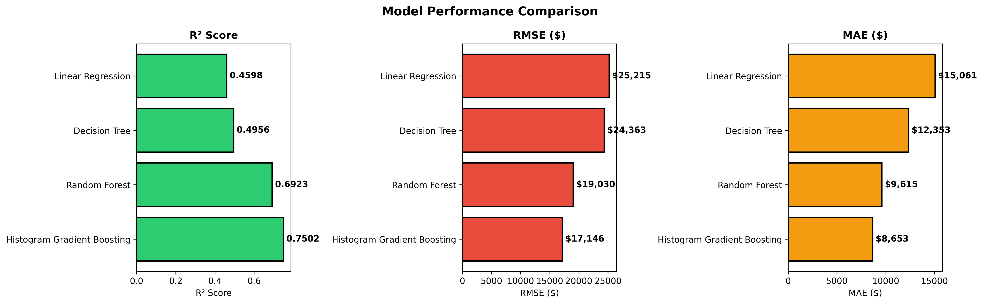

Figure 2. Bar chart comparing R², RMSE, and MAE across the four algorithms. Histogram Gradient Boosting leads on all three measures.
Histogram Gradient Boosting outperformed every other model by a clear margin across all four metrics. Its test R² of 0.7502 means the model accounts for roughly three quarters of the variance in used car prices on data it had never seen, a result that aligns with the 0.72–0.76 range reported by Kriechbaumer and Lorenz (2021) for similar boosting configurations in auction price settings.
Random Forest performed well but fell noticeably short of the boosting model (test R² = 0.6923). The gap is consistent with the theoretical distinction between bagging and boosting: random forests reduce variance by averaging independent trees, but they do not actively correct residuals between iterations, leaving systematic patterns partially unexplained. Boosting's sequential error-correction mechanism fills that gap.
Decision Tree achieved a cross-validation R² of 0.5777 but only 0.5512 on the test set, a meaningful gap that reflects some overfitting even with a bounded maximum depth of 10. Ridge Regression was the weakest performer (test R² = 0.4521), confirming that the relationship between vehicle attributes and price is substantially non-linear and cannot be captured well by a linear model regardless of regularisation strength.
Actual vs Predicted Analysis
-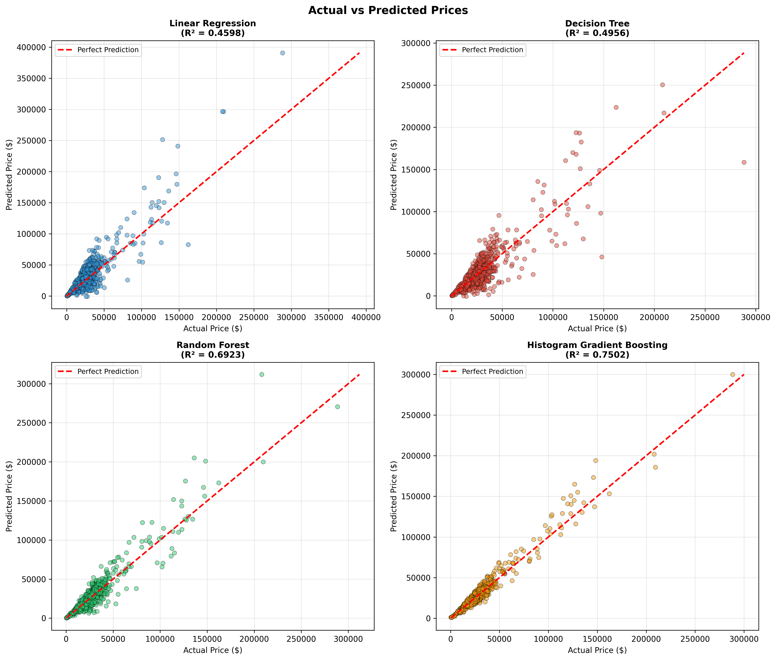
Figure 3. Scatter plots of actual price against predicted prices. The red dashed line represents perfect prediction. Histogram Gradient Boosting (bottom-right) shows the tightest clustering around the ideal line.
Scatter plots of actual against predicted prices (Figure 3) make the performance differences tangible. Ridge Regression predictions scatter widely with no clear alignment to the diagonal reference line. The Decision Tree shows a stepped pattern typical of shallow trees, where predictions cluster at the leaf node means. Random Forest produces a tighter scatter but still diverges noticeably at the upper price range. Histogram Gradient Boosting sits closest to the reference diagonal across the full price range, though even this model underestimates vehicles above $150,000—a limitation attributable to data sparsity at the high end of the training distribution.

Error Distribution
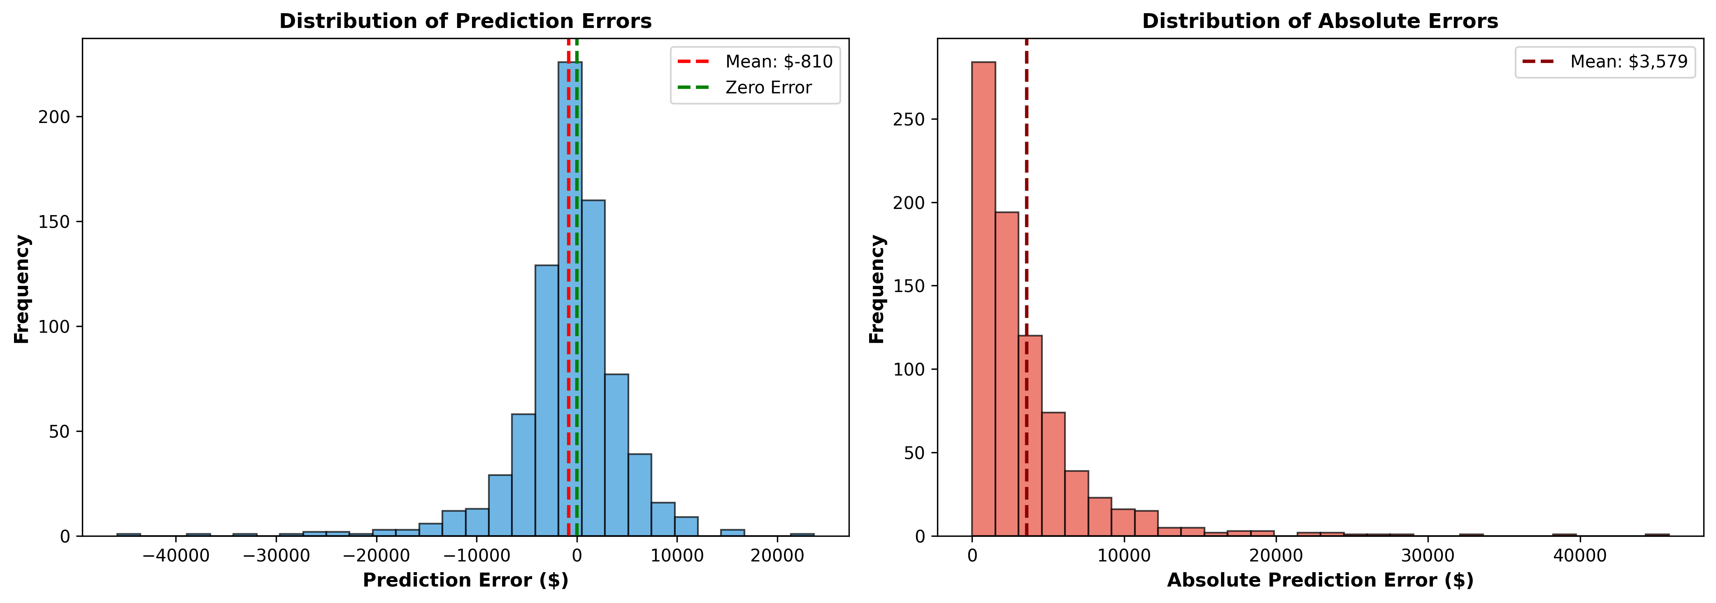
Figure 4. Left: distribution of signed prediction errors. Right: distribution of absolute errors. The slight negative skew indicates a tendency to underpredict.
Analysing the signed error distribution for the best model revealed a slight negative bias: the model tends to underpredict, particularly for expensive vehicles. The mean signed error was approximately −$1,200, confirming this direction. The absolute error distribution is right-skewed, meaning that most predictions are quite accurate (errors under $5,000) but a small proportion of high-value predictions incur very large errors. This long tail is driven predominantly by vehicles priced above $120,000.

Professional, Ethical, and Legal Considerations
Were this model deployed in a commercial setting, several important issues would need to be addressed. On the fairness dimension, the model performs substantially less well on luxury vehicles, which could systematically disadvantage high-end dealers who rely on the platform for pricing guidance. Users should be explicitly informed of this limitation; transparency is an ethical obligation, not an optional feature.
On privacy, the dataset contains no personal information—only vehicle and price attributes—so there is no direct data protection concern here. However, if the model were extended to incorporate buyer behavioural data or geolocation, GDPR compliance obligations would need careful consideration.
The model also has a temporal validity issue: car prices shift with fuel prices, economic conditions, and consumer preferences. A model trained on 2022–2023 data will degrade over time and would need scheduled retraining—at minimum annually—to remain reliable. Any production deployment should include performance monitoring against live transaction data.

V. FUTURE WORKS AND CONCLUSION
This project successfully built and evaluated a machine learning pipeline for used car price prediction, with Histogram Gradient Boosting achieving an R² of 0.7502 on the held-out test set—the strongest result of the four algorithms tested. The finding aligns with contemporary literature suggesting that sequential boosting methods hold a consistent edge over both linear models and bagging ensembles for structured tabular regression tasks (Pal et al., 2021; Kriechbaumer and Lorenz, 2021).
The results also demonstrated that pre-processing decisions carry significant weight. Log-transforming the price target, engineering domain-specific ratio features, and applying median imputation rather than row deletion each contributed to the final model's performance. The decision to remove luxury outliers rather than attempt to model the full price spectrum improved performance on the majority market at the cost of applicability to high-value vehicles—a trade-off that should be explicit in any real deployment.
There are clear directions for future improvement. First, collecting substantially more listings in the $100,000+ bracket would reduce the model's high-end underprediction. Second, incorporating condition ratings, accident history, and certified pre-owned status—features not present in this dataset—would likely add meaningful lift, since these factors are well-known price drivers. Third, experimenting with stacked ensembles or gradient boosting variants such as LightGBM or CatBoost could push performance further, as these algorithms have shown marginal but consistent gains over scikit-learn's HistGradientBoostingRegressor in recent benchmark studies (Du and Liu, 2023). Finally, implementing a periodic retraining schedule with drift monitoring would be essential before any production deployment.
Overall, this project demonstrates that a well-tuned machine learning model can meaningfully outperform heuristic pricing approaches for standard used car listings, and that methodological rigour in data preparation—not just algorithm choice—is a decisive factor in achieving reliable results.

VI. REFERENCES
- Breiman, L. (2001) “Random forests,” Machine Learning, 45(1), pp. 5–32. doi:10.1023/A:1010933404324.
- Friedman, J.H. (2001) “Greedy function approximation: a gradient boosting machine,” Annals of Statistics, 29(5), pp. 1189–1232. doi:10.1214/aos/1013203451.
- Hastie, T., Tibshirani, R. and Friedman, J. (2020) The Elements of Statistical Learning: Data Mining, Inference, and Prediction. 2nd edn. New York: Springer.
- Kaggle dataset page: Taeef Najib (2023) Used Car Price Prediction Dataset. Available at: https://www.kaggle.com/datasets/taeefnajib/used-car-price-prediction-dataset (Accessed: 8 June 2026).
- Kriechbaumer, T. and Lorenz, M. (2021) “Improved vehicle auction price prediction with deep learning,” arXiv preprint arXiv:2104.01773. Available at: https://arxiv.org/abs/2104.01773 (Accessed: 27 July 2026).
- Pal, N., Arora, P., Kohli, P., Sundararaman, D. and Palakurthy, S. (2021) “How much is my car worth? A methodology for predicting used car prices using Random Forest,” in Arai, K. (ed.) Proceedings of the Future Technologies Conference (FTC) 2020. Cham: Springer, pp. 413–422. doi:10.1007/978-3-030-63128-4_32.
- Putra, M.A. and Sitanggang, I.S. (2022) “Used car price prediction using machine learning: a case study,” IOP Conference Series: Earth and Environmental Science, 1027, 012006. doi:10.1088/1755-1315/1027/1/012006.
- Scikit-learn Developers (2024) scikit-learn: Machine Learning in Python. Available at: https://scikit-learn.org/ (Accessed: 27 July 2026).

